Climate smart agriculture
STUDY TITLE IN THIS SECTION]

AGRICULTURAL EDUCATORS AWARD REPORT

DATE: 14th August, 2025

Authored by: Nicola Cannon
Name of University/College: Royal Agricultural University

www.tfcct.co.uk

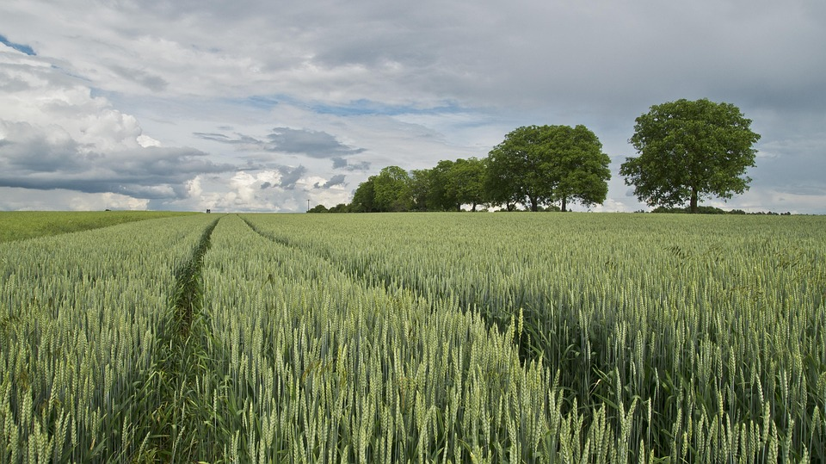


AGRICULTURAL EDUCATOR AWARD REPORT

TITLE | Climate smart agriculture
Scholar | Nicola Cannon
Objectives | To determine measures to improve resilience in agricultural systems in countries with great climatic variation and temperature stress.  To evaluate how climate change and policies introduced to try and mitigate climate change will impact agricultural production techniques and productivity.
Countries Visited | Saskatchewan, Canada  Western Australia
Key Messages | Farmers need to be aware of a range of adaptions they can make on their farms to cope with extreme weather events and help reduce costs during times of weather stress.  Water management on farms should be evaluated to explore opportunities for holding back water during peak rainfall periods to reduce flooding downstream whilst also holding more water on farm for use during drier periods.  Plant breeding can play an important role in developing more resilient traits within crop varieties.  Adapting cultivation and drilling techniques can help reduce costs whilst benefitting soil carbon retention.
The Farmers Club Charitable Trust

The Farmers Club Charitable Trust was founded in 1981 and is dedicated to supporting the agricultural community in the UK through education, leadership and innovation. Our mission is to enhance the agricultural sector by providing financial assistance to advance education and training within the food farming, and associated industries.

The Agricultural Educator Awards are part of a suite of initiatives; these are open for applications every Autumn and awards are made every March.

Full details can be seen on the Trust’s website www.tfcct.co.uk.

Published by The Farmers Club Charitable Trust
Email: ambassador@tfcct.co.uk

(The views in this report are those of the author only)

Climate smart agriculture

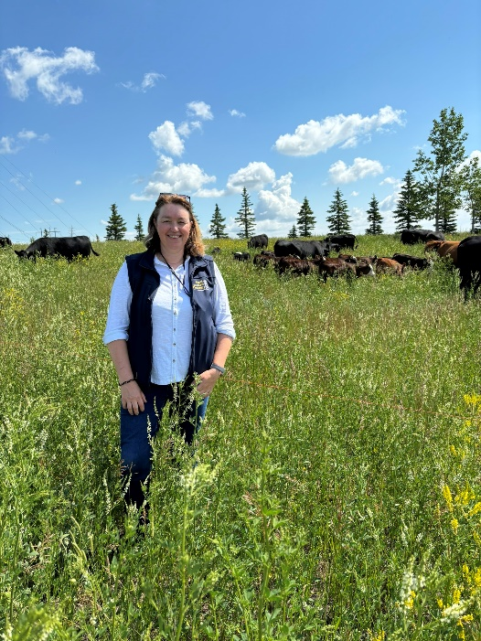

Professor Nicola Cannon


Table of Contents
Introduction 1
Background to the challenges 1
Study Aims 2
Study Locations 3
Reflections from Western Australia 3
Resilient vineyard 4
Conserving water in arable systems 4
Turning rain into grain 7
On-farm dams 8
Improving farm drainage 9
Breeding for long coleoptile wheat 9
Adopting precision farming techniques 10
Grain management 10
Stubble burning 11
Reflections from Canada 12
Introduction to agriculture in Saskatchewan (details from Richard Gray) 12
Reflection from visit to Indian Head Research station 16
Scale of commodity cropping in the region 17
Diverse cropping and smaller markets 18
Actively managing water on farms 19
Implications and opportunities for UK agriculture 20
Discussion 22
Conclusions 22
Acknowledgements 23
References 24
GRDC (2022). Long, longer, longest: new trials weigh up benefits of long coleoptile wheat varieties. 24
Appendices 25
Main study locations in Western Australia 25
Main study locations in Saskatchewan, Canada 25
Other events in the UK: 25

List of Tables
Table 1 Bunbury, WA weather data, accessed 29/06/2024 6
Table 2 Cirencester, UK weather data, accessed 29/06/2024 6
Table 3 Adoption of zero tillage in the major cropping areas of Canada 13

List of Figures
Figure 1. Principles of regenerative farming (Groundswell 2024) 2
Figure 2 Principles of regenerative farming as implemented on the RAU farms 4
Figure 3 A diagrammatic representation of hair-pinning during seed placement at drilling 5
Figure 4 The relationship between crop water use and grain yield across northern Australian farming systems. The minimum amount of water required is demonstrated by where the line of best fit crosses the X axis (GRDC 2024). 7
Figure 5 Satellite image showing the on-farm dams in the York, WA in the wheat belt from Google Earth 8
Figure 6 Satellite image showing the on-farm dams in the Margaret River, WA in the wine growing region from Google Earth 9
Figure 7 Long coleoptile wheat Photo credit: SDC 10
Figure 8 Seeding rig at Delage Farm Photo credit: Delage Farm from Instagram 12
Figure 9 Wet areas in field coming out of winter 2024-25 and getting ready to drill. Photo credit: Delage Farm from Instagram 13
Figure 10 A photo of an exhibit is the Western development museum in Saskatoon showing the great dust pool which lead to the further degradation of land, the loss of many lives and extreme hardship in the dry years of the 1930s. 14
Figure 11 Screenshots from google maps demonstrating the amount of surface water and implying the need for drainage in Saskatchewan and showing the grid layout of the land and square field boundaries of each section of 640 acres 15
Figure 12 Rainfall in rainfall figure in the Saskatoon and Regina regions 16
Figure 13 Visiting G3 grain depot 17
Figure 14 Gray farm, first generation farmers and contractors running machinery for longer and enjoying spending winters maintaining and improving machinery. 18
Figure 15 10 combines in a shed at Delage Farm next to the mobile workshop which follows the fleet of machinery around the farm 18
Figure 16 Left hand side, Kevin discussing the range of crops he grows and the markets. Right hand side is his grain storage….imagine having your grain store in the UK not on hard standing! 19
Figure 17 Monitoring and moving water on the field to make field work more convenient and store water more effectively 19
Figure 18 Left: An irrigator at the Irrigation Research and Demonstration Centre near the Gardiner dam; Right: Plant breeding company benefitting from water availability 20
Figure 19 UK Rainfall 01 June - 15 July 2025 (Metoffice 2025) 21
Figure 20 Winter wheat yields by region in the ODA early harvest survey 2025 22

Introduction
I am currently Professor of Agriculture at the Royal Agricultural University, Cirencester. I am a trained as an agronomist and have focused my career into investigating opportunities for improving cropping systems whilst taking account the economic, environmental and social sustainability of these systems. The farmers and students I work with are on the front line of the climate crisis and they require workable solutions to incentivise the next generation, maintain viable businesses whilst improving rural biodiversity. Previously, farmers have often been hesitant to adopt different methods as they have received greater farm income from maintaining business as usual. Over the last 5-10 years everyone has experienced increased extreme weather events which have threatened the health and well-being of the farmer, their land and the ability to feed the nation. The next generation need to be equipped through an excellent and modern education to face these challenges. Students, farmers and our Government are now seeking viable solutions which work in harmony with nature while improving biodiversity, enhancing soil carbon sequestration, improving animal welfare and reducing emissions whilst still producing food to feed our nation.

During my career so far, I have researched and taught topics on non-chemical weed control, legumes for fertility, cultivations, soil health and aiming towards circular agricultural systems. More recently, I have commented to the media on how weather conditions influence farmers and I wrote a very popular article on ‘how extreme weather conditions impact your Christmas dinner’ which was published in over 15 newspapers and magazines.

The Farmers Club Agricultural Educators Award would enable me to look for further climate smart adaptions which can be made and evaluate how these could be implemented into UK farming systems.

Background to the challenges
With a few exceptions, the UK has recently been privileged to have excellent food security despite being only approximately 55% self-sufficient in food. Increasingly, climate change and conflict are impacting global food security and food inflation has become a challenge. This situation will become increasingly severe as competition for food increases due to global population increases, loss of agricultural land and productivity due to degradation, urbanisation and now a rapidly developing climatic threats.

Agriculture is a major contributor to climate change and accounts for 11% of total GHG emissions in the UK but also has the potential to be part of the solution as the only industry that can become a carbon sink. Firstly, agriculture needs to transition to net zero emissions which requires agroecological solutions.
In recent years there has been a rapid increase in interest and then the adoption of regenerative farming principles which are:
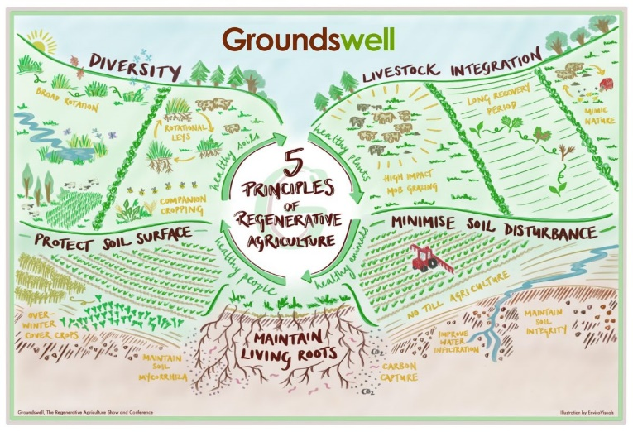
Figure 1. Principles of regenerative farming (Groundswell 2024)
Motivations for farmers adoption of regenerative farming systems appear to be driven by a range of factors from concerns over loss/low soil organic matter levels, the need for greater climate resilience, market/consumer demand (especially in direct marketing situations), pesticide resistance, increasing input costs and incentivisation through support mechanisms such as the Sustainable Farming Incentive. Regenerative agriculture is currently not a certified system of farming so farmers can select practices gradually if they wish and there is no inspection which requires compliance to specified legislation as required to become an organic farmer. Many farmers have already moved away from plough-based systems in the UK in favour of reduced tillage or direct drilling systems which is a small first step into these types of farming techniques by minimising soil disturbance whilst also making it easier to protect the soil surface.

Increasing the level of diversity on UK farms seems a greater step for many farmers as the range of profitable crops within an arable rotation is often limited. Many farms have become less integrated over the last 60 years leading to highly specialised arable and livestock units.

Study Aims
- To determine measures to improve resilience in agricultural systems in countries with great climatic variation and temperature stress.
- To evaluate how climate change and policies introduced to try and mitigate climate change will impact agricultural production techniques and productivity.

Study Locations
I visited Western Australia as it has contrasting climatic conditions across the state from desert agriculture to a Mediterranean climate. All areas have been profoundly impacted by climate change and I wanted to investigate how this influences the farming systems and business decisions. The state produces a wide range of agricultural products which provided an opportunity to look at a wide range of adaptations from farmers and researchers.

The second travel experience of my award was focused around the International Farm Management Conference in Saskatoon, Canada and attending the pre-conference study tour to visit a wide range of farms and business. The conference enabled an excellent networking opportunity whilst being in an environment to inspire and consider innovative farm management practices, as this year’s conference focuses on ‘Resilience through Innovation’. There were participants from about 25 countries at the conference.

Reflections from Western Australia
My arrival in Perth, Western Australia marked the end of the hottest and driest summer and the rain clouds gathering overhead introduced an air of optimism to a sector which was concerned about the upcoming planting season into very hot and dry seedbeds. Whilst the cooler temperatures were welcomed by everyone, the rain only fell in sufficient quantities in the wine region of Margaret River at this time and areas north of Perth only saw the clouds gather and then disperse. During my time in WA I saw the excitement in the start of the seeding season and then concern that newly established crops would be lost and farmers taking a break from planting until more rain was forecast. Already the cropping in this region is conducted in the winter to avoid the extreme temperatures reached during the summer months and the soil scorching high 40-degree temperatures. However, perennial crops such as vines still grow during this period and need to withstand these challenging conditions.
Wheat is a major grain crop in WA and is responsible for 65% of Australia’s annual grain production and generates A$2-5 billion each year for the economy (Department of Primary Industries and Reginal Development 2023). There are approximately 2900 family run farms within the WA wheat belt ranging from 1000-20,000ha. WA is responsible for about 40% of the total wheat production in Australia and more the 95% of WA wheat is exported mainly to Asia and the Middle East (Department of Primary Industries and Reginal Development 2023).

Resilient vineyard
I visited two vineyards within the Margaret River region both of which had tasting facilities and sold wine direct to consumers. Interestingly, both of the vineyards immediately mentioned that they were regenerative and they had adopted these techniques to improve the terroir of their wines. The techniques and changes described on these farms seem to be highly aligned to the regenerative farming principles as seen in this graphic which I have subsequently developed to demonstrate how we are implementing regenerative farming principles into the RAU farms.

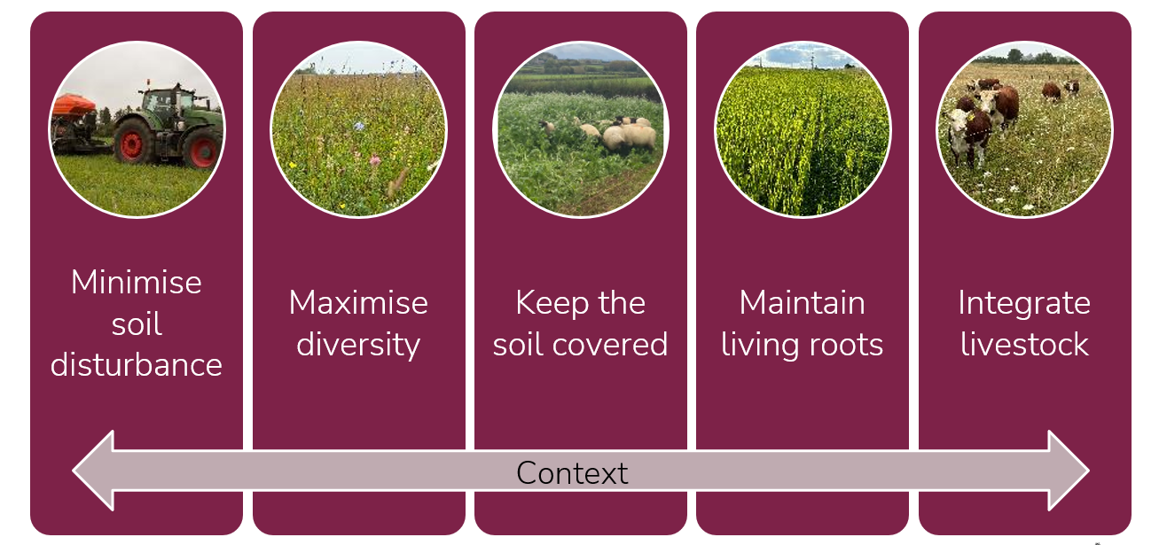
Figure 2 Principles of regenerative farming as implemented on the RAU farms

Conserving water in arable systems
Every farm I visited in WA practices direct drilling to reduce soil moisture loss, lower cultivation costs, maintain soil stability and avoid water and wind erosion, improving timeliness and reducing labour requirements. The drills used were predominately tine drills as although disc drills have lower soil disturbance, they can be prone to cracking open and thereby exposing and damaging the newly germinated seed. Other challenges of disc drills include hair pinning of straw leading to seedling toxicity and either seedling death or reduced vigour as well as bouncing over stones.
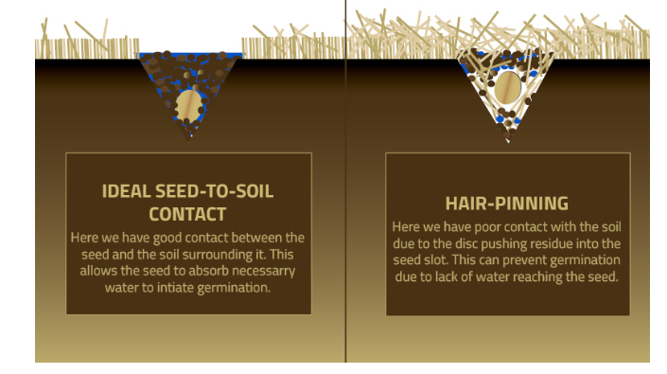
Figure 3A diagrammatic representation of hair-pinning during seed placement at drilling Ref: https://gooseneckimplement.wordpress.com/2017/07/18/hair-pinning-101/

As the wheat belt moves into the drier regions some farmers use a winter fallow to try and conserve water from the winter with the fallow for the subsequent season’s growth. Another technique for water conservation was the creation of a groove in the soil by the drill which helps collect rainwater, reduces water runoff and protects the newly emerged seedling from wind erosion.
The total amount of rainfall for Bunbury (a randomly chosen town in WA but with good weather data available, but there are wheat growing regions with far less rain than this) is not vastly different from Cirencester, UK where Bunbury receives on average 726mm/rain/annum whereas Cirencester gets 822mm/rain/annum (see table 1 and 2). The difference is that UK rainfall traditionally has fallen fairly evenly throughout the year whereas WA traditionally receives the majority of its rainfall between May and September. Both WA and the UK are becoming highly susceptible to dry conditions during the sowing session which can then have profound impacts on crop establishment, survival and yield. Because of the high winter rainfall rates in WA, farmers are very vulnerable to erosion but the higher temperatures lead to greater evapotranspiration losses.

Table 1 Bunbury, WA weather data, accessed 29/06/2024
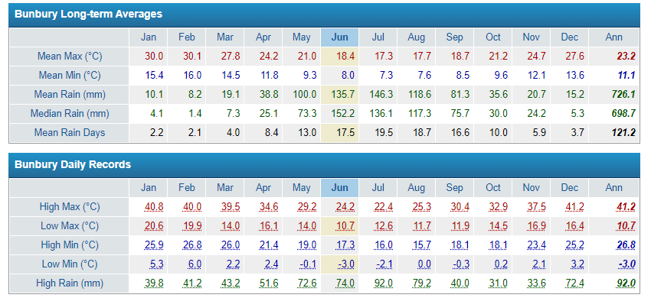https://www.farmonlineweather.com.au/climate/station.jsp?lt=site&lc=9965

Table 2 Cirencester, UK weather data, accessed 29/06/2024
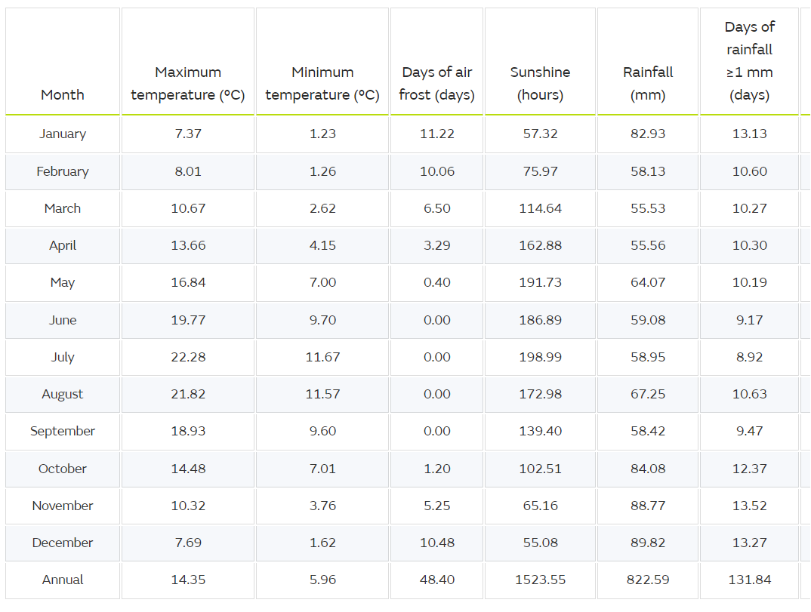
https://www.metoffice.gov.uk/research/climate/maps-and-data/uk-climate-averages/gcnw5nzzf
It should also be noted that winter frost risk, especially around anthesis (the flowering period) is a major threat for arable farmers in WA. The complexity of high day time temperature, drought, frost and potentially salinity in some areas makes it hard for plant breeders to select traits to combat all the climate challenges that WA are vulnerable to.

Turning rain into grain
WA is highly water stressed, with many places suffering marginal rainfall for arable production as well as the high temperature leading to increased evapotranspiration rates. The research organisations have several projects evaluating how different crops respond to high or low rainfall conditions. The critical thresholds of plant-available soil water are more than 110mm for wheat, more than 80mm for chickpeas and more than 140mm for sorghum (GRDC 2024). Water use efficiency has been evaluated in the top 20% of crops and it was found a water use efficiency of 23.2kg/ha/mm for wheat, 11.8kg/ha/mm for chickpeas, and 25.1kg/ha/mm for sorghum (Bell 2024).
Figure 3 determines the minimum amount of water that is need to enable a crop to accomplish sufficient biomass to produce grain. The minimum amount of rain required for chickpea to yield is 60mm, whilst wheat requires 100mm and sorghum 200mm. The higher requirement for sorghum is due to this crop growing during the summer months where there are high levels of evaporative losses.
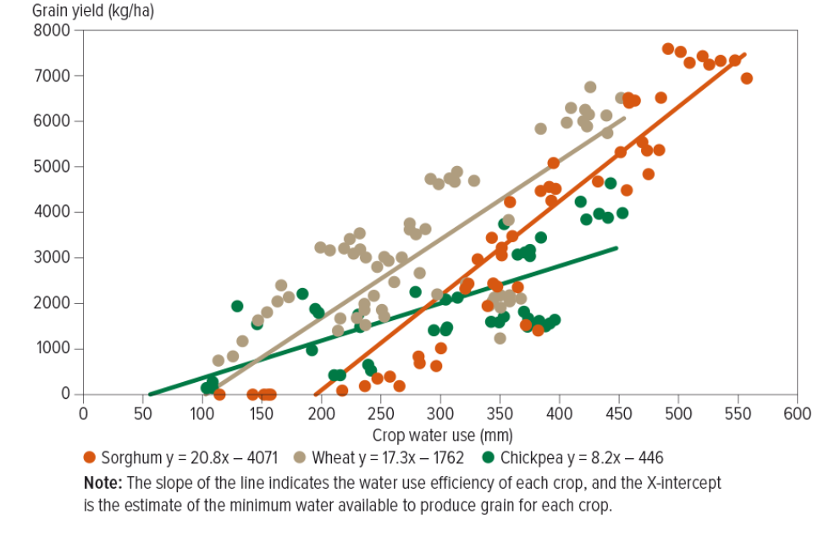
Figure 4 The relationship between crop water use and grain yield across northern Australian farming systems. The minimum amount of water required is demonstrated by where the line of best fit crosses the X axis (GRDC 2024).

On-farm dams
Arable farmers in WA are not irrigated but, every farm has multiple dams for collecting rainwater and surface runoff. The water in the dams is used for livestock drinking and some farms have developed pumping systems and pipelines to move the water around the farm to improve water supply. By collecting the rainwater, they are helping keep the water on the farm and reducing soil erosion and nutrient enrichment of rivers and lakes. The dams offer other benefits including greater diversity within the landscape, drinking places for animals (both farmed and unfarmed) and reduced flood risk from surface run-off. However, the dams do require the manipulation of field levels to enable water catchment whilst also having a small maintenance requirement.
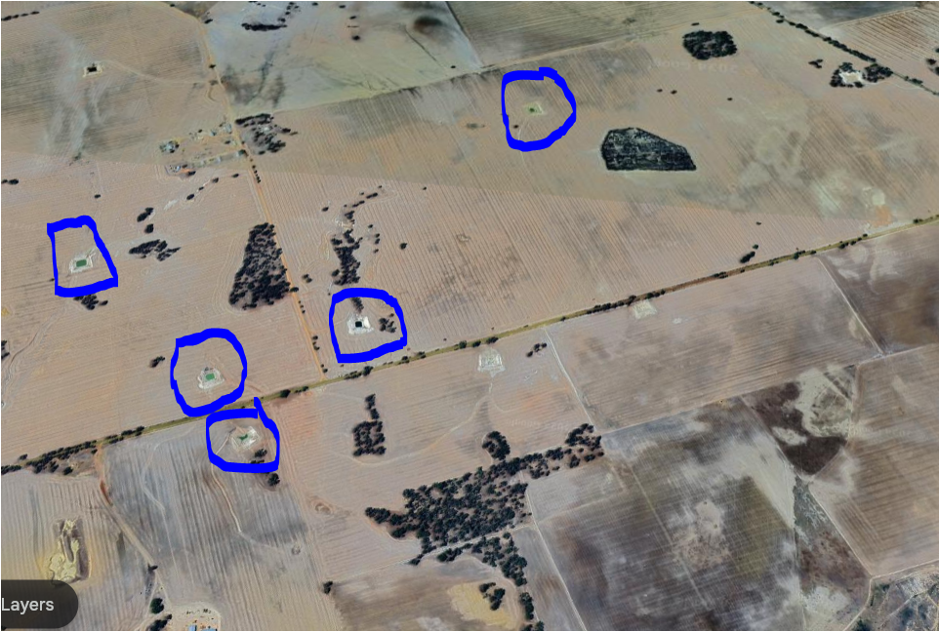
Figure 5 Satellite image showing the on-farm dams in the York, WA in the wheat belt from Google Earth
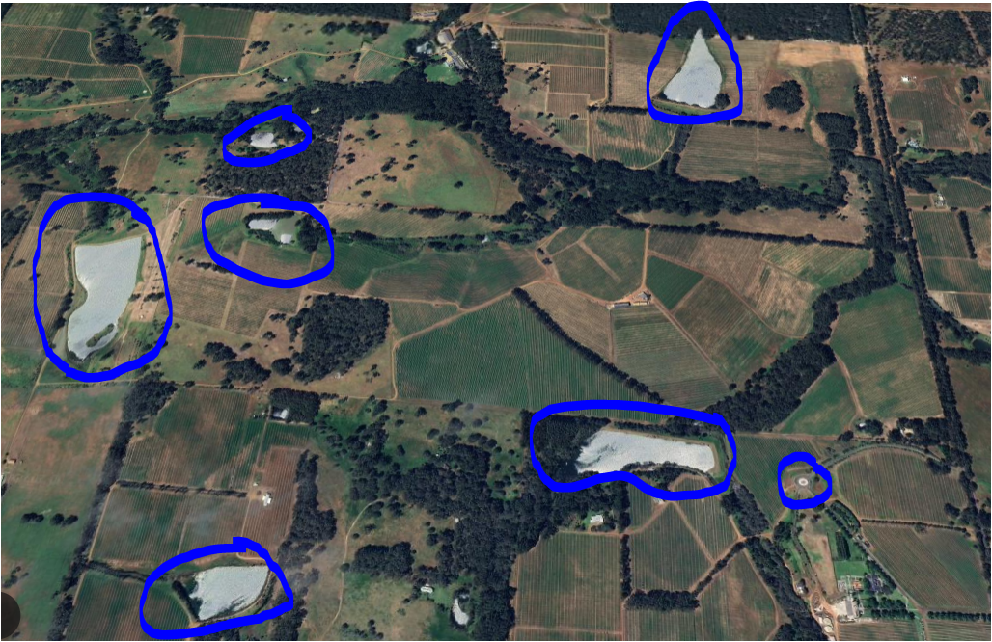
Figure 6 Satellite image showing the on-farm dams in the Margaret River, WA in the wine growing region from Google Earth

Improving farm drainage
Around Albany in the more southerly parts of WA the Stirling Farmers Group had developed a drainage project and were evaluating the benefits of improving excess water removal from arable field during periods of high rainfall. The project had proved highly successful and many farmers on clay rich land are now installing perforated plastic drainage pipes to avoid crop losses due to waterlogging. This programme demonstrates that drainage is required and is an effective farm management tool to improve soil management. Implementing success drainage programmes can help reduce water logging and therefore improve input timeliness and help the plant to recover more quickly after an extreme weather event, decrease run off erosion by reducing surface flow, reduce soil compaction and improve operational efficiency.

Breeding for long coleoptile wheat
There are several major programs taking place across WA looking into the opportunities of planting long coleoptile wheat (coleoptile is a cylindrical organ which forms a sheath around the first emerging leaf and shoot apex in grass species) to help mitigate against early moisture stress after crop establishment. GPRC (2022) state that conventional wheat lines generally have coleoptile lengths of approximately 60mm and are therefore should aim to be sown at depths of no deeper than 50mm. The longer coleoptile lines can be sown into depths of 70-90mm. The true long coleoptile wheats contain the Rht18 gene should be drilled at 100mm and produce a 120-140mm coleoptile. The aim of longer coleoptile wheats is that they can be earlier drilling and therefore an emerged plant with a developing root system can benefit from the rains when they come without needing to wait until the rains come for drilling.
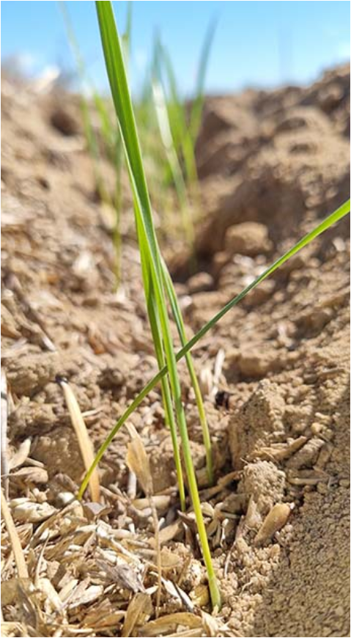
Figure 7 Long coleoptile wheat Photo credit: SDC

Adopting precision farming techniques
The adoption of precision farming techniques is generally very similar to the UK with all of the large arable farms having GPS and autosteer tractors. Some farmers are yield mapping but they are unsure of the economic benefits of the mapping.

Grain management
The large farm sizes in WA lend themselves to the adoption of chaser bins which helps reduce compaction from normal grain trailer tyres and thereby reducing crop growth potential. Most of the farms have limited grain storage facilities and rely on centralised grain storage. Low levels of on farm storage help reduce infrastructure costs and farm labour requirement. However, many farms suffer from snails within the harvested grain and they cannot send the grain away for storage with snail contamination so they therefore still have to treat grain on the farm with only limited resources. Interesting, one farm I visited had developed a neoprene roller system which crushes the snail shells but does not damage the grain when it is passed through the system. Another challenge with having minimal grain storage is the lack of infrastructure to dry grain in a wet harvest which seems to be an increasing issue with climate change.

Stubble burning
Many farms in WA are still burning stubble and see it as a good way to kill weed seeds and volunteers whilst cleaning up the stubble for drilling and therefore reducing blockages in the drill. The risk of uncontrolled fires is greater after the extremely hot and dry weather and farmers had waited for a little bit of rain to help reduce the previously tinder dry bush from catching fire.

Reflections from Canada

My journey in Canada started in Regina with the International Farm Management Association (IFMA) pre conference tour and ended in Saskatoon with the conference visiting numerous farms and agricultural businesses along the way.
The first thing that strikes when traveling in Saskatchewan is the vast size of the province with a total area of 651,900km² and with just 1.1 million people living there. To put this into perspective, England is 130,319km² with a population of 56 million people.

Introduction to agriculture in Saskatchewan (details from Richard Gray)
Saskatchewan contains 43.1% of all of Canada farmland. The average rainfall in the last 5 years had been 243mm but the farms are successfully growing cereals, oilseeds, lentils, chickpeas, peas, flax and canola (what we call oilseed rape). Interesting fact: Canola stands for Canadian oil low acid. All the canola is genetically modified and is generally the most profitable crop in the province. Despite the low rainfall, much of the farmland is very wet and farmers often try and crop through wet areas as they expect them to dry out as the growing season progresses. However, many times the tractor driver needs to make a decision on not entering a wet hole in case they get stuck, especially as there are lots of very big tractors and seeder rigs. The fields are often challenging wet at drilling and then baked and droughted out in the hot summer months. Crop rotations vary greatly from year to year and farm to farm depending on commodity prices, storage and the weather conditions. Fallow is still considered a valued break crop in the region with some farms simply growing fallow – crop - fallow – crop.
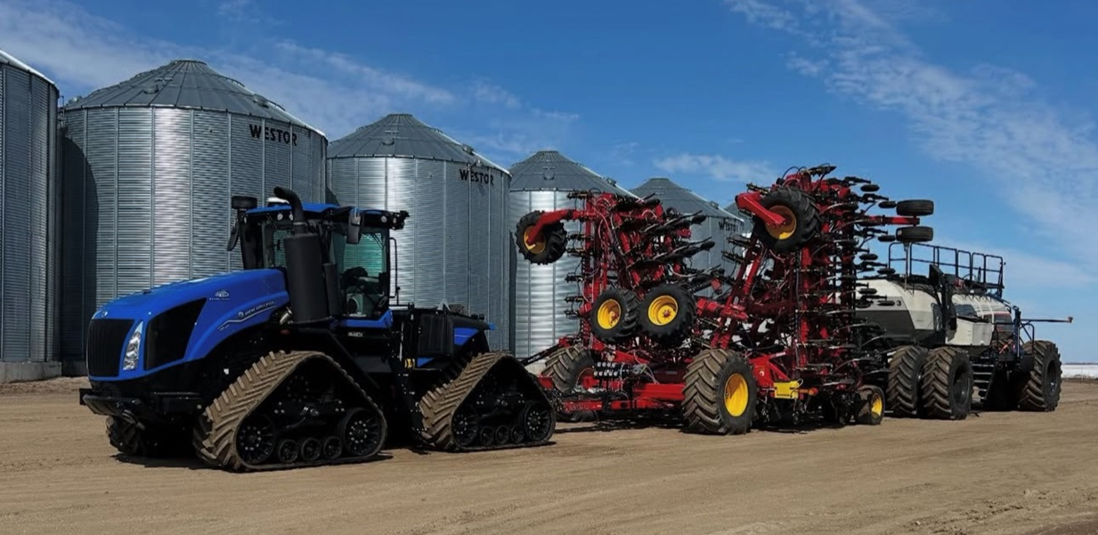
Figure 8 Seeding rig at Delage Farm Photo credit: Delage Farm from Instagram

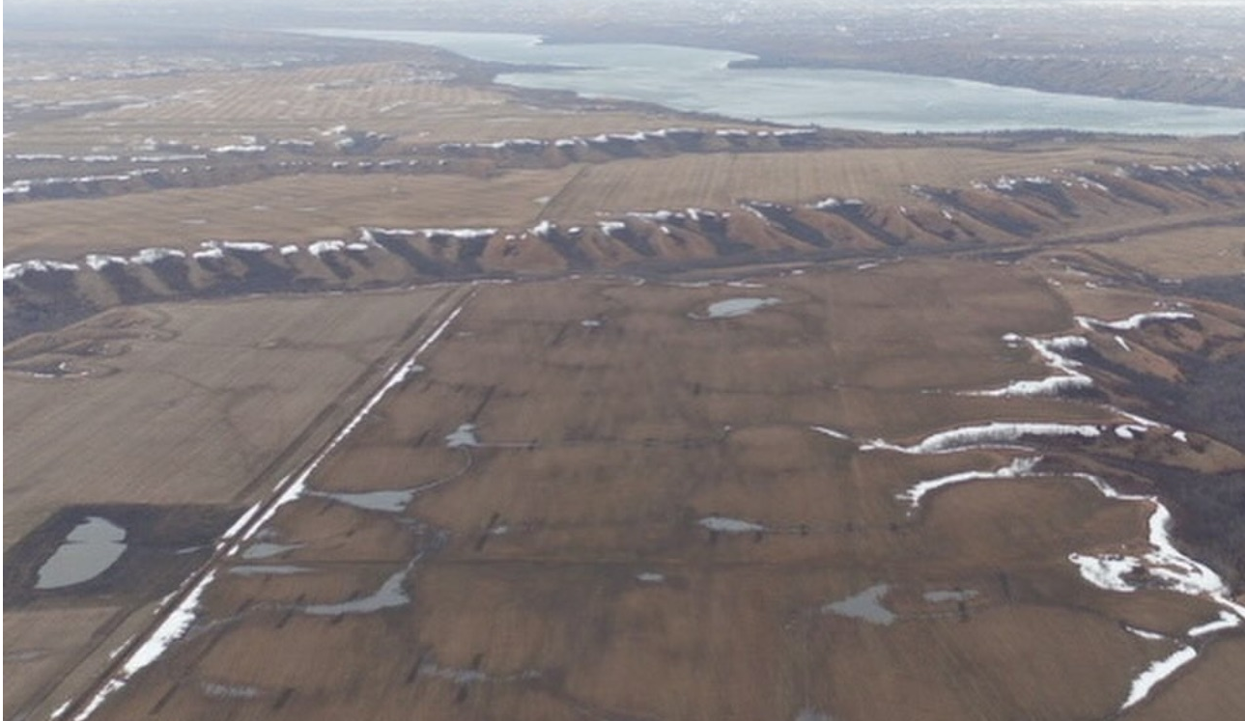
Figure 9 Wet areas in field coming out of winter 2024-25 and getting ready to drill. Photo credit: Delage Farm from Instagram

This land was first occupied for settled farming in 1880s and is part of the prairies. The area suffered badly from the great dust bowl in the 1930s and farmers started to appreciate some of the challenges of the summer fallow. During the fallow period many of the farmers were doing 6 or 7 tillage passes to try and eliminate problem weeds. The land is suffering from a loss of soil organic matter and fissure cracking resulting in reduced water infiltration. In more recent years there has been a rise in soil organic matters with levels rising from about 2.5% to 5.7%, with the increase attributed to the adoption of zero tillage. The adoption of zero tillage has been wide spread seeing a rise from 10% zero tillage in 1991 to 70% in 2011 in Saskatchewan.
Table 3 Adoption of zero tillage in the major cropping areas of Canada
 | % of cropland under zero till
 | 1991 | 2011
Alberta | 3% | 65%
Saskatchewan | 10% | 70%
Manitoba | 5% | 25%
Overall Canadian average |  | 61.6%
Summer fallow area | 19.5 million acres | 5.1 million acres

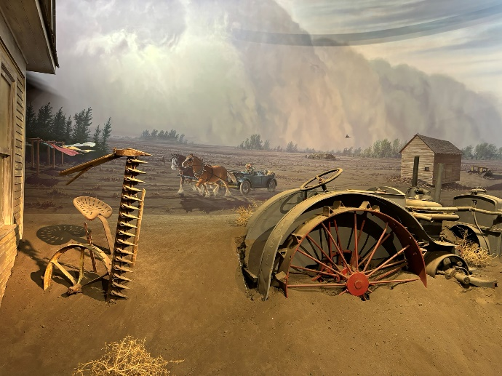
Figure 10 A photo of an exhibit is the Western development museum in Saskatoon showing the great dust pool which lead to the further degradation of land, the loss of many lives and extreme hardship in the dry years of the 1930s.
Initially, one of the barriers to the adoption of zero tillage was the lack of machinery and also the challenge of combine harvesters chopping straw effectively. Initially problems when adopting zero tillage included problems with depth control and seed placement in early trailed machines. A breakthrough in zero tillage occurred when a coulter was designed which helped maintain depth with individual seed openers and packers behind each coulter. I visited the farm where the main designer of this technology farmed at Halford Farms and still drilled with a Conservapak coulter. This Canadian design quickly took off in Western Australia and saw WA go from 0-100% zero tillage in 10 years.
It was described that controlled traffic farming is not a concept that Canadians particularly need to worry about due to the very cold winters with hard frosts going deep into the ground. Drilling is from April with harvest in early September – all spring cropping. There has traditionally been a bit of fear of early drilled crops catching an early frost during maturation, but this has not happened on a large scale for about 20 years.
The soils of the province tend to be comprised of glacial lake bottom with a 60% clay content, pH 7.8, high water holding capacity but often with a need for drainage.
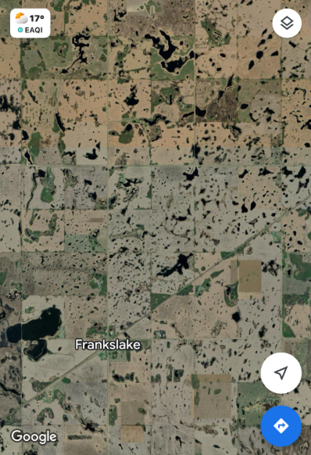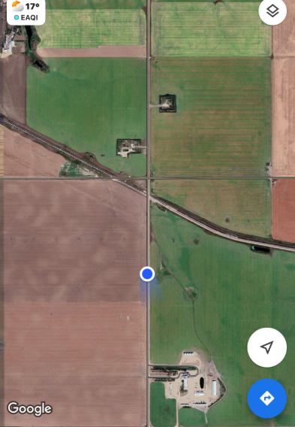
Figure 11 Screenshots from google maps demonstrating the amount of surface water and implying the need for drainage in Saskatchewan and showing the grid layout of the land and square field boundaries of each section of 640 acres
Nearly all farmers are using GPS for autosteer with 40-foot headers on combines and yield mapping everything. Various data is used for variable seed rates but section control is not as valuable as most farms are whole blocks and are square due to the apportioning of land. Farmers need to keep a firm control of costs and everyone could identify the cost of production for a t on wheat, canola, lentils etc. Whilst establishment is challenging, weed control seems relatively simple as little survives the winter. The farmers do not seem so concerned about plant diseases as the rainfall is very low in the cropping seasons which greatly reduces the disease threat. See the figure 10 for the rainfall figure in the Saskatoon and Regina regions.
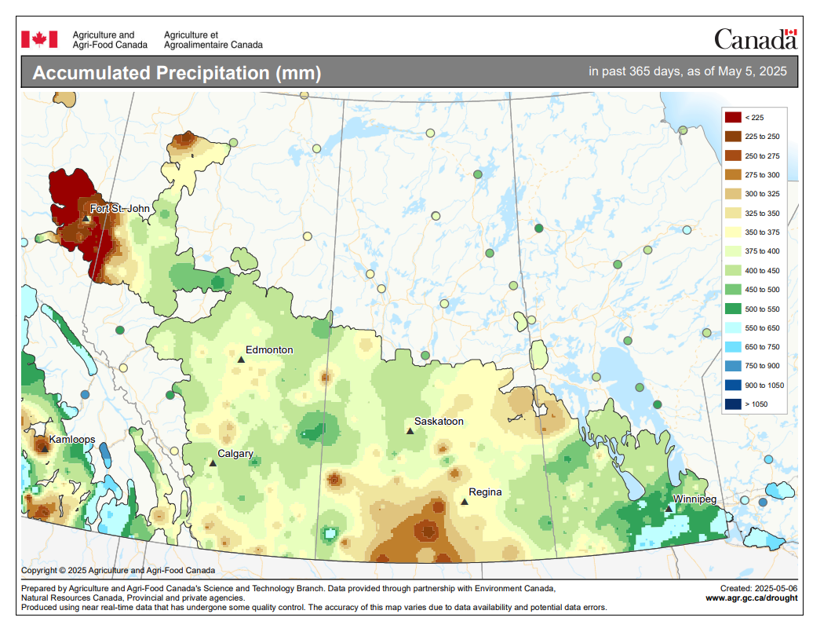
Figure 12 Rainfall in rainfall figure in the Saskatoon and Regina regions
Source https://www.agr.gc.ca/DW-GS/current-actuelles.jspx?jsEnabled=true&lang=eng

Reflection from visit to Indian Head Research station
The research station were growing a wide range of crops to try and improve crop management and deal with agronomic challenges. The station had played a key role in demonstrating the transition to zero tillage to the surrounding farming community. They were looking at bicropping opportunities to help improve the establishment of chickpeas and reduce fungicide applications by sowing them with flax. Chickpeas are highly sensitive to disease and generally receive about 6 fungicides applications but by drying out the top soil with the flax they have managed to successfully reduce to 2 fungicides. Another project was investing opportunities for growing camelina instead of canola as it is winter sown and could allow for an earlier sowing opportunity to then potentially make winter wheat a more viable crop for the region. Currently winter wheat survives winter but does not establish a big enough root system to survive either the cold and dry transition or the wet to dry transition and therefore is not a preferred crop for the region. There were various projects looking at mixing different legume crops to try and reduce Aphanomyces challenges which cause damping off and root rot diseases in legumes.

Scale of commodity cropping in the region
The Global Grain Group (3G) have 40,000t capacity and can load 147 train trucks in 10 hours, that’s moving 14,700t in 10 hours on a single train. They only store and handle durum wheat which all travels east and canola which all travels west and a small amount of chickpea and lentil. Once on the train tracks the commodities are mainly heading to China, Japan (canola), Mexico and United Arab Emirates. The site moves about 500-600,000t but in recent years has seen that the crops have been higher quality but lower yielding due to drier summers.
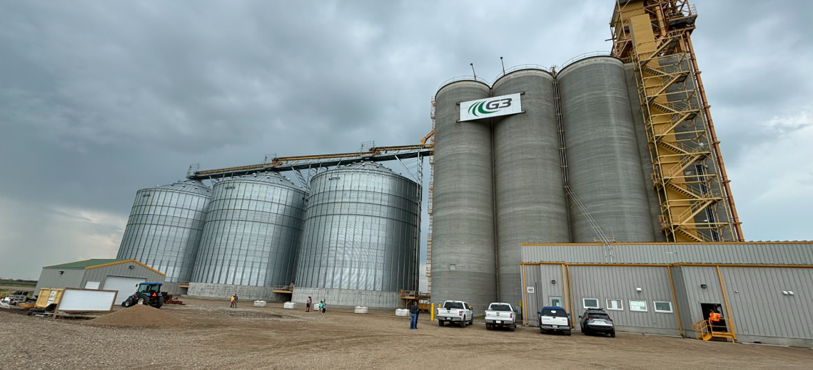
Figure 13 Visiting G3 grain depot
The site is surrounded by very large farms and this facility provides a simple marketing choice. The farm surrounding this facility was 100,000acres and running 18 combine harvesters. The scale seems an important aspect on farms in the province with small farm being around 3000 acres. These large farms are disparate, specialised, generally stockless and have a clear machinery policy. Some farms seem focussed on keeping new machinery to try and mitigate against breakdowns whilst another set of generally smaller farms seem to run old machinery and pride themselves on excellent workshop skills.
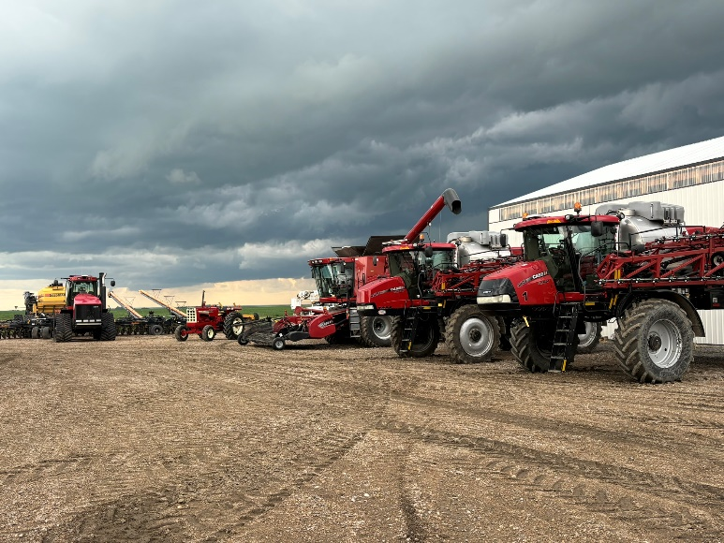
Figure 14 Gray farm, first generation farmers and contractors running machinery for longer and enjoying spending winters maintaining and improving machinery.
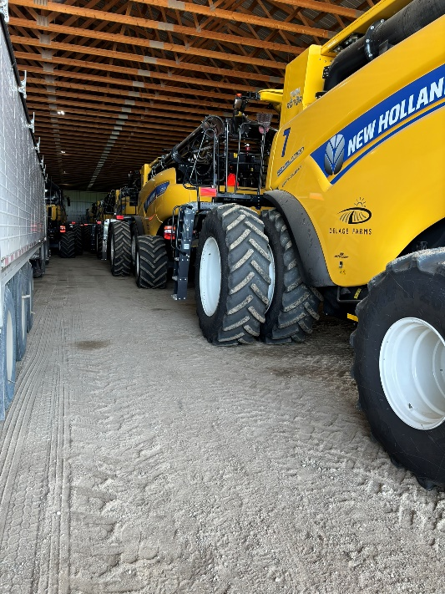
Figure 15 10 combines in a shed at Delage Farm next to the mobile workshop which follows the fleet of machinery around the farm

Diverse cropping and smaller markets
Kevin Hursh has spent the majority of his career as an agricultural journalist and consultant but also farms as well. Interestingly he had moved away from the mass commodity products of canola and wheat that most farmers in the focus on and now grows a much wider range of legumes for specialist markets. This approach fitted the smaller bins that he has on the farm whilst also spreading his seeding and harvesting windows which thereby somewhat mitigates against difficult weather conditions during peak periods.

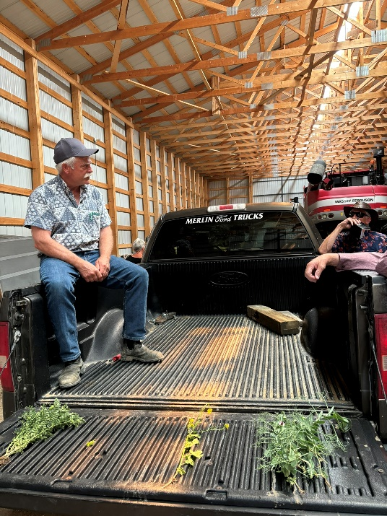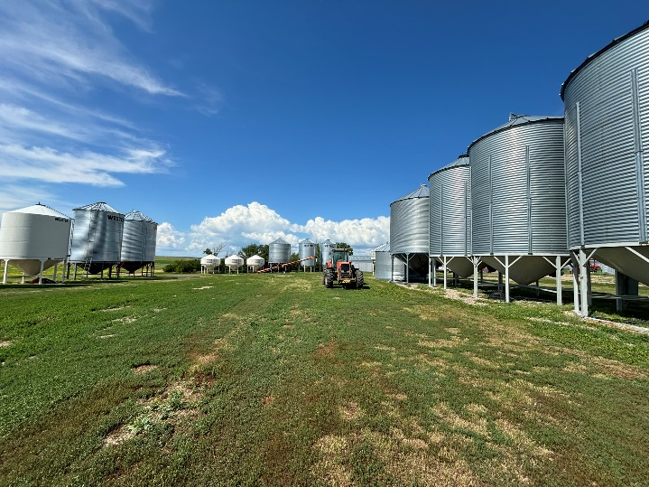
Figure 16 Left hand side, Kevin discussing the range of crops he grows and the markets. Right hand side is his grain storage….imagine having your grain store in the UK not on hard standing!

Actively managing water on farms
Drainage and moving water around has been very little in a province where wheat yields are 4t/ha (remembering they are virtually all spring wheats) and canola yields of 3t/ha with an almost exclusive spring cropping regime. However, a research station was looking a collecting water together in basin areas and then directing it into ditches or ponds to avoid missing cropping larger areas of the field due to water logging. The collection of this water then starts to offer opportunities of storing water and using for irrigation during prolonged periods of dry weather during the growing season.
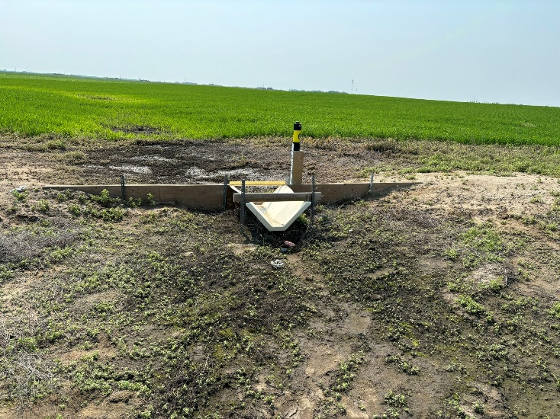
Figure 17 Monitoring and moving water on the field to make field work more convenient and store water more effectively

In 1967 the Qu’Appelle river dam opened as part of Canada’s centenary celebrations and in conjunction with Gardiner dam creates a vast 225km reservoir making it one of the largest earth filled dams in the world. The dam is used primarily for power generation but also for irrigation, recreation and wildlife (Water security agency 2025). Despite this huge resource it appears that there is only a very limited canal network to enable effective irrigation. In the basin of the reservoir

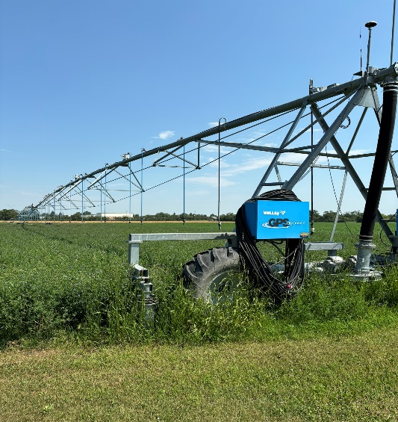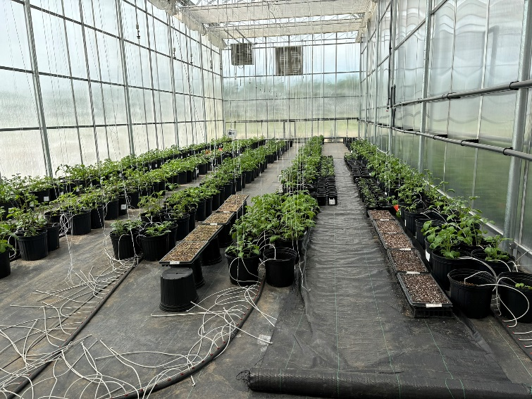
Figure 18 Left: An irrigator at the Irrigation Research and Demonstration Centre near the Gardiner dam; Right: Plant breeding company benefitting from water availability

Implications and opportunities for UK agriculture
During my travels I was struck by the amount of water in the landscape in comparison to the UK. We have more ditches and small rivers, but we have large areas of farmed land with no) bodies of water. Small waterbodies are becoming increasingly recognised as a refuge for species and for playing an important role in supporting biodiversity (Biggs, von Fumetti & Kelly-Quinn 2017). It has become particularly evident during the spring and summer of 2025 which was the second warmest spring on record, followed by the driest June in England since records began and up to 14 August 2025 there have been four official heatwaves during the summer. The whole of England has averaged just 37% of its annual rainfall for the whole summer (Figure 17).

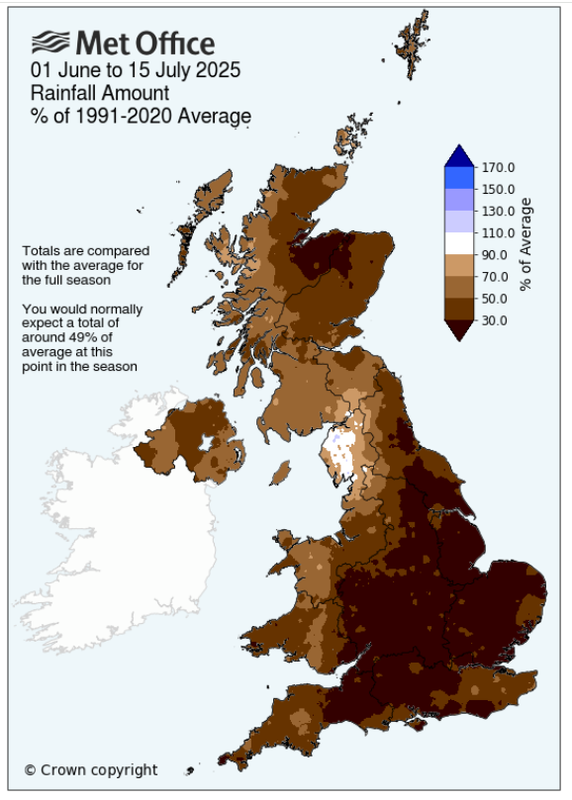
Figure 19 UK Rainfall 01 June - 15 July 2025 (Metoffice 2025)
The growing season has proved favourable for oilseed rape with above average yields, this was mainly due to good establishment during the wet August of 2024 and therefore good establishment. Wheat yields seem to be between 10-30% down on average and winter barley yields have been highly variable. However, spring barley yields have been very poor in drought prone soils with some crops only receiving about 45mm within the growing season. These lower crop yields are disastrous for many UK arable farmers as they have lost BPS support and are coupled with very low global commodity prices.

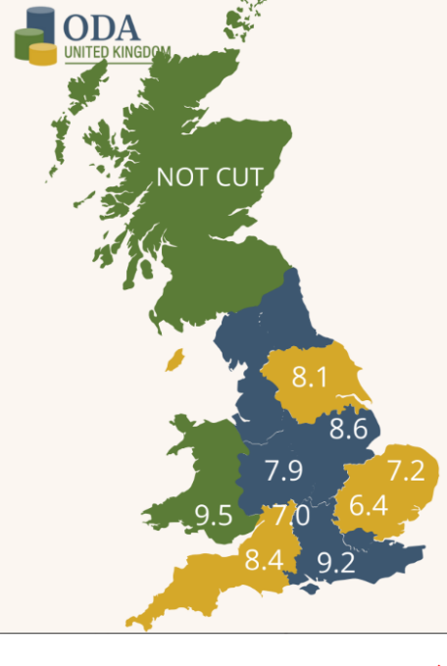
The average yield of winter wheat in the Cotswolds was just 7t/ha and parts of Essex seeing 6.4t/ha (see Figure 18) whilst Wales saw above average yields due to higher rainfall enabling the crop to take advantage of the extra sunshine hours for photosynthesis. Farmers and agronomists need to consider these weather extremes as the new normal and learn to adjust crop inputs according to the seasonal risk. Some farmers will be hesitant to lower inputs, but controlling variable costs and matching them to the seasonal challenges will be a vital part of becoming climate smart in agricultural decision making.
Farming in a changing climate is severely challenged by extreme and unpredictable weather events affecting many regions around the world. However, overall global harvests in 2025 have been good resulting in lower commodity prices, this further compounds the risks to unresponsive/poorly adapted farming systems of operating at a loss.

Figure 20 Winter wheat yields by region in the ODA early harvest survey 2025

Discussion
Farmers around the world are having to adapt their farming systems to ensure they are climate smart. Some of these adaptions may be incentivised through private finance such as carbon trading, but farmers are still going to carefully control their agronomic decision making to reflect these fast-emerging challenges. Many farmers globally, and especially in Canada and Western Australia have already reduced tillage and adopted no-tillage farming systems which helps reduce evaporation loss whilst also increasing soil organic matter which makes soils more resilient to extreme weather events.

Conclusions
- Farmers need to be aware of a range of adaptions they can make on their farms to cope with extreme weather events and help reduce costs during times of weather stress.
- Water management on farms should be evaluated to explore opportunities for holding back water during peak rainfall periods to reduce flooding downstream whilst also holding more water on farm for use during drier periods.
- Plant breeding can play an important role in developing more resilient traits within crop varieties.
- Adapting cultivation and drilling techniques can help reduce costs whilst benefitting soil carbon retention.

Acknowledgements
Firstly, I must express my gratitude to the Farmers Club Charitable Trust for funding and enabling this study. I feel very privileged to have had this experience during a time when agriculture is quickly having to adapt to a changing climate.
I would like to thank my RAU colleagues for enabling me to undertake this study and for covering for me when required.
Along the way I have met many generous, wonderful and inspiring people. I would like to thank them for their time, hospitality and honesty.

References

Biggs, J., von Fumetti, S. & Kelly-Quinn, M. The importance of small waterbodies for biodiversity and ecosystem services: implications for policy makers. Hydrobiologia 793, 3–39 (2017). https://doi.org/10.1007/s10750-016-3007-0
Department of Primary Industries (2023). https://www.agric.wa.gov.au/export-services/western-australian-wheat-industry Date accessed: 29 June 2024
Farm online weather (2024). https://www.farmonlineweather.com.au/climate/station.jsp?lt=site&lc=9965
Government of Canada (2025). https://www.agr.gc.ca/DW-GS/current-actuelles.jspx?jsEnabled=true&lang=eng Date accessed: 09 May 2025

GRDC (2022). Long, longer, longest: new trials weigh up benefits of long coleoptile wheat varieties.
https://groundcover.grdc.com.au/crops/cereals/long,-longer,-longest-new-trials-weigh-up-benefits-of-long-coleoptile-wheat-varieties Date accessed: 29 June 2024
Met Office (2024). https://www.metoffice.gov.uk/research/climate/maps-and-data/uk-climate-averages/gcnw5nzzf Date accessed: 29 June 2024
Met Office (2025). How is summer 2025 shaping up so far? https://www.metoffice.gov.uk/blog/2025/how-is-summer-2025-shaping-up-so-far Dtae accessed 14 August 2025
ODA united Kingdom(2025). Results: early harvest survey 2025.
Water Security Agency (2025). https://www.wsask.ca/lakes-rivers/dams-reservoirs/major-dams-and-reservoirs/gardiner-dam/#:~:text=Constructed%20between%20September%201958%20and,earthfill%20dams%20in%20the%20world. Date accessed: 12 May 2025

Appendices

Main study locations in Western Australia
Stella Bella vineyard, Margaret River, WA https://www.uwa.edu.au/
University of Western Australia https://www.uwa.edu.au/
Curtin University https://www.curtin.edu.au/
Fleay Family, Living Farm, York, WA https://www.livingfarm.com.au/
Chris Joyce, Fryer Farm, 2566 Goldfields Road, York, WA
Australian Export Grains Innovation Centre (AEGIC), York, WA
Andrew Slade, Glenridge Park, Kendenup, Nr Mount Baker, WA https://www.glenridgepark.com.au/
Phil Honey, Sterling to Coast Farmers, Albany, WA https://www.scfarmers.org.au/

Main study locations in Saskatchewan, Canada
Jim Halford, Halford Farms, Indian Head, SK https://www.researchgate.net/publication/302503529_The_Halford_Farm_Saskatchewan_Canada
Indian Hills Research Station, SK https://iharf.ca/
Janel Delage, Delage Farm, Indian Head, SK https://www.delagefarms.ca/
Richard Gray, Gray Farm, Moose Jaw, SK https://research-groups.usask.ca/canadian-grain-policy-chair/heading-pages/cv.php
G3 Pasque, Swift Current, SK https://www.g3.ca/en/our-network/g3-pasqua
Kevin Hursh, Hursh Farm, Cabri, SK https://hursh.ca/hursh-farms/

Other events in the UK:
Groundswell 24 and 25
Regenerative Agriculture accelerator program
CRFT Nuffield farm walk

