Ch 11 An ethical framework for the responsible use of technology in organic dairy farming
David Christian Rose, Harper Adams University, (formerly Royal Agricultural University), UK; Juliette Schillings, University College Dublin, Ireland; and Eden Keily-Thurstain, University of Cambridge, UK
Abstract: despite its potential benefits, organic farming has a complex relationship with technological innovation which has sometimes been stereotypically associated with intensive forms of production. This chapter discusses the ways precision and other new technologies can fulfil the core organic values of health, ecology, care and fairness. It outlines a responsible innovation framework in assessing how new technologies meet organic values, based on the principles of inclusion, anticipation, reflexivity and responsiveness. The chapter uses the example of virtual fencing to show how the framework can be used in practice.
Key words: digital technologies, health, low-input farming, organic, PLF, welfare.
Contents:
1 Introduction: organic farming values and standards
2 Organic dairy farming and technology: key principles
3 Precision and other technologies in organic dairy farming
4 Establishing a framework for responsible innovation
5 Applying a responsible innovation framework: the example of virtual fencing
6 Using a responsible innovation framework to accept or reject new technology
7 Conclusions
8 Where to look for further information
9 References

1 Introduction: organic farming values and standards
Before exploring the potential role of precision technology in organic dairying, it is important to trace the origin of the organic movement and the evolution of both the values and standards that play a role in the adoption or non-adoption of technology. Organic farming standards and values vary across time and space and thus defining it can be challenging. The FAO and WHO (1999) define organic agriculture as “a production management system which promotes and enhances agroecosystem health, including biodiversity, biological cycles, and soil biological activity”. Key features of organic livestock farming are the avoidance of synthetic fertilizers, pesticide, and routine use of antibiotics and wormers, achieving the highest possible animal welfare standards (e.g. space, outdoors where possible), and feeding a natural, organic diet (grass-rich, non-GM animal feed) (Soil Association, 2023).
We start with the evolution of organic values which are highly diverse (Duram, 2000). Leduc et al. (2023, 1) state “values act as driving forces for individuals to behave in a certain way or to choose certain actions”. In Europe, Padel et al. (2009) found that many organic producers acted on the basis of values, going beyond minimum standards. Organic farming originated as a counter-movement and is still widely considered to be the antithesis of conventional, intensive, capitalist forms of production (Holt-Giménez, 2019; Kledal, 2003; Kuepper, 2010). Kuepper (2010) describes how early pioneers set out to address problems caused by agriculture, including soil erosion, low quality food and livestock feed, rural poverty, and soil depletion. The values of the organic movement have been associated with resistance to global capitalised agriculture (Schreer and Padmanabhan, 2020), localised food production (Belasco, 2014), and shortened supply chains (Belasco, 2014; Pollan, 2006). The movement has come to represent a more holistic approach compared to its origins as a movement focusing on soil health.
Pollan (2006) identifies a distinctly countercultural vision for organic agriculture, popularised in the 1960s and 70s in the context of chemical scares and a growing environmental consciousness, which incorporates an alternative production mode, alternative delivery systems, and a ‘countercuisine’ with minimal processing. Bronson (2005, 20) argues that “organic production…could be seen as part of a wider…social movement involving farmers, consumers and others in a challenge against the assumptions and practices of unbridled economic growth, and the development ideologies at the epicentre of contemporary capitalist society.” In a study in Saskatchewan, Canada, Bronson (2005, ii) describes “a hope and determination amongst organic farmers who see themselves as resisting the erosion of the rural landscape at the hands of powerful corporations and a dominant industrial model of food production.”
These values ultimately structured organic farmers in particular ways, favouring short supply chains, small farms, employment of family and local labour, and little to no chemical use. Studies of the motivations of organic farmers around the world find that psycho-behavioural and psychosocial factors (Sapbamrer and Thammachai, 2021; Yazdanpanah et al., 2021, Iran), including strong anti-consumption values (Dalmoro et al., 2020, Brazil; Vail, 2022, USA), a dislike of agricultural policy that favours large-scale conventional farming (Duram, 2000, Illinois, USA), a negative attitude towards chemicals (Egri, 1998, Canada), a wish to live a more natural lifestyle (Schösler et al., 2012, The Netherlands; the ‘good life’, Vos, 2000), caring for the natural environment and family health (Kociszewski, 2020, Poland; Läpple, 2012, Ireland; Tress, 2001, Denmark), and as an economic option (including as a means of development in the Global South) through the higher prices that organic produce can attract (Seufert et al., 2017). A study in the Czech Republic found organic farming to be a way of life, an occupation, and a way of producing food of perceived higher quality (and eating more ‘naturally’) than conventional farming (Zagata, 2009).
From this, four principles of organic farming have come to the fore:
- Health – of the natural environment, livestock, and humans.
- Ecology – protecting the natural environment.
- Care – adopting a precautionary principle to new innovations.
- Fairness – ensuring benefits of production are evenly shared and support local communities, families, and workers, rather than benefiting big corporations.
As the organic farming movement has changed over time, incorporating standards as well as basing activities on values, concerns have been raised. Just as the alternative food movement literature is critical of the centrality of market logics, the organic literature has identified a recent trend of the ‘conventionalisation’ of organic agriculture, where market forces have hollowed out the essence of the movement (Obach, 2007, 2015).
By setting minimum organic standards, it has been argued that organic certification allows large, corporate players to ‘enter the game’, as well as creating ‘ceilings’, where farms can do the bare minimum to reach organic status and fall short of agro-ecological ideals (Guthman, 2000, 265), resulting in an “organic lite” (Guthman, 2004, 301). Padel et al. (2009) describe how the growth of the organic market and globalisation have been identified by some organic farmers as problematic. Research on the structural aspects of organic farming in California depict highly capitalized, large- scale, industrial production that increasingly mirrors conventional agriculture (Buck et al., 1997), a situation which Konstantinidis (2014) argues has also occurred in Europe as organic has become ‘capitalism in green disguise’. Further research in California indicates that as agribusiness makes in-roads into organic production, sustainability may be sacrificed (Guthman, 1998). This reinforces the point made at the start of this chapter – organic farming as a movement has become highly diverse and this complicates decision-making over adoption of the technologies discussed below.
Standards for organic farming are based on values and equally vary in time and space. Taking the EU as an example, which aims to have 25% of its agricultural land under certified organic farming by 2030 (EU Commission, 2020), current rules on livestock in organic systems cover:
- Abiding by organic principles – such as 100% organic feed, suckling animals being fed by natural milk, natural methods of reproduction.
- Animal welfare – e.g. personnel on farm having the right skills to look after animals, low stocking densities, open air, grass grazing where possible, no routine use of antibiotics, no use of hormones or similar substances.
- Rules for the food chain – e.g. separation of organic and non-organic products, a minimum organic content of 95% of organic ingredients, clear rules on labelling.
- Permitted substances in organic production – e.g. substances used in organic production must be pre-approved by the EU Commission etc.
The full rules can be found here.

2 Organic dairy farming and technology: key principles
We recognise that ‘technology’ is more than just physical manifestations of science and engineering and that it is important to understand what technology ‘does’ rather than just what it ‘is’ (Carolan, 2019). Taking such a view is important when considering how technology intersects with the values of organic farming, which is the basis for adoption decisions by farmers. We also reiterate the diversity of organic farmers so adoption decisions are difficult to predict and generalisations should be treated with caution. A useful report has started to consider the values-based decisions that organic farmers take with regards to technology (Mason et al., 2024).
With this caveat in mind, however, it is fair to say that agricultural technology is sometimes stereotyped as benefitting high-tech, intensive visions of farming over low-input systems such as organic (Lassen, 2015; Castell et al., 2021; Sullivan, 2023). Critical social scientists have argued that agricultural technology has been traditionally designed to support intensive, large-scale production by replacing labour (“fairness”), increasing emissions and outputs, and (by claiming to improve efficiency) masking the environmental impacts of intensive farming that has been made possible by many of the same technologies (“ecology”) (Bronson and Sengers, 2022; Carolan, 2019; Ditzler and Driessen, 2022; Fairbairn et al., 2022; Sullivan, 2023).

These concerns intersect with the principles of organic farming. There is scepticism about whether agricultural technology is being used to reduce farmer autonomy by legitimising algorithmic rationality and surveillance capitalism (Brooks, 2021; Gardezi and Stock, 2021; Miles, 2019; Stock and Gardezi, 2021), a process potentially being driven by larger players to benefit the status quo (“fairness”) (Birner et al., 2021; Clapp, 2023; Hackfort, 2023; Duncan et al., 2021). The potential for technological lock-in and uneven power relations has been identified (Bronson and Sengers, 2022; Clapp and Ruder, 2020) (“fairness”). In addition, there remain concerns that existing and emergent gene-based technologies (modification or editing) are still being primarily developed, owned, and distributed by powerful, corporate actors who lock producers into a dependent relationship and create a ‘biohegemony’ (Escobar, 2016) (“fairness”). Related to this are concerns over the lack of transparency and corporate control over emergent technologies and lack of adherence to responsible innovation principles from some industry players, including genomics experts (Clapp, 2023; Hackfort, 2023; Guthman and Biltekoff, 2021; Ruder and Kandlikar, 2023) (“fairness”). With these concerns have come worries over data ownership (“fairness”) (Rotz et al., 2019) and the potential facilitation of more intensive farming, including in livestock systems (“health” and “ecology” (Schillings et al., 2021a). It is also apparent that the full set of consequences of emergent technologies are often difficult to predict (“care”) (Rose and Chilvers, 2018). The concerns listed above can set off ‘alarm bells’ within the organic sector, particularly if we recall the origins of the movement rooted in counterculture and rejection of neoliberal, corporate control over the food system.

However, it is also clear that technologies, including in the dairy sector, can support low-input (including organic) farming. In certain cases, technology may offer more to organic farming, particularly if precision equipment can work more effectively than conventional machinery and other methods in such systems (Daum, 2021). Organic farming is not anti-technology per se, but these farmers may question what technology “does” (in terms of its wider social and ethical impacts) more than conventional farmers. Some organic farmers may be concerned about abandoning ‘naturalness’ and take a precautionary approach (Milestad et al., 2020). If technologies are designed with the smaller-scale farmer in mind, are used to support environmentally- and welfare-friendly visions of farming (Daum, 2021), and benefit producers as well as corporations. then alignment with organic principles may be achieved. This would involve a shift in embedded principles of technology development towards values-based, equitable design.
3 Precision and other technologies in organic dairy farming
Existing technology used in organic dairying (set out below) is helping in a number of areas, including for health and ecology, and emergent precision technologies have the potential to enhance animal welfare by minimising negative welfare outcomes, although opportunities to encourage positive animal welfare are currently limited (though developing all the time) (Schillings et al., 2021b). This means that precision technologies tend to focus on reducing harm to animals, rather than setting out to explicitly enhance welfare, which is a key organic principle.
We focus first in this section on the potential benefits of technology for organic dairying, noting that many, if not all, of the positive claims below could be a double-edged sword. Long before the digital technology age, various technologies were being widely used (and continued to be used) on organic dairy farmers, which is also true in other farm enterprises. Whilst earlier technologies might have been superseded on some farms by digital equipment, they still continue to perform a useful function on many other farms that is easily forgotten by the rush to consider digitalisation (Rose et al., 2022). Technologies for farmers can include ‘lower-tech’ products like wellington boots, farm vehicles, a white/blackboard, pen, and paper to facilitate planning, mobility scoring charts for lameness, right through to ‘higher-tech’ equipment such as mobile phone apps and other digital tools (see Mason et al., 2024). Examples of useful technologies for organic dairying include plate meters to measure grass growth, conventional milking parlours, traditional fencing, and so many more. There are increasing calls for organic farming to re-examine its relationship with biotechnology approaches, such as gene editing (Fernandes et al., 2022; Husaini and Sohail, 2018; Wickson et al., 2016). As for breeding, there appears to be no global consensus about the selection strategies that align with organic principles, most likely because the practices and principles of organic agriculture vary across time and space (Nauta et al., 2005).
Whilst developments in precision technologies can be geared towards more intensive production systems, many digital tools can be applied to extensive systems. Precision technologies can be used to optimise grassland management and ensure economic sustainability whilst mitigating the environmental impacts of pasture-based dairy systems (Murphy et al., 2021). For example, some tools can be used to accurately quantify herbage mass, pasture heterogeneity or grass quality, and to advise farmers on grassland management thanks to decision support tools that have been developed in Europe (Murphy et al., 2021). Other decision support tools are being used by organic dairy farmers to access markets and reduce time and waste, for example the FarmSuite initiative in Italy (https://www.farmsuite.it/en/).
A technology that is gaining increased interest for pasture-based livestock is virtual fencing, which makes it possible to contain cattle out on pasture within a given area without the need for physical fences. Using a mobile application, a virtual fence is drawn, and GPS-equipped neck collars are used to track animal location in real-time. When cows approach the virtual fence, they receive an audio warning. If they continue to walk towards the boundaries, the intensity of the signal increases, and if they fail to turn around and cross the boundaries, they receive an electric pulse that will encourage them to move back to the designated area. The use of virtual fencing technology is associated with many benefits, including animal welfare, biodiversity, and landscape conservation (Stampa et al., 2020). Virtual fencing can encourage farmers to keep their cows out on pasture, sometimes on lands that are difficult to access and to physically fence (e.g., upland farming systems).
Higher animal welfare standards and a reduced use of antibiotics are some of the key features of organic farming. There are numerous digital solutions can theoretically help organic dairy farmers adhere to higher welfare standards. These range from oestrus, calving and lameness detection to precision feeding, automated body condition scoring, monitoring gastrointestinal health, feeding behaviour, or location. Some tools even aim to move beyond a sole focus on animal health to focus on animal emotional expressivity, a dimension that is integral to animal welfare, with mobile applications developed to conduct qualitative behavioural assessments and promote positive welfare (Schillings et al., 2023). The use of precision tools could help organic dairy farmers to reach higher welfare goals by allowing the early detection of health issues, thus helping farmers to act in a timely and efficient manner. Indeed, digital tools could allow the detection of health and welfare problems before they are detected by farmers or veterinarians (Taneja et al., 2020; Berckmans et al., 2015). In turn, this could help prevent negative impacts on animal welfare and minimise reliance on antibiotics, thus helping in addressing the core principles of organic farming. Many precision livestock technologies have been developed to monitor dairy cattle welfare and productivity, with devices such as sensors, cameras, boluses, radio-frequency identification (RFID) tags or microphones that are either commercially available or at earlier development stages (Schillings et al., 2021b; Tzanidakis et al., 2023). By monitoring rumination activity, it is possible to detect feeding deficiencies, which can be an indicator of potential illnesses (Sowell et al., 1998; Weary et al., 2009). In their study, for example, Weary et al. (2009) found that cows with decreased feeding times were more likely to have clinical metritis. Similarly, monitoring lying activity with digital technologies can provide helpful indications as to cows’ welfare states, since the length and frequency of lying behaviour are useful indicators of cow comfort, which can be influenced by the type of housing or the presence of painful conditions such as sole ulcers (Haley, et al., 2000; Vasseur et al., 2012). There are several other mobile applications for planning, market access, communication, animal welfare, and other tasks that are being used on farm to varying degrees.
The use of automated milking systems is also increasing in organic farming for smaller herd sizes and can offer reduced physical workload and flexible working hours (Butler et al., 2012). Automated milking systems are sometimes associated with higher welfare and improved human-animal relationship, since they can allow cows to ‘choose’ when to be milked, thus potentially reducing stressful handling. Other robots, such as unmanned aerial vehicles, can be used to locate and monitor animals out on pasture.
Many of the potential benefits of technology are, of course, theoretical, especially where newer technologies are at an early stage of development. Technologies that enable farmers to implement practices for enhanced health and welfare require are not enough in themselves. To be effective, the farmer must implement an effective change of practice. It is thus also important to assess whether technologies are enabling these shifts in practice, a topic which is rarely researched (Schillings et al., 2021).
Adoption factors for farm technology in general are well-known and include issues related to trust and data ownership, attitudes and values, ease and cost of adoption (which is affected by scale and skills), reliability, peer recommendation, regulations, interoperability and connectivity (Rose et al., 2016). In this context, it is useful to highlight the scale of organic farming, and organic dairying in particular. Organic farms tend to be smaller than conventional farms, although not always. In the USA, for example, the average size of an organic farm is 285 acres compared to an average of 444 acres for all farms (USDA stats reported by Modern Farmer). Across the EU, low-input dairy farms, including organic, tend to be smaller than their higher-input counterparts (Scollan et al., 2017), although there is considerable variation between countries (Wallenbeck et al., 2018), while some authors have questioned whether organic agriculture in the EU is substantially differently structured than conventional farming (Konstantinidis, 2014).
Despite a wide range of technologies available, their adoption in extensive systems is lower than in more conventional systems, often due to connectivity issues related to the large and sometimes remote areas used. In addition, a lack of validation, doubts around reliability, and the high cost associated with precision technology, often represent an important barrier to their adoption (Heins et al., 2023). Other challenges include familiarisation with new technologies, willingness to adopt, difficulties interpreting the data, and lack of technical support. As precision technologies often operate independently, a lack of integrated system can make the use of multiple systems difficult to manage for farmers.
Overall, technology adoption on organic dairy farms is, therefore, influenced by a variety of factors, including:
- Values and trust
- Size/scale of operation
- Standards/rules within a jurisdiction
Turning now to the other side of the ‘double-edged sword’, many of the claims made above could be challenged depending on how technologies are used. In terms of values and trust, animal welfare is an important part of the organic ‘health’ principle. Different organic farmers will hold different perceptions of the role of technology in improving animal welfare, for which there are often conflicting points of view (Schillings et al., 2021a). Whilst technologies may enhance animal welfare, there are concerns over the negative implications of some wearable technology, technologies that may provide a shock to livestock, or that increases the distance between stockpersons and their stock (Butler et al., 2012), or are uncomfortable to wear (Schillings et al., 2021b). Concerns have been raised regarding the potential of automated milking robots to lead to restricted pasturing and increased use of concentrates (to attract cows into the milking system), and changing human-animal relationships (Butler et al., 2021), which may not always be suitable to organic standards (Bühlen et al., 2014). Furthermore, forced traffic systems can actually restrict the freedom of choice for the cow (Munksgaard et al., 2011). In terms of human ‘health’, technologies like robotic milking may free up time and enhance the lifestyle of farmers, whilst others will experience enhanced stress and reduced enjoyment from 24/7 technology-based monitoring of livestock (Lundström and Lindblom, 2021; Martin et al., 2022). Ultimately, the decision may come down to how each organic farmer defines the notion of “care” that they give to their stock (Lundström and Lindblom, 2021).
As stated above, in terms of other organic principles, technologies may lead to reduction of environmental footprint through emissions or materials (e.g. fencing) reduction (“ecology”). In terms of ‘fairness’, technologies could increase transparency in the supply chain for the benefit of farmers, consumers and other actors, but there are concerns over ownership and use of data collected and distribution of benefits across the supply chain, as well as control exerted by private companies and reduced farmer autonomy (Schillings et al., 2021b). Technology could help to facilitate better data collection for organic certification. There may be realistic concerns over labour displacement, the erosion of farmer autonomy and experienced-based knowledge. Precaution is likely to be important to organic dairy farmers with clear evidence needed of how each technology affects the four principles of organic farming before adoption. Important to all of the above is the need for a farmer to take effective action based on data, which is aligned with organic principles/standards. If data is too difficult to interpret, or the suggested actions are too hard or costly to implement, then the promises of technology may not actually be delivered in practice (Schillings et al., 2021).
Looking at size/scale of operation, not all organic dairy farms are small, but stocking rates tend to be smaller than average. This may reduce the need for some precision livestock technologies which developers argue can help monitor individual animals more easily in larger herds. Size of the farm can also affect ability to invest or skills availability to use equipment if there is a less diverse workforce. Alternatively, however, new technologies could free up time for small-scale farmers to perform other roles. Finally, standards and regulations within some countries and regions may prohibit the use of certain technologies, perhaps most obviously genetic modification or engineering products.
4 Establishing a framework for responsible innovation
Since technology provides both opportunities and risks for organic dairying, a framework is needed to assist in structuring thought processes when deciding on whether to adopt or not. The application of the four organic principles – health, ecology, fairness, and care (precaution) – within a responsible innovation framework can be used for these structured deliberations.
Responsible innovation is defined as ‘taking care of the future through collective stewardship of science and innovation in the present” (Stilgoe et al., 2013). Innovation can be made more responsible through the processes of:
- inclusion (inviting stakeholders to contribute)
- anticipation (considering the potential impacts of innovation)
- reflexivity (listening, challenging assumptions)
- responsiveness (learning from new knowledge, changing course)
Innovation that is not responsible runs the risk of causing problems that were not anticipated when they could have been. The framework has been applied to agriculture in several research studies with a number of different methods being proposed to implement its four elements (see e.g. Eastwood et al., 2019; Rose and Chilvers, 2018). We propose that this framework is ideal in considering if and how dairying technologies align with the values and standards of organic farming. The four pillars align with the principles of organic farming:
- firstly, substantive inclusion of all affected stakeholders can lead to a fairer, or more just, development process.
- secondly, anticipating the consequences of dairy technologies, both good and bad, and elucidating uncertainties requiring further research can help organic stakeholders to understand whether impacts underpin the principles of ecology, and health, as well as allowing a precautionary approach to be taken if there is limited evidence.
- thirdly, listening and being prepared to challenge assumptions and consider moral responsibility indicates a fairer development process, rather than one that is dominated, for example, by the interests of private technology developers.
- Lastly, having systems in place to respond to new knowledge ensures that the contribution of dairy technology to ecology and health can be consistently monitored and a precautionary stance can be taken in the face of new information.
Below, we demonstrate how a responsible innovation framework might be applied in the consideration of an emergent technology which organic dairy farmers are increasingly able to implement: virtual fencing (VF). We argue that this process could be applied to any technology for dairying to allow organic farmers to judge whether or not it matches their values and standards (see Figure 1). Ensuring the responsible use of technologies such as VF requires further investigation that can help to inform policy and allow to build recommendations that align with the principles of organic farming.

Figure 1: Principles of organic farming combined with elements of the responsible innovation framework (from Stilgoe et al. 2013).

5 Applying a responsible innovation framework: the example of virtual fencing
As mentioned previously, virtual fencing is an emergent technology allowing livestock farmers to create ‘unseen’ boundaries to keep animals in designated areas. These areas can be controlled by the farmer through a digital app and constantly changed, with animals learning to stay within boundaries by wearing GPS-equipped neck collars which give an alert or shock when boundaries are nearly (or actually) crossed (Figure 2).
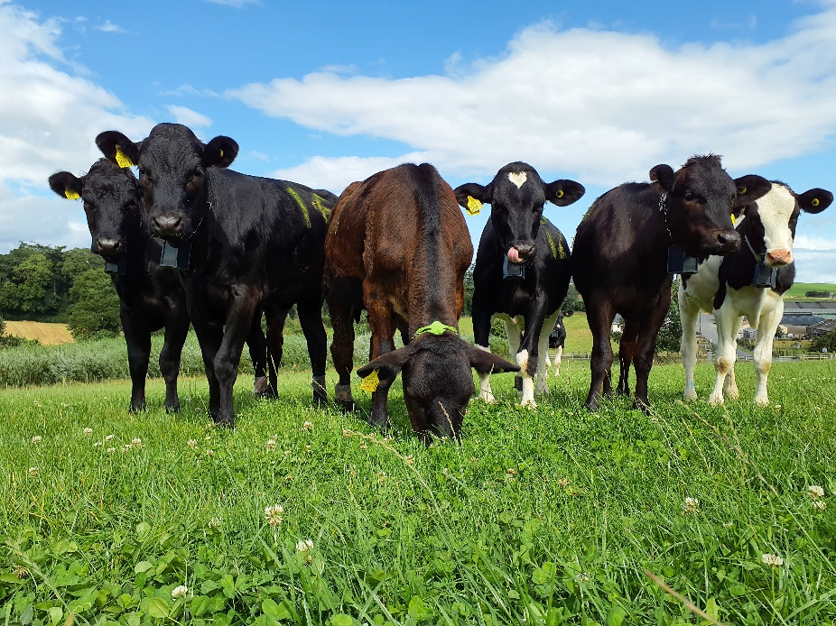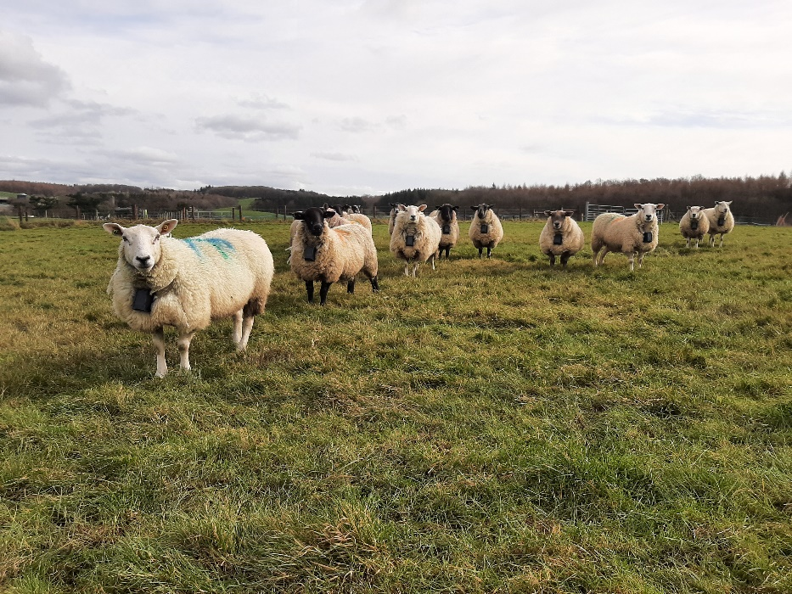
Figure 2: Virtual fencing neck collars worn by cows and sheep. These collars generally produce a sound when an animal is approaching a virtual boundary to discourage them from crossing it. A shock may be given in the case of non-compliance (Photos used with kind permission from AFBI, NI).
Inclusion
The first task in responsible innovation is to include a full range of stakeholders in the development process, which aligns with the organic principle of fairness. Without substantive inclusion, it is hard to gather the range of insights and knowledge needed to judge if and how virtual fencing aligns with organic principles of care, ecology, and health. When considering food system interventions, inclusion can be difficult because, technically, everyone has a stake in the food system (Ayris et al., 2024). Whilst full inclusion of everyone is always likely to be impractical, research has shown that engagement exercises often focus on a narrow group of stakeholders: for example a select number of farmers only, missing ‘harder to reach’ farmers, rural communities, consumers, and other stakeholders (Ayris et al., 2024; Bronson and Sengers, 2022). In the case of virtual fencing, necessary stakeholders to include (not a comprehensive list) will be livestock farmers (who implement the technology), veterinarians, NGOs and animal welfare scientists (for evidence of impact on animals), other supply chain actors (who play a hand in implementation and standards), rural communities (who need to understand how the technology works e.g. to prevent reports or panic around livestock escape), and policy-makers (who use policy instruments for implementation e.g. incentives, regulation).
The inclusion of citizens in early discussions is an important aspect of responsible innovation. In the context of virtual fencing, uncertainties around the potential impacts on animal welfare could represent an important barrier regarding public acceptance of the technology, since animal welfare is increasingly a subject of concern (European Commission, 2016). Whilst citizens generally lack knowledge of livestock farming practices, their involvement in early discussions on the use of virtual fencing technology should not be neglected, as a lack of acceptance could hinder the widespread use of virtual fencing technology (similar to what has been observed with food technologies such as GMOs or nanotechnology (Siegriest and Hartmann, 2020). In the smart dairying sector, there has been little citizen participation, generally due to difficulties in engaging with community actors and limited perceived benefits (Eastwood et al., 2019). The importance of involving the public to gather their perceptions on the development of these types of technologies was further emphasised by Brier et al. (2020) to ensure a responsible innovation process.
Anticipation
To judge whether the technology aligns with organic principles requires a concerted effort to understand its easily and less easily foreseen benefits and risks. The development and use of virtual fencing technology, as described in the previous section, is often associated with a range of benefits, including financial and environmental advantages. However, there are also concerns relating to their potential socio-ethical consequences, including perceived negative impacts on animal welfare or difficulties for farmers in adjusting to and making effective use of virtual fencing (Brier et al 2020). Whilst there are many potential benefits associated with virtual fencing (e.g., decreased labour and costs, facilitating strategic grazing management, encouraging conservation grazing…), there are also concerns relating to its use (e.g., impact on animal welfare, negative public perception, impacts on stockmanship). It is important that these potential benefits and risks are assessed at an early stage to minimise uncertainties and negative consequences whilst being able to decide on the direction to take so as to achieve better and more desirable outcomes. A variety of methods can be used to perform inclusive anticipation exercises, including foresighting or scenario building (Eastwood et al., 2019), within which a range of knowledge and views need to be brought together.
Crucial to these processes, however, is openness and transparency. Critical social science literature on emergent agricultural technologies, such as cultured meat and robotics, has argued that powerful food system actors are consolidating their control and developing solutions in secret without offering enough information to stakeholders and without including them (Clapp, 2023; Hackfort, 2023; Guthman and Biltekoff, 2021). If, during the process of discussing potential future effects, stakeholders do not know how and why technologies are being developed, as well as how they work and what they do, it can be nearly impossible to make an informed judgement over alignment with organic standards and principles. However, it could be argued that, in a closed innovation process in which ‘big’ food system actors dominate development and distribution of technology, organic dairy farmers would decide not to adopt.
Several studies have focused on virtual fencing’s efficiency in containing animals and its impacts on animal welfare. Studies that have compared virtual fencing with conventional electric fences so far have suggested minimal differences in terms of impacts on animal behaviour and welfare ​(Umstatter, Morgan-Davies and Waterhouse, 2015; Verdon, Langworthy and Rawnsley, 2021; Aaser et al., 2022; Sonne et al., 2022)​. In their study comparing virtual fencing and physical fences, ​Hamidi et al. (2022)​ found no significant differences in cattle behaviour, live weight gain, herbage consumption and cortisol levels. This concurs with findings from ​Ranches et al. (2021)​, who found no differences in cortisol levels or animal behaviour. However, a study conducted by ​McSweeney et al. (2020)​ on dairy cows revealed a reduction in the time animals spent grazing and ruminating, suggesting that negative impacts on animal welfare are a possible outcome. This lack of clarity underlines the need for more research on the long-term impacts of VF on animal behaviour and welfare.
Whilst several studies have investigated impacts on animal welfare, fewer studies have explored stakeholders’ acceptance and perceptions of virtual fencing for livestock grazing management. In a study conducted by Brier et al (2020) foresight exercises were undertaken with farming practitioners in New Zealand to anticipate potential consequences of using this technology, and key benefits and risks were identified. These included better environmental protection and feed allocation, the possibility of using previously inaccessible grazing locations, decreased labour and improved individual animal management. Making more efficient use of pasture and being able to reduce labour and maintenance cost by not having to set-up physical fences is, indeed, an important benefit often associated with virtual fencing. A study conducted in Ireland also highlighted the potential of virtual fencing to promote the efficiency and sustainability of livestock grazing systems, particularly in upland areas – although important aspects remain to be addressed to enable efficient redesign of these systems (Schillings et al., 2024).
The benefits of virtual fencing may not be possible if proper support and training is not provided to farmers, as the technology may not be suited to certain types of production systems and may require specific skills to navigate the technology. Other key barriers also identified by Brier et al (2020) were a lack of value proposition as perceived by farmers, perceived negative consequences on animal welfare, farmers’ lack of feed budgeting skills and training time, further highlighting the need to adopt an inclusive approach to better understand end-users’ and other stakeholders’ expectations, and ensure the technology is mutually beneficial to farmers, animals, and the farming industry.
Reflexivity
Reflexivity means to listen, learn, and challenges one’s assumptions in light of the inclusive anticipation exercises mentioned previously. If closed innovation processes are dominated by private technology companies who are not willing to change trajectories or re-consider assumptions in response to feedback from stakeholders, then innovation cannot be responsible. Where possible, a values-based design process should be followed. For virtual fencing technology, the views of stakeholders in the organic dairy sector should be taken into account when developing and implementing virtual fencing. However, the outcome for organic dairy farmers could be as simple as a particular community deciding that virtual fencing does not currently align with its values or standards, leading to the choice not to adopt. This may not affect development and implementation in other farm enterprises.
Responsiveness
To be seen as suitable for implementation in organic systems, mechanisms must be in place to ensure that virtual fencing aligns with organic principles and standards. If organic farmers are satisfied in principle that the likely consequences of virtual fencing are acceptable, various rules and regulations could be put in place to ensure this. For example, minimum standards around virtual fencing (e.g. how the technology works in regards to electric shocks) could be put in place to influence how it is developed for and used in an organic dairying context. Organic produce from farms using virtual fencing should be required to follow these basic minimum standards decided by the organic community. Monitoring systems must also be put in place so that unforeseen problems can be addressed quickly.
It will also be necessary to understand how the potential use of virtual fencing aligns with existing regulations on organic produce and wider legislation. In the UK for example, the use of shock collars for cats or dogs is banned in Wales and applying a sustained shock to an animal is illegal under the Animal Welfare Regulations (2014) in the Republic of Ireland. A lack of clarity regarding legal and regulatory aspects was also highlighted by DEFRA in England. It is crucial to clarify these aspects before the widespread adoption of virtual fencing technology, as a lack of regulatory framework could have serious implications for the welfare of farm animals. Setting up codes of conduct and standards based on scientific knowledge to encourage the responsible use of virtual fencing technology could help facilitate reflexivity and build trust between different stakeholders and make sure it is right for organic dairying.
6 Using a responsible innovation framework to accept or reject new technology
The responsible innovation framework above could be applied to individual or suites of technology in organic dairying systems and can be used as a mechanism for farmers to accept, conditionally accept, or reject them. In working through the framework, conclusions can be reached about whether technology aligns with organic principles (or standards) held by individual or groups of producers. One overarching concern of organic producers about emergent precision technologies could be that they currently tend to focus on reducing harm to animals, rather than explicitly enhancing welfare, which is a key organic principle (Schillings et al., 2021).
Using the framework in the virtual fencing example, some organic producers might decide not to adopt until further evidence is available regarding the stress and welfare impacts caused to livestock during the training phase (‘health’ and ‘care’ principle). Or, organic farmers could decide to adopt if the shock mechanism for training was replaced with an alternative or conclude that the impact on the animal is not sufficiently negative as to endanger the principle of ‘health’.
Other examples can be worked through. For example, artificial intelligence technologies are increasingly available to enable automated body condition scoring or earlier detection of diseases such as lameness (Schillings et al., 2023). When anticipating possible consequences of this technology, farmers have raised concerns over data ownership and privacy, specifically who would have access to data and benefit from it. Other queries related to a change in the human-animal relationship and concerns over lack of reliability (Schillings et al., 2023). In the anticipation, responsiveness, and reflexivity phases, therefore, organic farmers may decide that the technology does not align with principles of fairness or, for example, may/may not be satisfied that developers have listened to their concerns and acted to implement transparent and acceptable governance of data. Alternatively, organic farmers may not think they have been satisfactorily involved in the process of developing and implementing the technology such that they cannot be sure over alignment with organic principles.
Assessing automated milking (Figure 3) using a responsible innovation framework could also lead to more informed decisions by organic farmers about whether and how to adopt. In anticipating consequences, concerns may be raised over the human-animal relationship (e.g. potential impact on stress of handling stock if contact is limited), 24/7 data stress affecting farmer/worker mental health, balanced with other evidence about the possible improvement to farmer lifestyles and working conditions, as well as being able to more closely monitor animal health through data. Again, if organic farmers do not feel that they can adapt the technology to align with their values or do not see enough evidence that negative impacts on animals and workers are being avoided (or indeed opportunities for enhanced health and welfare), a non-adopt decision could be reached.

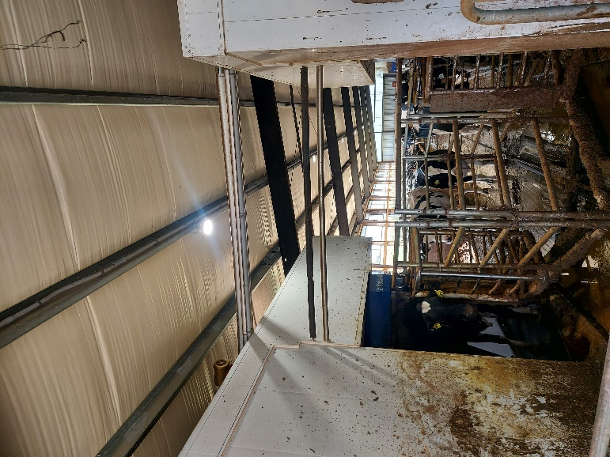
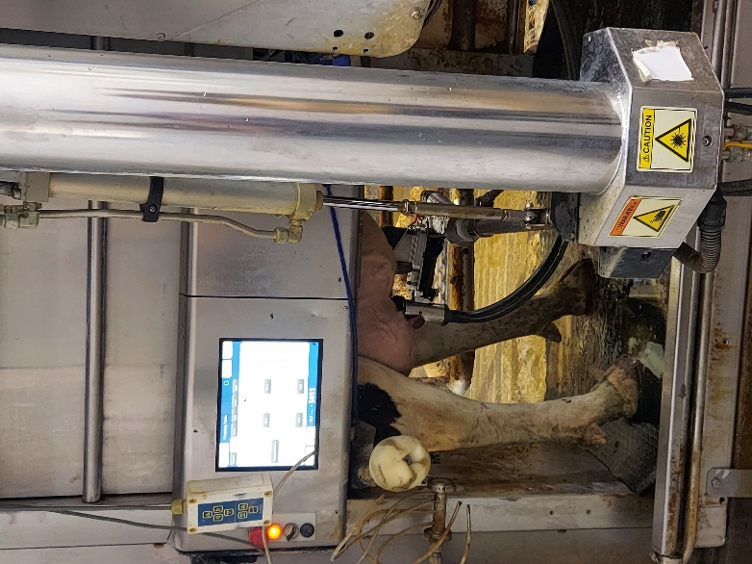

Figure 3: A cow being milked (photograph from two angles) by an automated milking robot (author owned copyright [David Rose]).
We also believe that the responsible innovation framework should be used by developers of technology who intend to market products to organic dairy producers. It would firstly encourage them to include organic stakeholders in the design and implementation of their technology, helping to anticipate the effects of intended and unintended consequences. In our experience, developers do not always consider the unintended or less easily foreseen consequences of their technology beyond their ‘sales pitch’, and may not fully appreciate that technology is not always used exactly as intended in practice or that technology itself shapes farms, farmers, and animals in ways not foreseen (Rose et al., 2018). Thus, they may legitimately think that their technology aligns with organic standards and values, but this view may not be based on a full appreciation of on-farm human and non-human impacts. Using a reflexive and responsive process, the design and delivery of the technology could be undertaken in a way that addresses stakeholder concerns and ensures better alignment with not only organic standards, but values. This should ideally involve a re-orientation of the purpose of technology, not only to reduce harm to animals and people, but explicitly to enhance health and welfare for the animal, farmer, and worker.
7 Conclusions

Whether digital or non-digital, old or new, technology will continue to play an important role in organic dairying. This chapter has indicated, however, that decisions over the implementation of existing and emergent technologies on organic dairy farms are affected by two components:
- firstly, whether the use of a technology matches organic standards in a given place
- secondly, whether it aligns with the values and principles held by organic farmers
Making a judgement on the latter, however, may not be easy. The impacts of emergent technologies are not always certain and, therefore, there is a need for a structured decision-making process to consider suitability for use in organic systems. We propose that the responsible innovation process can be worked through by the organic community, in collaboration with technology developers, supply chain actors, policy-makers, and the research community, to anticipate whether or not individual technologies match organic values and standards.
While it may be impractical to do this collectively for every technology, a set of standards and valued-based positions could be drawn up as a guide for the organic community to judge new or existing technologies against. Where ‘red flags’ are raised, for example the technology may cause animal welfare problems, is controlled by large corporate actors without including stakeholders, has uncertain impacts, or is not considered natural, a non-adoption decision could be reached. A clear message for those interested in increasing the adoption of technologies in organic dairying, including technology companies and policy-makers, is to ensure that development is responsible. This will require interventions from private companies and policy-makers, including opening up development processes, deliberately designing for the small-scale organic farmer, and using standards and regulations appropriately.
8 Where to look for further information
Guthman, J. (2004). The Trouble with ‘Organic Lite’ in California: A Rejoinder to the ‘Conventionalisation’ Debate. Sociologia Ruralis, 44(3), 301–316.

Rose, D. C., Chilvers, J. (2018). Agriculture 4.0: Broadening Responsible Innovation in an Era of Smart Farming. Frontiers in Sustainable Food Systems, 2, 1-7.

Schillings, J., Bennett, R., and Rose, D. C. (2021). Exploring the potential of Precision Livestock Farming technologies to help address farm animal welfare. Frontiers in Animal Science. doi: 10.3389/fanim.2021.639678

Stilgoe, J., Owen, R., Macnaghten, P. (2013). Developing a framework for responsible innovation. Research Policy, 42(9), 1568–1580.
9 References
Aaser, M.F. et al. (2022) Is Virtual Fencing an Effective Way of Enclosing Cattle? Personality, Herd Behaviour and Welfare, Animals, 12(7), 842.
Ayris, K., Jackman, A., Mauchline, A., Rose, D. C. (2024) Exploring inclusion in UK agricultural robotics development: who, how, and why?. Agriculture & Human Values. https://doi.org/10.1007/s10460-024-10555-6
Belasco, W. J. (2014). Appetite for Change: How the Counterculture Took On the Food Industry / Warren J. Belasco. (Second Updated Edition.). Ithaca, NY : Cornell University Press, [2014].
Berckmans, D., Hemeryck, M., and Berckmans, D. (2015). Animal sound … talks ! In: Real-time Sound Analysis for Health Monitoring in Livestock. International Symposium on Animal Environment and Welfare, 1–8.
Birner, R., Daum, T., Pray, C. (2021). Who drives the digital revolution in agriculture? A review of supply-side trends, players and challenges. Applied Economics Perspectives and Policy, 43(4), 1260-1285.
Brier, D. et al. (2020) Foresighting for Responsible Innovation Using a Delphi Approach: A Case Study of Virtual Fencing Innovation in Cattle Farming, Journal of Agricultural and Environmental Ethics, 33(3–6), 549–569
Bronson, K. (2005). Of Global Cause and Consequence: The Organic Farmers of Saskatchewan Versus Monsanto and Bayer. Thesis, University of Saskatchewan, Saskatoon
Bronson, K., & Sengers, P. (2022). Big tech meets big ag: Diversifying epistemologies of data and power. Science as Culture, 31(1), 15–28.
Brooks, S., (2021). Configuring the digital farmer: A nudge world in the making? Economy and Society 50(3), 374-396.
Buck, D., Getz, C., Guthman, J. (1997). From Farm to Table: The Organic Vegetable Commodity Chain of Northern California. Sociologia Ruralis, 37(1), 3-20.
Bühlen, F., Ivemeyer, S., Krutzinna, C. et al. (2014). Potential effects of automatic milking systems on grazing in organic dairy farming. Organic Agriculture, 4, 301–308
Butler, D., Holloway, L., Bear, C. (2012) Milking Systems and the Changing Role of the Stockperson’, Journal of the Royal Agricultural Society of England, 173(January), 1–6.
Carolan, M. (2020). Automated agrifood futures: Robotics, labor and the distributive politics of digital agriculture. The Journal of Peasant Studies, 47(1), 184–207.
Castell, S., Clemence, M., Kamvar, R., Reynolds, M. (2021). Living Landscapes. Public dialogue on the future of land use. Conducted on behalf of the Royal Society. https://royalsociety.org/-/media/policy/Publications/2021/23-03-21-living-landscapes-public-dialogue.pdf
Clapp, J. (2023). The rise of big food and agriculture: corporate influence in the food system. 45-66 in Sage, C. L. (ed) A Research Agenda for Food Systems, Edward Elgar Publishing.
Jennifer Clapp, Sarah-Louise Ruder; Precision Technologies for Agriculture: Digital Farming, Gene-Edited Crops, and the Politics of Sustainability. (2020). Global Environmental Politics, 20 (3): 49–69. doi: https://doi.org/10.1162/glep_a_00566
Dalmoro, M., de Matos, C. A., de Barcellos, M. D. (2020). Anticonsumption beyond consumers: The role of small organic producers in environmentally oriented anticonsumption. Psychology and Marketing, 37(2), 291-307.
Daum, T. (2021). Farm robots: ecological utopia or dystopia?, Trends in Ecology & Evolution, 36(9), 774-777.
Ditzler, L., Driessen, C. (2022). Automating Agroecology: How to Design a Farming Robot Without a Monocultural Mindset? Journal of Agricultural and Environmental Ethics, 35(1), 2.
Duncan, E., Glaros, A., Ross, D. Z., Nost, E. (2021). New but for whom? Discourses of innovation in precision agriculture. Agriculture and Human Values, 38, 1181-1199.
Duram, L.A. (2000). Agents' perceptions of structure: How Illinois organic farmers view political, economic, social, and ecological factors. Agriculture and Human Values 17, 35–48
Eastwood, C. et al. (2019) Making sense in the cloud: Farm advisory services in a smart farming future. NJAS - Wageningen Journal of Life Sciences, 90–91, 100298
Egri, C. P. (1999) .Attitudes, backgrounds and information preferences of Canadian organic and conventional farmers: implications for organic farming advocacy and extension. Journal of Sustainable Agriculture. 13(3), 45-72.
Escobar, L. G. (2016). The Red de Semillas Libres: Contesting Biohegemony in Colombia. Journal of Agrarian Change, 16(4), 711-719.
EU Commission (2020). Farm to Fork Strategy. For a fair, healthy and environmentally-friendly food system. https://food.ec.europa.eu/system/files/2020-05/f2f_action-plan_2020_strategy-info_en.pdf
European Commission (2016). Special Eurobarometer 442: Attitudes of Europeans Towards Animal Welfare. Animal Welfare. doi: 10.2875/884639
Fairbairn, M., Kish, Z., Guthman, J. (2022). Pitching agri-food tech: Performativity and non-disruptive disruption in Silicon Valley. Journal of Cultural Economy, 15(5), 652–670. https://doi.org/10.1080/17530350.2022.2085142
FAO, WHO (1999) Guidelines for the Production, Processing, Labelling and Marketing of Organically Produced Foods. Rome: FAO. (available atwww.fao.org/input/download/standards/360/cxg_032e.pdf)
Fernandes, P. M. B., Favaratto, L., Fernandes, A. A. R., Vicien, C., Capalbo, D. M. F., Zerbini, F. M. (2022). To become more sustainable organic agriculture needs genome editing technology. Frontiers in Bioengineering and Biotechnology, 10
Gardezi, M., Stock, R. (2021). Growing algorithmic governmentality: Interrogating the social construction of trust in precision agriculture. Journal of Rural Studies, 84, 1-11.
Guthman, J. (1998). Regulating meaning, appropriating nature: The codification of California organic agriculture. Antipode, 30(2), 135–154.
Guthman, J. (2000). Raising organic: An agro-ecological assessment of grower practices in California. Agriculture and Human Values, 17(3), 257–266. https://doi.org/10.1023/A:1007688216321
Guthman, J. (2004). The Trouble with ‘Organic Lite’ in California: A Rejoinder to the ‘Conventionalisation’ Debate. Sociologia Ruralis, 44(3), 301–316.
Guthman, J., Biltekoff, C. (2021). Magical disruption? Alternative protein and the promise of de-materialization. Environment and Planning E: Nature and Space, 4(4), 1583–1600
Hackfort, S. (2023). Unlocking sustainability? The power of corporate lock-ins and how they shape digital agriculture in Germany, Journal of Rural Studies, 101, 103065
Haley, D.B., Rushen, J., de Passillé, A.M. (2000) Behavioural indicators of cow comfort: Activity and resting behaviour of dairy cows in two types of housing, Canadian Journal of Animal Science, 80(2), 257–263.
Hamidi, D. et al. (2022) Heifers don’t care: no evidence of negative impact on animal welfare of growing heifers when using virtual fences compared to physical fences for grazing, Animal, 16(9), 100614
Heins, B. J., Pereira, G. M., Sharpe, K. T. (2023). Precision technologies to improve dairy grazing systems. Presented as part of the Joint ADSA Midwest Branch/Forages and Pastures Symposium: Grazing to Improve Profitability of Midwest Dairy Farms held at the ADSA Annual Meeting. JDS Communications, 4(4), 318-323
Holt-Giménez, E. (2019). Capitalism, food, and social movements: The political economy of food system transformation. Journal of Agriculture, Food Systems, and Community Development, 9(Suppl. 1), 23–35
Husaini, A. M., Sohail, M. (2018). Time to Redefine Organic Agriculture: Can’t GM Crops Be Certified as Organics? Frontiers in Plant Science, 9.
Kledal, P. R. (2003) The Political Economy of Organic Foods. Paper at: SAFO: Sustaining Animal Health and Food Safety in Organing Farming. "Socio Economic Aspects of Health and Food Safety in Organic Livestock", Florence, Italy, 5-7th of September 2003
Kociszewski, K., Graczyk, A., Mazurek-Lopacinska, Sobocinska, M. (2020). Social values in stimulating organic production involvement in farming – The case of Poland. Sustainability, 12(15), 5945.
Konstantinidis, C. (2014). Capitalism in Green Disguise: The Political Economy of Organic Farming in the European Union. Working Paper 2014-01. http://repec.umb.edu/RePEc/files/2014_01.pdf
Kuepper, G. (2010). A brief overview of the history and philosophy of organic agriculture. Kerr Center for Sustainable Agriculture, Poteau, OK.
Läpple, D. (2013). Comparing attitudes and characteristics of organic, former organic and conventional farmers: Evidence from Ireland. Renewable Agricultural and Food Systems, 28(4), 329-337.
Lassen, J. (2015). Technologies in organic farming: consumers’ values and acceptance. EurSafe2015 Conference: Know your food! – Food Ethics and Innovation. Cluj-Napoca, Romania, May 27-30, 2015
Leduc, G., Billaudet, L., Engström, E., Hansson, H., Ryan, M. (2023). Farmers’ perceived values in conventional and organic farming: A comparison between French, Irish and Swedish farmers using the Means-end chain approach. Ecological Economics, 207, 107767.
Lundström, C., and Lindblom, J. (2021). Care in dairy farming with automatic milking systems, identified using an Activity Theory lens. Journal of Rural Studies, 87, 386-403.
Martin, T., Gasselin, P., Hostiou, N. et al. Robots and transformations of work in farm: a systematic review of the literature and a research agenda. Agron. Sustain. Dev. 42, 66 (2022). https://doi.org/10.1007/s13593-022-00796-2
Mason, A., Thomas, P. Woodward, L. (2024). Agroecological Intelligence
Establishing Criteria for Agroecological Appropriate Technology. https://abiggerconversation.org/wp-content/uploads/2024/05/ABC_Agroecological-Intelligence-Report_Final_280524.pdf
McSweeney, D. et al. (2020) Virtual fencing without visual cues: Design, difficulties of implementation, and associated dairy cow behaviour’, Computers and Electronics in Agriculture, 176, 105613
Miles, C. (2019). The combine will tell the truth: On precision agriculture and algorithmic rationality. Big Data & Society, 6(1), 1-12.
Milestad, R., Röös, E., Stenius, T., & Wivstad, M. (2020). Tensions in future development of organic production—Views of stakeholders on Organic 3.0. Organic Agriculture, 10(4), 509–519
Munksgaard, L., Rushen, J., de Passillé, A.M., Krohn, C.C. (2011). Forced versus free traffic in an automated milking system. Livestock Science, [online] 138(1-3), 244-250.
Murphy D. J., Murphy M. D., O’Brien B., O’Donovan M. (2021). A Review of Precision Technologies for Optimising Pasture Measurement on Irish Grassland. Agriculture, 11(7), 600
Nauta, W. J., Groen, A. F., Veerkamp, R. F., Roep, D., Baars, T. (2005). Animal breeding in organic dairy farming: an inventory of farmers' views and difficulties to overcome, NJAS - Wageningen Journal of Life Sciences, 53 (1), 19-34
Obach, B. K. (2007). Theoretical interpretations of the growth in organic agriculture: Agricultural modernization or an organic treadmill? Society & Natural Resources, 20(3), 229–244.
Obach, B. K. (2015). Organic struggle: The movement for sustainable agriculture in the United States. MIT Press.
Padel, S., Röcklinsberg, H., O. Schmid (2009) The implementation of organic principles and values in the European Regulation for organic food. Food Policy 34, 245‐251.
Pollan, M. (2006). The Omnivore’s Dilemma: The Search for a Perfect Meal in a Fast-Food World.
Ranches, J. et al. (2021) Effects of virtual fence monitored by global positioning system on beef cattle behavior, Translational Animal Science, 5(Supplement_S1), S144–S148
Rose, D. C., Barkemeyer, A., de Boon, A., Price, C., Roche, D. (2022). The old, the new, or the old made new? Everyday counter-narratives of the so-called fourth agricultural revolution. Agriculture and Human Values, 1–17
Rose, D. C., Chilvers, J. (2018). Agriculture 4.0: Broadening Responsible Innovation in an Era of Smart Farming. Frontiers in Sustainable Food Systems, 2, 1-7.
Rose, D. C., Morris, C., Lobley, M., Winter, M., Sutherland, W. J. and Dicks, L. V. (2018) Exploring the spatialities of technological and user re-scripting: the case of decision support tools in UK agriculture. Geoforum, 89, 11-18.
Rose, D. C., Sutherland, W. J., Parker, C., Lobley, M., Winter, M., Morris, C., Twining, S., Ffoulkes, C., Amano, T., Dicks, L. V. (2016). Decision support tools for agriculture: Towards effective design and delivery. Agricultural Systems, 149. 165-174
Rotz, S., Gravely, E., Mosby, I., Duncan, E., Finnis, E., Horgan, M. et al. (2019) Automated pastures and the digital divide: How agricultural technologies are shaping labour and rural communities, Journal of Rural Studies 68,112-122.
Ruder, S. L., Kandlikar, M., (2023). Governing gene-edited crops: risks, regulations, and responsibilities as perceived by agricultural genomics experts in Canada. Journal of Responsible Innovation, 10(1), 2167572. https://doi.org/10.1080/23299460.2023.2167572
Sapbamrer R., Thammachai A. (2021). A Systematic Review of Factors Influencing Farmers’ Adoption of Organic Farming. Sustainability. 13(7), 3842
Schillings, J., Bennett, R., and Rose, D. C. (2021b). Exploring the potential of Precision Livestock Farming technologies to help address farm animal welfare. Frontiers in Animal Science. doi: 10.3389/fanim.2021.639678
Schillings, J., Bennett, R., Rose, D. C. (2021a). Animal welfare and other ethical implications of Precision Livestock Farming Technologies. CABI Agriculture and Bioscience, 2, 17.
Schillings, J., Holohan, C., Lively, F., Arnott, G., Russell, T. (2024) The potential of virtual fencing technology to facilitate sustainable livestock grazing management. animal, 101231, https://doi.org/10.1016/j.animal.2024.101231
Schösler, H., De Boer, J., Boersema, J. J. (2013). The organic food philosophy: A qualitative exploration of the practices, values, and beliefs of Dutch organic consumers within a cultural–historical frame. Journal of Agricultural and Environmental Ethics, 26, 439–460.
Schreer, V., Padmanabhan, M. (2020). The many meanings of organic farming: Framing food security and food sovereignty in Indonesia. Organic Agriculture, 10(3), 327–338.
Scollan, N., Padel, S., Halberg, N., Hermansen, J., Nicholas, P. et al. (2017). Organic and Low-Input Dairy Farming: Avenues to Enhance Sustainability and Competitiveness in the EU. Eurochoices. DOI: 10.1111/1746-692X.12162
Seufert, V., Ramankutty, N., Mayerhofer, T. (2017). What is this thing called organic? – How organic farming is codified in regulations. Food Policy, 68, 10–20.
Siegrist, M., Hartmann, C. (2020) Consumer acceptance of novel food technologies, Nature Food, 1(6), 43–350
Soil Association (2023). Organic principles. https://www.soilassociation.org/who-we-are/organic-principles/
Sonne, C. et al. (2022) Cortisol in Manure from Cattle Enclosed with Nofence Virtual Fencing, Animals, 12(21), 3017.
Sowell, B.F. et al. (1998) Radio frequency technology to measure feeding behavior and health of feedlot steers, Applied Animal Behaviour Science, 59(4), pp. 277–284.
Stampa, E., Zander, K., Hamm, U. (2020) Insights into German Consumers’ Perceptions of Virtual Fencing in Grassland-Based Beef and Dairy Systems: Recommendations for Communication, Animals, 10(12), 2267.
Stilgoe, J., Owen, R., Macnaghten, P. (2013). Developing a framework for responsible innovation. Research Policy, 42(9), 1568–1580.
Stock, R., Gardezi, M. (2021). Make bloom and let wither: Biopolitics of precision agriculture at the dawn of surveillance capitalism, Geoforum, 122, 193-20
Sullivan, S. (2023) Ag-tech, agroecology, and the politics of alternative farming futures: The challenges of bringing together diverse agricultural epistemologies. Agriculture & Human Values. https://doi.org/10.1007/s10460-023-10454-2
Taneja, M. et al. (2020) Machine learning based fog computing assisted data-driven approach for early lameness detection in dairy cattle, Computers and Electronics in Agriculture, 171, 105286
Tress, B. (2001). Converting to organic agriculture – Danish farmers’ views and motivations. Danish Journal of Geography, 101(1), 131-143.
Tzanidakis C., Tzamaloukas O., Simitzis P., Panagakis P. (2023). Precision Livestock Farming Applications (PLF) for Grazing Animals. Agriculture. 13(2), 288.
Umstatter, C., Morgan-Davies, J., Waterhouse, T. (2015) Cattle Responses to a Type of Virtual Fence, Rangeland Ecology & Management, 68(1), 100–107
Vail, D. D. (2022). A Counterculture Agriculture: Organic Farming in a Commercial Food Age. In Hurt, R. D. (ed). A Companion to American Agricultural History. John Wiley & Sons Ltd.
Vasseur, E. et al. (2012) Sampling cows to assess lying time for on-farm animal welfare assessment, Journal of Dairy Science, 95(9), 4968–4977.
Verdon, M. et al. (2020) Pre-Exposure to an Electrical Stimulus Primes Associative Pairing of Audio and Electrical Stimuli for Dairy Heifers in a Virtual Fencing Feed Attractant Trial, Animals, 10(2), 217.
Wallenbeck, A., Rousing, T., Sørensen, J.T. et al. (2019). Characteristics of organic dairy major farm types in seven European countries. Organic Agriculture. 9, 275–291
Weary, D.M., Huzzey, J.M., von Keyserlingk, M.A.G. (2009) Board-invited Review: Using behavior to predict and identify ill health in animals, Journal of Animal Science, 87(2), 770–777
Wickson F., Binimelis R., Herrero A. (2016). Should Organic Agriculture Maintain Its Opposition to GM? New Techniques Writing the Same Old Story. Sustainability. 2016; 8(11), 1105
Yazdanpanah, M., Moghadam, M. T., Zobeidi, T., Turetta, A. P. D., Eufemia, L., Sieber, S. (2022). What factors contribute to converstion to organic farming? Consideration of the Health Belief Model in relation to the uptake of organic farming by Iranian farmers. Journal of Environmental Planning and Management, 65(5), 907-929.
Zagata, L. (2010). How organic farmers view their own practice: Results from the Czech Republic. Agricultura and Human Values, 27(3), 277-290.

https://agriculture.ec.europa.eu/farming/organic-farming/organic-production-and-products_en
https://modernfarmer.com/2018/06/by-the-numbers-state-of-the-independent-farmer/ (2018)

