Factors that influence dairy farmers’ decisions to implement Johne’s Disease control practices: A systematic review

Rosie Morrison a, David Christian Rose b

A School of Water, Energy and the Environment, Cranfield University, Bedford MK43 0AL, UK

B Royal Agricultural University, Cirencester, GL7 6JS, UK

Introduction
Infections by Mycobacterium avium, subspecies paratuberculosis (MAP) are known as Johne’s Disease (JD) and are a chronic and infectious ruminant disease that can cause economic loss for farmers through reduced milk yields and infertility and has negative implications for animal welfare (Garvey, 2020). The disease progressively damages the intestines of affected animals and can eventually result in severe weight loss, loss of condition and infertility. However, in many dairy herds, the presence of JD is only realized due to progressive reduction in milk yields. Due to the cryptic nature of the infection and in many cases the absence of overt clinical symptoms, the disease can spread throughout a herd causing significant long- term economic losses to the farmer and welfare issues to the animals which may suffer illness. There have also been suggestions that JD in cattle is linked to Crohn’s Disease in humans, however this has yet to be proven (Davis and Madsen-Bouterse, 2012). JD is endemic in the bovine populations of many countries including the UK, USA, Canada, Denmark and the Netherlands (Geraghty et al., 2014) and is widely recognised as one of the most important endemic diseases of cattle. For example, based on a UK survey of 794 professionals and 441 dairy farmers conducted by the Agriculture and Horticulture Development Board (AHDB) and Ruminant Health and Welfare, Johne’s was ranked number one out of nineteen cattle diseases in terms of its impact on national production efficiency (AHDB, 2021). As a result, many countries have introduced schemes and programmes to try and control the spread of JD amongst dairy cattle, these have had mixed success and uptake.

Controlling JD can be challenging due to the long incubation period of the disease and the poor sensitivity of tests (Strain, 2018). However, managing its prevalence within a herd is possible if the correct management practices are put in place (Strain, 2018). Most JD control programmes recommend a mixed approach of test-and-cull combined with improved management practices that control on-farm risks (Orpin et al. 2020; Shepard et al., 2016; Donat et al., 2022). Whilst the successes and failures of such programmes have been analysed across many individual studies, a wider perspective of what drives Johne’s control is missing from the literature. This systematic review seeks to fill this gap and offer a broad understanding of what the drivers and barriers are to farmers adopting JD control measures and participating in JD control schemes. This can help to inform future policies and ensure control programmes are designed to meet the needs of farmers.

This study begins with a brief overview of Johne’s control measures and programmes. It then details the methods used and the results from the systematic review. Finally, a discussion section places the results in the context of the wider literature and highlights some key conclusions that should be considered in future policy making.

Johne’s Disease control
Dairy farmers are familiar with disease control, having to constantly manage both viral and bacterial diseases on-farm. For example, Bovine Viral Diarrhoea (BVD) poses a significant threat to dairy herds around the world (Yarnall & Thrusfield, 2017) and requires farmers to vaccinate cattle and implement a test-and-cull strategy. This has proved highly effective (Moennig & Yarnall, 2021). Bovine Tuberculous (bTB) is another common dairy cattle disease. In the EU and UK, farmers are required to test all their herd for bTB and any positive cattle are slaughtered (Allen, et al., 2018). Restrictions on cattle movements are also implemented. The bTB scheme in the UK has had mixed success (Godfray, et al., 2018), whilst within the EU, bTB eradication has been achieved in several countries (Allen, et al., 2018). However, differences in the epidemiology of JD compared to BVD and bTB mean that test-and-cull control strategies are inefficient (NigschI, et al., 2021). JD tests indicate the level of MAP/MAP antibodies present within the faeces or milk of dairy cattle and these levels can increase or decrease depending on the stresses that animal is experiencing (Pritchard, et al., 2017). Cows with high MAP/MAP antibody levels are often recommended to be culled. However, as JD is sub-clinical and Johne’s tests have relatively low sensitivity, even if an animal does test negative, it does not mean it is free from infection (Karuppusamy, et al., 2019) Therefore, a wider package of measures to control JD are needed.

Most JD control programmes and schemes have been initiated in the last 30 years, with the scale and nature of these programmes differing between regions (Geraghty et al., 2014). The programmes are often voluntary and therefore rely on farmer enrolment and retention for their success (Zoche-Golob et al., 2021). Participation is generally low despite the benefits of JD control having been communicated for decades (Zoche-Golob et al., 2021). In Germany and Canada, control programmes are developed by individual states and provinces (Donat et al., 2022; MacDonald-Phillips et al., 2021) meaning there is not one set of harmonised rules across the countries. In the UK, Johne’s control is led by an industry group who have developed the National Johne’s Management Plan. Adherence to the plan is often enforced by milk buyers or farm assurance schemes (Orpin et al., 2023). In some countries, parties such as milk buyers and processers set the minimum standards for Johne’s control (Queensland Government, 2023; Farmers Weekly, 2017) and therefore farmers either have to comply or change buyer. In the Netherlands, milk processors are often reluctant to buy from farmers who have any test-positive cattle in their herd (Geraghty, et al., 2014).

Johne’s control strategies involve regular testing, increased hygiene, the segregation of high-risk cows from calves and the culling of high positive animals. Vaccination for Johne’s Disease is currently not cost-effective (Ugochukwu et al., 2020) and unsuitable for areas with bTB as it can interact with tests (McAloon et al., 2019). Despite control measures being pushed by various governments, institutions and buyers, Johne’s control has proved very hard to achieve (Geraghty et al., 2014). This study aims to provide a broad understanding of the drivers and barriers to the adoption of JD control measures by farmers.

Methods
The method used for this systematic review is drawn from the PRISMA statement (Moher et al., 2009) which provides a framework to identify and analyse academic literature systematically and transparently. An initial search of online databases (Scopus and Web of Science) was carried out using keywords. These keywords were identified by experts in Johne’s Disease and farmer behaviour change. The words were divided into two categories: population and outcomes. The population search terms refer to the individual, animal and disease which form the focus of the research. The following terms were included in the population category:
(farm* OR vet* OR veterinarian OR agri* OR dairy OR cattle OR bovine OR ruminant* OR cow*) AND (Johne’s OR Johnes OR paratuberculosis OR ‘Mycobacterium paratuberculosis’ OR ‘Mycobacterium avium subspecies paratuberculosis’ OR ‘Mycobacterium avium ssp’)
The outcome category included terms related to the adoption of Johne’s control measures. These were:
(adopt* OR particpa* OR scheme OR action OR control OR cull* OR segregat* OR implement* OR invest* OR approach* OR prevent* OR manage* OR engage* OR application OR program*).
Papers included in the search had to be published after 2010 to ensure they were relevant to our most recent understanding of Johne’s control. Papers also had to be in English. The literature search was carried out in July 2023. The search generated 1582 articles in Scopus, 1841 in Web of Science and 1011 in PubMed, giving a total of 4434 articles. The titles and abstracts of these articles were uploaded into Rayyan, an online software to help with systematic reviews. Rayyan automatically detects and excludes duplicated articles. 2532 articles were excluded leaving 1902 articles for the abstract sift.
The abstract screening process involved each abstract being assessed against the inclusion and exclusion criteria shown in Box 1. A sample of 10% of the articles where randomly selected by Rayyan to be screened by another author. There were no conflicting decisions at this stage. The abstract screening resulted in 212 articles being included, 207 of which could be located via university access to publishers and databases. The additional 5 articles were not available online. The full texts of these 212 were then uploaded into Sysrev, another online platform to assist with systematic literature reviews. At this stage, the same inclusion and exclusion criteria were used to assess the full text of each article and 43 were included for the final analysis of relevant literature. A diagram of the PRISMA process is shown in Figure 1.
Box 1: Inclusion and Exclusion criteria
Include criteria:
- Must be a study on Europe, the US, Australia, Canada or New Zealand.
- Must be focused on dairy cattle (including cows, goats and sheep)
- Must focus on the drivers of JD management practices OR barriers to JD management practices OR both OR must focus on a scheme or control programme for JD.
- Studies must be published after 2010.
Exclude criteria:
- African, Asian or South American countries as these farmers tend to be lower income and therefore face unique challenges in disease control.
- Studies that are purely scientific in focus and do not contain any social science
- Studies published before 2010.
- Studies that look at non-dairy cattle including beef cows.

Records identified through Web of Science core collection
n = 1582

Records identified through Scopus
n = 1841

Records after duplicate removal
n = 1902
Records excluded as not relevant
n = 1690
Additional full-text records identified
(grey literature)
n = 8
Full-text records assessed for eligibility
n = 212
Identification
Screening

Eligibility
Included
Records excluded
n = 169
Total studies included

n = 51
Records identified through PubMed
n = 1011

Figure 1: Article identification process using the PRISMA framework

A search of grey literature was also carried out. This was done by systematically searching relevant government websites and through a google search. The grey literature was also assessed against the inclusion and exclusion criteria in Box 1 to ensure it was relevant to the research topic. Eight pieces of grey literature were identified and included.
Results
The articles selected for the final analysis covered 10 individual countries whilst 6 articles focused on multiple countries. All of the articles looked at either the drivers and barriers to scheme participation or the drivers and barriers to the adoption of Johne’s control measures. Figure 2 shows the study countries by the focus of the article. Canada was the most studied country, followed by the USA and Denmark/Australia.
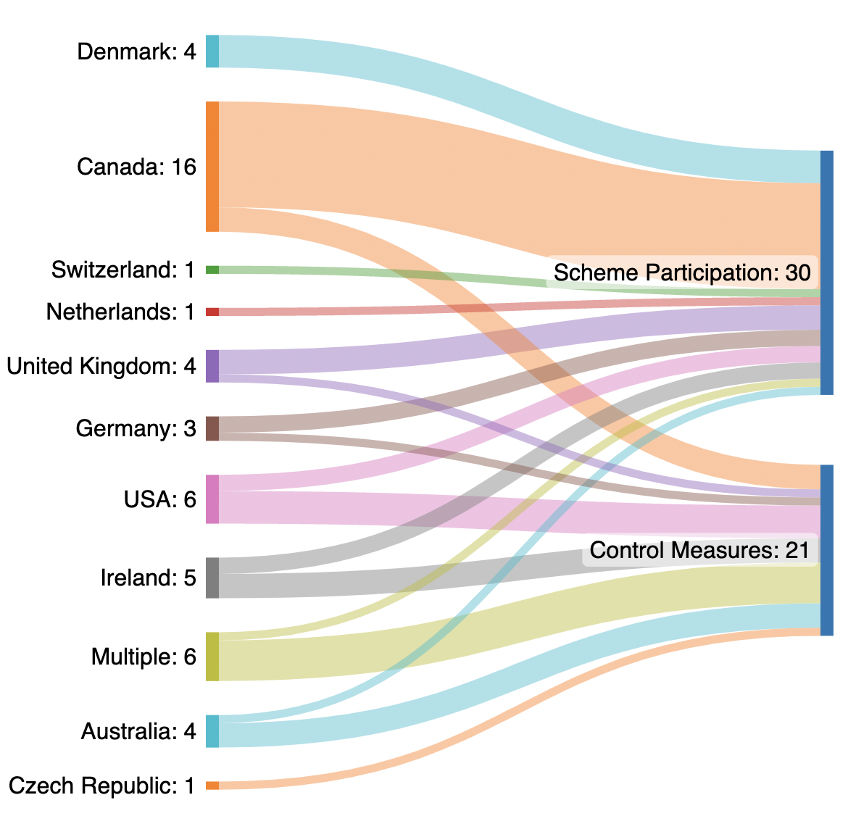

Figure 2: The number of articles which focus on the drivers or barriers of either adoption of Johne’s Disease control measure, or participation in Johne’s Disease control scheme, by country.
The majority of academic papers used quantitative methods (n = 21), followed by qualitative (n= 18). A few studies used mixed methods (n=2) and two study was a systematic review. All studies focused on dairy cows.
The 47 academic papers identified in the literature search were written by 126 authors. Many of the authors were named on more than one publication. The network map in Figure 3 shows each author connected to who they have co-authored a paper with. The size of each node represents how many publications each author is named on. The high amount of interconnection in the main component of the network graph indicates that many publications are authored by similar groups of people which could offer the potential for some bias in data.
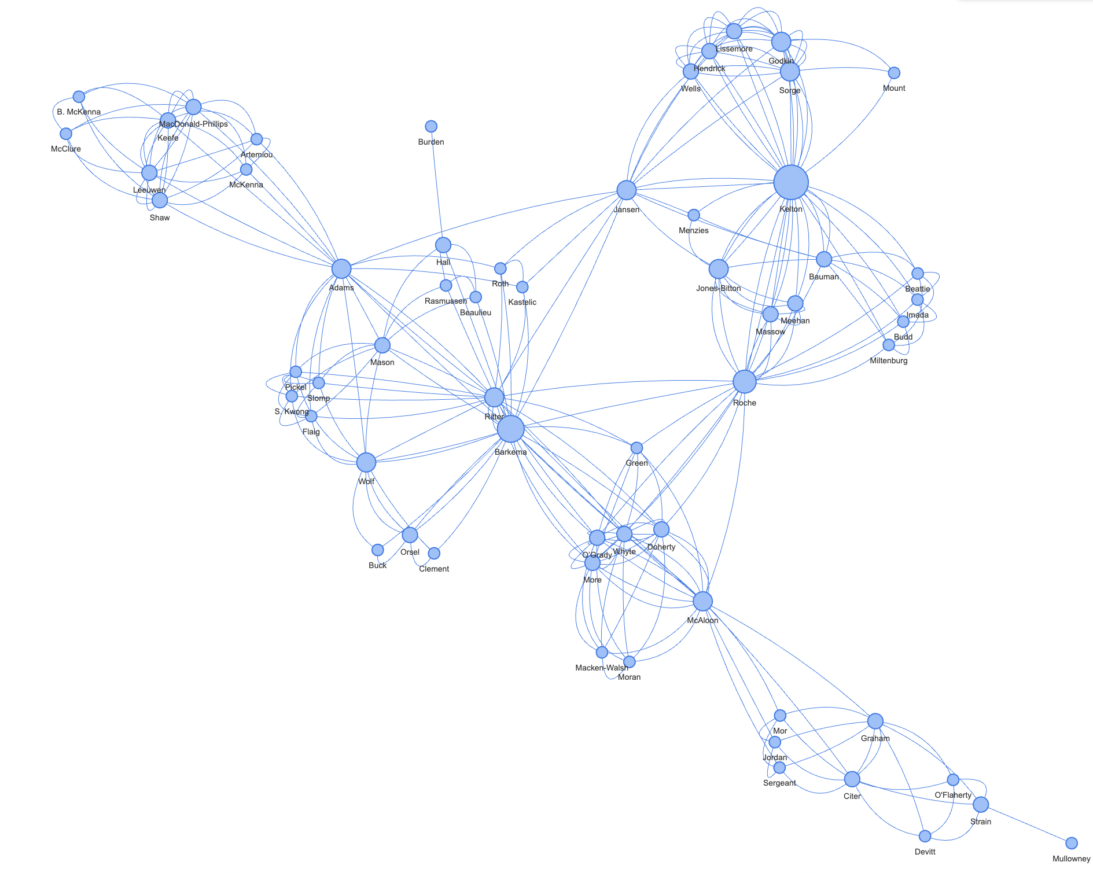
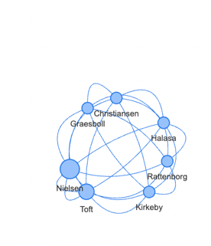
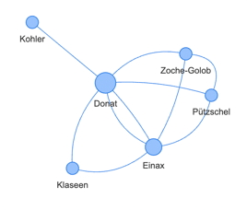
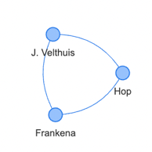
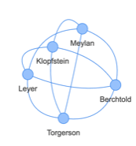
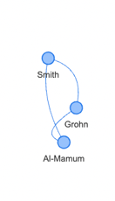
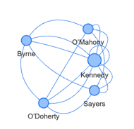
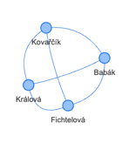
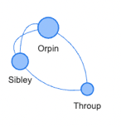
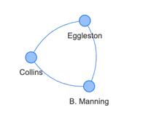
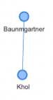
Note: The study by Whittington et al. (2019) has been excluded from this network map as their global systematic review included authors/studies that also focused on African, Asian and South America countries.

Köhler
Figure 3: Network map showing who the authors of articles which focus on drivers or barriers of either adoption of JD control measure, or participation in JD control schemes, in North America, Australia or Europe, have co-authored papers with.
As part of the data analysis process, each article included in the review was tagged with the barriers and drivers to Johne’s control that they discuss and with the recommendations they present for future control strategies. Through this process, key themes in the literature were identified. For the barriers to Johne’s control these were; concerns over testing, time taken to see results, a lack of interest, economics and a lack of space. For the drivers of Johne’s control these were; economics, herd health, better knowledge of Johne’s and human health. The recommendations for improved Johne’s control were categorised into improvements to control schemes and improvements to extension efforts. These themes are not mutually exclusive and there may be some overlap between them. The articles that discuss each theme are listed in Table 1.

Barriers to Johne’s Control  Table 1: Themes identified in the literature review and the corresponding literature | Studies | Drivers of Johne’s Control | Studies | Recommendations for Johne’s control
Concerns with tests | MacDonald-Philips et al, 2021;  Tuberquia- López et al, 2022;  Donat et al., 2022; International Dairy Federation, 2023;  Jordan et al., 2020; Ollis, 2011; Orpin, 2017; Kohl & Baumgartner, 2012; Bakker, 2013; McAloon et al., 2019; Donat and Köhler, 2016;Herd Health Pty Ltd, 2016 | Economics | Orpin, 2017; Sorge et al., 2010a; Nielsen, 2011; Hop et al., 2011; Jordan et al., 2020; Collins et al., 2010; Smith et al., 2017; Robinson, 2020; Whittington, et al., 2019 | Improvements to control schemes | Nielsen & Toft, 2011; Klopfstein et al, 2021; Donat & Köhler, 2016; Khol and Baumgartner, 2012; Donat and Köhler, 2016; Gavey et al., 2021; Whittington, et al., 2019; Barkema, et al., 2018;  Garry, 2011; Fichtelová, et al., 2022; Mullowney & Strain, 2012
Time taken to see results | Kohl & Baumgartner, 2012; Barkema et al., 2018; Nielsen & Toft, 2011; Ritter et al., 2015; Rasmussen, et al., 2021; Jordan et al., 2020; Klopfstein et al., 2021 | Herd health | Orpin, 2017; Nielsen, 2011; Zoche-Golob et al., 2021; Hop et al., 2011; Roche et al., 2019; Ritter et al., 2015 | Improvements to extension efforts | Roche, et al., 2015; Orpin, 2017; Devitt, et al., 2018; MacDonald-Phillips, et al., 2022; Sorge et al., 2010b; McAloon, et al., 2019, p. 57; Ritter et al., 2016; Ritter et al., 2015; Burden & Hall, 2021; Kennedy et al., 2014; Roche et al., 2019; Sorge et al., 2010a; Barkema, et al., 2018
Lack of interest in Johne’s control | Jordan et al., 2020; Sorge et al., 2010a; Donat et al., 2022; Ritter et al., 2016; Klopfstein et al., 2021 | Better knowledge of Johne’s | McAloon et al., 2017; Rasmussen et al., 2021; Ritter et al., 2015; MacDonald-Phillips, et al., 2021; Ritter et al., 2016; Klopfstein et al., 2021; Barwell, 2022; Mullowney & Strain, 2012
Economics | Kirkeby et al., 2016; Collins, 2019; McAloon et al., 2019; Orpin, 2017; Zoche-Golob et al., 2021; Burden, 2019; Burden & Hall, 2021; Collins, 2020; Robinson, 2020; Wolf et al., 2016; McAloon et al., 2017; Whittington, et al., 2019; Wolf, et al., 2014 | Human health | Robinson 2020; Roche, et al., 2019; Zoche-Golob, et al., 2021; Ollis, 2011; Sorge, et al., 2010a
Lack of Space | Sorge et al., 2010b; Orpin, 2017; Collins et al., 2010; Imada et al., 2022; Roche et al., 2019

Barriers to the adoption of JD control practices
Testing
The most common test for JD is the Enzyme Linked Immunosorbent Assay (ELISA) which detects MAP-specific antibodies, usually in milk (Tuberquia-López et al., 2022; Khol and Baumgartner, 2012). Its popularity is mostly due to its cost, ease and time to perform (Tuberquia-López et al., 2022). However, these tests tend to have low sensitivity, particularly in young cattle (Bakker, 2013) and in animals with subclinical disease (Tuberquia-López et al., 2022; Orpin, 2017). Faecal sampling is also commonly used to identify levels of MAP (Ritter et al., 2015; Geraghty et al., 2014). Some control schemes use faecal sampling alongside ELISA tests or as an alternative. However, faecal sampling has received the same criticisms as ELISA, with diagnosing ‘light shedders’ of the disease proving challenging (Espeio et al., 2015). A study by Espeio et al. (2015) found the performance of both ELISA tests and faecal sampling to be similar. As a result, farmers view JD tests as unreliable and can be concerned about making culling decisions based on the result (McAloon et al., 2017; Orpin, 2017). In Australia, the existence of ‘false positive’ tests meant that farmers would rather leave the control programme than deal with the stress of the experience again (Herd Health Pty Ltd, 2016).

The nature of Johne’s tests means that whilst dairy cattle may be positive or negative, farmers are also given a value that indicates the level of MAP/MAP antibodies present. Farmers are then required to make culling decisions based on the level of MAP/MAP antibodies present. Receiving test results in this way was viewed as a disincentive to farmers joining control schemes as they felt that they would never be able to achieve Johne’s free status (Jordan et al., 2020). In the Thuringian Bovine Johne’s Disease Control Program, farmers can be certified ‘non-suspect’, however the frequent testing schedule required to maintain the status due to low sensitivity of the tests was found to be both expensive and frustrating for farmers (Donat et al., 2022; International Dairy Federation, 2023). Two studies noted the link between JD testing and bovine tuberculous (bTB) testing. Carrying out a Johne’s test within a 90-day time period of a bTB test can cause false positives (Picasso-Risso et al., 2019) which furthered farmer distrust of test results (Tuberquia-López et al., 2022; Orpin, 2017). One study found that some farmers are unaware of the issues surrounding Johne’s testing, leading them to put too much trust in the results which may result in incorrect management practices being adopted (MacDonald-Phillips et al., 2021).

Time taken to see results
The epidemiology of JD combined with the absence of viable vaccinations or treatment and the inefficiency of test-and-cull strategies means that it can take a long time for farmers to observe any results from the control measures. This was found to reduce the acceptance of the programmes and control measures amongst both farmers and vets (Khol and Baumgartner, 2012). Humans tend to discount future benefits, meaning the large upfront costs of JD control and the delayed realisation of benefits can cause farmers to view control measures as uneconomical (Rasmussen et al., 2021). The delayed realisation of benefits also creates problems when assessing whether a programme is successful therefore reduces the likelihood of current participants motivating new farmers to join control schemes (Ritter et al., 2015; Nielsen and Toft, 2011). One study found that farmer enthusiasm for Johne’s control problems waned over the long time period and many participants left the voluntary scheme (Barkema et al., 2018).

Lack of interest in Johne’s control
Several studies found that some farmers have no interest in Johne’s control. It was found that farmers who have not experienced JD problems in their herd were more likely to view control measures as not worth implementing and were therefore unlikely to engage in voluntary programmes or adopt precautionary measures (Jordan et al., 2020; Sorge et al., 2010b). Even some farmers who do find the disease in their herd are unwilling to act on JD as they do not consider it a dangerous disease (Ritter et al., 2016; Donat et al., 2022; Klopfstein et al., 2021).

Economics
The cost effectiveness of Johne’s control was found to differ from herd to herd and under certain circumstances, farmers viewed the cost to be too high (Kirkeby et al., 2016; Collins, 2019; Wolf et al., 2015). This was particularly apparent in smaller herds where, when considering returns on investment, farmers have been found to choose to not control Johne’s at all (McAloon et al., 2019). The high costs of culling due to decreased milk production and the cost of Johne’s testing all act as disincentive to farmers who may not see the long-term financial benefits (Orpin, 2017; ZocheGolob et al., 2021; Burden 2019; Robinson 2020). For some farmers, this is due to a lack of understanding of the economic benefits of JD management and therefore they may not be making economically rational decisions (Burden and Hall, 2021). On top of this, farmers may be required to cull high yielding and healthy-looking cows which they are reluctant to do (Collins, 2020).

Lack of space
One of the main recommendations in many Johne’s control schemes and biosecurity plans is to calve infected cows in a separate area to reduce the risk of them spreading JD to calves. Implementing separate calving areas can be costly and impractical for farmers with 3 studies identifying a lack of space to be the core barrier to Johne’s control (Sorge et al., 2010b; Orpin, 2017; Collins et al., 2010). Often even farmers who are highly engaged in Johne’s control and understand the benefits of separate calving pens lack the space to segregate their cows (Imada et al., 2022). Lack of space tends to be a bigger issue for smaller herds where costs related to modifications of existing buildings or spatial reorganisation to accommodate new calving pens are proportionally higher when compared to larger farmers (Klopfstein et al. 2021). Interesting, studies in Europe and North America cited a lack of space as a barrier despite the latter having larger farms and less land scarcity.

Drivers of the adoption of Johne’s practices

Economics
Whilst the cost effectiveness of Johne’s control was identified as a barrier to the adoption of control measures, the economic benefits of JD control measures were also identified as a driver of adoption. Both Orpin (2017) and Ritter (2017) found that some farmers felt that having a Johne’s problem on farm reduced their farm margins and were therefore keen to control it. The farmers who were most concerned by the economic impacts of Johne’s Disease tended to have previously experienced the disease on farm (Sorge et al., 2010a; Nielsen, 2011; Hop et al., 2011). In fact, it is argued that farmers will not see Johne’s as worth addressing until they see clinical disease that requires excessive culling on their farm (Jordan et al., 2020). The economic benefits of Johne’s control depend on the type of controls being recommend and the existing prevalence of Johne’s within the herd (Collins et al., 2010; Smith et al., 2017; Orpin et al., 2020).

Some Johne’s control programmes offered financial support and rewards to participating farmers. This was generally found to drive engagement in the programme. For example, Donat et al. (2022) argued that the financial aid offered as part of the Thuringian Bovine Johne’s Disease Control Program made it ‘achievable’ for farmers to control the disease. Similarly, in the Dutch JD control programme, which has widely been regarded as a success (Farmers Weekly, 2012), milk processors initially covered most of the costs for producers (Jordan et al 2020). This made the scheme more economically attractive to farmers and resulted in high levels of participation. This financial support has been slowly reduced over time and now just covers the participation fee (Jordan et al., 2020). However, evidence from the USA indicates that whilst short term financial incentives may increase farmer participation, once this support is reduced, participation declines rapidly (Geraghty et al., 2014). Furthermore, in Canada, even when the programme was fully subsidised, many producers still did not participate (Roche et al., 2019).

Herd Health
The overall health of the herd and animal welfare were viewed as major benefits of Johne’s control by farmers (Orpin 2017; Nielsen, 2011). In a study of German dairy farmers, improvements in animal health were found to be one of the main motivators of participation in a Johne’s programme, with about 40% of farmers assuming they would see calf and herd health improvements after implementation of measures (Zoche-Golob et al., 2021). Participants in a Dutch control programme were similarly found to be more concerned about animal welfare and herd health than non-participants (Hop et al., 2011).

Human Health
Human health and the zoonotic potential of JD was a worry for farmers. The link between MAP and Crohns Disease in humans, although unproven, was a concern for many who wanted to maintain consumer confidence in their products (Roche et al., 2019; Zoche-Golob et al., 2021; Ollis, 2011). Farmers saw the potential link between MAP and Crohns as an important issue for the industry and therefore wanted to act proactively (Sorge et al., 2010a) to avoid a consumer food scare (Robinson, 2020).

Increased Knowledge
Farmers JD knowledge comes from both extrinsic sources, such as scientists and vets, and their own intrinsic knowledge of diseases (McAloon et al., 2017). Farmers with higher self-assessed knowledge of JD were more likely to have risk assessments done and to participate in Johne’s control programmes (Ritter et al., 2017; Ritter et al., 2016). Rasmussen et al. (2021) similarly argued that farmers decision to adopt JD control measures are mostly dependent on the level and quality of information available to them. Vets are often a key source of information for farmers and can have a positive effect on the enrolment of farmers in Johne’s programmes (Ritter et al., 2016). Therefore, it is also important to increase vet knowledge so they can train farmers (MacDonald-Phillips et al., 2021).

Interaction between drivers and barriers
The drivers and barriers of JD control are not mutually exclusive and certain factors will impact upon others. Some of these relationships are discussed in the literature and are shown diagrammatically in Figure 4.

The economics of JD acts as both a driver and barrier to implementing control measures. However, how cost-effective JD control is, or is perceived to be, will be determined by multiple factors. For example, farmers may view JD control as uneconomical as many of the benefits are realised far into the future (Rasmussen et al., 2021). This may be more prominent in smaller dairy farms for whom the initial investment is proportionately more. Therefore, the time taken to see results can have a negative effect on the perceived economic benefit of JD control. Continued JD testing is expensive for farmers, especially when a scheme or programmes requires frequent tests (Donat et al., 2022; Geraghty et al., 2014). How often farmers are required to test and whether there is any support to cover the cost of testing will affect how economically viable a JD control scheme is for the farmer.

Concerns over the reliability of tests can further perpetuate a lack of interest in Johne’s control. Donat et al (2022) found that farmers’ negative perceptions of tests made them ‘resistant’ to Johne’s control measures despite them still making economic sense, even with the testing limitations. Similarly, the time taken to see any results of Johne’s control measures can create disinterest and apathy towards JD control schemes (Khol and Baumgartner, 2012). Finally, farmers who have no interest in JD are likely to have less knowledge about the disease. Hop et al. (2011) found that amongst Dutch farmers, having little interest in controlling JD resulted in farmers learning less about the disease. Interestingly, this relationship may not be reciprocal as Ritter et al. (2016) argue that a lack of interest in JD control is not due to a lack of knowledge, but rather negative perceptions they had towards controlling the disease.

The interactions discussed in this section are limited to those specifically mentioned in the literature, however there are undoubtly more relationships and interdepencies between the drivers and barriers which have not been explored.

Barriers
Drivers
Herd Health
Increased knowledge
Human Health
Economics
Lack of space
Testing
Time taken to see results
Lack of interest
Positive effect
Negative effect

Figure 4: Diagram showing the interactions between the drivers and barriers of Johne’s Disease control that are discussed in the literature included in the systematic review.

Recommendations for increased uptake of Johne’s control
Many of the articles made recommendations to promote the uptake of Johne’s control measures. These recommendations could be grouped into two categories: improvements to control programme design and improvements to extension.

It is recommended that schemes should seek to certify herds as low risk as this can incentivise farmers to participate but can also reduce the risk of buying in Johne’s cows and therefore reduce JD spread (Nielsen and Toft, 2011). In a critique of the current approach to Johne’s control across the EU, which is comprised of voluntary and scattered control programmes, Khol and Baumgartner (2012) recommend that harmonised minimum standards should be set across the EU. They argue that compulsory minimum standards which are low cost and easy to implement may help keep farmers engaged in JD control, resulting in less MAP bring spread in the environment (Khol and Baumgartner, 2012). The potential of mandatory programmes is also discussed by Donat & Köhler (2016) who found that mandatory control programmes were accepted by farmers in parts of Germany and that in Thuringian, more than 70% of cattle farmers would prefer a mandatory control programme as an alternative the current voluntary one. Finally, Klopfstein et al. (2021) suggest that further incentives are needed to increase the enrolment of farmers in Johne’s control schemes.

A variety of improvements to Johne’s extension efforts are recommended in the literature. The role of peer learning is raised in two studies (Roche et al., 2015; Orpin, 2017). Visiting farms who have successfully controlled JD can help farmers learn about Johne’s control from trusted sources and help with demonstrating that the disease is controllable if the correct measures are put in pace. Vets are currently a key source of Johne’s information for farmers and therefore focusing on improvements to vet communication skills can be an important strategy (Devitt et al., 2018; MacDonald-Phillips et al., 2022; Sorge et al., 2010b).

Extension efforts should also take into consideration the audience and type of farmer they are working with. Communication should be ‘tailored to the mindset of the farmer’ (McAloon et al., 2019, p.57), which is especially crucial for vets who are in a position to assess farmer perceptions and understand their specific issues (Ritter et al., 2016). In a similar vein, Donat & Köhler (2016) recommend that extension strategies need to adapt to focus on the less innovative and late adopting farmers. Some studies also recommended a general improvement of farmer knowledge (Ritter et al., 2015; Kennedy et al., 2014). It was argued that farmers may feel more motivated if they fully understand the benefits of JD control measures, including on other diseases. Burden and Hall (2021) also argue that expenses incurred by participating in control programmes need to be justified and understood by farmers if they are to join.

Farming Systems
The studies included in this review cover multiple countries which all have different dairy systems. Countries such as Canada and Australia tend to have larger industrial dairy herds when compared to Europe. There will also be significant variance of milk yield and herd size within countries. How farm size affects farmer decisions to adopt Johne’s practices is unclear from the literature. In their review of 48 countries, which cover a wide range of dairy systems, Whittington et al. (2019) found that countries with larger herd sizes were likely to have a higher prevalence of MAP, indicating that the farmers are less engaged with Johne’s control. However, a study in Australia found that farm characteristics such as herd size and annual milk production had no statistically significant effect on the adoption of JD control measures (Burden and Hall, 2021). Whereas a study by Ritter et al. (2015) found that in Alberta, Canada, farmers with larger herds were more likely to participate in a Johne’s control scheme. Evidence from studies in Europe is also inconsistent. Nielsen and Toft (2011) found that in Denmark, herd size had no impact on the prevalence of Johne’s Disease. Instead, they argue that the prevalence is related to farmer behaviour such as their purchase behaviour. In contrast, Kennedy et al (2014) found in their study of Irish farms that larger herd sizes are more likely to engage in hazardous practices for MAP transmission.

Whilst different drivers and factors may be more important for certain groups of farmers, as discussed above, the overall impact of farm and herd size on decisions to adopt JD control is unclear. It may be that relationship between farm size is country specific, or it may be, as Nielsen and Toft (2011) suggest that farm size and farming system is less relevant than individual farmer behaviour.

Discussion

The results of this systematic review highlight that there are three broad sets of factors which affect the adoption of Johne’s control measures and participation in Johne’s control programmes. Firstly, there are a set of psychological factors related to farm decision-making. Secondly, there are physical on-farm barriers that prevent Johne’s control measures being implemented. Finally, there are factors related to the science of JD control.

Psychological factors
Farmers are not a homogenous group and therefore their attitudes, motivations and risk perceptions will differ, resulting in staggered practice adoption. Different extension strategies will be needed to help different farmers navigate their journey to controlling JD on their farms. This supports conclusions from the broad thrust of general agricultural extension studies, which argue that multiple strategies and actors must be involved in effective advisory provision to help farmers with varying motivations and abilities to act (see e.g. Davis, 2019; Cofré-Bravo et al., 2019; Hurley et al., 2022).

Farmer attitudes towards JD control were determined by various factors. Personal experience of the disease and associated perception of its seriousness meant that farmers who have not experienced JD on their farm were not as aware of the risks and costs associated with JD. They therefore maintained little interest in controlling the disease. This is also a common occurrence with other dairy diseases (Marshall, et al., 2023; Ritter et al., 2017). The presence of cognitive dissonance can cause farmers to question whether new livestock management practices actually do improve the health and welfare of the animal (Kristensen and Jakobsen, 2011). Regarding Johne’s control, farmers are often advised to snatch calve, which involves taking the calf away from the mother immediately after birth. Studies have shown that farmers may have negative views of such calf management practices (Wathes et al., 2022) and view them as bad for animal welfare. Farmers can also be reluctant to cull healthy looking and high yielding animals (Collins, 2020). Therefore, whilst some farmers may view JD control to better the health and of their herd and adopt the measures, other farmers may view their existing practices to be better for the animal’s welfare. However, all farmers will have different attitudes and opinions towards animal welfare and herd health (Adler et al., 2019) and some will simply not view it as a priority. The economics of JD control was also clearly a key factor influencing attitudes, as was the length of time associated with control programmes.

These psychological barriers to disease prevention are not unique to Johne’s Disease. Farmers in the USA experience similar cognitive dissonance regarding antibiotic use. Some farmers believe that antibiotics are important for their animals’ welfare and are resistant to reducing their use of them (Ruegg, 2022). Ruegg (2022) therefore recommends that the benefits of reduced antibiotic use are communicated in terms of animal wellbeing as opposed to human health. In a similar manner, it may be worth considering how extension and communication strategies on JD can focus on the human health, animal welfare and economic benefits of control measures and how education can be tailored to meet the needs of the farmer.

Similar to JD, bTB control programmes are often discussed in decades rather than the short-term (Whittington et al., 2019). Whilst the length of these programmes may negatively affect attitudes towards them, bTB programmes are usually mandatory and backed by legal frameworks. In contrast, JD schemes are usually voluntary. One of the most successful JD control programmes has been in the Netherlands where there is a high participation rate and a declining incidence of disease (Farmers Weekly, 2012; Geraghty, et al., 2014). The programme allows farmers to be certified to indicate that they have a low prevalence of JD and often milk processors will refuse to buy from herds with test positive cattle (Geraghty, et al., 2014). Therefore, whilst the programme is voluntary, strong informal enforcement mechanisms exist which ensure producers comply. If JD control is to remain voluntary, more enforcement mechanisms such as this may need to be implemented. The need for certification and more enforcement were both identified as important for JD control schemes in the literature.

Enhanced knowledge through peer-to-peer learning and veterinary involvement is also seen as a way of addressing attitudes towards animal disease control across the wider literature and therefore can help increase the adoption of Johne’s control measures (e.g Morgans et al., 2021). Peer-to-peer learning is an established method of extension through which farmers learn from another farmer. Through peer learning, farmers can receive first hard verification of the impact of the disease and its control measures from a reliable and relatable source (Rust et al., 2022; Knoche et al., 2015). This approach to farmer education is recommended in two articles included in the review (Roche et al., 2015; Orpin, 2017) as it could help farmers who have not experienced JD better understand the risks and economic costs behind the disease. However, farmers also rely heavily on information from their vets as well as other farmers, therefore the participation and support of veterinarians (and indeed buyers and other supply chain actors) is also crucial if farmers are to engage in JD control programmes.

Physical barriers

A lack of space to implement JD control recommendations is a physical barrier which many farmers face. Several studies noted that this was the main barrier to JD control (Sorge et al., 2010b; Orpin, 2017; Collins et al., 2010). Most Johne’s programmes recommend the segregation of high-risk cows, especially when it comes to calving as cow to calf transmission is thought to be the major route of Johne’s spread. However, having space on farm to house these cows is challenging and many farmers will simply not be able to do it. This may act as a disincentive to implement or partake in any Johne’s control measures. Therefore, focusing JD control programmes on lower cost and low labour measures and pushing for these to be adopted at scale may be more effective. This will reduce the spread of MAP in the environment having positive effects for all farmers. This approach was recommended by Khol and Baunmgartner (2012) in their study, yet has been a feature of many JD control schemes who emphasise the need for biocontainment plans and regular testing above other more costly measures (Geraghty, et al., 2014). A lack of space on-farm is a common barrier to implementing various dairy biosecurity measures, for example in Belgium limited space meant farmers did not quarantine bought-in heifers for the recommended 15 days (Renault, et al., 2018). Interesting, the studies which found lack of space as a barrier to JD control spanned both European and North American dairy systems, despite the latter often being associated with larger farms and less land scarcity.

Scientific factors
The barriers to the adoption of JD control measures are not just psychological and physical but also relate to scientific knowledge. Notably issues regarding the accuracy of tests were raised in many of the articles included in this review. A study in 2018 found the specificity and sensitivity of the Johne’s ELISA test to be around 99.5% and 61.8% respectively (Meyer et al., 2018). Similar results were reported for the environmental faecal sampling (Espejo, et al. 2015). Whilst animals with a high level of MAP/MAP anti-bodies are likely to be identified as positive, those with lower levels of MAP/MAP anti-bodies may be harder to detect and therefore an inaccurate reading may be provided (Meyer et al., 2018). Control schemes that use ELISA/faecal sampling have been proven to be acceptable to farmers in certain contexts (Donet et al., 2022; Farmers Weekly, 2012) and evidence suggests that even with the low sensitivity of tests, these schemes have been proven to be cost effective. Therefore, it is important that farmers understand the scientific limitations of testing, but also understand that these limitations do not undermine the benefits of Johne’s control.

Conclusion
There are many drivers and barriers to the adoption of Johne’s control measures. Based on the literature reviewed in this paper, it is challenging to identify whether some are more important than others. Most drivers and barriers were identified in studies focused on both Europe and North America, despite their different farming systems. Therefore, it does not appear that certain barriers and drivers are more prominent in specific contexts, but rather farmer behaviour and attitudes are more relevant than the farming system they operate within.
It was, however, noted in several studies that smaller herds may experience greater economic uncertainty regarding JD investments and therefore economic barriers may be more relevant for them. The relationship between JD testing and bTB testing may also amplify concerns over tests in areas where bTB is still prominent, for example in the UK.

The diversity of barriers, which are faced by farmers across different contexts and countries highlights the importance of taking a multi-disciplinary and participatory approach to JD control. Since the barriers to JD control are mostly rooted in human behaviour, programmes must be designed to deal with a range of farmer needs and attitudes. Involving farmers, advisers, and supply chain actors in the design and delivery of control programmes will help to tailor programmes for particular communities of farmers, accounting for differing attitudes and levels of knowledge, and creating the right mix of incentives (e.g. carrot and stick) to encourage change. Given the long time-scale of JD control, informal or formal enforcement mechanisms may help keep farmers engaged in the control programmes for a longer period.

Bibliography
Adler, F., Christley, R., & Campe, A. (2019). Examining farmers' personalities and attitudes as possible risk factors for dairy cattle health, welfare, productivity, and farm management: A systematic scoping review. Journal of Dairy Science , 102(5).

AHDB/Ruminant Health & Welfare. (2021). Cattle and sheep health welfare priorities
-a ‘grassroots’ survey across the four nations of the UK. https://bit.ly/3ENFLO5

Allen, A. R., Skuce, R. A. & Byrne, A. W., 2018. Bovine Tuberculosis in Britain and Ireland – A Perfect Storm? the Confluence of Potential Ecological and Epidemiological Impediments to Controlling a Chronic Infectious Disease. Front. Vet. Sci..

Bakker, D. (2013 ). Danish designs on the control of bovine paratuberculosis. The Veterinary Journal, 198, 311–312.

Barkema, H., Orsel, K., Ritter, C., Schuster, J., Corbett, C., Wolf, R., . . . Kelton, D. (2018). Lessons Learned from the Canadian Johne's Disease Programs. WCDS Advances in Dairy Technology .

Barkema, H. W. et al., 2018. Knowledge gaps that hamper prevention and control of Mycobacterium avium subspecies paratuberculosis infection. Transboundary and Emerging Disease, Volume 65.

Barrett, D., More, S., Graham, D., O'Flaherty, J., Doherty, M., & Gunn, H. (2011). Considerations on BVD eradication for the Irish livestock industry. Irish Veterinary Journal, 64(12).

Barwell, R., 2022. Johne's disease management in Australia: update. Dublin, Bulletin of the International Dairy Federation.

Burden, P. D. (2019). Lessons from the Australian Johne's disesase control policies and programs. Calgary: University of Calgary.

Burden, P., & Hall, D. C. (2021). Variations in the profitability of dairy farms in Victoria, Australia by different levels of engagement in bovine Johne’s disease control. Preventive Veterinary Medincine , 186.

Cofré-Bravo, G., Klerkx, L., Engler, A. (2019). Combinations of bonding, bridging, and linking social capital for farm innovation: How farmers configure different support networks,
Journal of Rural Studies, 69, 53-64,

Collins, M. T. (2019). The story of Johne's Disease for non-experts. Madison: University of Wisconsin .
Collins, M. T. (2020). JD Control Failures. Retrieved March 2023, from https://johnes.org/news/jd-control-failures/

Collins, M. T., Eggleston, V., & Manning, E. J. (2010). Successful control of Johne’s disease in nine dairy herds: Results of a six-year field trial. Journal of Dairy Science , 93, 1638–1643.

Davis, W., & Madsen-Bouterse, S. (2012). Crohn's disease and Mycobacterium avium subsp. paratuberculosis: The need for a study is long overdue. Veterinary Immunology and Immunopathology, 145, 1-6.

Davis, K. (2019). The complex processes of agricultural education and extension. The Journal of Agricultural Education and Extension, 25(3), 193-194.

Devitt, C., Graham, D. A., O’Flaherty, J., Strain, S., & Citer, L. (2018). Veterinary experiences of a Johne's disease control programme in Ireland. Vet Record.

Donat, K., & Köhler, H. (2016). Paratuberculosis in Germany: A step forward to control in cattle herds . Nantes: Proceedings of the 5th Paratuberculosis forum .

Donat, K., Einax, E., & Klassen, A. (2022). Evaluation of the Thuringian Bovine Johne’s Disease Control Program—A Case Study. Animals, 12.

Espejo, L.A., F.J. Zagmutt, H. Groenendaal, C. Muñoz-Zanzi, and S.J. Wells. 2015. "Evaluation of performance of bacterial culture of feces and serum ELISA across stages of Johne’s disease in cattle using a Bayesian latent class model ." Journal of Dairy Science 98 (11).

Farmers Weekly, 2012. National Johne’s programme cuts disease in Holland. [Online]
Available at: https://www.fwi.co.uk/livestock/dairy/national-johne-s-programme-cuts-disease-in-holland
[Accessed August 2023].

Farmers Weekly. (2017). Milk buyer puts plans in place to tackle Johne’s disease . Retrieved March 27, 2023, from https://www.fwi.co.uk/livestock/health-welfare/livestock-diseases/milk-buyer-puts-plans-place-tackle-johnes-disease

Fichtelová, V., Králová, A., Babák, V. & Kovařčík, K., 2022. Effective Control of Johne's Disease in Large Czech Dairy Herds. Journal of Veterinary Research, 2022, 66(1).
Garry, F., 2011. Control of Paratuberculosis in Dairy Herds. Veterinary Clinics of North America: Food Animal Practice, 27(3).

Garvey, M. (2020). Mycobacterium Avium Paratuberculosis: A Disease Burden on the Dairy Industry. Animals, 10(10).

Gavey, L., Citer, L., More, S. J., & Graham, D. (2021). The Irish Johne's Control Programme . Frontiers in Veterinary Science, 8.

Geraghty, T., Graham, D., Mullowney, P., & More, S. J. (2014). A review of bovine Johne's disease control activities in 6 endemically infected countries. Preventive Veterinary Medicine, 116(1-2), 1-11.

Godfray, C. et al., 2018. Bovine TB strategy review, London: Department for Environment, Food and Rural Affairs .

Herd Health Pty Ltd. (2016). Review of the Australian Johne’s Disease Market Assurance Program for cattle (CattleMAP). Maffra, Victoria : Animal Health Australia .

Hop, G., Velthuis, A., & Frankena, K. (2011). Assessing Dutch farmers’ incentives to join a voluntary Johne's Disease programme. NJAS: Wageningen Journal of Life Sciences, 58(1-2), 57-64.

Hurley, P., Lyon, J., Hall, J., Little, R., Tsouvalis, J., White, V., and Rose, D. C. (2022). Co-designing the environmental land management scheme in England: The why, who and how of engaging ‘harder to reach’ stakeholders. People and Nature, 4(3), 744-757.

Imada, J. B., Roche, S. M., Bauman, C. A., Miltenburg, S., Budd, R., Beattie, K., & Kelton, D. F. (2022). Descriptive analysis of the changes in Johne’s disease management practices on Ontario dairy farms through repeat risk assessment. Journal of Dairy Science , 105, 9107–9118.

International Dairy Federation . (2023). Proceedings of the 7th and 8th IDF paratuberculosis fora. Brussels: Bulletin of the Federation .

Jordan, A. G., Citer, L. R., McAloon, C. G., Graham, D. A., Sergeant, E. S., & More, S. J. (2020). Johne’s disease in Irish dairy herds: considerations for an effective national control programme. Irish Veterinary Journal, 73(18).

Karuppusamy, S., Kirby, G. M., Mutharia, L. & Tripathi, B. N., 2019. An update on Mycobacterium avium subspecies paratuberculosis antigens and their role in the diagnosis of Johne’s disease. World Journal of Microbiology and Biotechnology .

Kennedy, A. E., O’Doherty, E. F., Byrne, N., O’Mahony, J., Kennedy, E. M., & Sayers, R. G. (2014). A survey of management practices on Irish dairy farms with emphasis on risk factors for Johne’s disease transmission. Irish Veterinary Journal volume, 67.

Khol, J. L., & Baunmgartner, W. (2012). Examples and Suggestions for the Control of Paratuberculosis in European Cattle. Japanese Journal of Veterinary Research, 60.

Kirkeby, C., Græsbøll, K., Nielsen, S., Christiansen, L., Toft, N., Rattenborg, E., & Halasa, T. (2016). Simulating the Epidemiological and Economic Impact of Paratuberculosis Control Actions in Dairy Cattle. Front. Vet. Sci., 3(90).

Klopfstein, M., Leyer, A., Berchtold, B., Torgerson, P. R., & Meylan, M. (2021). Limitations in the implementation of control measures for bovine paratuberculosis in infected Swiss dairy and beef herds. PLOS ONE, 16(2).

Knoche, H., Rao, P. S., Jamadagni, H., & Huang, J. (2015). Actions and advice in coli: a mobile social network to support agricultural peer learning: Proceedings of the 17th International Conference on Human-Computer Interaction with Mobile Devices and Services Adjunct.

Kristensen, E., & Jakobsen, E. B. (2011). Challenging the myth of the irrational dairy farmer; understanding decision-making related to herd health . New Zealand Veterinary Journal , 59(1).

MacDonald-Phillips, K. A., Keefe, G. P., VanLeeuwen, J., Shaw, D. H., McClure, J., & McKenna, S. L. (2021). Dairy producer satisfaction and knowledge transfer with the veterinary- administered risk assessment and management plan in a voluntary Johne’s disease control program. Journal of Dairy Science , 105, 2499–2508.

MacDonald-Phillips, K. A., McKenna, S. L., Shaw, D. H., Keefe, G. P., VanLeeuwen, J., Elpida Artemiou & Adams, Cindy L. (2022). Communication skills training and assessment of food animal production medicine veterinarians: A component of a voluntary Johne’s disease control program. Journal of Dairy Science, 105, 2487–2498.

Marshall, J. et al., 2023. A focus group study exploring dairy farmers’ perspectives of cull cow management in Ontario, Canada. Front. Vet. Sci., Volume 10.

McAloon, C. G., Macken-Walsh, Á., Moran, L., Whyte, P., More, S. J., O’Grady, L., & Doherty, M. L. (2017). Johne’s disease in the eyes of Irish cattle farmers: A qualitative narrative research approach to understanding implications for disease management. Preventive Veterinary Medicine, 141, 7-13.

McAloon, C. G., Roche, S., Ritter, C., Barkema, H. W., Whyte, P., More, S. J., . . . Doherty, M. L. (2019). A review of paratuberculosis in dairy herds — Part 2: On-farm control. The Veterinary Journal, 246, 54–58.

Meyer, A., Bond, K., Winden, S. V., Green, M., & Guitian, J. ( 2018). A probabilistic approach to the interpretation of milk antibody results for diagnosis of Johne’s disease in dairy cattle. Preventive Veterinary Medicine, 150, 30-37.

Moennig, V. & Yarnall, M. J., 2021. The Long Journey to BVD Eradication. Pathogens.

Moher, D., Liberati, A., Tetzlaff, J., & Altman, D. G. (2009). Preferred reporting items for systematic reviews and meta-analyses: the PRISMA statement . BMJ, 339.

Morgans, L. C., Bolt, S., Bruno-McClung, E., Dijk, L. v., Escobar, M. P., Buller, H. J., . . . Reyher, K. K. (2021). A participatory, farmer-led approach to changing practices around antimicrobial use on UK farms. Journal of Dairy Science , 104(2).

Mullowney, P. & Strain, S., 2012. Johne’s Disease Control in Ireland - Past, Present and Future. s.l., Proceedings of the 3rd ParaTB Forum.

Nielsen, S. S. (2011). Dairy farmers’ reasons for participation in the Danish control programme on bovine paratuberculosis. Preventive Veterinary Medicine, 98, 279–283.

Nielsen, S. S., & Toft, N. (2011). Effect of management practices on paratuberculosis prevalence in Danish dairy herds. Journal of Dairy Science , 94, 1849-1857.

NigschI, A. et al., 2021. Who infects whom?—Reconstructing infection chains of Mycobacterium avium ssp. paratuberculosis in an endemically infected dairy herd by use of genomic data. PLOSone.

Ollis, G. (2011). Alberta Johne’s Disease Initiative. Alberta: WCDS Advances in Dairy Technology .

Orpin, P. (2017). Dairy UK Johne’s survey – winning farmer engagement. Cattle Practice , 25(3).

Orpin, P., Sibley, D., & Bond, K. (2020). Johne's disease in dairy herds 2. Effective control using the National Johne's Management Plan. InPractice, 42(3), 159-168.

Orpin, P., Sibley, D., Bond, K., & Taylor, E. N. (2023). An update on the progress of the UK National Johne’s Management Plan and InterHerd+ Johne’s Disease Tracker. Dublin: Proceedings of the 7th and 8th IDF Paratuberculosis Fora.

Orpin, P., Sibley, R., T. S., & Braddock, A. (2017). The National Johne’s Management Plan: progress and future developments. Cattle Practice , 25(2).

Picasso-Risso, C., Grau, A., Bakker, D., Nacar, J., Mínguez, O., Perez, A., & Alvarez, J. (2019). Association between results of diagnostic tests for bovine tuberculosis and Johne's disease in cattle . Veterinary Record, 185(22).

Pritchard, T. C. et al., 2017. Phenotypic effects of subclinical paratuberculosis (Johne’s disease) in dairy cattle. Journal of Dairy Science, pp. 679-690.

Queensland Government. (2023). Johne's disease . Retrieved March 27, 2023, from https://www.business.qld.gov.au/industries/farms-fishing-forestry/agriculture/biosecurity/animals/diseases/guide/johnes-disease

Rasmussen, P., Barkema, H. W., Beaulieu, E., Mason, S., & Hall, D. C. (2021). Estimation of the value of Johne’s disease (paratuberculosis) control to Canadian dairy producers. Preventive Veterinary Medicine, 189.

Renault, V. et al., 2018. Biosecurity practices in Belgian cattle farming: Level ofimplementation, constraints and weaknesses. Transboundary and Emerging Diseases, Volume 65.

Ritter, C., Jansen, J., Roche, S., Kelton, D. F., Adams, C. L., Orsel, K.,… Barkema, H. W. (2017). Determinants of farmers' adoption of management-based strategies for infectious disease prevention and control. Journal of Dairy Science , 100(5), 3329-3347.

Ritter, C., Jansen, J., Roth, K., Kastelic, J. P., Adams, C. L., & Barkema, H. W. (2016). Dairy farmers’ perceptions toward the implementation of on-farm Johne’s disease prevention and control strategies. Journal of Dairy Science. 99, 9114-9125.

Ritter, C., Kwong, P. S., Wolf, R., Pickel, C., Slomp, M., Flaig, J., . . . Barkema, H. W. (2015). Factors associated with participation of Alberta dairy farmers in a voluntary, management-based Johne’s disease control program. Journal of Dairy Scienc, 98, 7831 - 7845.
Robinson, P. A. (2020). "They've got to be testing and doing something about it": Farmer and veterinarian views on drivers for Johne’s disease control in dairy herds in England. Preventive Veterinary Medicine , 182.

Roche, S. M., Jones-Bitton, A., Meehan, M., Massow, M. V., & Kelton, D. F. (2015). Evaluating the effect of Focus Farms on Ontario dairy producers’ knowledge, attitudes, and behavior toward control of Johne’s disease. Journal of Dairy Science, 98, 5222–5240.

Roche, S. M., Kelton, D. F., Meehan, M., Massow, M. V., & Jones-Bitton, A. (2019). Exploring dairy producer and veterinarian perceptions of barriers and motivators to adopting on-farm management practices for Johne’s disease control in Ontario, Canada. Journal of Dairy Science, 102, 4476–4488.

Ruegg, P. L., 2022. Realities, Challenges and Benefits of Antimicrobial Stewardship in Dairy Practice in the United States. Microorganisms.

Rust, N. A., Stankovics, P., Jarvis, R. M., Morris-Trainor, Z., Vries, J. R., Ingram, J., . . . Reed, M. S. (2022). Have farmers had enough of experts? Environmental Management, 69, 31-44.

Shepard, R., Williams, S., & Beckett, S. ( 2016). Farm economic impacts of bovine Johne's disease in endemically infected Australian dairy herds. Australian Veterinary Journal, 94(7), 232-239.

Smith, R. L., Al-Mamun, M., & Gröhn, Y. (2017). Economic consequences of paratuberculosis control in dairy cattle: a stochastic modeling study. Preventive Veterinary Medicine, 138(17-27).

Sorge, U. S., Mount, J., Kelton, D. F., & Godkin, A. (2010b). Veterinarians’ perspective on a voluntary Johne’s disease prevention program in Ontario and western Canada. The Canadian Veterinary Journal, 51(4), 403–405.

Sorge, U., Kelton, D., Lissemore, K., Godkin, A., Hendrick, S., & Wells, S. (2010a). Attitudes of Canadian dairy farmers toward a voluntary Johne’s disease control program. Journal of Dairy Science, 92, 1491–1499.

Strain, S. (2018). Johne’s disease control: a challenging yet achievable goal. The Veterinary Record, 182(17).

Tuberquia-López, B. C., Correa-Valencia, N. M., Hernández-Agudelo, M., Fernández-Silva, J. A., & Ramírez-Vásquez, N. F. (2022). Paratuberculosis control strategies in dairy cattle: A systematic review. Open Veterinary Journal, 12(5), 525–539.

Ugochukwu, A. I., Phillips, P. W., & Ochieng, B. J. (2020). Driving Adoption and Commercialization of Subunit Vaccines for Bovine Tuberculosis and Johne’s Disease: Policy Choices and Implications for Food Security. Vaccines, 8(4).

Wathes, S. M., Booth, R., & Blackie, N. (2022). A survey of calf management practices and farmer perceptions of calf housing in UK dairy herds. Journal of Dairy Science , 105(1), 409-423.

Whittington, R. et al., 2019. Control of paratuberculosis: who, why and how. A review of 48 countries. BMC Veterinary Research volume, Volume 198.

Wolf, R., Clement, F., Barkema, H. & Orsel, K., 2014. Economic evaluation of participation in a voluntary Johne's disease prevention and control program from a farmer's perspective–The Alberta Johne's Disease Initiative. Journal of Dairy Science, 97(5).

Wolf, R., Barkema, H. W., Buck, J. D., & Orsel, K. (2015). Factors affecting management changes on farms participating in a Johne’s disease control program. Journal of Dairy Science , 98, 7784–7796.

Yarnall, M. J. & Thrusfield, M. V., 2017. Engaging veterinarians and farmers in eradicating bovine viral diarrhoea: a systematic review of economic impact. Vet Record.

Zoche-Golob, V., Pützschel, R., Einax, E., & Donat, K. (2021). Identification of different attitudes towards paratuberculosis control using cluster analysis applied on data from an anonymous survey among German cattle farmers. Irish Veterinary Journal , 74(24).

