A revised system for interpreting great crested newt habitat suitability indices

Authors: Buxton A.S.^{1,2,3}*. and Griffiths. R.A.¹.
¹ - Durrell Institute of Conservation and Ecology, School of Anthropology and Conservation, University of Kent, Marlowe Building, Canterbury, Kent, CT2 7NR, United Kingdom
² - Amphibian and Reptile Conservation Trust, 744 Christchurch Road, Boscombe, Bournemouth, Dorset BH7 6BZ, United Kingdom
3 – The Royal Agricultural University, Stroud Road, Cirencester, GL7 6JS
* Corresponding Author
Key Words: Habitat Suitability Index; Triturus cristatus; HSI; UK Regions; environmental DNA

Author contributions
AB – Data analysis and drafting the manuscript
RG – Concept and drafting the manuscript

Ethical Statement
This manuscript contains only the analysis of publicly available data. No surveys were undertaken by the authors, however the data the manuscript is based on was collected using industry standard protocols but the regulatory authority for nature conservation in England and did not require the capture or disturbance of any individuals of the target species.

Abstract
A widely used system for assessing habitat for the great crested newt, uses five categories ranging from ‘poor’ to ‘excellent’ based on thresholds for the habitat suitability index. However, how these categories relate to pond occupancy, at an England wide scale, is unknown. Equally, the habitat suitability index system has so far only been validated using traditional direct observation methods rather than environmental DNA protocols that are becoming commonplace. Without further validation on a national scale, misleading decisions may be made concerning the likely presence or likely absence of great crested newts. Using environmental DNA data collected from over 5300 ponds distributed across much of England, we show that the existing scoring system underestimates pond occupancy in the lower categories and overestimates pond occupancy in the higher categories, while the median habitat suitability index value was found just within the “good” category. We found that the median habitat suitability index for occupied ponds was 0.7, confirming this value as a target to aim for when creating or restoring ponds for great crested newts. We suggest a revised system based on the median occupied pond habitat suitability index score, whereby the two extreme “poor” and “excellent” categories each contain just 10% of occupied ponds; the “below average” and “good” categories each contain 20% of all occupied ponds, and the “average” category contains the central 40% of occupied ponds. Although regional variation in estimated pond occupancy rates using this system may need to be accounted for when interpreting habitat suitability index scores, the revised scoring system is generally robust across England. Both the existing and revised habitat suitability index scoring systems are no substitute for surveys, and caution is needed when interpreting absence of newts based on habitat suitability data only.

Main Text
Assessments of habitat quality are often used to inform conservation recommendations and decisions. Such assessments are frequently constrained by short timeframes needed for decisions, and this has driven the development of simple habitat suitability indices (HSI) that can be rapidly derived and applied by non-specialists (Allen & Hoffman, 1984; U.S. Fish and Wildlife Service, 1976, 1980, 1981; Wesche et al., 1987). The principle underlying the HSI is that it combines a range of easily assessed habitat variables into a single overall score for habitat suitability, based on the requirements of the target species.
The great crested newt (Triturus cristatus) HSI scoring system was developed by Oldham et al. (2000) and is extensively used in ecological impact assessments. Initially developed for use within Great Britain, it is now commonly used across the species range (Unglaub et al.2015). The HSI assessment focuses on the pond and is based on 10 criteria for ‘suitability’: geographic location, pond area, frequency of drying, water quality (based on an invertebrate assessment), perimeter shading, waterfowl presence, fish presence, pond density within 1 km, terrestrial habitat quality and macrophyte cover. Each of these suitability indices (SIs) are scored between 0.01 and 1 with the geometric mean taken as the final HSI score (Oldham et al., 2000). Although more robust statistical methods are available to assess predictors of species presence and detectability (e.g. Sewell et al., 2010), the Oldham et al. (2000) HSI remains popular amongst practitioners because of its simplicity, and has also been used alongside national surveys such as PondNet (Ewald, 2018) and the National Amphibian and Reptile Recording Scheme (Wilkinson & Arnell, 2013).
A widely-used categorisation system groups ponds with an HSI score below 0.5 as “poor”, 0.5<0.6 as “below average”, 0.6<0.7 as “average”, 0.7<0.8 as “good”; and greater than 0.8 as “excellent” (ARG UK, 2010). Although there may be inconsistent relationships between HSI score and newt abundance or density (Lewis et al., 2007; Unglaub et al., 2015; Unglaub et al. 2018), the HSI is sometimes used to infer or rule out likely occupancy (Buxton et al., 2021a). In a study of 248 ponds in south-east England - an area known for high pond occupancy (the proportion of sites with species presence) and high pond density - ponds categorised as “excellent” had a pond occupancy rate of 0.93, “good” of 0.79, “average” of 0.55, “below average” of 0.2 and “poor” of 0.03 (ARG UK, 2010). Less variation between the categories has been found elsewhere using environmental DNA (eDNA), with ponds categorised as “excellent” having a pond occupancy rate of 0.17, “good” of 0.18, “average” of 0.12, “below average” of 0.11 and “poor” of 0.07 (Buxton et al., 2021a). However, there has so far been no evaluation of the likely proportion of ponds falling into each of these categories on an England-wide scale, or the likely occupancy by newts of ponds that fall into each category. This may have far-reaching consequences for conservation decision-making, as cases of “poor” or “below average” scores have been used as justification for ruling out occupancy without targeted surveys (see Buxton et al. (2021a) for examples). Furthermore, a value of HSI = 0.7 has been used as a target for ‘success’ in pond creation and restoration schemes, such as that being undertaken within recent District Level Licencing (DLL) programmes for great crested newts in England (Natural England, 2019; Nature Space Partnership, 2019). The application of thresholds that are not fully understood in terms of likely site occupancy rates carry a risk of inappropriate decisions being made concerning habitat and species protection.
The use of surveys targeting eDNA has revolutionised widespread aquatic species surveys, leading to the ability to conduct national distribution assessments with relative ease, generating quantities of data that were previously unfeasible (Biggs et al., 2015). This permits a review of protocols that were originally developed using traditional surveys of small samples of ponds at limited spatial scales. Here we examine an eDNA based occupancy assessment of 5865 ponds across much of England, with associated HSI information. We examine the relative numbers of great crested newt ponds falling within each of the currently used HSI categories (ARG UK, 2010), and provide adjusted thresholds based on the proportion of ponds falling into these categories nationally. Using the Government Office Regions of England, we further examine regional variation in the proportion of ponds in each category when these revised thresholds are applied.
Ponds were surveyed for great crested newts targeting both eDNA and collecting HSI data. The surveys were commissioned by Natural England as part of a national distribution assessment for the great crested newt, with the data made publicly available through Natural England’s Open Data Portal (see acknowledgments for URL). The surveys followed standard UK great crested newt eDNA protocols (Biggs et al., 2014), and great crested newt HSI protocols (ARG UK, 2010; Oldham et al., 2000). Presence was assigned to any site where the eDNA sample showed amplification of at least one qPCR replicate. This threshold is commonly used in assigning occupancy of eDNA samples to increase sensitivity, however there is a risk that a low qPCR replication threshold may exacerbate false positive error (Buxton, et al. 2021b; Buxton et al., 2022). We removed 359 records where an HSI score could not be calculated due to missing information, we further removed 188 records that gave an inconclusive eDNA result so could not be assigned to either species presence or absence, which left a total sample size of 5318. 1633 eDNA samples returned at least one positive qPCR replicate giving an observed (= ‘naïve’) occupancy of 0.307 across all sites.
The HSI scores for occupied ponds were found not to be normally distributed (Shapiro-Wilks normality test: W=0.975, P < 0.0001) and had a negative skew (-0.58). We therefore express central tendency and variation in scores as medians and interquartile ranges, plotting density graphs in Base R 4.0.5 (R-Core Team, 2021) to examine the distribution of HSI data for both positive and negative ponds (Fig. 1). Ponds occupied by great crested newts had a median HSI of 0.704 with interquartile range of 0.61-0.79. Unoccupied ponds had a median HSI of 0.65 with interquartile range of 0.63-0.74. (Fig. 1). Occupied ponds do therefore have a higher average HSI score than the ponds with no confirmed occupancy, as has been reported elsewhere (Buxton et al., 2021a).
We calculated observed occupancy within each HSI category as simply the number of great crested newt ponds with confirmed presence divided by the total number of sites in that category. Any categorisation system generated should be examined at a spatial scale similar to that at which it will be applied, i.e. with national data rather than data from only one region. As the data we examined were collected across much of England it is therefore appropriate to suggest a categorisation system at the England-wide scale.
The national eDNA data showed much higher occupancy rates in low scoring HSI categories than would be expected from the ARG UK advice note (ARG UK, 2010). The advice note found just 3% of ponds to be occupied in the “poor” category, based on a smaller sample of ponds in south-east England. However, using the ARG UK (2010) categorisation system we observed 20% observed occupancy in the “poor” category using the larger eDNA data set (Table 1). Conversely, we found a much lower observed occupancy rate in the higher categories than the ARG UK (2010) advice note. The latter found 93% of ponds classified as “excellent” were occupied, compared to 47.6% observed occupancy for that category using the larger eDNA dataset (Table 1). This general trend of higher occupancy in lower-scoring habitat categories and lower occupancy in higher-scoring habitat categories was also observed by Buxton et al. (2021a). Several factors may contribute to this discrepancy. Firstly - and acknowledging that O’Brien et al. (2017) deemed the HSI scoring system to be generally appropriate in Scotland – habitat suitability may vary across the range (Harper, et al., 2019; Miró et al. 2017). Secondly, when high-quality habitat is widespread - such as in parts of south-east England where the ARG UK (2010) data were collected - the species may avoid lower quality ponds in a way they would not if the density of high-quality habitat were lower. Thirdly, the ARG UK (2010) system was based on multiple surveys using traditional survey methods (i.e. visual encounters of all stages and trapping). Small numbers of newts in poor quality ponds, or transient individuals, are more likely to be detected using eDNA than using traditional methods, and this may contribute to the apparently higher pond occupancy in the lower scoring categories using eDNA. Fourthly, using a single positive qPCR amplification to indicate “presence” may mean occupancy estimates are inflated slightly by a low level of false positives (Buxton et al., 2021b).
We argue that if a categorisation of HSI scores is to be helpful to non-specialists in the interpretation of results, a system with an estimated proportion of occupied ponds likely to fall in each category, and an estimated identifiable occupancy rate on a national scale, would improve the interpretation of results We therefore determined revised habitat suitability thresholds so that approximately 40% of the sites fell within the “average” category; 20% of sites fell in each the “below average” and “good” categories; and the extreme 10% of ponds at either end of the scale fell in the “poor” and “excellent” categories (Table 1).
These new proposed thresholds would limit the categories of “poor” and “excellent” to just those sites with exceptionally low or high scores respectively and allow habitat suitability to be interpreted in terms of likely pond occupancy within each category. No occupied ponds were identified with an HSI score below 0.21, but then no ponds at all were identified with a HSI score of 0.20 or less. This is comparable to other great crested newt HSI studies such as Buxton et al. (2021a) which identified occupied ponds with an HSI score of 0.28, with no ponds identified below an HSI score of 1.9. Indeed, only 1% of all occupied ponds within the present data were found to have an HSI score below 0.31. Nevertheless, great crested newts occupied 20% of all ponds below HSI = 0.31, and this corresponds with the overall occupancy rate within the “poor” category of both the existing (ARG UK, 2010) and the revised schemes. As a result, there is no reliable threshold for assuming absence of great crested newts.
HSI thresholds based on an expected proportion of occupied sites within each category permits a more informative interpretation of the index based on the England-wide picture. For example, a suggested interpretation for a pond with a “good” HSI categorisation may be: “41.3% of ponds with a “good” HSI score are occupied nationally and this represents 20% of all occupied ponds”. This interpretation can be repeated using information from Table 1 for the other categories and allows non-specialists to assess likely occupancy of a pond and how it compares to ponds in other categories. Nevertheless, the presence of the species should never be ruled out based solely on low HSI score or “poor” categorisation. Indeed, the fact that 20.0% of ponds classified as “poor” nationally, using either categorisation, return a positive eDNA sample, supports the conclusions of Buxton et al. (2021a) using a separate eDNA data set. Although a positive eDNA sample may occasionally reflect the recent presence of a transitory individual great crested newt, under current legislation such individuals remain protected. We therefore reiterate that ruling out the presence of the species based on a low HSI score is unwise.
The median HSI score for ponds with confirmed occupancy of 0.704, is very close to the boundary between the “average” and “good” categories in the existing categorisation (ARG UK, 2010). Indeed, 52.4% of occupied ponds and 36.3% of ponds with no confirmed occupancy were found to exceed the 0.7 threshold. Assuming “above average” is a reasonable target, selection of an HSI = 0.7 as a threshold for successful habitat creation in DLL projects is appropriate. If this were raised to include only “good” and “excellent” ponds using the proposed HSI categorisation, a threshold of 0.77 would apply, but this would only encompass 31.8% of ponds, occupied or not. This is unlikely to be achievable for practical reasons in widespread habitat creation projects, and we recommend that a target based on the median HSI score is maintained.
We further examined how the HSI score performs on a regional scale, based on the Government Office Regions of England, in relation to the existing and proposed categorisation. Although the great crested newt HSI accounts for suitability varying between three broad-scale zones (Oldham et al., 2000), finer-scale regional variation may need to be accounted for. The three most northerly regions North East England (observed occupancy = 0.179), North West England (observed occupancy = 0.198) and Yorkshire and the Humber (observed occupancy = 0.234) had lower overall observed occupancy than the two most southern regions South West England (observed occupancy = 0.316) and South East England (observed occupancy = 0.283), which showed lower occupancy rates than the three central regions West Midlands (observed occupancy = 0.428), East Midlands (observed occupancy = 0.411) and Eastern England (observed occupancy = 0.371). All regions had a median occupied pond HSI score within 0.032 of the national median (Supplementary Figure S1; Supplementary Table S1).
The data suggest that the proposed thresholds generated on a national scale are largely appropriate at a regional scale across much of England. However, the three northerly regions showed observed occupancy rates deviating from the national figures (supplementary information Table S1). The North East had a smaller sample than the other regions and this may represent an outlier, but North West and Yorkshire and the Humber regions had sample sizes similar to other regions, and may therefore represent true geographic differences. Regional variation may therefore warrant further investigation. Nevertheless, the data do not suggest a simple north-south divide, as the deviations from the national values varied between northern regions. With most regional HSI categorization broadly similar to the national categories, we do not currently propose applying region-specific HSI thresholds, but do urge caution when interpreting habitat suitability using the proposed system in under-sampled regions. With only two positive samples and only 20 samples in total, there were insufficient data for the London region to be included.
In conclusion, based on a large, national data set, the proposed categorisation for the great crested newt HSI permits a more informative interpretation of the calculated indices using eDNA. The proposed thresholds for different categories of habitat suitability – HSI score below 0.49 as “poor”, 0.49<0.63 as “below average”, 0.63<0.77 as “average”, 0.77<0.85 as “good”; and greater than 0.85 as “excellent” – can be interpreted in terms of the estimated proportion of ponds falling within that category and likely pond occupancy. We believe these thresholds are robust enough to be applied across England, and even though there is some regional variation in pond occupancy, median occupied pond HSI score remains stable. Overall, accounting for likely pond occupancy rates within the HSI categories should lead to improved interpretation of HSI scores, more evidence-based decision-making and better conservation outcomes for great crested newts.

References
Allen, A. W., & Hoffman, R. D. (1984). Habitat suitability index models: Muskrat. U.S. Fish and Wildlife Service, 82, 10.46.
ARG UK. (2010). ARG UK Advice Note 5: Great Crested Newt Habitat Suitability Index.
Biggs, J., Ewald, N., Valentini, A., Gaboriaud, C., Dejean, T., Griffiths, R., … Dunn, F. (2015). Using eDNA to develop a national citizen science-based monitoring programme for the great crested newt (Triturus cristatus). Biological Conservation, 183, 19–28.
Biggs, J., Ewald, N., Valentini, A., Gaboriaud, C., Griffiths, R., Foster, J., et al. (2014). Analytical and methodological development for improved surveillance of the great crested newt Appendix 5. Technical advice note for field and laboratory sampling of great crested newt (Triturus cristatus) environmental DNA. Defra Project WC1067. Oxford; 2014.
Buxton, A., Diana, A., Matechou, E., Griffin, J., & Griffiths, R. A. (2022). Reliability of environmental DNA surveys to detect pond occupancy by newts at a national scale. Scientific Reports, 12, 1295.
Buxton, A., Tracey, H., & Downs, N. C. (2021a). How reliable is the habitat suitability index as a predictor of great crested newt presence or absence? Herpertological Journal, 31, 51–57.
Buxton, A., Matechou, E., Griffin, J., Diana, A., & Griffiths, R. A. (2021b). Optimising sampling and analysis protocols in environmental DNA studies. Scientific Reports, 11, 11637.
Ewald, N. (2018). eDNA monitoring for great crested newts 2018. Retrieved from https://freshwaterhabitats.org.uk/wp-content/uploads/2019/04/eDNA-Great-Crested-Newt-2018.pdf
Harper, L. R., Downie, J. R., & McNeill, D. C. (2019). Assessment of habitat and survey criteria for the great crested newt (Triturus cristatus) in Scotland: a case study on a translocated population. Hydrobiologia, 828, 57–71.
Lewis, B., Griffiths, R.A. & Barrios, Y. (2007). Field assessment of great crested newt Triturus cristatus mitigation projects in England. Natural England Research Report NERR001. Natural England, Sheffield, England.
Miró, A., O’Brien, D., Hall, J., & Jehle, R. (2017). Habitat requirements and conservation needs of peripheral populations: the case of the great crested newt (Triturus cristatus) in the Scottish Highlands. Hydrobiologia, 792, 169–181.
Natural England. (2019). A Framework For District Licensing Of Development Affecting Great Crested Newts: TIN176. Retrieved from http://publications.naturalengland.org.uk/file/4976658752995328
Nature Space Partnership. (2019). NatureSpace Partnership. 2019. South Midlands region extension GCN District Licensing project Implementation Strategy. Stamford, UK.
O’Brien, D., Hall, J., Miró, A., & Wilkinson, J. (2017). Testing the validity of a commonly-used habitat suitability index at the edge of a species’ range: great crested newt Triturus cristatus in Scotland. Amphibia-Reptilia, 38, 265–273.
Oldham, R. S., Keeble, J., Swan, M. J. S., & Jeffcote, M. (2000). Evaluating the suitability of habitat for the great crested newt (Triturus cristatus). Herpetological Journal, 10, 143–155.
R-Core Team. (2021). R: Language and Environment for Statistical Computing. Vienna, Austria: R Foundation for Statistical Computing.
Sewell, D., Beebee, T. J. C., & Griffiths, R. A. (2010). Optimising biodiversity assessments by volunteers: The application of occupancy modelling to large-scale amphibian surveys. Biological Conservation, 143, 2102–2110.
U.S. Fish and Wildlife Service. (1976). Habitat Evaluation Procedures ESM 101. Washington DC.
U.S. Fish and Wildlife Service. (1980). Habitat Evaluation Procedures (HEP) ESM 102. Washington DC.
U.S. Fish and Wildlife Service. (1981). Standards for the development of habtiat suitability inidex models for use in teh habitat evaluation procedures (HEP). Washington DC.
Unglaub, B., Steinfartz, S., Drechsler, A., & Schmidt, B. R. (2015). Linking habitat suitability to demography in a pond-breeding amphibian. Frontiers in Zoology, 12, 9.
Unglaub, B., Steinfartz, S., Kühne, D., Haas, A., & Schmidt, B. R. (2018). The relationships between habitat suitability, population size and body condition in a pond-breeding amphibian. Basic and Applied Ecology, 27, 20–29.
Wesche, T. A., Goertler, C. M., & Hubert, W. A. (1987). Modified habitat suitability index model for brown trout in southeastern Wyoming. North American Journal of Fisheries Management, 7, 232–237.
Wilkinson, J. . W., & Arnell, A. P. (2013). NARRS report 2007-2012. In ARC Research Report 13/01. Bournemouth, UK.

Tables and Figures
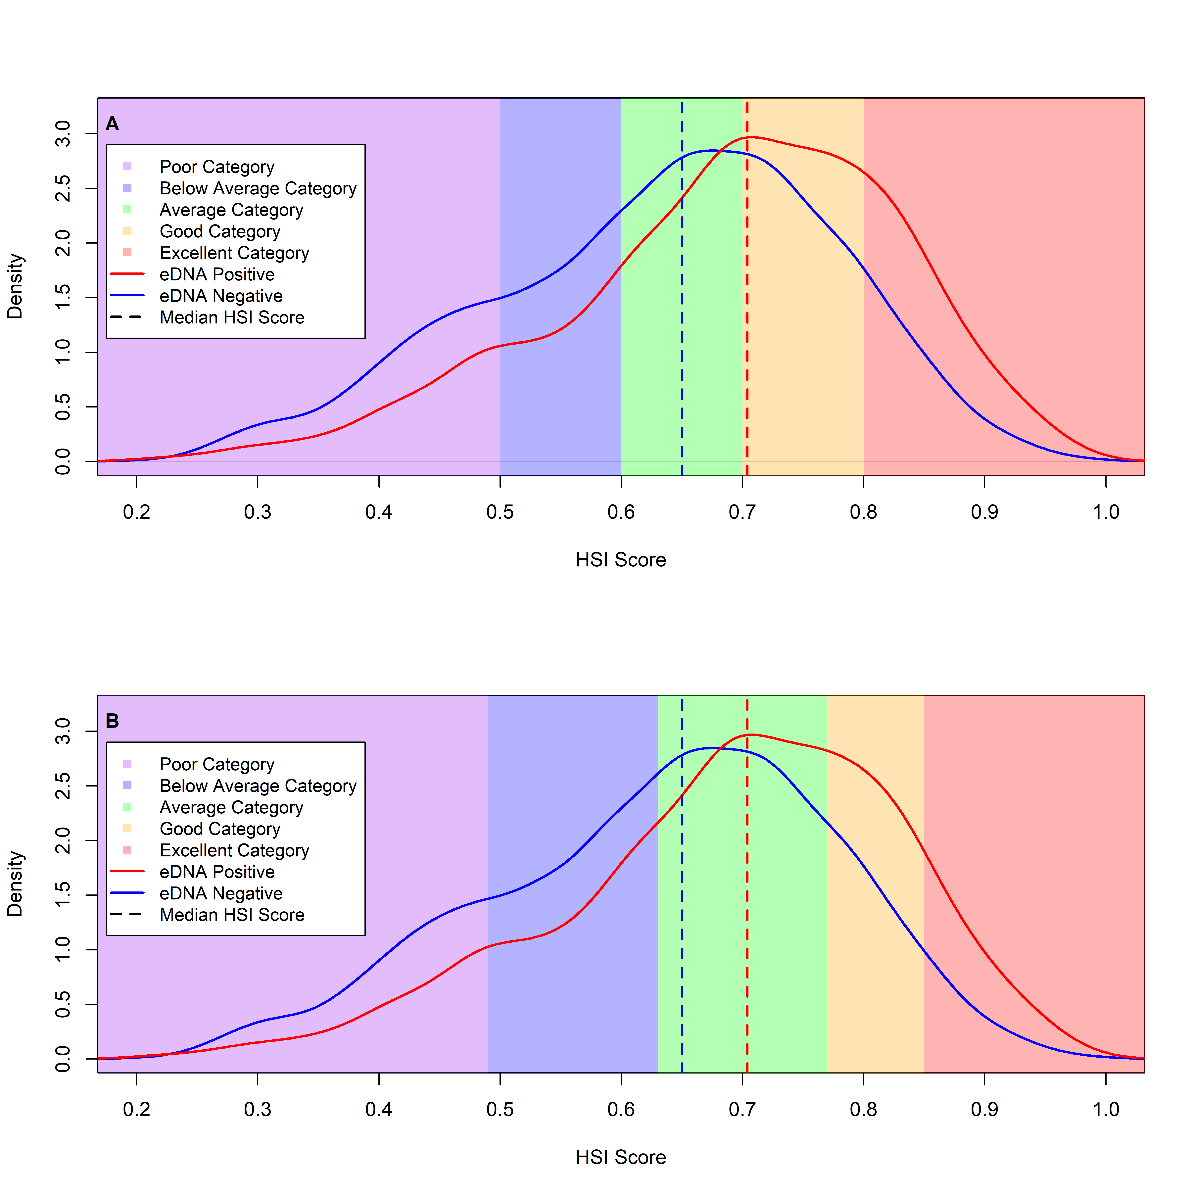
Figure 1 – HSI score sample density for ponds with confirmed occupancy (red), and no confirmed occupancy (blue), median HSI for each is indicated by a dashed line. A – Existing HSI scoring system (ARG UK, 2010); B – Revised HSI scoring system. In both cases the different categories are emphasised by background colour.

Category | HSI Score ranges | Observed category occupancy percentage | Percentage of all occupied ponds | Percentage of all unoccupied ponds
Existing categorisation (ARG UK, 2010)
Poor | <0.50 | 20.0 | 10.8 | 19.2
Below Average | 0.50<0.6 | 23.0 | 12.2 | 18.1
Average | 0.60<0.7 | 29.1 | 24.4 | 26.4
Good | 0.70<8 | 34.3 | 29.5 | 25.0
Excellent | >0.80 | 47.6 | 23.0 | 11.2
Proposed categorisation (this study)
Poor | <0.49 | 19.9 | 10.1 | 18.1
Below Average | 0.49<0.63 | 24.9 | 19.7 | 26.4
Average | 0.63<0.77 | 31.1 | 38.9 | 38.2
Good | 0.77<0.85 | 41.6 | 20.7 | 12.9
Excellent | >0.85 | 51.5 | 10.5 | 5.1

Table 1 – The observed (‘naïve’) occupancy rate, percentage of ponds within each category which are occupied and the percentage of all unoccupied ponds when the national eDNA data set was analysed both using the existing ARG UK (2010) categorisation bands and the revised categorisation bands proposed here. The estimated occupancies are based on 5138 ponds sampled using eDNA.

Acknowledgments and Data Accessibility
We would like to thank Natural England for making the data they collect freely available online. The raw data used in the model comparison case study was collected by Natural England and is available through the Natural England Open Data Portal https://naturalengland-defra.opendata.arcgis.com/datasets/ffba3805a4d9439c95351ef7f26ab33c_0/data. We would like to thank Dr Eleni Matechou from the School of Mathematics, Statistics and Actuarial Science at the University of Kent for advice with statistical terminology.

