Assessing the Impact of Enterprise and Entrepreneurship Education

Literature and Policy Project Report

Authors: Kelly Smith, David Bozward, Matthew Draycott, Mokuba Mave, Vic Curtis,
Chinthaka Aluthgama-Baduge, Rob Moon and Nigel Adams

July 2020

Executive Summary

The following report summarises the actions to date and future planned activity with respect to a systematic literature review and an investigation of policy-related data and documents relating to enterprise and entrepreneurship education (EntEd) activity in UK Higher Education institutions (HEIs).

The key findings are:

- There is a lack of information and context, necessary for educators to make informed decisions about what works (or not), provided in published papers. Research to date focusses on short-term impact relating to awareness, knowledge, and entrepreneurial intent.

- Analysis of Teaching Excellence Framework (TEF) submissions shows that the majority of institutions include EntEd-related activity in their submissions. Results narratives are more likely to highlight 'enterprise’ related activity at higher levels of TEF award and where it is a sustained and strategic part of the university’s educational offer.

- Research and impact work relating to enterprise, entrepreneurship, or entrepreneurial education can provide a meaningful contribution to Research Excellence Framework (REF) results and therefore research funding. It can also have a significant impact on the communities it serves.

- Returns to the Higher Education Business and Community Interaction (HE-BCI) survey show that the number of student and graduate new-start businesses per year was relatively constant for the four years analysed (2014/2015 to 2017/2018) at around 4,000 business each year with a mean average of 38.3 new-starts per returning institution in 2017/2018. Active companies reportedly employed an estimated mean average of 1.9 FTE employees, and had an average estimated turnover of £53,506.

- 3 of the 10 highest ranking institutions for new-start businesses in 2017/2018 were specialist art, music, dance, or drama institutions. This increased to 6 of the top 10 when a proxy for the proposed new Knowledge Excellence Framework (KEF) metric for student entrepreneurship was applied. The KEF proxy used here was the number of HE-BCI reported new-start businesses by an institution by its total student population recorded for the same year of data collection.

- The highest-ranking institution returned a number of new-starts to HE-BCI that equated to 12.7% of its total student FTE population in 2017/2018. Only 6 institutions (including the highest ranking) have a KEF proxy figure of over 2% of their total student FTE; 85 institutions report less than 0.5%.
The results of the systematic literature review and the TEF, REF, HE-BCI and KEF proxy analysis have been used to inform questions to be used in a Delphi study exploring impact measurement, and will be taking forward into conference and journal submissions as appropriate.

Contents Page

1. Systematic Literature Review 4
1.1 Action to date 4
1.2 How this information has been used 5
1.3 Next steps 5
2. Teaching Excellence Framework (TEF) Review 6
2.1 Action to date 6
2.2 How this information has been used 7
2.3 Next steps 7
3. Research Excellence Framework (REF) Review 8
3.1 Action to date 8
3.2 How this information has been used 9
3.3 Next steps 9
4. Higher Education Business & Community Interaction survey (HE-BCI) and the Knowledge Excellence Framework (KEF) Review 10
4.1 Action to date 10
4.2 How this information has been used 13
4.3 Next steps 13
5. Graduate Outcomes 14

Systematic Literature Review

  - Action to date

A systematic literature review was conducted based on the methodologies used in a previous review conducted by Nabi et al. (2017). This was done to ensure that the literature used to inform this research project was the most up to date possible.

In Stage 1, searches were conducted using recognised research databases (e.g. Science Direct, ProQuest, Social Science Citation Index) of literature published from 2016 onwards using the following combinations of search terms:

- Entrepreneurship Education + Impact/Effect/Influence + Higher Education/College/University.
- Enterprise Education + Impact/Effect/Influence + Higher Education/College/University.
- Entrepreneurial Education + Impact/Effect/Influence + Higher Education/College/ University.
- Entrepreneurial Education + Impact/Effect/Influence + Tertiary Education.
- Entrepreneurship Education + Impact /Effect/Influence + Outcome/Result/Consequence.

This resulted in identification of 322 outputs for further consideration in Stage 2 of the review.

In Stage 2, papers were selected based on the following criteria:

- Scholarly Peer Reviewed;
- English Language; and
- Published in an Academic Journal.

This resulted in 60 articles being passed onto Stage 3. Here, members of the project team divided the articles to be assessed amongst themselves. The results of this process were then discussed between the team and a decision on the inclusion of the article was made.

The Stage 3 review criteria was based on that used by Nabi et al. (2017). Articles were rejected if:

- It was a conceptual paper;
- There was insufficient information or context provided on the level and/or type of educational intervention provided;
- The article was based on student populations in general rather than exploring links to specific enterprise education initiatives;
- The article focussed on University-provided support of current entrepreneurs or community start-up training rather than on the student learning experience; or
- The article focussed on educators rather than the students themselves.

A final set of 18 papers were selected for review. They were assessed by the project team using two criteria set out in Nabi et al. (2017): the nature of entrepreneurship education pedagogical methods, and operational level impact indicators (see Figure 1 overleaf).

The review of recent literature found similar findings to that of Nabi et at. (2017) in that there is still a lack of information and context provided in published papers. Given that this information is necessary for educators to make informed decisions about what works (or not) or, to apply learning to their own practice, this can be seen as an important issue which needs to be addressed.

Furthermore, the majority of the published papers only explored impact at Levels 1 or 2 and tended to focus on entrepreneurial intent. Only two of the papers looked at Level 3 impact or above (one at Level 3 and one at Level 5). These two papers looked at students who attended entrepreneurial universities or who may have participated in multiple entrepreneurial education opportunities; it is therefore only possible to draw general conclusions about impact, rather than being able to drill down into the effects of specific educational practice. This also echoes findings by Nabi et al. (2017) and serves to further illustrate the work required to address this challenge.
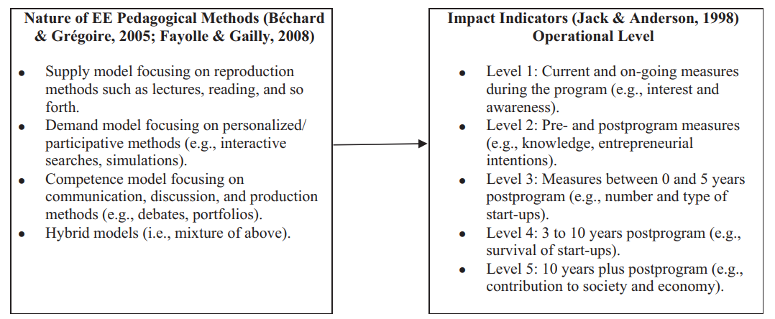

Figure 1: The integrated teaching model framework encompassing entrepreneurship impact and underpinning pedagogy presented in Nabi et al. (2017)

  - How this information has been used

The results of the literature review have been used to develop questions to be used in the Delphi study. This include questions on the importance (or not) of measuring impact, what types of impact measurements are or could be useful, how educators currently measure impact, and how are the results of impact evaluation currently used.

  - Next steps

- The results of the literature review will be used for journal article submission(s) that emerge from the study; and
- References for the 18 new articles found will be made available to EEUK if this is deemed useful to EEUK members.

Teaching Excellence Framework (TEF) Review

An analysis of TEF submission and panel reports is being conducted to explore if and how enterprise and entrepreneurship education is promoted as a positive aspect of an institution’s educational offer, and if active engagement with entrepreneurial education leads to a higher TEF rating. Although TEF is not currently directly linked to institutional funding (other than those having a TEF award of any level being able to charge slightly higher tuition fees), higher levels of TEF awards are used in marketing of programmes and courses and may have an impact on student recruitment. TEF may therefore indirectly affect income generation.

  - Action to date

The TEF submission documents and results narratives (made available by the Office of Students) for 128 universities were reviewed for mentions of the words ‘enterprise’, ‘entrepreneurship’, and ‘entrepreneurial’. Initial results are presented in Tables 1 and 2 (overleaf). Table 1 shows that ‘enterprise’ was mentioned by a large majority (83%) of universities in their submissions. The words ‘entrepreneurship’ and ‘entrepreneurial’ were used by around half of universities (50.0% and 45.0% respectively). Reviews of the submissions suggests that use of these words range from very broad and general (e.g. mention of being an entrepreneurial university) through to detailed descriptions of in- or extra- curricular activities.

Table 1: Percentage numbers of University submissions using enterprise-related words

 | Number / Percentage | Enterprise | Entrepreneurship | Entrepreneurial | Total  Awarded
Gold | N | 28 | 22 | 22 | 47
 | % | 80.9 | 46.8 | 46.8 | 36.7
Silver | N | 57 | 34 | 1 | 67
 | % | 85.1 | 50.7 | 41.8 | 52.4
Bronze | N | 11 | 8 | 7 | 14
 | % | 78.6 | 57.1 | 50.0 | 10.9
Total | N | 106 | 64 | 57 | 128
 | % | 83.0 | 50.0 | 45.0 | 100.0

Table 2: Percentage numbers of results narratives using enterprise-related words

 | Number / Percentage | Enterprise | Entrepreneurship | Entrepreneurial | Total  Awarded
Gold | N | 6 | 3 | 0 | 47
 | % | 12.8 | 6.4 | 0 | 36.7
Silver | N | 3 | 3 | 1 | 67
 | % | 4.5 | 4.5 | 1.5 | 52.4
Bronze | N | 0 | 1 | 0 | 14
 | % | 0 | 7.1 | 0 | 10.9
Total | N | 9 | 10 | 1 | 128
 | % | 7.0 | 5.5 | 0.8 | 100.0

Results narratives used fewer enterprise-related words than university submissions (see Table 2) with ‘enterprise’ appearing more often than ‘entrepreneurship’ at higher levels of award.

Initial analysis suggests that use of the words in results narratives reflects the detail and ‘embeddedness’ of the activity described in the university submissions. Mention of enterprise-related activity only appears to be made by reviewers where there is strong evidence that this is a sustained and strategic part the university’s education activity. This provides early-stage evidence for the hypothesis that active engagement and explicit articulation of enterprise-related work has an impact in terms of level of TEF award gained. Further analysis is needed to confirm and elaborate.

  - How this information has been used

The initial results have been used to inform a question in the Delphi study about how the results of impact evaluation is currently used, for example, to report to Senior Managers (who might be in a position to influence future TEF submissions).

  - Next steps

- A further, more in-depth, analysis is currently being conducted;
- TEF enterprise-related results will be cross-referenced against Small Business Charter status as the latter award has a strong enterprise and entrepreneurship education focus; and
- The results of the analysis will be used for journal article submission(s) that emerge from the study.

Research Excellence Framework (REF) Review

The REF is intended to meet the UK funding councils’ policy aim to ‘secure the continuation of a world-class, dynamic and responsive research base across the full academic spectrum within UK higher education’. According to REF2021 information, the REF outcomes are used to calculate about £2 billion per year of public funding for universities’ research, and affect their international reputations. REF results therefore directly affect research funding income. The REF2014 exercise included an assessment of the impact of research which contributed 20% cent of the overall quality profile; research outputs contributed 65% (this will change to 25% and 60% respectively for REF2021).

Research impact was assessed via submission of impact case studies with the number of case studies that a unit of assessment was required to submit linked to the number of FTE staff that were submitted. Impact for each unit of assessment (no score is provided for individual impact case studies) was assessed by a REF panel using the following criteria:

Table 3: REF2014 impact ratings

Four star | Outstanding impacts in terms of their reach and significance.
Three star | Very considerable impacts in terms of their reach and significance.
Two star | Considerable impacts in terms of their reach and significance.
One star | Recognised but modest impacts in terms of their reach and significance

Submission of research outputs (academic papers) and impact case studies is carefully considered by institutions and reflects the importance that work in a particular research area is given by each institution. The star rating that the REF panels give outputs and impact represents the value of research work to national and international communities.

  - Action to date

Searches were conducted for REF2014 output and impact case study submissions using the following search criteria:

- Enterprise education;
- Entrepreneurship education;
- Entrepreneurial education;
- Business start-up; and
- Entrepreneurship support.

The searches returned 3 impact case studies and 15 outputs submitted to REF2014 related to education search terms, and 1 impact case study and 2 outputs related to business start-up. 4 institutions submitted relevant impact case studies, 11 submitted outputs. All of the impact case studies and the majority of the outputs were submitted to the Business and Management Studies unit of assessment (19). 2 outputs were submitted to Education (25) and 1 output to Music, Drama, Dance, and the Performing Arts (35).

The impact rating for the 4 institutions submitting relevant impact case studies were explored. A separate impact rating was not provided for 1 of the 4 institutions due to low numbers of FTE returned. The impact case study for 2 of the institutions was rated at least 3* (very considerable or outstanding); 1 was rated at least 2* (considerable, very considerable or outstanding). This shows that research and impact work relating to enterprise, entrepreneurship, or entrepreneurial education can provide a meaningful contribution to REF results and therefore research funding. It can also have a significant impact on the communities it serves.

  - How this information has been used

The initial results have been used to inform a question in the Delphi study about how the results of impact evaluation is currently used, for example, for research purposes.

  - Next steps

- The results of the analysis will be used for journal article submission(s) that emerge from the study.

Higher Education Business & Community Interaction survey (HE-BCI) and the Knowledge Excellence Framework (KEF) Review

UK HEIs collect graduate start-up data through routinely collected data surveys such as Higher Education Business & Community Interaction survey (HE-BCI). It should be noted that some HEIs which are known to actively support student or graduate business start-up do not currently submit HE-BCI data.

University-led submission of verified data relating to graduate spin-outs (start-ups) is returned annually.

The following data is requested:

- Number of new start-ups created;
- Number of start-ups still active which have survived at least 3 years;
- Number of active firms;
- Estimated current employment (FTE);
- Estimated current turnover; and
- Estimated external investment.

Graduate spin-out data from HE-BCI is not currently included in the Higher Education Innovation Fund funding formula, unlike other items of the HE-BCI return. However, the recently launched KEF will use the HE-BCI reported graduate start-ups rate by student FTE and it was announced in January that full participation in the KEF is likely to become a condition of Research England funding from the academic year 2020/21. This may make graduate start-up activity and submission of related outcomes more of a priority for HEIs in the future.

The metric to be used in the KEF is likely to be a ratio of the number of new start-ups created by the student FTE for the institution.

  - Action to date

HE-BCI submissions for 2014/2015 to 2017/2018 and the associated number of student FTEs were obtained from HESA.

It is not clear from the published KEF information which year of student FTE will be used in relation to which HE-BCI return year, and whether all students or a sub-set of specific student groups will be included in the student FTE figure. It is important to note that HE-BCI relates to both undergraduate students and graduates (who have been activity supported by an institution) whereas student FTE relates to enrolled students only. The total student FTE includes non-EU international students who are not able to start up a business whilst a student due to visa restrictions; non-EU international graduates can apply for a visa to start-up a business with university support, however. The student FTE (total studying at all levels and fee status) for the year of the HE-BCI return has been used as a proxy here (i.e. the 2017/2018 HE-BCI return will be matched with the 2017/2018 total student FTE numbers).

Table 4 (overleaf) gives the reported levels of activity for the six HE-BCI items related to student and graduate entrepreneurship. The number of institutions making a return for each of the items is given in Table 5 (overleaf). Of the 167 institutions in 2017/2018, 108 returned a number of new starts whereas only 66 reported an estimate of external investment. Table 6 (overleaf) presents the mean, median, and range statistics for each item in 2017/218.

It can be seen from Table 4 that the number of new-starts per year has been relatively constant for the four years presented at around 4,000 business each year. This equates to a mean average of 38.3 new starts per returning institution in 2017/2018. Active companies reportedly employed an estimated average of 1.9 FTE employees, and had an average estimated turnover of £53,506.

Table 4: HE-BCI graduate spin-out returns and student FTE from 2014/2015 to 2017/2018

 | 2014/2015 | 2015/2016 | 2016/2017 | 2017/2018 | Total
New starts (N) | 4,124 | 3,905 | 4,149 | 4,024 | 16,202
3-year survival (N) | 4,474 | 5,421 | 5,810 | 6,181 | 21,886
Active (N) | 10,978 | 11,397 | 12,367 | 13,314 | 48,056
Employment (FTE) | 20,886 | 22,892 | 22,983 | 24,466 | 91,227
Turnover (000s) | 574,082 | 616,732 | 629,790 | 750,752 | 2,571,282
Investment (000s) | 302,791 | 146,252 | 182,288 | 164,027 | 795,358
Student FTE | 1,854,610 | 1,886,855 | 1,933,875 | 1,974,575 | 7,649,915

Table 5: Number of institutions making a return for each HE-BCI graduate spin-out item

 | 2014/2015 | 2015/2016 | 2016/2017 | 2017/2018
New starts (N) | 109 | 109 | 105 | 108
3-year survival (N) | 89 | 91 | 96 | 99
Active (N) | 107 | 107 | 109 | 110
Employment (FTE) | 94 | 95 | 95 | 99
Turnover (000s) | 89 | 91 | 90 | 91
Investment (000s) | 59 | 62 | 59 | 66
Total number of institutions | 165 | 166 | 167 | 167

Table 6: Mean, median, and range statistics (by institution) for each HE-BCI graduate spin-out item for 2017/2018
 | New starts  (N) | 3-year survival  (N) | Active  (N) | Employment  (FTE) | Turnover (000s) | Investment (000s)
Mean | 38.3 | 64.4 | 124.4 | 254.9 | 8,531 | 2,604
Minimum | 1 | 1 | 1 | 1 | 3 | 3
Quartile 1 | 8 | 11.3 | 21 | 30 | 518 | 45
Median | 23 | 31.5 | 69 | 133.5 | 2,986 | 205
Quartile 3 | 43 | 78 | 162 | 348 | 11,430 | 2,627
Maximum | 250 | 625 | 972 | 2,156 | 81,448 | 38,689

Figure 2 (overleaf) shows the number of new-starts reported in 2017/2018 by 108 institutions, ranked from the highest number of returns to the lowest number. This shows that a relatively small number of institutions were responsible for the majority of the returns with 10 institutions reporting between 100 and 250 new-starts each, 9 institutions returned between 50 and 100 new starts, and the remaining 86 institutions reported fewer than 50 new starts each. 3 of the 10 highest ranking institutions were specialist art, music, dance, or drama institutions.

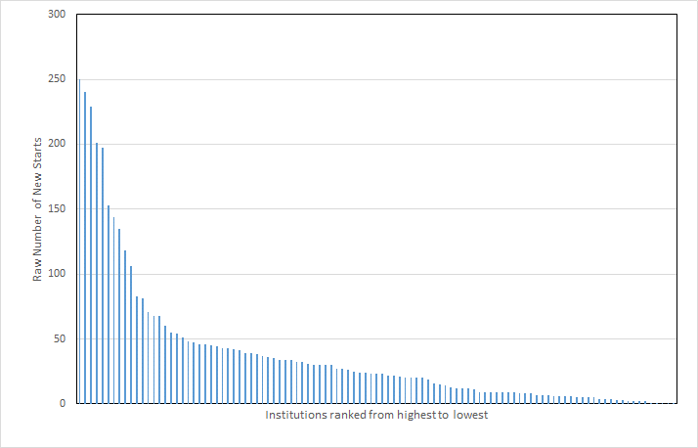

Figure 2: Number of new-starts reported in 2017/2018 by 108 institutions, ranked from the highest number of returns to the lowest

Figure 3 presents the number of new starts reported for each institution in 2017/2018 by the total number of students for that institution reported in the same year. The ratio is shown as a percentage and is used here as a proxy for the KEF matric relating to student entrepreneurship.

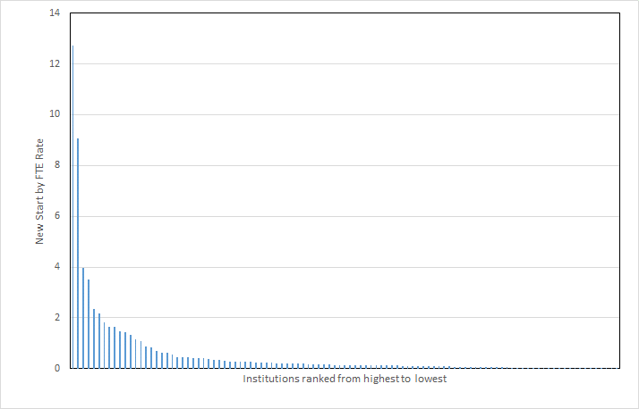

Figure 3: Percentage number of new-starts by total FTE reported in 2017/2018 by 108 institution, ranked from the highest percentage of returns to the lowest.

Figure 3 shows that the highest-ranking institution returned a number of new-starts to HE-BCI that equated to 12.7% of its total student FTE population in 2017/2018. Only 6 institutions (including the highest ranking) have a KEF proxy figure of over 2% of their total student FTE; 85 institutions report less than 0.5%. 6 of the 10 highest ranking institutions were specialist art, music, dance, or drama institutions with the KEF proxy used here compared with 3 using the raw HE-BCI new-start numbers. It is important to note the high levels of graduate spin-outs related to the creative industries as the impact on these subjects to the economy can be overlooked from graduate salary information collected by through the Longitudinal Education Outcomes data which does not adequately reflect graduate income from self-employment and business ownership.,

  - How this information has been used

The initial results have been used to inform questions in the Delphi study relating to how the results of impact evaluation are currently used and why measuring impact might be useful.

  - Next steps

- The analysis above was carried out before the HE-BCI data for 2018/2019 were released;
- 2018/2019 data will be included in subsequent analysis;
- The results of the analyses will be used for journal article submission(s) that emerge from the study; and
- The analysis reported here could potentially be used by EEUK in discussions with HESA and others in relation to reviews of HE-BCI and the KEF.

Graduate Outcomes

Early results of the national Graduate Outcomes survey were released in June. Communications with HESA suggest that there are plans to release further data specific to self-employment and business start-up activity 18 months after graduation. We will monitor for further data releases and look to explore this when available.

Nabi, G., Liñan, F., Fayolle, A., Krueger, N., and Whalmsley, A. (2017), ‘The Impact of Entrepreneurship Education in Higher Education: A Systematic Review and Research Agenda’, Academy of Management Learning & Education, 16 (2), 277–299.
https://www.qs.com/what-do-prospective-students-think-about-the-teaching-excellence-framework/
https://www.officeforstudents.org.uk/advice-and-guidance/teaching/tef-outcomes/#/tefoutcomes/
https://www.ref.ac.uk/about/what-is-the-ref/
https://www.ref.ac.uk/about/guide-for-research-users/
https://www.ref.ac.uk/2014/media/ref/content/pub/REF%2001%202014%20-%20full%20document.pdf
https://www.ref.ac.uk/media/1092/ref-2019_01-guidance-on-submissions.pdf
https://www.ref.ac.uk/2014/panels/assessmentcriteriaandleveldefinitions/
https://results.ref.ac.uk/(S(d5zybn1idwqziwkvrx304xtg))/Search
https://re.ukri.org/documents/2019/knowledge-exchange-framework-decisions-16-jan-2020/
https://www.hesa.ac.uk/data-and-analysis/business-community/ip-and-startups
https://www.hesa.ac.uk/data-and-analysis/students/table-2
https://assets.publishing.service.gov.uk/government/uploads/system/uploads/attachment_data/file/669747/SFR76_2017_Sel fEmployment_earnings.pdf
https://www.universitiesuk.ac.uk/our-work-in-parliament/Documents/Universities%20UK%20parliamentary%20briefing%20-%20uses%20and%20limits%20of%20LEO%20data.pdf
https://www.hesa.ac.uk/data-and-analysis/graduates

