Land Use Policy

Using scenario-based influence mapping to examine farmers’ biosecurity behaviour

Damian Maye¹*, Gareth Enticott² and Rhiannon Naylor³

¹ Countryside and Community Research Institute, University of Gloucestershire,

Oxstalls Lane, Longlevens, Gloucester, GL2 9HW, UK (dmaye@glos.ac.uk)

² Cardiff School of Planning and Geography, Cardiff University (EnticottG@cardiff.ac.uk)

³ Royal Agricultural University, Cirencester (rhiannon.naylor@rau.ac.uk)

* Corresponding author. Tel.: +44-1242-714133; Fax: +44-1242-714395.

Accepted for publication in Land Use Policy: 13.04.2017

Using scenario-based influence mapping to examine farmers’ biosecurity behaviour

Abstract

Understanding of farmers’ influences relating to biosecurity is surprisingly weak, beyond general remarks that farmers tend to trust their private vet. Previous studies have explored influences in relation to single issue events. There is a need for better methodologies to fully appreciate how farmers’ biosecurity practices are shaped. Using bovine Tuberculosis as a case study, this paper uses stakeholder mapping methods applied across different scenarios. The aim is to identify how farmers’ responses to animal disease policy are shaped by their relationships with different actors. Interviews were conducted with 50 farmers in three areas in England. Farmers were presented with four scenarios to control bovine TB: 1) a badger cull, 2) an oral badger vaccine, 3) a cattle vaccine and 4) a range of control measures. The results show that as things get more uncertain, government institutions become more influential. Government institutions and government vets are also important in situations where farmers do not consider themselves ‘experts’ i.e. vaccination as opposed to culling. The influence of other farmers was not universal; it differed between scenarios. These data show the value of scenario-based stakeholder mapping as a methodology that can enable biosecurity researchers to: more accurately and systematically determine stakeholder influence and understand how these influences change and evolve; understand the role of farmer biosecurity practices, the self-concept and ‘good farming’; and identify broader logics of biosecurity that influence and potentially frustrate animal disease policy goals.

Keywords: Farmer behaviour, social norms and influence; Good farming; Stakeholder analysis; Scenario-based influence mapping; Bovine Tuberculosis; England.

1. Introduction

It is increasingly accepted that understanding animal disease transmission requires not just epidemiological science, but social science approaches that allow the attitudes and practices of people to be taken into account. There is a now well-established social science biosecurity literature (for reviews see Bingham et al. 2008, Dobson et al. 2013, Reed and Curzon 2015, Hinchliffe et al. 2016) that includes analysis of international, national and sub-national biosecurity governance frameworks (e.g. Barker 2010, Maye et al. 2012, Higgins et al. 2016) and local analysis of biosecurity techniques among stakeholder groups/populations, including ‘configurations of practices’ on farms (e.g. Enticott 2008, Hinchliffe and Ward 2014, Naylor et al. 2017). Local and global disease events such as Foot and Mouth, bovine Tuberculosis (bTB) and Avian Influenza have promoted a concern and emphasis within biosecurity studies to understand the behaviour of farmers, vets and other stakeholders. In other policy areas, studies of farmer behaviour have typically relied upon behavioural frameworks such as the Theory of Reasoned Action (TORA) and the Theory of Planned Behaviour (TPB). These approaches have been widely used in agricultural and environmental contexts, suggesting that farmers’ behaviour is shaped by subjective norms – the influence of others upon social norms of behaviour, usually pointing to farmers’ reliance on “dialogue with other farmers for ideas and information, as well as professional advisers, agricultural newspapers and magazines” (Garforth 2015, p.31).

Biosecurity studies have sought to identify the levels of interest and influence amongst different stakeholders as a means of optimising disease prevention communication. These studies have drawn on farmer behaviour studies and consequently theoretical approaches applied to examine stakeholder influence and its relationship with farmer biosecurity practices have tended to be dominated by behavioural and psychological frameworks (TORA/TPB) (Gunn et al. 2008). Whilst the theoretical frameworks used in these psychological studies can offer a way of understanding biosecurity behaviour, Burton (2004a) and Fielding et al (2008) have suggested that caution is required in interpreting their results. They point to failures of inadequately specifying and measuring the full range of stakeholders and their relative importance in different contexts. In short, for different diseases, a different range of actors may be more or less influential than others. Without identifying the most appropriate stakeholders for each policy field, generic measures will dilute the influence of the most appropriate. Methods are required that can both identify and assess the level of influence of each actor. As Reed and Curzon (2015, p.15) note, “…attempts to systematically identify, categorise or analyse stakeholders in this field are relatively rare”.

This paper argues that scenario-based influence mapping is a useful methodological approach that provides a systematic approach for researchers to identify and tease out the different social influences on farmers’ biosecurity practices and behaviours in specific governance contexts. Scenario-based influence mapping contributes to and builds on recent social science approaches that have been developed to address the limitations of behavioural frameworks and psychological approaches. This work gives greater emphasis to social, cultural and institutional influences, using theories of social capital (Fisher 2013), trust and risk (Enticott et al. 2014), lay and situated knowledges (Hinchliffe and Ward 2014, Maye et al. 2014) and institutional logics (Higgins et al. 2016). The aim here is to extend this work by identifying how farmers’ responses to animal disease policy are shaped by their relationships with different actors. Other studies have explored these influences in relation to single issue events (e.g. studies of specific disease events, such as Foot and Mouth outbreaks). In this paper we use stakeholder mapping methods developed by Oreszczyn et al. (2010) across a range of different scenarios. The scenarios all relate to potential solutions to address bovine Tuberculosis (bTB) in England and reflect not just different technical solutions, but also different solutions to the governance of animal disease. This contributes to an understanding of how farmers are encountering and reacting to the changing governance of animal disease in the United Kingdom (Enticott et al. 2011, Maye et al. 2014). It also helps to account for social and cultural influences related to the self-concept and ‘good farming’ (Burton 2004a/b, Naylor et al. 2017) and connects the biosecurity literature more explicitly with theories of social learning and ‘webs of influence’ (Oreszczyn et al. 2010).
The rest of the paper is structured as follows. First, the importance of appropriate stakeholder mapping exercises in agricultural and disease control research is reviewed. Second, the case context of the study – bTB and its changing governance – is introduced. Third, methods and scenarios are explained, including the design of influence maps, before presenting results. Finally, we discuss the benefits of the stakeholder mapping approach developed in the paper as a means to understand webs of influence (Oreszczyn et al. (2010). This includes reflections on how conversations with farmers related to the influence maps could be used to deepen analysis of biosecurity logics that can help explain resistance to biosecurity policies (Higgins et al. 2016).

2. Biosecurity stakeholders, webs of influence and significant others
There has been increasing interest in animal disease in the social sciences (Fish et al. 2011, Dobson et al. 2013, Hinchliffe et al. 2016). Partly, this has been driven by the global and spectacular nature of diseases such as Foot and Mouth and Avian Influenza. The spread of animal disease, though, can also be seen as a symptom of climate change, contributing to the challenge of food security (Godfray et al. 2010, Maye and Kirwan 2013) captured within the ‘one-health’ agenda (AVMA 2008). Whilst these concerns have prompted technological efforts to reduce the impact of animal disease (such as the development of new vaccines), they have also been accompanied by attempts to change farmers’ behaviour and develop forms of social resilience in agricultural communities. In doing so, Governments have sought to identify and analyse the key drivers for animal disease behaviour amongst farmers, vets and other agricultural professionals, in order to identify the best possible means to communicate with and influence their behaviour.

This kind of research is not unfamiliar to land-use and agricultural scholars. Numerous studies exist, for example, that seek to understand farmers’ behaviour in relation to their participation in environmental schemes (Morris and Potter 1995), the delivery of ecosystems services (Wynne-Jones 2013), conservation practices (Beedell and Rehman 2000, Pannell et al. 2006), farmers’ responses to climate change (Fleming and Vanclay 2010, Hyland et al. 2016), soil management (Ingram 2008), and the adoption of new agricultural technologies (Garforth et al. 2006, Higgins 2007). Many of these studies rest on the assumption that identifying how farmers behave, and the influence of their social networks, can help ensure that new policies and practices can be more effectively communicated to them, thereby ensuring greater policy efficiency. Such a belief is also attractive to policy makers in the field of animal disease, such that recent studies of farmers’ animal health practices are justified on these grounds. For example, Garforth (2015, p.30) argues that this kind of research “can help in the design of appropriate, targeted communication, and of effective policies and regulatory frameworks”. In relation to biosecurity, Alarcon et al. (2014, p.224) argue that “effective communication of relevant disease-related knowledge is essential to facilitate farmers’ decisions on disease control and, thereby to help them minimize the impact of diseases”. Similarly, Hernández-Jover et al. (2012, p.262) suggest that “understanding stakeholders’ interest and influence on the issue can assist in the development of risk management and communication strategies identifying those most likely to be in a position to influence the actions of the target group”.

Where studies are based on a risk communication rationale, they have frequently relied on psychological models of human behaviour such as TORA or TPB (Ajzen 1991, Fishbein and Ajzen 2010). These models provide an explanation of how attitudes link to behavioural intentions through the incorporation of subjective norms – the extent to which an individual believes significant others believe that they should engage in a behaviour. Perceived behavioural control is also included in the TPB to account for the extent to which people believe they can do something about the challenges (such as disease outbreaks) they face.

Although these approaches have been widely used in agricultural studies (Carr and Tait 1990), Burton (2004a) argues that many are flawed through incorrect application. Firstly, he suggests that many studies fail to take into account the influence of significant others on decision making by conflating subjective norms with attitudes, such that resulting explanations are divorced from the social context in which farmers’ make decisions. For example, Benjamin et al. (2010) examine farmers’ attitudes to cattle disease but make no mention of subjective norms. Alternatively, studies often measure the influence of people within farmers’ ‘information environments’ to account for subjective norms. However, Terry et al. (1999) argue that these can only be considered subjective norms when they are behaviour specific and follow the ‘principle of compatibility’ – i.e. they are specific to the situation being researched. As noted by Fielding et al. (2008) and Terry and Hogg (1996), aggregating impressions of people who are more or less important runs the risk of diluting the significance of those people who are relevant to that behaviour. Burton (2004a) also points to the importance of differentiating between social norms and subjective norms, or the difference between those behaviours approved of by others, and the perceived evaluations of those behaviours.

One reason for the failure to produce data “capable of producing a broad enough picture of farmer motivation” (Burton 2004a, p.365) is the time and funding such research demands. As Gilmour et al. (2011) show, accounting for all the potential sources of subjective norm can be a lengthy process, when done properly, leading to a lengthy questionnaire (Burton 2004a). As a result, biosecurity researchers may simply reduce the various sources of influence to a ‘core-set’ to make research more practical (see for example, Toma et al. 2013). Alternatively, the TPB may simply be used as a qualitative interview guide rather than as a tool for quantitative assessment. For example, Alarcon et al. (2014) use the TPB framework to investigate pig producers biosecurity practices, identifying vets and other farmers as the key sources of influence upon their disease management practices (see also Gunn et al. 2008, Ellis-Iversen et al. 2010). Similarly, Garforth et al. (2013) examine pig and sheep farmers’ practices using a qualitative application of the TPB, finding that neighbouring farmers ‘hardly figure’ as a source of influence.

For Burton (2004a), these findings appear unlikely, and provide a further criticism of attempts to model farmers’ behaviour using TORA/TPB. That farmers’ behaviour is not influenced by other farmers contradicts research that shows farming to be conservative in nature and ‘heavily imbued with status symbols’ used to create notions of ‘good farming’ and the ‘good farmer’ that can play important roles in guiding and shaping farmer behaviour (Burgess et al. 2000, Oreszczyn and Lane 2000, Egoz et al. 2001, Burton 2004b). Apart from subjective norms, other social and cultural influences such as the ‘self-concept’ or self-identity factors (Stryker 1994) are also likely to influence behaviour. Incorporating quantitative measures of self-identify into the TPB, Fielding et al.’s (2008) study of riparian zone management practices also shows that these factors are significantly related to farmers’ behavioural intention. In the context of biosecurity, qualitative research by Naylor et al. (2017) shows how different ideas of farming self-identity influence decisions farmers take over exotic disease, such as reporting and prevention.

The outcome from this is that research into farmers’ biosecurity behaviours needs to take more seriously subjective norms – whether part of a framework like TPB or not – to fully understand biosecurity behaviour, and if so required, design effective communication strategies. To date that does not appear to have happened: subjective norms are either ignored, conflated with attitudes, reduced to broad groups, and/or do not follow the principle of compatibility. Moreover, whilst interviews and focus groups are recommended as a way of developing a list of normative influences (Ajzen 2002), it is frequently unclear how researchers have conducted this task. Despite calls for participatory approaches to epidemiology and biosecurity (see Catley et al. 2012), new methodological tools for identifying relevant stakeholders have not been developed. Instead, studies have tended to rely on traditional methods of interviews, focus groups and researcher verification (Hernández-Jover et al. 2012).

One way of addressing these gaps is by using one of the various established methods of stakeholder analysis. Reed and Curzon (2015) identify a range of different stakeholder identification methods. Stakeholder identification can occur ex-ante, through consultation of official documents, or ad hoc in which the list of stakeholders is developed through an iterative consultative process. One exception is research by Gilmour et al. (2011) who describe how a biosecurity stakeholder map was developed through separate rounds of consultation, although it is unclear how stakeholders were selected. Stakeholder mapping can also be used to identify the different people that farmers consult, and gauge their level of influence, often according to pre-existing categories based on their level of interest and influence (Mills et al. 2011). Whilst these methods are useful for policy analysis, Oreszczyn et al. (2010) draw on methods of cognitive mapping to analyse farmers’ networks of influence in the context of genetically modified crops. Their approach relied on a method of interactive and discursive mapping in interviews. Farmers were asked to write down potential influencers on post-it notes and place them on concentric circles representing their perceived level of influence. The process was iterative, in that the initial map could be changed following discussion between the researcher and participant about the location in which they had placed each influencer and why they had placed them there.

Interestingly, the results presented by Oreszczyn et al. (2010) are ambiguous when it comes to assessing the influence of other farmers, questioning the significance of the self-concept. On the one hand, Oreszczyn et al. (2010) find that farmers lack a ‘strong formal organisational framework’ and operate as a ‘distributed network of practice’ in which ideas and advice are sought and given from a wide range of actors. In dealing with this complex social learning system, farmers relied on experiential learning, and interacted with fellow farmers in their ‘network of practice’. However, they did not feel that they learned directly from these interactions, such as with farming neighbours or taking part in farmers’ discussion groups. Instead, a wider ‘web of influencers’ – people and organisations who are not farmers – emerged that directly influenced farmers’ practices and decision-making. Whilst these were relatively stable, they could change over time, particularly following changes to the politics of agricultural governance such as the reduction in government agencies providing extension services to farmers in the UK e.g. ADAS.

These studies question the significance of other farmers as influencers and the influence of self-identity. This is a surprising finding but it could also be that questions lack focus – i.e. they fail the principle of compatibility. This is an ever-present problem in biosecurity research in which the broad meaning of biosecurity or disease underplays the contested meanings of biosecurity and how farmers can respond to different disease threats in different ways (Naylor et al. 2017). Alternatively, Burton (2004a) suggests that farmers’ strong sense of ‘independence’ may mean they are unwilling to admit that they are under the strong social influence of their peers. Factors relating to self-identity may also be expressed in other ways. As Fielding et al. (2008) point out, identity factors may be expressed in relation to the extent to which situations are judged to be between one of ‘us’ and ‘them’, and the extent to which an out-group’s power and status is judged to be legitimate. Where this is the case, strategies of non-compliance will follow.

Expressions of self-identity can be found in resistance towards biosecurity and other areas of agricultural and land use policy. Fielding et al. (2008), for example, measured aspects of intergroup identity based on distinctions between rural and urban society and the legitimacy of rule makers, finding a relationship between identity and behaviour. Biosecurity research frequently finds that resistance to animal disease policy and new biosecurity rules are based in perceived beliefs of illegitimate power. Frequently, these are based on the legitimacy of different kinds of ‘expertise’ (Maye et al. 2014) and ‘trust’ (Enticott et al. 2014) conceptualised through a rural versus urban distinction (Enticott 2008). Similarly, Higgins et al.’s (2016) analysis of biosecurity governance in Australia, involving government and industry stakeholders, identifies three institutional logics (neoliberal, productivist and agrarian) that provide roles and codes of conduct. The agarian logic draws on Aitken’s (1985) idea of ‘countrymindedness’ through which Higgins et al. (2016, p. 1144) show how resistance to biosecurity rules reflect a “contrast between the artificiality of city life, where political power resides, and the authentic as well as ennobling virtues of farming and rural living”. Importantly, Higgins et al. suggest that new forms of biosecurity governance are likely to deepen the differences between this logic of biosecurity, and the neoliberal logic which sees producers as owners and implementers of biosecurity policy. Indeed, the tensions between these different logics are likely to be exacerbated by the development of new forms of animal disease governance that seek to redistribute costs and responsibilities to farmers, further reflecting the belief that governments are “disconnected from the “realities” of rural life, making it even more difficult for governments to engage producers in taking more responsibility for biosecurity” (Higgins et al. 2016, p. 1147).

This section has identified some major limitations in the biosecurity literature in terms of strategies to systematically identify the different influences on farmers’ biosecurity practices. This critique can be summarised as follows. Firstly, theoretical models of farmer behaviour suggest the importance of subjective norms. However, in relation to biosecurity, and more specifically the identification of different influences on farmers’ biosecurity practices, analysis of extant studies suggests the full range of actors is not always considered. There is also a failure to specify the relative importance of actors in different contexts. Methodologies are available to more fully identify relevant actors and avoid aggregating different social groups. Secondly, there is ambiguity over the role of other farmers in influencing farmers’ decisions. This may be related to the principle of compatibility in which vague notions – such as ‘biosecurity’ – conflate a range of different actions each with their own specific influences. Analysing a range of separate and specific activities can help to resolve these problems. Thirdly, analysis of the full range of actors may also reveal different expressions of the self-concept, particularly in relation to the governance of biosecurity. This is missing in current behavioural and social science studies of farmers’ biosecurity practices. As new forms of biosecurity governance develop, it is important to understand how farmers’ identities mesh with or jar against these new ways of controlling disease. Common to all strands of this critique is the need for better methodologies to fully appreciate how farmers’ biosecurity practices are shaped. The following section sets out a methodology that allows these problems to be explored more fully.

3. Methodology
In seeking to explore farmers’ biosecurity behaviour, we propose the use of scenario-based influence mapping as a methodology. This approach provides a systematic method to identify webs of influence. The social science biosecurity literature regularly recognises the significance of wider influences through related discussions about ‘trust’, ‘expertise’, ‘local knowledge’, ‘credibility’, etc. However, a more systematic approach is needed. The scenario-based influence mapping methodology set out here provides a way to more accurately determine and identify stakeholder influences in specific contexts. Taking this approach to identify and categorise stakeholders thus addresses a key limitation of psychological studies, which often lack context sensitivity and conflate subjective norms with attitudes. It also enables social science researchers to relate understandings of farmer biosecurity practice to notions of ‘good farming’ (Naylor et al. 2017). We begin this section by defining how scenarios can be used, before analysing forms of stakeholder and influence mapping. Finally, we outline how we put these methods to use in analysing farmers’ biosecurity behaviour.

3.1 Scenarios

Scenarios are plausible descriptions of alternative futures that can be used to stimulate thinking or challenge preconceptions (Quine et al. 2011). They provide opportunities to elicit attitudes and beliefs about complex and potentially sensitive situations (Soleri and Cleveland 2005, Hulme and Dessai 2008) and to examine the causes and consequences of what may happen in future (van der Heijden 1996). The approach is applied in future studies and other fields, including psychology and health care (see, for example, Miller-Perrin et al. 1990, Hughes and Huby 2002).

In relation to agriculture or disease control, applications of scenario methodologies are limited. Soleri and Cleveland (2005) used scenarios to understand farmers’ biological knowledge in relation to crop growth. Research by Quine et al. (2011) developed scenarios to explore organisational responses to zoonotic threats with land managers, finding that individuals are unlikely to simply respond to information but instead are influenced by a wide range of sources (not restricted to ‘official’ sources) and signals e.g. not just information, but also the actions of others (Quine, et al. 2011). Oreszczyn et al. (2010) also use scenarios to explore the potential impacts and outcomes of GM technology amongst farmers. They argue that scenarios are best developed in consultation with those directly affected by them.

Scenario exercises often develop and then refine scenarios following extensive reflection and cognitive mapping (see van der Heijden 1996). In this paper, scenarios were used in a targeted way: as a tool to construct stakeholder influence maps with farmers in relation to specific technical bTB control options for cattle/wildlife. To do this, four scenarios were developed in close consultation with Government policy officials responsible for bTB (summarised in Table 1). The scenarios reflected the contents of their proposed eradication strategy (Defra 2014a), formed the basis of a public consultation exercise and were explored in more depth as part of a citizen dialogue exercise (Defra 2014b). The sscenarios reflected the use of different disease control methods (wildlife culling and vaccination, and cattle vaccination) and the role for different methods of governance (government versus farmer-led control schemes). Farmers were not directly involved in the process of developing scenarios. However, as part of a longitudinal study, the farmers involved had met the researchers on three prior occasions to discuss a range of issues related to the control of bTB on their farms, the governance of the disease, and methods of prevention. In that sense, the conversations provoked by the scenarios were familiar to them and did not present any significant challenges to them. Moreover, the scenarios all reflected possible near futures. This reflects Berkhout and Hertin’s (2002) advice to avoid scenarios set too far ahead as they are difficult to engage with and can seem meaningless to many people.

--- Insert Table 1 about here ---

3.2 Scenarios and influence mapping
For all four scenarios the aim was to collect farmer responses and views but to also use them to better understand who/what influences farmer decisions. The exercise was therefore not simply about identifying relevant stakeholders, but searching for explanations and rationales for farmers’ choices. This reflects experiences from previous applications of scenario methods: Oreszczyn and Carr (2008), for example, found that discussions about the scenarios were as important as the points that were documented on a given scenario. Scenario discussions typically examine causes and consequences of what might happen in the future. Here farmer responses were more prescriptive, designed to examine farmers’ likely influences. To do this, we relied on the same interactive mapping exercise used by Oreszczyn et al. (2010). In their case, seventeen farmers undertook a group-based interactive mapping exercise, whereby they were asked to place ‘influencers’ (i.e. key people that influence their farm business decision making) on a circular grid. Post-it notes were used to locate influencers on the map, with those having the most influence being placed at the centre and those with the least influence placed nearer the edge or outside of the concentric circles. Farmers were asked how the map would change if they were considering new technologies and GM crops, and post-it notes were taken away or added accordingly.
For our study, the interactive mapping exercises took place as part of longitudinal interviews with a panel of 50 farmers in three study areas in the west and south-west of England. The three study areas were Stroud (Gloucestershire), Congleton (Cheshire) and Great Torrington (Devon). The study locations are all areas where bTB is high. The 50 cattle farmers (31 beef, 19 dairy) had been part of the study for four years. They were originally selected for interview from a telephone survey of 341 farmers based on their varied levels of confidence in bTB control methods and herd size/type. Participant details are shown in Table 2. Further methodological details can be found in Maye et al. (2014).

--- Insert Table 2 about here ---

For each scenario, farmers firstly discussed the scenario in general, before being asked what actions they would take in that scenario. People and organisations that farmers said they would seek advice from were recorded on to post-it notes. Farmers were then asked to rate the people they mentioned by placing the post-it notes onto the concentric circles of the influence map (see Figure 1). Those with most influence were positioned towards the centre of the circle and those with progressively less influence were positioned further towards the edge. The range of influencers included organisations, such as the farming press or Defra, but also named individuals. For example, farmers would frequently refer to specific farmers or ‘their’ vet, rather than farmers or private vets in general. The qualitative comments farmers provided during the interviews for each influence map were critical to identify such differences. Thus, whilst these influences have been coded as farmers or vets, it is important to recognise that they are related to individuals rather than as a collective.

--- Insert Figure 1 about here ---

In terms of scoring, the centre circle (my farm) was 0 and the surrounding concentric circles were labelled 1-6. In the analysis responses were re-coded 1-7. Where post-it notes overlapped interviewees were asked to identify which circle they should be placed within. On a few occasions respondents placed a person or organisation (referred to henceforth as an ‘influencer’) on the outside boundary of the map (i.e. beyond the concentric circles). These responses were coded as 8 in the analysis. For each influencer, the interviewee was asked a series of questions relating to their positioning and the factors that they consider important. Interviewees were questioned about any notable changes/differences between scenarios in terms of influencers. Following the discussion, farmers were given the opportunity to change the influence map if they so wished before a photograph was taken of the final version (see Figure 2 for an example).

--- Insert Figure 2 about here ---

As far as possible, the exercise was guided by the interviewees’ responses. Prompts from the researcher were given only if necessary. Prior to the interviews a list of potential influencers was developed by the research team. The list was drafted based on previous interview findings, as well as literature review suggestions. This list was only introduced to farmers for cross-checking after farmers had listed stakeholders unprompted. In some cases it helped to remind farmers of stakeholders they had forgotten about but on reflection felt were important; in other cases farmers did not map some influencers although on our list; many stakeholders on the list had already been mapped unprompted. Interviews were completed in November and December, 2013. The interviews were conducted by the same researchers who conducted the early rounds of interviews. Most interviews lasted under one hour but some were longer. Most interviews took place in farmers’ homes. The 50 interviews were all audio recorded and transcribed. A photo of each influence map was taken for the four scenarios [four per interview x 50 interviews = 200 maps in total]. The influence maps thus provided two forms of data: the maps and scorings themselves and, crucially, the verbal explanations provided by farmers. Interview transcripts were imported into NVivo9 and coded for analysis. The influencers were coded and scores of each in relation to specific scenarios were recorded and analysed in SPSS. The maps were analysed per scenario across the sample to determine the influence of individuals, groups or other sources identified by farmers.

4. Results
In total, farmers placed 1515 influencers on the scenario-based influence maps across the four scenarios. Initially, these influencers represented 82 different influencers, ranging from family members, specific TV or radio programmes, local markets and agencies. Similar influencers were combined into the same categories to produce 26 distinct influencers. The results for each scenario exercise are presented in Figures 3-6. Each figure displays the modal response for each ‘influencer’ scaled to the number of participants mentioning them. ‘Influencers’ with less than 10 mentions in each scenario are not included in the figures.

Scenario 1: National badger cull
Scenario 1 suggested that the Government would grant additional licences to allow for further badger culls in the areas participants were farming in. On the whole, farmers viewed this scenario positively. However, concerns were raised about personal safety and potential sabotage that farmers could become victim of if they were involved in a cull. Moreover, many farmers voiced significant concerns about the impact a cull would have on the public perception of farming and farmers:

“I’m for it apart from the relationships with the public. That’s damaging and a major concern that farmers will be viewed badly by the public. In terms of trying to control TB in cattle, it’s a good thing” (GT1084).

However, these concerns were only partly reflected during the mapping exercises (see Figure 3). Only 14 farmers placed ‘local community’ on their influence maps, with a modal score of 6. Similarly, only 4 farmers mentioned the ‘local press’, and ‘national media’ was ranked lowest (mode = 8) by 13 farmers. By contrast, farmers ranked people on the farm (n = 26, mode = 2, mean 2.15), farming organisations (n = 38, mode = 2, mean = 3.53) and their private vet highest (n = 36, mode = 2, mean = 3.56). Amongst farming organisations, it was the National Farmers Union (NFU) that stood out as the main source of information and were seen as an organisation from whom farmers could ‘find out all the details and what was going on’ (GT1023). Slightly more popular than farming organisations, were other local farmers (n = 40). Neighbouring farmers and farming friends were also noted as influential by some interviewees and it was noted that peer pressure was likely to be a significant factor in relation to this scenario. Government institutions (such as AHVLA or Defra) (n = 36, mode = 6) or government vets were not seen as particularly influential (n = 24, mode = 6), partly due to the cultural difference between themselves and farmers:

“They’re those stupid people, the AHVLA. What on earth are they really? That’s who’s in charge of TB. They’re pen-pushers, as long as they fill the form in they don’t really bother.”(C574)

--- Insert Figure 3 about here ---

Overall, for this scenario, farmers could be described as sticking to the people that they know best and who were closest both physically and culturally. Despite the public controversy of badger culling, few farmers felt the need to seek out the views of the public. Other public interest groups such as supermarkets (in the food chain category) were also not seen as important or particularly influential. The set of influencers identified seems to reflect other research that suggests farmers think of bovine TB as a problem that can be solved best by ‘country people’ with relevant farming expertise (Maye et al, 2014).

Scenario 2: Oral badger vaccine

Scenario 2 suggested that an oral badger vaccine was available, and the Government would allow farmers and other land-owners to use it on their farmland. Farmers expressed mixed views on this scenario. On the one hand, some farmers, particularly in the Congleton area, thought that the use of bait rather than injecting vaccine made it a more practical and publicly acceptable method of badger control. Farmers in Devon were less enthusiastic, arguing that it was badger numbers that was a significant part of the problem and they would need controlling too. Here, farmers invoked various lay epidemiologies of badger control described in Maye et al. (2014) drawing on ideas of clean and dirty badgers, and population limits. For example:

“If you know you’ve got a clean sett, fine, vaccinate them and then they’re covered, but you need them tested first to know what we’re dealing with really. What’s the point of vaccinating a badger that’s got TB anyway? If the cull has worked, and the badgers left are clean, fine, vaccinate them” (GT1100).

For this scenario, farmers attributed similar levels of influence to those ‘influencers’ in the first scenario (Figure 4). One key difference was the role of Government institutions (n = 36, mode = 3, mean = 4.12) which was seen to be more influential. This seems to reflect a difference in expertise: whereas farmers viewed themselves as experts in badger control, vaccination invoked questions of practicality, cost and administration. Whilst farmers felt that culling was something farmers could do, vaccination was more the preserve of government officials such that farmers felt that information would be made available to them through written communication from Defra. This included information about effectiveness, the practicalities associated with administering the vaccine and costs.

--- Insert Figure 4 about here ---

In this situation, farmers were generally reluctant to source information themselves and instead assumed that it would be given to them by relevant bodies:

“Defra are the ones that jump on top of you and take charge of everything when you’ve got TB aren’t they? I’d expect them to sort it out for you really.” (C531)

Interestingly, government vets were not seen in the same way. Neither, too, were actors in the food chain (n = 18, mode = 8, mean = 5.21), which is surprising given broader concerns about the role of vaccines in controlling diseases like Foot and Mouth Disease, or the wider use of drugs (such as antibiotics) in food production. Whilst this may have simply reflected that vaccines have to be safe to be licenced, it also suggests a division in how farmers see approaches to bovine TB: Government only plays a role when solutions are not solely within the realm of other physically and culturally proximate advisors.

Scenario 3: Cattle vaccine

Scenario 3 suggested that a new cattle vaccine had been licenced and was now available for use. Farmers responded positively to this scenario, arguing that it was probably the most effective – if not only – way of preventing the spread of bTB. Some farmers raised concerns over the potential cost of a vaccine. Interviewees spoke about costs/benefit associated with a TB vaccine and suggested that if a cattle vaccine cost less to administer than the current cost of bTB testing and losses incurred due to the disease then it would be worth vaccinating their cattle. On the other hand, if a cattle vaccine cost more than current bTB control costs they would be more reluctant to implement it. Others raised concerns about the potential for cattle vaccination to impact upon international trade. For example:

“[A key] thing is how it affects exports and what other countries are doing...I’d need to know what the implications were on trade issues but certainly if vaccination is available and it’s a way forward then we would go along with it” (S397).

The potential for food scares were noted by a minority of farmers in the sample and there was also a feeling among some farmers that cattle vaccination would need to be compulsory to ensure that all farmers vaccinated their cattle:

“Yes, but you could have a food problem. If it got on the television and you couldn’t eat the meat for some reason then it would be a disaster.” (GT1023)

Farmers’ concerns about the vaccine meant that the most influential advisors were their private vet (n = 45, mode = 2, mean = 2.2) and Government institutions (n = 40, mode = 2, mean = 4.2). Government vets were also rated higher in this scenario than for the previous scenarios, but other farmers were less important (Figure 5). Concerns about food safety, however, meant that food chain organisations were also rated more highly than previous scenarios. For this scenario then, the technical nature of the task, and potential for food safety issues, created a different landscape of advice and influence.

--- Insert Figure 5 about here ---

Scenario 4: All options available to farmers

Scenario 4 suggested that all options would be open to farmers and they could select any ones they wished but would have to pay for them. Such a scenario is similar to the neoliberal model of animal health in New Zealand and Australia in which government hands over the responsibility to farmers to create new structures and organisations. When presented with this scenario, farmers felt that it would be an ideal situation as farmers would be able to choose the most appropriate control measures to use for their own farm. Nonetheless, the vast majority of interviewees favoured cattle vaccination, with most farmers suggesting that the use of other controls would not be necessary.

There did not seem to be significant concern among farmers about taking on financial responsibility for their chosen control measure, although some noted that costs would influence which measures they would choose to implement. While the general consensus among interviewees was that cattle vaccination would be the favoured option, complemented by badger culling in some instances, concerns were raised about the potential for contiguous farms to implement different control measures. As such, the actions of interviewees’ farming neighbours appear to be more influential in this scenario than in the previous three scenarios. This viewpoint is summarised well by a Great Torrington farmer:

“The neighbours would be important on this one. You’d need to find out which way they were going to go – were they going to vaccinate their stock and do the trapping, or what? On this sort of thing you really wouldn’t want all people doing different things so you’d have to ask which way they was going to go and if they agree which way I was going to go” (GT1023).

Indeed the mapping exercise revealed that ‘other farmers’ (N = 43, mode = 3, mean = 3.6) were cited just as often and were slightly less influential as private vets (N = 43, mode = 2, mean = 2.5). This reiterates previous findings which noted the influence of specific groups of other (in this case neighbouring) farmers (Oreszczyn et al., 2010). At the same time, Government vets and institutions, and farming organisations remained important (see Figure 6).

--- Insert Figure 6 about here ---

In some respects this finding is not surprising: in an uncertain policy environment, farmers are likely to trust the people who have always delivered animal disease policy, particularly when it covers many different technical aspects of disease control. However, at the same time, the scenario allows farmers to approach the problem of disease control in new and novel ways: the combination of different control methods requires coordination and co-operative working, particularly as disease control measures would be the financial responsibility of farmers. In the main, however, farmers did not deviate from the organisations that they were already familiar with by suggesting new organisations or partnerships. Thus, the freedom to develop disease control in line with farmers own preferences, did not lead to farmers suggesting new organisational structures.

5. Discussion: webs of influence and logics of biosecurity
This paper has argued that the existing behavioural and social science biosecurity literature needs to develop a more systematic method to examine social norms and influences on farmers’ biosecurity practices and behaviours. Below we discuss two ways the stakeholder mapping approach contributes to the biosecurity governance literature. Firstly, we discuss the extent to which these methods tell us something new about farmers’ ‘webs of influence’ (Oreszczyn et al. 2010; Reed and Curzon 2015) in relation to biosecurity and how this informs future work on farmer biosecurity practices. Secondly, we provide examples of how scenario analyses may contribute to further theoretical development, as well as identifying stakeholders. Reflecting on the process of stakeholder mapping, we show, for example, how these exercises inform understandings of farmers’ biosecurity behaviours and the ‘institutional logics’ (Higgins et al. 2016) that guide farmers’ responses to different disease control options. Potentially this provides a more robust method to identify stakeholders (in terms of categorisation, differentiation, contextualisation, etc.), and crucially, to improve and develop understandings of farmers’ disease management behaviour and their responses to biosecurity policy.
i. Webs of influence
At a general level the scenario mapping exercise has helped to confirm previous biosecurity research regarding influencers. In terms of key influencers, the private vet was regularly considered to be an important influence on farmer decisions (Fisher 2013). Private vets were considered to be particularly knowledgeable about vaccination in general and therefore farmers valued their views on cattle vaccination for bTB (scenario 3). The importance of the private vet confirms findings reported elsewhere (Gunn et al. 2008, Heffernan et al. 2008). Similarly, farmers noted the importance of being able to speak about the bTB situation with local farmers who were frequently identified as the most influential. Whilst these similarities confirm other research, the scenario methodology helps to provide a robust and systematic method to begin accounting for subjective norms in farmers’ biosecurity decisions.

The use of multiple scenarios is also instructive and novel, revealing how context, and the principle of compatibility (Burton 2004a), has an important bearing on who influences farmers’ biosecurity decisions. For example, farmer influence was not universal, but varied between scenarios. Pressure to ‘go along’ with what other farmers were doing was expressed in relation to scenarios 1 and 4, for instance, despite concerns about personal safety. For other scenarios relating to badger vaccination, this social pressure was absent, despite the need for all farmers to participate for vaccination to work. Oreszczyn et al. (2010) suggested that farmers learned directly from their interactions with farming neighbours and farmers’ discussion groups, working more as a means of identity support. To some extent this is evident here, with farmers explaining, for example, that they would speak to neighbouring farmers and farming friends about oral badger vaccination but they would not consider them to be influential:

“I wouldn’t be influenced by them [other farmers]. I’d be interested to know because I am just a nosey person. I wouldn’t say they’re doing it so I [have] got to do it” (S367).

The scenario exercises have therefore helped to confirm key findings from previous social science biosecurity research but they have also highlighted some important differences. In particular, in some – but not all – scenarios, Government organisations were identified as highly influential. Other studies suggest that biosecurity advice from government agencies is not trusted or influential (e.g. Heffernan et al. 2008). The multiple scenarios in our research revealed that these sources of advice were much less important when their advice was likely to be at odds with farmers’ established expertise. For scenarios based on badger culling, for instance, farmers explained that they already have adequate information and knowledge about culling and have already formed strong opinions about it, identifying sources who they know well (private vet, farmer organisations, other farmers). In contrast, in the fourth scenario farmers would seek advice and information from a wider range of sources, including other farmers, farmer organisations and vets but also Government organisations. Given the range of options available to farmers this is perhaps not surprising. What is more surprising when comparing scenario scores is the retreat back to the state as situations become more complex and uncertain, with government vets and government institutions more important in scenarios 2, 3 and 4. In this sense, farmers’ responses were at odds with the Government’s view of biosecurity, which suggests that farmers should bear the costs and responsibilities for animal disease (Maye et al. 2014). We see then the value of scenario-based influence mapping as a means to enable decision-makers to more effectively understand likely farmer responses to specific biosecurity interventions. The extent to which farmers’ logics of biosecurity diverged from those of government are explored in more depth in the next section.

ii. Logics of biosecurity
Another advantage of the scenario-based influence mapping method was that the identification of influencers was an active and iterative process in which participants explained and justified their choices and selections. Farmers were encouraged to talk about and explain the rationale behind their mapping preferences. The discursive comments farmers provided to explain the logic behind specific influence maps is therefore valuable to researchers and policymakers to understand how farmers think about biosecurity governance issues. Recent work on institutional logics, which seeks to understand “how the ordering of biosecurity through the devolution of responsibility is challenged by competing goals and imperatives” (Higgins et al. 2016, p. 1136), suggests that multiple logics need to be accounted for in biosecurity governance contexts. In analysing the responses and rationales farmers provided relating to biosecurity influencers, three broad biosecurity ‘logics’ (i.e. patterns of rules/beliefs that guide organisational processes) could be detected. The three logics, described below, show the value of the method in not just identifying ‘multiple logics’ in specific biosecurity governance contexts but in also connecting them to specific referent groups, which is essential for the targeted development of disease management and communication strategies (Reed and Curzon 2015).

The first logic is localism. This is where farmers identify with local referent groups. The connections are both physical and cultural in terms of relational distance (Enticott 2014). The private vet is particularly important as a source of local knowledge, as are neighbouring farmers. For farmers in scenario 1, for example, although badger culling is highly controversial and politically debated, it was not complex in terms of finding out new information about organisational processes (i.e. how it would work in practice or whom and what it would involve). Farmers identified referent groups who were ‘close to them’ (private vet, other farmers, farmer organisations) and who they regarded as reliable and trustworthy. Farmers frequently talked about the importance of local knowledge and familiarity with specific localised bTB situations on a particular farm was considered to be important. Farmers explained that private vets could provide tailored advice due to their knowledge of a particular farm or cattle herd. Farmers also noted the importance of having contact with the local NFU branch rather than just accessing information from the NFU at national level. Many farmers knew their local NFU representatives well and often referred to them by name during the interviews. On-the-ground experience was also considered to be important: the experiences of farmers whose badgers had been culled or vaccinated were more important than government scientific advice.

The second logic is paternalism. This is similar to what Higgins et al. (2016) call an ‘agrarian logic’ and is where farmers identify government institutions and the government as the ones who are responsible for – and should deal with – certain agricultural biosecurity and animal health issues, particularly in relation to vaccination. As noted earlier, as the scenarios became more complex government institutions and government vets became more important. In the oral badger vaccine scenario, for example, farmers argued badger vaccination issues were the state’s responsibility. State vets were therefore identified as important in scenario 3, which was technically demanding in terms of food safety regulations. Reliance on state vets for these scenarios contradicts the preference for local vets. There was an engrained sense of distrust in government among some interviewees, linked to perceived political inaction on the bTB issue. Indeed, the competence and commitment of the government was often raised by interviewees. The logic of paternalism helps to explain this apparent conflict. Whilst farmers might not have trusted the government, it was their role to ‘sort out the mess’ that they had created. Rather than create a space in which the governance of animal disease could be made anew, the logic of paternalism allows farmers express negative views of the Government whilst simultaneously seeking the security of traditional institutions to resolve problems seemingly beyond their control (cf. Harries 2008).

This tension is also reflected in a third logic, which we term business as usual. This logic re-imagines an old-style policy community between government and the NFU to work together to manage and maintain the countryside (Marsden et al. 1993). This logic combines aspects of both localism – the need to ground policy in local experience and country expertise – and paternalism – the need for traditional institutions to maintain control of problems and resolve them. Business as usual was most recognisable in relation to scenario 4. It does not suggest a radical new form of governance or come close to the cost-sharing model currently envisaged by Government.

These findings have research and practice implications at two levels. First, from a policy perspective, government attempts to develop new models of biosecurity governance appear to be at odds with how farmers believe disease should be managed. The logics of ‘paternalism’ and ‘business as usual’ highlight the difficult task faced by UK governments to generate new approaches to animal disease policy where farmers contribute to the costs and responsibility of policy. This is despite the logic of localism which venerates local expertise and local traditions. Together, these logics, whilst seemingly in some tension, highlight farmers’ beliefs in the importance of tradition and continuity in the governance of biosecurity. This raises a wider policy challenge in terms of harmonising relations between bTB biosecurity governance and farmers’ institutional logics. Second, the identification of these logics has methodological implications for future biosecurity studies. On the one hand, scenario analysis appears to provide an effective method of identifying relevant stakeholders in biosecurity disputes for different policy contexts sensitive to the principle of compatibility. This fills an important methodological gap, particularly as biosecurity researchers have been encouraged to adopt more participatory approaches (Catley et al. 2012). On the other hand, the logics of localism, paternalism and business as usual identify particular aspects of producer identity. For survey research on biosecurity, scenario analysis can therefore assist in the identification of key dimensions of self-identity around which questions can be framed. Fielding et al. (2008) have already shown that such dimensions of self-identity to be important in explaining farmers’ behaviour. For instance, specific questions could be devised to examine the localism sense of identity in relation to bTB policy control. Scenario analysis and influence mapping could therefore help further refine aspects of self-identity in biosecurity research.

6. Conclusions
This paper has argued for the need to develop better methods to identify stakeholders to improve understandings of farmers’ biosecurity and thus better inform strategies of disease prevention communication. Past studies that apply TORA/TPB frameworks are problematic in the sense that they do not account for appropriate influencers in specific contexts (Burton 2004a) and because they fail to account for the role of self-identity (Fielding et al. 2008) in determining farmer behaviour. We have argued that scenarios and influence mapping methods can help to overcome this problem. Identifying biosecurity influencers should avoid categorising stakeholders into general groups or talking about biosecurity in general because behaviours and decisions vary both between diseases and contexts. Using bTB as a test case we have shown how the use of different scenarios can help to assess whether influences differ between situations (principle of compatibility). In the analysis of bTB we have identified relevant stakeholders but have also argued that influence varies in specific contexts. For example, government institutions are important in less familiar situations such as cattle vaccination. The paper has identified three logics – ‘localism’, ‘paternalism’ and ‘business as usual’ – that farmers’ draw upon when talking about influencers in relation to specific animal health governance scenarios. It is important to recognise these logics because they not only guide actions but also influence farmer responses to change (Higgins et al. 2016). Recognising multiple logics and their interplay is important in terms of communication with farmers, which needs to be sensitive to farmers’ knowledge and socio-cultural beliefs if uptake of changes by farmers is to be successful.
Scenario-based influence mapping, which combines scoring influences with an interactive dialogue with farmers/actors to understand processes, therefore reveals a wider understanding of the self-concept. We see from the data presented how farmer understandings are linked to cultural beliefs about nature, disease and how the countryside should be governed. This reveals a much broader understanding of the self-concept beyond notions of ‘good farming’ so far included in quantitative studies of influence (Fielding et al. 2008). Through the discussion of logics we see too how cultural identities and beliefs about who should be responsible for certain action/technologies determines who farmers identify as influential. The methods presented address weaknesses in existing behavioural and social science biosecurity research and have the potential to significantly contribute to better understandings of farmer behaviour and influences in the future thereby improving disease prevention communication and related areas of agriculture and land use policy.

Acknowledgements
The research on which this paper draws was funded by Defra (Department for Environment, Food and Rural Affairs), as part of a larger project examining farmer confidence in methods to control bTB in wildlife (grant award numbers: SE3121 and SE3135). We acknowledge with thanks the constructive comments of the reviewers. Thanks also to James Kirwan for his help with the farmer interviews. The usual disclaimers apply.

References

Aitken, D. (1985) ‘‘Countrymindedness’’ – The spread of an idea. Australian Cultural History. 4, 34-41.

Ajzen, I. (1991) The theory of planned behaviour. Organisational Behaviour and Human Decision Processes. 20, 179-211.

Ajzen, I. (2002) Perceived Behavioural Control, Self-Efficacy, Locus of Control, and the Theory of Planned Behaviour. Journal of Applied Social Psychology. 32(4), 665-683.

Alarcon, P., Wieland, B., Mateus, A. L. P. and Dewberry, C. (2014) Pig farmers’ perceptions, attitudes, influences and management of information in the decision-making process for disease control. Preventive Veterinary Medicine. 116(3), 223-242.

AVMA. (2008) One Health: a New Professional Imperative. American Veterinary Medical Association, NW Washington, DC.

Barker, K. (2010) Biosecure citizenship: politicising symbiotic associations and the construction of biological threat. Transactions of the Institute of British Geographers. 35, 350-363.

Beedell, J. and Rehman, T. (2000) Using social-psychology models to understand farmers’ conservation behaviour. Journal of Rural Studies. 16(1), 117-127.

Benjamin, L. A., Fosgate, G. T., Ward, M. P., Roussel, A. J., Feagin, R. A. and Schwartz, A. L. (2010) Attitudes towards biosecurity practices relevant to Johne's disease control on beef cattle farms. Preventive Veterinary Medicine. 94(3–4), 222-230.

Berkhout, F. and Hertin, J. (2002) Foresight futures scenarios: developing and applying a participative strategic planning tool. Greener Management International. 37, 37.

Bingham, N., Enticott, G., and Hinchliffe, S. (2008) Biosecurity: Spaces, practices, and boundaries. Environment and Planning A. 40, 1528-33.

Burgess, J., Clark, J. and Harrison, C. M. (2000) Knowledges in action: an actor network analysis of a wetland agri-environment scheme. Ecological Economics. 35(1), 119-132.

Burton, R. J. F. (2004a) Reconceptualising the ‘behavioural approach’ in agricultural studies: a socio-psychological perspective. Journal of Rural Studies. 20(3), 359-371.

Burton, R. J. F. (2004b) Seeing Through the `Good Farmers' Eyes: Towards Developing an Understanding of the Social Symbolic Value of `Productivist' Behaviour. Sociologia Ruralis. 44, 195-215.

Carr, S. and Tait, J. (1990) Farmers’ attitudes to conservation. Built Environment. 16, 218-231.

Catley, A., Alders, R.G., Wood, J.L.N., (2012). Participatory epidemiology: Approaches, methods, experiences. The Veterinary Journal. 191, 151-160.

Defra (2014a). The Strategy for Achieving Officially Bovine Tuberculosis Free Status for England. Defra, London.

Defra (2014b). Defra bovine TB citizen dialogue. Cross-cutting summary. Defra, London.

Dobson, A., Barker, K. and Taylor, S. (eds.) (2013) Biosecurity: The Socio-Politics of Invasive Species and Infectious Disease. Routledge, Abingdon.

Egoz, S., Bowring, J. and Perkins, H. C. (2001) Tastes in tension: form, function, and meaning in New Zealand’s farmed landscapes. Landscape and Urban Planning. 57(3–4), 177-196.

Ellis-Iversen, J., Cook, A. J. C., Watson, E., Nielen, M., Larkin, L., Wooldridge, M. and Hogeveen, H. (2010) Perceptions, circumstances and motivators that influence implementation of zoonotic control programs on cattle farms. Preventive Veterinary Medicine. 93(4), 276-285.

Enticott, G. (2008) The ecological paradox: Social and natural consequences of the geographies of animal health promotion. Transactions of the Institute of British Geographers. 33(4), 433-446.

Enticott, G. (2014) Relational distance, neoliberalism and the regulation of animal health. Geoforum. 52, 42-50.

Enticott, G., Donaldson, A., Lowe, P., Power, M., Proctor, A. and Wilkinson, K. (2011) The changing role of veterinary expertise in the food chain. Philosophical Transactions of the Royal Society B: Biological Sciences. 366(1573), 1955-1965.

Enticott, G., Maye, D., Fisher, R., Ilbery, B. and Kirwan, J. (2014) Badger vaccination: dimensions of trust and confidence in the governance of animal disease. Environment and Planning A. 46(12), 2881-2897.

Fielding, K. S., Terry, D. J., Masser, B. M. and Hogg, M. A. (2008) Integrating social identity theory and the theory of planned behaviour to explain decisions to engage in sustainable agricultural practices. British Journal of Social Psychology. 47(1), 23-48.

Fish, R., Austin, Z., Christley, R., Haygarth, P.M., Heathwaite, L.A., Latham, S., Medd, W., Mort, M., Oliver, D.M., Pickup, R., Wastling, J. M. and Wynne, B. (2011) Uncertainties in the governance of animal disease: an interdisciplinary framework for analysis. Philosophical Transactions of the Royal Society B - Biological Sciences. 366, 2023-2034.

Fishbein, M. and Ajzen, I. (2010) Predicting and changing behavior: The reasoned action approach. Psychology Press, New York.

Fisher, R. (2013) ‘A gentleman’s agreement’: the role of social capital and trust in transforming information into usuable knowledge. Journal of Rural Studies. 31, 13-22.

Fleming, A. and Vanclay, F. (2010) Farmer responses to climate change and sustainable agriculture. A review. Agron. Sustain. Dev. 30(1), 11-19.

Garforth, C. (2015) Livestock Keepers' Reasons for Doing and Not Doing Things Which Governments, Vets and Scientists Would Like Them to Do. Zoonoses and Public Health. 62, 29-38.

Garforth, C., McKemey, K., Rehman, T., Tranter, R., Cooke, R., Park, J., Dorward, P. and Yates, C. (2006) Farmers' attitudes towards techniques for improving oestrus detection in dairy herds in South West England. Livestock Science. 103(1–2), 158-168.

Garforth, C. J., Bailey, A. P. and Tranter, R. B. (2013) Farmers’ attitudes to disease risk management in England: A comparative analysis of sheep and pig farmers. Preventive Veterinary Medicine. 110(3–4), 456-466.

Gilmour, J., Beilin, R. and Sysak, T. (2011) Biosecurity risk and peri‐urban landholders – using a stakeholder consultative approach to build a risk communication strategy. Journal of Risk Research. 14(3), 281-295.

Godfray, H. C. J., Beddington, J. R., Crute, I. R., Haddad, L., Lawrence, D., Muir, J. F., Pretty, J., Robinson, S., Thomas, S. M. and Toulmin, C. (2010) Food Security: The Challenge of Feeding 9 Billion People. Science. 327(5967), 812-818.

Gunn, G. J., Heffernan, C., Hall, M., McLeod, A. and Hovi, M. (2008) Measuring and comparing constraints to improved biosecurity amongst GB farmers, veterinarian and the auxiliary industries. Preventive Veterinary Medicine. 84(3-4), 310-323.

Harries, T. (2008). "Feeling secure or being secure? Why it can seem better not to protect yourself against a natural hazard." Health, Risk & Society 10(5), 479-490.

Heffernan, C., Nielsen, L., Thomson, K. and Gunn, G. (2008) An exploration of the drivers to bio-security collective action among a sample of UK cattle and sheep farmers. Preventive Veterinary Medicine. 87(3-4), 358-372.

Hernández-Jover, M., Gilmour, J., Schembri, N., Sysak, T., Holyoake, P. K., Beilin, R. and Toribio, J. A. L. M. L. (2012) Use of stakeholder analysis to inform risk communication and extension strategies for improved biosecurity amongst small-scale pig producers. Preventive Veterinary Medicine. 104(3–4), 258-270.

Higgins, V. (2007) Performing Users: The Case of a Computer-Based Dairy Decision-Support System. Science, Technology, & Human Values. 32(3), 263-286.

Higgins, V., Bryant, M., Hernández-Jover, M., McShane, C. and Rast, L. (2016) Harmonising devolved responsibility for biosecurity governance: The challenge of competing institutional logics. Environment and Planning A. 48(6), 1133-1151.

Hinchliffe, S. and Ward, K.J. (2014) Geographies of folded life: How immunity reframes biosecurity. Geoforum. 53, 136-144.

Hinchliffe, S., Bingham, N., Allen, J. and Carter, S. (2016) Pathological Lives Disease, Space and Biopolitics. Wiley-Blackwell, Chichester.

Hughes, R. and Huby, M. (2002) The application of vignettes in social and nursing research. Journal of Advanced Nursing. 37(4), 382-386.

Hulme, M. and Dessai, S. (2008) Negatiating future climates for public policy: a critical assessment of the development of climate scenarios for the UK. Environmental Science and Policy. 11 (1), 54-70.

Hyland, J. J., Jones, D. L., Parkhill, K. A., Barnes, A. P. and Williams, A. P. (2016) Farmers’ perceptions of climate change: identifying types. Agriculture and Human Values. 33(2), 323-339.

Ingram, J. (2008) Are farmers in England equipped to meet the knowledge challenge of sustainable soil management? An analysis of farmer and advisor views. Journal of Environmental Management. 86(1), 214-228.

Marsden, T., Murdoch, J., Lowe, P., Munton, R. and Flynn, R. (1993) Constructing the Countryside: An approach to rural development. Routledge, Abingdon.

Maye, D., Dibden, J., Higgins, V. and Potter, C. (2012) Governing biosecurity in a neoliberal world: comparative perspectives from Australia and the United Kingdom. Environment and Planning A. 44, 150-68.

Maye, D. and Kirwan, J. (2013) Food security: A fractured consensus. Journal of Rural Studies. 29 (0), 1-6.

Maye, D., Enticott, G., Naylor, R., Ilbery, B. and Kirwan, J. (2014) Animal disease and narratives of nature: Farmers' reactions to the neoliberal governance of bovine Tuberculosis. Journal of Rural Studies. 36, 401-410.

Miller-Perrin, C. L., Wurtele, S. K. and Kondrick, P. A. (1990) Sexually Abused and Non-abused Children’s Conceptions of Personal Body Safety. Child Abuse and Neglect. 14, 99-112.

Mills, P., Dehnen-Schmutz, K., Ilbery, B., Jeger, M., Jones, G., Little, R., MacLeod, A., Parker, S., Pautasso, M., Pietravalle, S. and Maye, D. (2011) Integrating natural and social science perspectives on plant disease risk, management and policy formulation. Philosophical Transactions of the Royal Society B: Biological Sciences. 366(1573), 2035-2044.

Morris, C. and Potter, C. (1995) Recruiting the new conservationists: Farmers' adoption of agri-environmental schemes in the U.K. Journal of Rural Studies. 11(1), 51-63.

Naylor, R., Hamilton-Webb, A., Little, R. and Maye, D. (2017) The ‘Good Farmer’: Farmer Identities and the Control of Exotic Livestock Disease in England. Sociologia Ruralis, in press, DOI: 10.1111/soru.12127

Oreszczyn, S. and Carr, S. (2008) Improving the link between policy research and practice: using a scenario workshop as a qualitative research tool in the case of genetically modified crops. Qualitative Research. 8(4), 473-497.

Oreszczyn, S. and Lane, A. (2000) The meaning of hedgerows in the English landscape: Different stakeholder perspectives and the implications for future hedge management. Journal of Environmental Management. 60(1), 101-118.

Oreszczyn, S., Lane, A. and Carr, S. (2010) The role of networks of practice and webs of influencers on farmers' engagement with and learning about agricultural innovations. Journal of Rural Studies. 26(4), 404-417.

Pannell, D. J., Marshall, G. R., Barr, N., Curtis, A., Vanclay, F. and Wilkinson, R. (2006) Understanding and promoting adoption of conservation practices by rural landholders. Australian Journal of Experimental Agriculture. 46(11), 1407-1424.

Quine, C. P., Barnett, J., Dobson, A. D. M., Marcu, A., Marzano, M., Moseley, D., O'Brien, L., Randolph, S. E., Taylor, J. L. and Uzzell, D. (2011) Frameworks for risk communication and disease management: the case of Lyme disease and countryside users. Philosophical Transactions of the Royal Society. 366 (1573), 2010-2022.

Reed, M. and Curzon, R. (2015) Stakeholder mapping for the governance of biosecurity: a literature review. Journal of Integrative Environmental Sciences. 12, 15-38.

Soleri, D. and Cleveland, D. A. (2005) Scenarios as a tool for eliciting and understanding farmers' biological knowledge. Field Methods. 17(3), 283-301.

Stryker, S. (1994) Identity theory: its development, research base, and prospects. In: Denzin, N. K. (ed.) Studies in Symbolic Interactionism. Vol. 16. JAI Press, 9-20.

Terry, D. J. and Hogg, M. A. (1996) Group norms and the attitude behaviour relationship: a role for group identification. Personality and Social Psychology Bulletin. 22(8), 776-793.

Terry, D. J., Hogg, M. A. and White, K. M. (1999) The theory of planned behaviour: Self-identity, social identity and group norms. British Journal of Social Psychology. 38, 225-244.

Toma, L., Stott, A. W., Heffernan, C., Ringrose, S. and Gunn, G. J. (2013) Determinants of biosecurity behaviour of British cattle and sheep farmers—A behavioural economics analysis. Preventive Veterinary Medicine. 108(4), 321-333.

van der Heijden, K. (1996) Scenarios: The art of strategic conversation. John Wiley & Sons, Chichester.

Wynne-Jones, S. (2013) Ecosystem Service Delivery in Wales: Evaluating Farmers' Engagement and Willingness to Participate. Journal of Environmental Policy & Planning. 15(4), 493-511.

Table 1: bTB scenarios
- Scenario 1: Rolling out a national badger cull in high risk areas. It’s April 2014 and the results of the pilot badger culls that took place in Gloucestershire and Somerset in 2013 have been officially reported. The Government has decided to roll out the scheme to other high risk areas in England. Natural England has therefore reported that they will be granting 10 additional licences for 2014, one of which could cover an area in which your farm is located.
- Scenario 2: Oral badger vaccine. We are now in 2019 and an oral badger vaccine has been licensed and is available for use across England. Farmers are able to obtain the vaccine in a bait form to use on their own farms. Use of the oral badger vaccine is not compulsory but the Government is making farmers – as well as other landowners and wildlife groups – aware of its availability and potential use as a way to combat bTB.
- Scenario 3: Cattle vaccination. We now fast forward to 2023 and an announcement comes from Defra (or its equivalent at that time) that a cattle vaccination for bTB has been licensed by the EU and the Veterinary Medicines Directorate and is now available for use in England.
- Scenario 4: A range of measures are available. We are in 2025 and there are a wide range of measures available to farmers to tackle bTB on their farms. There is a cattle vaccine available, as well as an oral badger vaccine. You are also allowed to employ a trained marksman to cull badgers (through cage trapping and / or free shooting) on your farm. Farmers are expected to pay for the measures they select to control TB.

Table 2: Interview sample by farm type
 | Stroud | Congleton | Great Torrington | Total
Beef farmers | 11 | 10 | 9 | 30
Dairy farmers | 6 | 5 | 7 | 18
Farmers with beef and dairy cattle | 0 | 1 | 1 | 2
Total number of interviewees | 17 | 16 | 17 | 50

Figure 1: Influence map
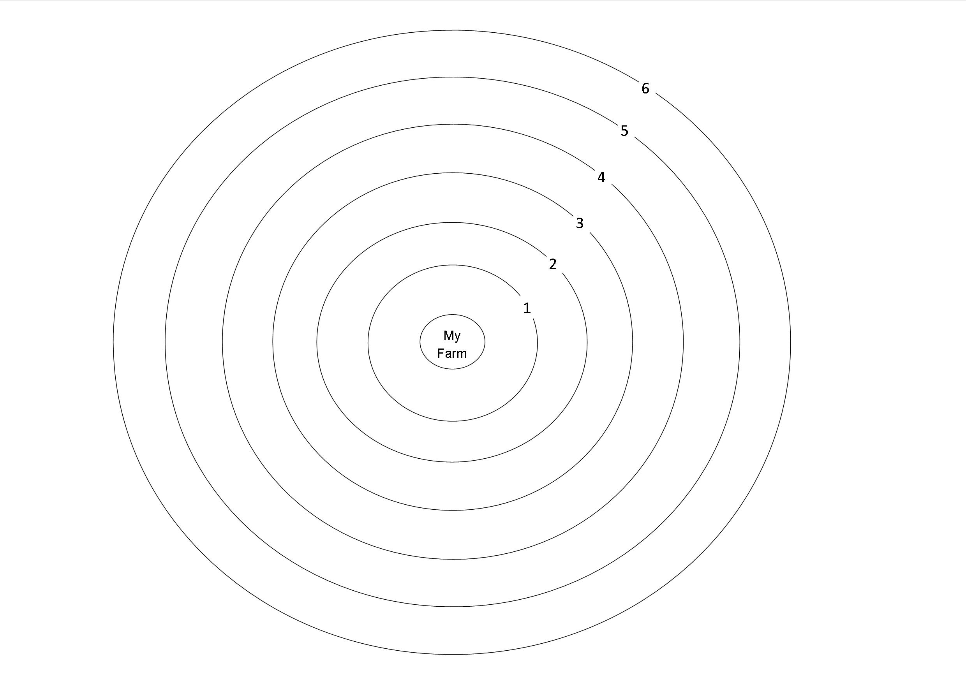

Figure 2: Example of completed influence map (authors’ survey)
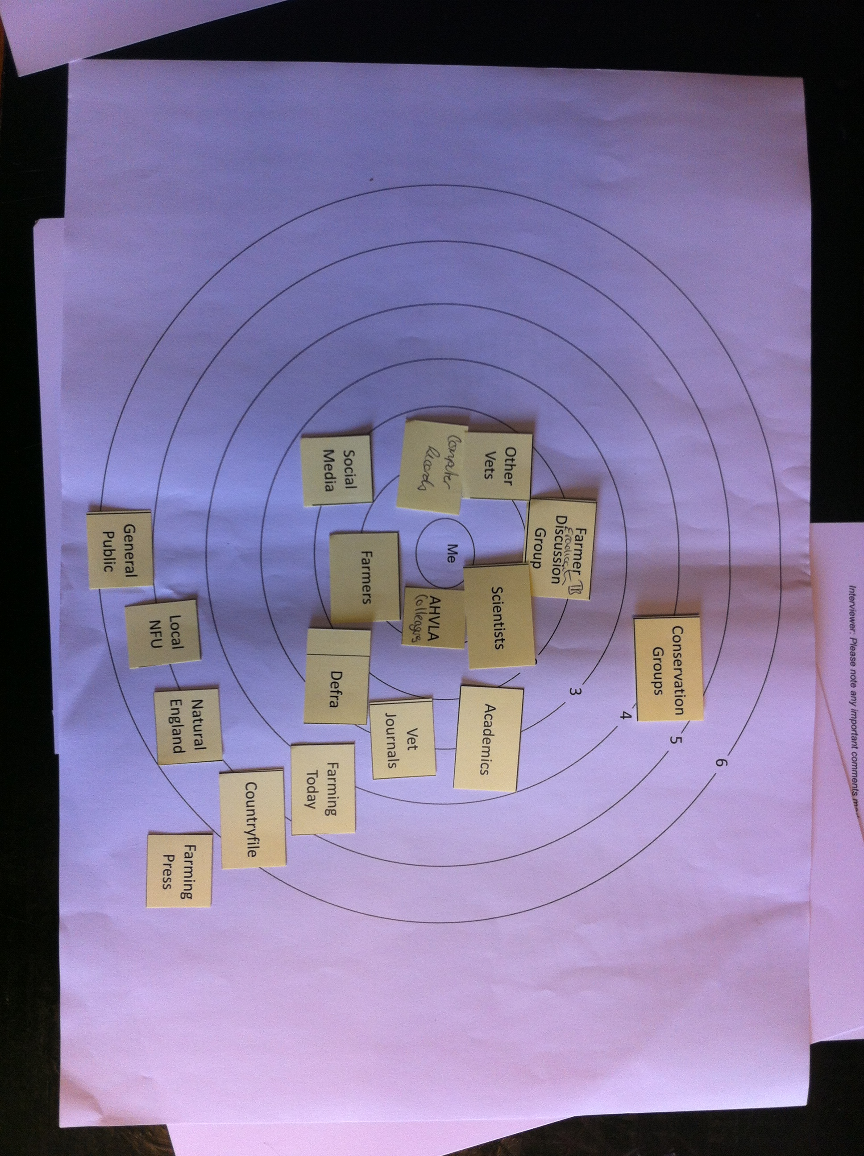

Figure 3: Influence map, scenario 1 (badger cull)
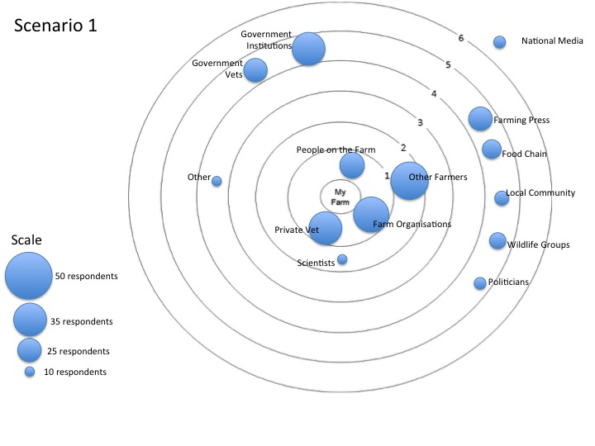

Figure 4: Influence map, scenario 2 (oral badger vaccine)
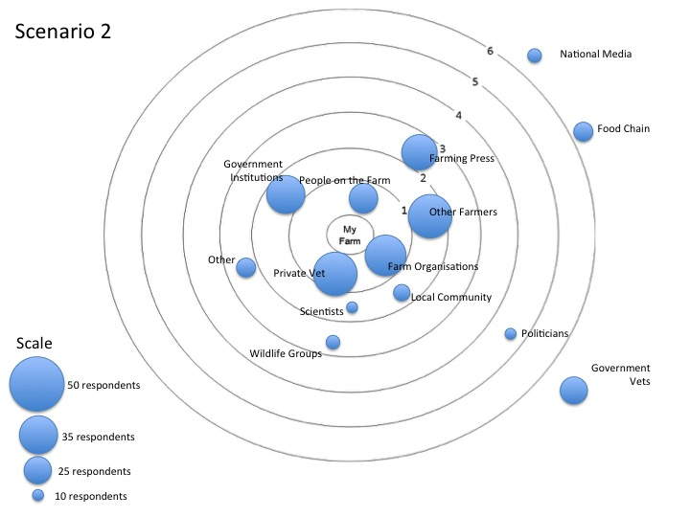

Figure 5: Influence map, scenario 3 (cattle vaccine)
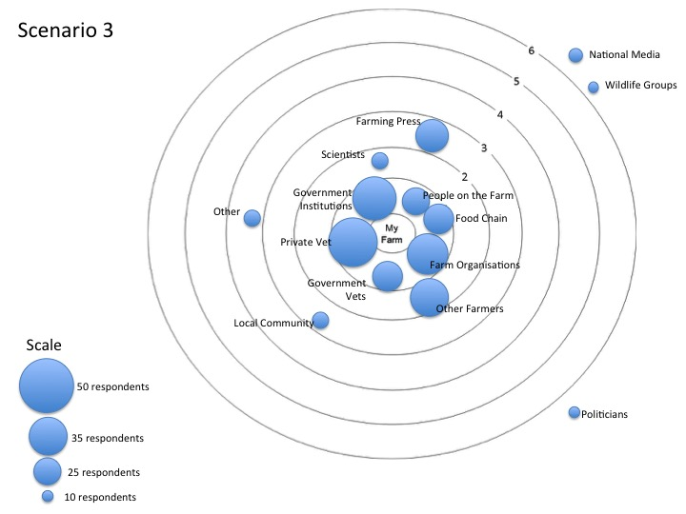

Figure 6: Influence map, scenario 4 (all options)
