**TITLE: Galanthamine production in tissue culture and metabolomic study on Amaryllidaceae alkaloids in *Narcissus pseudonarcissus* cv. Carlton**

**a Ferdausi Aleya, b Chang Xianmin, c Hall Anthony, d Jones Meriel**

a PhD, Institute of Integrative Biology, University of Liverpool, Liverpool, United Kingdom.

Present address: Associate Professor, Department of Genetics and Plant Breeding, Bangladesh Agricultural University, Mymensingh-2202, Bangladesh.

Email: aferdausi.gpb@bau.edu.bd

Tel: +8801747173836

b Senior Lecturer, Crop Production Technology, Royal Agricultural University, Cirencester

Gloucestershire, GL7 6JS, United Kingdom.

Email: [Xianmin.Chang@rau.ac.uk](mailto:Xianmin.Chang@rau.ac.uk)

Tel: 01285 652531

c Head of Plant Genomics, Anthony Hall Group, Earlham Institute, Norwich Research Park, Norwich, NR4 7UG, United Kingdom

Email: [anthony.hall@earlham.ac.uk](mailto:anthony.hall@earlham.ac.uk)

Tel: +44 1603 450 989

d Senior Lecturer, Functional and Comparative Genomics, Institute of Integrative Biology, The Biosciences Building, Crown Street, The University of Liverpool , Liverpool, L69 7ZB

United Kingdom

Tel: 0151 795 4562

Email: [m.g.jones@liverpool.ac.uk](https://owa.liv.ac.uk/owa/redir.aspx?C=C09fNmt0AlS6vCRBm36VeQWfppWiP8OJBgnf1lrSAg-kpuWmjvDTCA..&URL=mailto%3am.g.jones%40liverpool.ac.uk)

Corresponding author: Aleya Ferdausi a

Declarations of interest: none

**ABSTRACT**

The Amaryllidaceae alkaloids e.g. galanthamine (Gal), lycorine and narciclasine are noted for their pharmaceutical properties. Gal is a long acting, selective, and competitive acetylcholinesterase inhibitor approved for the treatment of early to mid-stage Alzheimer's diseases. The biosynthesis of alkaloids by plants using *in vitro* systems has been considered as a tool for drug discovery and production since total chemical synthesis is not economic. The biosynthetic pathways, especially for Gal, are starting to be understood, but still far from complete. This study is emphasised on the yield from whole plant and developing cell culture systems for optimized alkaloid production.

*In vitro* cultures of *Narcissus pseudonarcissus* (cv. Carlton) initiated from twin-scale explants cultured on Murashige and Skoog (MS) agar medium fortified with different concentrations of growth regulators, were screened for their ability to produce alkaloids through GC-MS (gas chromatography-mass spectrophotometry). Callus obtained mainly from the MS medium containing high concentration of auxins i.e. 20 mg/l NAA (naphthalene acetic acid), while media with low auxin (4 mg/l NAA) and MS basal medium gave bulblets with both white and green shoots. Regenerated bulblets developed from callus found in both high and low auxin MS media. Tissue culture derived materials (callus and bulblets) and field grown samples (bulb, basal plate and leaves) from 'Carlton' were analyzed for galanthamine content. The highest amount of galanthamine was obtained from basal plate tissue followed by bulb tissues, leaves, bulblets with green shoots, bulblets with white shoots and regenerated bulblets. Trace amount of galanthamine was found in callus.

An NMR (nuclear magnetic resonance) based metabolomic analysis showed that the relative concentrations of compounds involved in phenylalanine and tyrosine metabolism, the initial stage biosynthetic pathways that yield the Amaryllidaceae alkaloids, were higher in field samples than *in vitro* samples which support the GC-MS findings of high Gal production in field samples.

**Keywords:** *Narcissus*, Tissue culture, Amaryllidaceae Alkaloids, Galanthamine, GC-MS, NMR

**1. Introduction**

Plants always have been the main source of alkaloids although chemical synthesis has been achieved (Satcharoen et al., 2007). Due to the increased demand for galanthamine and the limited availability of plant sources, *in vitro* culture has attracted the attention of researchers as an alternative approach for the sustainable production of Gal (Pavlov et al., 2007). *In vitro* tissue and tissue-based systems have been extensively used for the production of quality plant materials (Giri et al., 2012) with continuous, sustainable, and economically viable production of natural compounds including secondary metabolites (Verpoorte et al., 2002; Dias et al., 2016). Considerable efforts have been devoted to establish *in vitro* production of plant secondary metabolites from undifferentiated callus or suspension culture, but the commercial success has been very narrow (Bogdanova et al., 2009; Georgiev et al., 2012; Schumann et al., 2012). Low yield of secondary metabolites in *in vitro* cultured plants are due to brief stationary phase and inhibition of the action of enzymes, normally present in mature plants (Muhitch and Fletcher, 1985).

The monocotyledon family Amaryllidaceae contains 75 genera and about 1100 species including well-known ornamentals such as the type genus *Amaryllis, Galanthus* (snowdrops) and *Narcissus* (daffodils) (Takos and Rook, 2013) as well as the most widely considered medicinal plant families (Jin and Xu, 2013). The alkaloids found in Amaryllidaceae plants are known as Amaryllidaceae alkaloids (Bastidaet al.,2006) namely lycorine, homolycorine, haemanthamine, tazettine, narciclasine, montanine, and galanthamine. Studies have been made into the biosynthesis of Amaryllidaceae alkaloids belonging to twelve different ring type subgroups (Jin and Xu, 2013). All Amaryllidaceae alkaloids are derived from the aromatic amino acids phenylalanine and tyrosine, which produce the common precursor 4′-*O*-methylnorbelladine and the cyclisation of the precursor by three alternative ways of C-C phenol coupling viz. *ortho-para', para-para',* and *para-ortho'* lead to Amaryllidaceae alkaloids (Takos and Rook, 2013). If the biosynthetic pathway of plant derivatives is understood it is possible to determine starting substances (Singh et al., 2018) and use insights from enzymatic pathways for *in vitro* chemical synthesis (Leonard et al., 2009).

In addition to their ornamental properties, *Narcissus* contains more than 20 alkaloids with pharmaceutical properties (Bastida et al., 2006; Lubbe et al., 2011). Galanthamine is usually reported as the major alkaloid in the bulbs of *Narcissus* followed by haemanthamine, lycorine, lycoramine and O-methyllycorenine (Lubbe et al., 2013; Torras-Claveria et al., 2013). Galanthamine was first isolated from *Galanthus*; commonly known as snowdrops, *Leucojum aestivum* (snowflakes) is an industrial source of Gal in Eastern Europe (Berkov et al., 2013), and currently is extracted from plants such as daffodils (*Narcissus* cultivar Carlton), *Lycoris radiata*, *Ungernia victoria* and alternatively by chemical synthesis (Berkov et al., 2014). Amaryllidaceae alkaloids possess a number of pharmacological properties like inhibitor of acetylcholinesterase and ascorbic acid biosynthesis, cytotoxicity, anti-cancer, anti-tumour, and anti-viral activities (Tahchy et al., 2010).

Galanthamine; lycorine, anhydrolycorine, crinine, demethylmartidine and narwedine were found to be present in *in vitro* cultures of *Narcissus pseudonarcissus* and other Amaryllidaceae species through GC-MS screening (El Tahchy et al., 2011). The establishment of *in vitro* culture in *Narcissus* is often difficult due to a high rate of contamination in cultures initiated from explants originated from underground plant parts (Sochacki and Orlikowska, 2005), strong bulb dormancy and low speed of propagation (Seabrook et al., 1976). Different explants, including leaf base, leaf lamina, scape (flower stem), bulb scale, young anther, terminal bulb unit, and twin-scale with basal plate tissues have been used for *Narcissus* cell differentiation and regeneration. Among them twin-scale has been found to have the highest success rate (Anbari et al., 2007; Abu Zahra and Oran, 2007). Appropriate concentrations and combinations of different growth regulators, sucrose concentrations, and elicitor treatments reported as mandatory for the production of secondary metabolites in plant cell culture (Codina, 2004; Singh and Chaturvedi, 2012; Ivanov et al., 2013).

Metabolomic studies have provided new knowledge about the dynamics of secondary metabolite production in plants (Matsuda et al.,2010). The metabolomic platforms can be grouped into three groups, based on their underlying principles namely, chromatographic methods (gas or liquid chromatography, capillary electrophoresis, thin layer chromatography), mass spectrometry and nuclear magnetic resonance (NMR) spectroscopy (Kim et al.,2006).

Mass spectrometry-based metabolomic analysis has been primarily chosen due to its selectivity, sensitivity, comprehensiveness, and relatively low cost (Zhao et al.,2013). However, another important criterion for developing a metabolomics platform is the ease and time needed for sample preparation as well as metabolite identification and quantitation (Verpoorte et al.,2007). NMR-based analyses, when compared with chromatographic techniques are highly reproducible, rapid, and require very simple sample preparation (Van Der Kooy et al.,2009). The spectrum can provide detailed structural information on metabolites, including chemical shifts and coupling constants (Zhi et al.,2012). Secondary metabolites can be directly observed in NMR spectra obtained from plant tissues (Schripsema et al.,2007) including crude extracts of cell cultures (Schripsema, 2010).

In this study, a novel workflow is presented to describe *Narcissus* tissue culture approach for the synthesis of bioactive alkaloids, mainly galanthamine in different tissue types including field grown plant tissues with a simple and rapid GC-MS metabolic profiling (Berkov et al., 2011) and NMR based metabolomics for other small metabolites (Kim et al.,2006).

**2. Materials and Methods**

*2.1 Tissue culture*

*2.1.1 Plant materials*

*Narcissus* bulbs from variety 'Carlton' were used, supplied by New Generation Daffodil Ltd, UK. Underground bulbs of eight to nine months old harvested in June-July after flowering senesced, weighted approximately 4.0 to 4.5 kg were used for tissue culture (Figure 1). Bulbs were kept under cold treatment (4oC) for at least one month to break the bulb dormancy before hot water treatment (45oC, 52oC and 54oC, for 1 to 2 h) and surface sterilization was performed using Domestos bleach solution (20%) for 30 min and rinsed (3×) with sterile distilled water. The disinfected bulbs were cut as twin-scale (cut from the basal part of bulbs with 2 or 3 scales of 0.8-1.0 cm in size) in a laminar hood to initiate tissue cultures. Autoclaving, alcohol and flame sterilization were used to sterilize the forceps, needles and scalpels to cut the twin-scale explants.

*2.1.2 Culture media and culture condition*

Two twin-scale explants were inoculated per Petri plate onto three different types of MS (Murashige and Skoog, 1962) media; MS basal medium (4.3 g/l MS powder, 50 g/l sucrose and 8 g/l agar), MS basal medium supplemented with yeast extract (100 mg/l), ascorbic acid (50 mg/l), polyvinylpyrrolidone (30 mg/l), kinetin (0.5 mg/l), benzyl amino purine (BAP) (1.5 mg/l) and 20 mg/l naphthalene acetic acid (NAA) (MSM1) or 4 mg/l NAA (MSM2). The media pH was adjusted to 5.6-5.8 with 1M NaOH or HCL prior to autoclaving (121oC, 108 kPa and 30min). All growth regulators and ascorbic acid were filter-sterilized (0.22 µm) and added to the sterilized media. Petri plates were sealed with a single layer of parafilm and incubated in a culture room (24±2oC, 12 h photoperiod). MS media, ascorbic acid and all the growth regulators were purchased from Duchefa Biochemie (Netherlands), polyvinylpyrrolidone from Sigma-Aldrich (UK) and yeast extract from Thermo Scientific (Germany). All the tissue culture materials were maintained for three to six months by sub-culturing every three weeks until an adequate amount of materials was achieved for alkaloid analysis (GC-MS) and metabolomics (NMR). The complete protocol for the tissue culture of *Narcissus* is represented in Figure 2.

*2.1.3 Calculations and data interpretation*

The results of bulb treatment (Figure 3), *in vitro* tissue responses (callus, direct bulblets, regenerated bulblets) (Figure 5) are represented in total number of explants responded to callus/regenerated bulblets/direct bulblets/contaminated/senesced to the total number of explants under treatments (temperature or media). As for example, the percentage of explant, regenerated bulblets, direct bulblets (DB) and number of explants contaminated were calculated based on the number of explants developed to callus or direct bulblets or regenerated bulblets to the total number of explants or callus incubated on the respective media (MS, MSM1 and MSM2) and number of explants under temperature treatments (45oC, 52oC and 54oC, for 1 to 2 h).

Representative equations are as follows:

$$Percent \left(\%\right) of explants contaminated =\frac{total number of explants contaminated}{total number of explants in temerature tretments }×100$$

$$Percent \left(\%\right) of callus =\frac{total number of callus obtained from explants grown on MSM1 or MSM2}{total number of explants incubated in MSM1 and MSM2}×100$$

$$Percent \left(\%\right) of RB=\frac{total number of RB obtained from callus incubated on MSM1 or MSM2}{total number of callus incubated in MSM1 and MSM2}×100$$

$$Percent \left(\%\right) of DB=\frac{total number of DB obtained from explants grown on MS or MSM1 or MSM2}{total number of explants incubated in all three media (MS, MSM1,MSM2)}×100$$

*2.2 Quantification of Gal through GC-MS*

*2.2.1 Plant materials*

Leaves, dormant bulbs (harvested in June to July), bulbs harvested after flowering (harvested in April to May) and basal plate tissues of dormant and harvested bulbs from field grown 'Carlton' including all tissue culture derived materials were harvested, weighed and stored at -80oC until final extraction. Carlton bulb tissues were used as control for all sample extractions.

*2.2.2 Sample preparation*

For alkaloid extraction 100mg frozen plant material was placed in 2 ml microfuge tube with 500 µl methanol (HPLC grade, Fisher Scientific, UK) and homogenized for 2 × 60 seconds (Pellet Pestle 1.5 ml Stainless Steel Pk1 with pestle motor, Kimble Chase, USA). Another 500 µl methanol was added and after vortexing for 30 seconds samples were incubated for 5 h at room temperature assisted by an ultrasonic bath (Grant Instruments Ltd. England) for 15 min of every 30 min. After extraction, the samples were centrifuged at 12,000 *g* for 1 min then 500 µl supernatant was removed slowly without disturbing the pellet to a labelled 2 ml glass vial (Thermo Scientific, Germany). The freshly prepared samples (65 µl) were directly transferred to the GC-MS vial (Chromacol Ltd. USA) with 2 µl (5 µg/µl) codeine for analysis. Each alkaloid extract was analyzed in triplicate.

*2.2.3 Standard solution preparation*

Galanthamine (Gal) was used as an external standard (ES) and codeine (Cod) was used as internal standard (IS) (Sigma-Aldrich, UK). Standard solutions of three different galanthamine concentrations (0.1 mg/ml, 0.05 mg/ml and 0.01 mg/ml) along with codeine (5 mg/ml) were used to obtain the calibration curve for method validation. Each standard concentration was used in three replicates for the Gal peak areas in total ion current (TIC) mode.

*2.2.4 Chromatographic conditions*

The GC-MS mass spectra were recorded on a Micromass GCT instrument (Waters Ltd. UK) operating in positive ion EI (Electron Ionization) mode with a source temperature of 180oC and ionization energy of 70 eV. The chromatography column used was a non-polar general purpose BPX5 (30 m × 0.25 mm × 0.25 µm) (SGE Analytical Science). The temperature program was: 70oC for an initial time of 2 min then an increase of 10oC min-1 to 320oC held for a final time of 8 min. The flow rate of the carrier gas (helium) was 0.7 ml min-1. The injection temperature was 250oC and the splitless injection mode was used. Aliquots of the extract solutions (1µl) were injected.

*2.2.5 GC-MS analysis*

Samples were analyzed in the Centre of Proteome Research; University of Liverpool using GC-MS. Automated injection of samples to the Micromass GCT instrument was performed. All samples were run in a total of seven batches, including 24 samples in a single batch. Standards were run with each batch of samples including at the start, in the middle after 12 samples and at the end of 24 samples.

*2.2.6 Calculations and data interpretation*

The equations generated from the calibration curves (section 3.4, Figure 6) of Gal standards (ES) were used to calculate the amount of galanthamine from all sample extracts. As the calibration curve analysis was based on external standards (Gal); therefore calculations were more accurate and reproducible than internal standard (Cod) equations. The amount of galanthamine was calculated based on fresh weight (FW). Calibration curves and GC-MS chromatogram graphs were generated using Microsoft Excel 2010 and used to calculate the molarity of the samples. These molarities were then converted to the Gal content (µg) of per g fresh weight plant material. The amount of Gal have been converted and represented in µg Gal/g (FW) in result section.

*2.3 Metabolites identification through NMR analysis*

*2.3.1 Plant Materials*

Bulb and basal plate tissues from four different Carlton bulbs, calli from high auxin media, direct white shoot, green shoot and regenerated white shoot (section 3.2, Figure 5) including three replicates for each sample were selected for sample preparation.

*2.3.2 Sample preparation*

Fresh ice-cold solvent solution was prepared with 50% HPLC grade acetonitrile and 50% double distilled water. 500 μl ice-cold solvent solution was added to all 1.5 ml microfuge tubes with ~20 mg frozen samples. The microfuge tubes were placed in an ice bath and sonicated with a probe sonicator (Soniprep 150 plus, MSE, UK) to disrupt cellular membranes for 3 bursts of 30 seconds at 10 kHz to prevent heating. After vortexing for 1min the materials were centrifuged at 12000 *g* for 10min at 4oC and the supernatant was collected, flash frozen in liquid nitrogen and lyophilized overnight in Freeze Dryer Lyolab 3000, Thermo Fisher Scientific, UK (Beckonert et al.,2007).

Stock phosphate buffer was prepared with 8 ml, 1 mM sodium phosphate pH 7.4, 80 μl of 100 mM tri-methylsilylpropanoate (TSP), 80 μl, 1.2 mM NaN3 and made to a final volume of 80ml with 100% 2H2O. 700 μl of stock phosphate buffer was added to each microfuge tube containing frozen lyophilized samples, vortexed for 1 min and was centrifuged at 12000 *g* for 2 min at room temperature. 600 μl of supernatant from each sample was removed without disturbing the sample pellet and pipetted carefully into 5 mm NMR tubes (Sigma Aldrich, UK) (Lubbe et al.,2013). The NMR Centre, University of Liverpool, supplied all chemicals (Sigma Aldrich, UK) and instruments to run this experiment.

*2.3.3 NMR measurement*

NMR spectra were acquired on a Bruker 600 MHz spectrometer (Coventry, UK), equipped with a TCI cryoprobe and Sample Jet auto sampler. Temperatures were calibrated to 25oC within a margin of 0.2oC for each experiment. The experiment was optimized by lock, tune and shim to achieve the best baseline and water suppression possible for each sample. Two 1H-1D NMR experiments, Carr-Purcell-Meiboom-Gill (CPMG) and Nuclear Overhauser Effect (NOE) (Kim et al., 2010) were collected for each sample. The NOE displayed 1H from both large and small molecules present in the extract. The CPMG, however, selected for 1H resonances from small molecules (typically < 500Da) only. For each experiment 128 scans were recorded using the following parameters: 0.15 Hz/ point, pulse width (PW) 8-9 μs, spectral width of 18.00 ppm and relaxation delay (RD) = 4.0 s. TSP (trimethylsilylpropanoic acid) (0.05%, w/v) was used as the internal standard for 2H2O (Lubbe et al., 2013).

*2.3.4 Data processing and multivariate data analysis*

NMR spectra were analyzed using AMIX software (Topspin, Bruker) to view and compare spectra by creating pattern files. The region δ 4.7 to 6.2 ppm was excluded from the analysis because of the presence of signal from residual water. After bucketing, the intensities of signals in each bucket were calculated by dividing signal intensities by the relative intensity to a reference area (single peak at 0 ppm from reference compound TSP). Pattern files of identified metabolites with their corresponding 1H chemical shifts (ppm) were generated. MetaboAnalyst (Xia et al., 2015) was used for univariate analysis (one-way ANOVA and *post-hoc* analysis) and multivariate analysis (PCA) to process the NMR spectra.

**3. Results and discussion**

*3.1 Establishment of culture condition*

Initially six Carlton bulbs were used to establish suitable culture conditions; two bulbs (48 twin-scale explants) for each temperature treatment (45oC for 2 h, 52oC and 54oC for 1 h) were used. After hot water treatment and surface sterilization, twenty-four twin-scale explants were cut from each disinfected bulb and incubated up to 10 weeks on MS basal, high auxin (20 mg/l NAA) and low auxin (4 mg/l NAA) media. Data were collected and recorded after two weeks of incubation (24 ± 2oC, 12 h photoperiod) and continued for another six weeks on a regular basis checking all the cultured plates containing twin-scale explants.

From Figure 3, it was observed that 52oC; 1 h gave the best results as the amount of contamination as well as senescence of explants was the lowest. The largest proportion of explants (37.5%) developed as callus or bulblets (successful growth). Results were pooled from the three media for this comparison.

High level of contamination was observed in bulbs treated at the lower temperature of 45oC, while at the higher temperature of 54oC, although contamination was reduced, many explants were senesced (Figure 3). Therefore, 52oC, 1 h was selected for bulb treatment. Similar bulb treatments were reported in previous studies; hot water treatment of *Narcissus* bulbs prior to surface sterilization with bleach solution has been reported as a mandatory step to reduce contamination in culture condition (Sochacki and Orlikowska, 2005; Abu Zahra and Oran, 2007). Sochacki and Orlikowska, 2005, used 54oC, 1h for the treatment of *N. tazetta* bulbs in their study, while in the current study this resulted in higher senescence. On the other hand, pre-culture treatment with low temperature for longer duration (44.4oC, 3 h) has been used for Carlton bulb sterilization (Abu Zahra and Oran, 2007) that showed higher contamination of explants in this study.

Results indicated that the moderate temperature (52oC, 1 h) is the most suitable one for bulb treatment, as high temperature might kill the cells (most explants senesced) and a lower temperature is not enough to kill contaminants in the tissues (most explants contaminated).

*3.2 In vitro tissue differentiation of twin-scale explants*

Twenty-five Carlton bulbs were used to initiate *in vitro* culture from twin-scale explants (24 twin-scales per bulb) (Figure 4A). Among the 24 twin-scale explants obtained from each bulb, 12 twin-scales were cultured on MS basal media, 6 on high auxin, and 6 on low auxin media, incubated at 24 ± 2oC, 12 h photoperiod.

After about four weeks of culture initiation, some explants had developed into undifferentiated callus (Figure 4B). In addition, explants started to give rise to small bulblets with white (Figure 4C) and green shoots (Figure 4D) directly from the base of a scale, hence named direct bulblets or direct shoots. Calli were sub-cultured on the same media of calli induction. After another six weeks some callus developed into regenerated bulblets (Figure 3E). A very few bulblets with roots (16 bulblets with 55 roots) from 11 explants were also obtained from MS basal medium (Figure 4F). Callus induction, somatic embryogenesis, and organogenesis from twin-scale explants have been successful in several *Narcissus* species (Sharma and Kanwar, 2002; Yanagawa, 2004).

*3.3 Effect of different media and growth regulators on tissue differentiation*

The percentage of callus, direct bulblets and regenerated bulblets were calculated from the number of explants developed to callus or direct bulblets or regenerated bulblets to the total number of explants incubated on media (MS or MS with high auxin or MS with low auxin) (Section 2.1.3). MS basal and modified MS media with both high and low auxin were tested for callus induction. Carlton twin-scale explants completely failed to induce callus on MS medium (without growth regulators) which was previously reported in *N. confusus in vitro* cultures from media lacking auxins (Selles et al.,1999). Therefore, data presented in Figure 5A includes callus from high and low auxin media. In both media, callus initiation from twin-scale started about 2-3 weeks after culture initiation but better callus formation was recorded after 8-12 weeks from high auxin medium (67% of total explants cultured on both media) than the low auxin medium (13% of total explants cultured on both media) (Figure 5A). Some recent studies showed the similar findings; MS medium containing high auxin was the most suitable medium for callus induction and proliferation derived from bulb explants of *N. tazetta* var. *italicus* (Taleb et al.,2013). That suggests growth regulators are mandatory for cell growth and differentiation (George et al.,2008) and higher concentration of auxins often facilitate the callus formation.

After being on induction media, MS with high and low NAA for ten weeks and regular sub-culture for every 3 to 4 weeks on same media, calli started to form small white bulblets after another six weeks. Calli regenerated into bulblets with white shoots in both high auxin (45% of total calli inoculated on both media) and low auxin (52% of total calli inoculated on both media) media as illustrated in Figure 5B. The presence of growth regulators was also necessary for callus differentiation; similar findings showed that no differentiation was observed in MS basal medium deprived of growth regulators in *N. pseudonarcissus* (El Tahchy et al.,2011).

Figure 5C shows that the initiation of small bulblets directly grown from the base of twin-scale explants, was influenced by low concentration of auxin (51% of total explants inoculated in all three media) and MS basal medium (48% of total explants inoculated in all three media). Whereas, a lower percentage (11% of total explants inoculated in all three media) were obtained from high auxin medium (Figure 5C). The best result for shoot proliferation was also previously reported in MS medium supplemented with low auxin, especially a NAA to a high cytokinin from *in vitro* bulb scale culture of *N. asturiensis* (Santos et al.,2002).

In addition, green (total 51 shoots) and white (total 160 shoots) shoots were found in bulblets grown from MS basal and the low auxin medium, whereas the high auxin medium did not give any green shoots, only white shoots (total 76 shoots) were obtained. Rooted plantlets (Figure 4F) were obtained from MS basal media. Similar findings on shoot and root development were reported previously in *Narcissus* (Abu Zahra and Oran, 2007; Anbari et al., 2007).

*3.4 Calibration curve analysis for Gal quantification in field and in vitro tissues*

The calibration curves were prepared plotting the Gal peak areas versus Gal molarities (0.0002671 M, 0.0001336 M and 0.00002671 M). Standards were analyzed with the samples and showed high linearity over the range of Gal molarities (0.0002671 M to 0.00002671 M) with correlation coefficient (*r2*) of 0.902 to 0.954 across the batches of field and *in vitro* plant tissues. A typical linear regression equation for standards is shown in Figure 6, where *x* represents Gal molarities and *y* is the total Gal peak area.

Similar calibration methods have previously been used for alkaloid extractions in *Narcissus* (Berkov et al., 2011; Torras-Claveria et al.,2013). Galanthamine has been identified in more than 100 species of *Narcissus* by a calibration curve method using galanthamine standards (1-100 µg/ml) standardized with codeine (Torras-Claveria et al.,2013).

The galanthamine content from methanol extracts of field and *in vitro* samples were analyzed using GC-MS and the Gal amounts (Table 1 and Table 2) were calculated based on the external standard (ES) equations. Carlton bulb tissue was used as control for all tissue culture sample analysis.

Field (organized) tissues showed a higher amount of galanthamine than the culture derived samples on a fresh weight (FW) basis (Table 1 and Table 2). Among the field samples, Carlton basal plate tissue contained the highest (1250 µg Gal/g FW) amount followed by bulb (1110 µg Gal/g FW) and leaf tissues (420 µg Gal/g FW). Basal plate tissues (830 µg Gal/g FW) and bulb tissues (960 µg Gal/g FW) of Carlton dormant bulb showed slightly less galanthamine content than harvested bulbs after flowering (Table 1).

This pattern of galanthamine production supports the previous findings obtained from *Narcissus* species. Previous findings on the amount of galanthamine from field grown bulb (2000-2800 µg/g Gal DW) and leaf tissues (500-800 µg/g Gal DW) of *Narcissus* 'Carlton' showed higher amounts than our findings (Lubbe et al.,2013). This increased amount could be due to the dry weight basis quantification and also they used different method of alkaloid analysis (NMR) that also might affect the results. Among the tissue culture derived samples, the callus contained low levels or no galanthamine. There was a trace amount of Gal (1.0-7.0 µg Gal/g FW) in callus cultured on MS medium supplemented with high auxin but no galanthamine in callus obtained from low auxin medium (Table 2).

However, differentiation of callus to regenerated tissues (small bulblets or white shoots) grown on low auxin medium showed an increased galanthamine level (13-50 µg Gal/g FW). Direct bulblets grown from the base of twin-scales and white part of their shoots contained less galanthamine (10-215 µg Gal/g FW) than the photosynthetic part (green shoots) (97 and 130 µg Gal/g FW) or the field grown materials. Galanthamine was absent from root extracts (Table 2). That indicates the increased production of galanthamine is closely related with cellular differentiation and as photosynthesis occurs in green tissues so that these also have access to greater carbon sources. Gal concentration in *N. pseudonarcissus* shoot cultures has been reported in a previous study showing the amount varied from 10-80 µg/g DW with the highest amount reported 100µg/g, based on dry weight (El Tahchy et al.,2011).

Similar findings were observed from *in vitro* cultures of *N. confusus*; where callus had the lowest galanthamine content (0.03 µg/g DW) followed by shoot-clumps (0.14 µg/g DW) and plantlets (1.43 µg/g DW) (Codina, 2002). Another recent study also has reported the similar pattern of lower Gal content in callus (30-60µg/g DW) than *in vitro* shoots (110-130 µg/g DW) of *N. confusus* (Berkov et al., 2014).

*3.5 Metabolites identification*

NMR-based analysis was performed to detect the metabolites present in *N. pseudonarcissus* cv. Carlton field samples, tissue culture derived calli, regenerated white shoots, direct white and green shoots.

Table 3 summarizes the important metabolites identified across Carlton basal plate, Carlton bulb, callus, regenerated white shoot grown from callus; direct white shoot and green shoot grown directly from the base of twin-scale with a total of 230 peaks. Representative 1H-NMR spectra for field (bulb and basal tissue) and calli showing the major groups of metabolites with their relative positions (ppm) are shown in Figure 7.

The differential presence of identified metabolites in different tissues was generated with the help of one-way ANOVA (heatmap) analysis and the groupings of samples was performed using multivariate PCA analysis by MetaboAnalyst 3.0 (Xia *et al.,* 2015).

The ANOVA analysis showed that 225 peaks were significantly different among the samples under analysis. The MetaboAnalyst parameters for ANOVA analysis were: data normalization by mean and *pareto-*scaling, p-value threshold set to 0.05 and Fisher’s LSD was used for the *post-hoc* analysis. In previous studies, ANOVA has been used to identify significant differences between datasets for the quantification of amino acids, fatty acids, sugars and alkaloids in *Narcissus* bulbs prior to principal component analysis (PCA) as performed in the present study (Lubbe et al.,2012; Lubbe et al.,2013). The relative concentrations of metabolites involved in the tyrosine and phenylalanine metabolism (Table 3), the initial compounds involved in Amaryllidaceae alkaloid biosynthesis, are represented in Figure 8. Some metabolites showed large variation among treatments (error bars) may be due to the different bulbs used for sample preparation causing treatment variations as well as normalization of metabolite data to standard (AMIX) (Figure 8).

It was observed that the precursors (Figure 8) for the production of Amaryllidaceae alkaloids were present in higher concentrations in field samples and other *in vitro* tissues than callus. The presence of high amount of tyrosine and tyramine in field tissues could relate to the higher amount of galanthamine accumulation in field tissues (Table 1). A NMR-based metabolomic study has previously shown the presence of high amount of tyrosine in *Narcissus* bulbs, which was predicted to relate to the up-regulation of the phenylpropanoid pathway for the biosynthesis of phenolic compounds (Lubbe et al., 2013).

Calli differentiation in regenerated white shoots showed increased amount of tyramine, succinylacetone and 3-phenypropionate which are also involved in phenylalanine and tyrosine metabolism. Therefore, the detection of these metabolites in differentiated tissues could be in accordance with the higher content of galanthamine in differentiated tissues (direct, regenerated and green tissues) than callus that was observed in GC-MS analysis (Table 2). The reason behind the higher accumulation of different primary and secondary metabolites in organized tissues (bulblets or shoots) could be related to their nature of accumulation in specific or organized tissues (Dias et al.,2016).

A three-component model PCA explained 89.7% of the total variance (Figure 9) with 4th and 5th components explaining an additional 4.7% and 1.6% variance respectively. The first two principal components accounted for maximum variance (65.9%) in the dataset. In the score plot of PC1 and PC2, the field samples (bulb and basal plate) were clearly separated from each other and from the *in vitro* tissues along PC1and PC2 (Figure 10A). However, some replicates of callus, direct white and green shoot were overlapped with basal plate along PC1. Regenerated white shoot, basal plate, and bulb tissues were clearly separated along PC2 (Figure 10A).

The samples with the lowest score on PC1 and PC2 (most to the left on score plot) were callus, clearly distinguished from field tissues with middle scores and from the *in vitro* regenerated white shoot tissue in the high scoring area of PC2. Thus, the regenerated white shoot cluster was highly correlated with PC2 variance (28.1%) and callus cluster showed highly negative correlation with both PCs variance. The basal plate showed moderate correlation with both PCs while bulb cluster mainly showed correlation with PC2 but moderate correlation with PC1 variance. On the other hand, green shoot and direct white shoot clusters showed positive correlation with both PCs variation except one replicate of direct white shoot (Figure 10A).

The corresponding loadings of assigned sample clusters in score plot are represented in a loading plot (Figure 10B). It showed the distribution of metabolites, which were responsible for the separation of the samples under study. The most important signals assigned to callus were sucrose, glucose, lactose, galactitol and glucitol. Metabolites responsible for bulb clustering were 5-aminolevulinate, lactate, galactarate, tyrosine, proline, glycolate, and galactonate. Alanine, arginine, betaine, carnitine, tyramine, xylose and cadaverine were observed as important signals for regenerated white shoot cluster. However, most of the metabolite signals were found to be densely situated on the cluster from the basal plate, direct shoot, and green shoot. The metabolites assigned for their separation from the other samples were mainly p-cresol, biotin, thymol, proline, 4-aminobutyrate, and 3-hydroxymandelate.

NMR-based metabolomics has many applications in plant science including differentiation of plants from different origins, environments or after different treatments (Kim et al., 2010). This study showed NMR-based metabolite identification of *N. pseudonarcissus* cv. Carlton grown in two different environments; naturally grown field samples and artificially controlled tissue culture samples. Most of the metabolites detected in the field tissues (bulb and basal plate) in this study were similar to those that have been previously reported in studies using GC-MS (Berkov et al.,2011) and NMR-based extraction from *N. pseudonarcissus* cv. Carlton bulbs (Lubbe et al.,2011, 2012 and 2013). Lubbe et al., used a similar PCA (score and loading) approach as used in this study to identify the metabolic differentiation in *Narcissus* bulbs subjected to different levels of fertilizers (2011); different fungicide treatments (2012) and the effect of growing season on *Narcissus* bulb, leaf and root metabolite production (2013). These studies have also reported the NMR-based identification of Amaryllidaceae alkaloids such as galanthamine, haemanthamine, narciclasine, and lycorine. In our study, it was not possible to identify any such alkaloids due to the lack of alkaloids in the reference library (Chenomx). However, precursors responsible for the production of Amaryllidaceae alkaloids such as tyrosine, tyramine, 3-phenylpropionate, p-cresol, and succinylacetone were detected in samples under analysis. Mahmud et al.,(2015) also reported the detection of tyrosine in sugarcane calli, which was also observed in *Narcissus* calli (Figure 8).

The relative intensity of notable sugars (e.g. glucose, sucrose and lactose) and sugar alcohols (glucitol and galactitol) signals were higher in callus than all other samples. This could relate to the callus metabolism in media supplemented with sucrose based carbon supply. High amounts of glucose and sucrose were reported previously in both *C. roseus* and sugarcane calli (Yang et al.,2009; Mahmud et al.,2015). Elevated glucose and sucrose has also been reported earlier in an NMR-based metabolomic study on protocorm callus cultures of *Vanilla panifolia* (Palama et al.,2010).

**4. Conclusion**

This study described a complete and reproducible tissue culture method for *Narcissus pseudonarcissus* cv. Carlton to obtain an adequate number of different types of tissues and also showed the amount of galanthamine in different tissues obtained from different growth conditions (field versus *in vitro*). Carlton field samples showed higher amount of galanthamine content than *in vitro* grown tissues. However, among *in vitro* tissues, the higher galanthamine level was observed in differentiated tissues such as bulblets and shoots than undifferentiated callus. Moreover, other metabolites responsible for the alkaloid production including amino acids, organic acids and carbohydrates were also detected in samples under analysis. However, further analysis at molecular level would insight the underlying reasons for the accumulation of different amount of alkaloids in different tissues.

**Acknowledgements:**

The research has received funding support from the Commonwealth Scholarship Commission and University of Liverpool, United Kingdom. Authors wish to thank Mr. Mark Prescot, Centre of Proteomics, University of Liverpool for running the GC-MS and Dr. Phelan Marie, NMR Centre, University of Liverpool for NMR analyses support.

**References:**

Abu Zahra, H., Oran, S., 2007. Micropropagation of the wild endangered daffodil *Narcissus tazetta* L. International Medicinal and Aromatic Plants Conference on Culinary Herbs. 826, 135-140.

Anbari, S., Tohidfar, M., Hosseini, R., Haddad, R., 2007. Somatic embryogenesis induction in *Narcissus* papyraceus cv. Shirazi. Plant Tissue Culture and Biotechnology. 17**,** 37-46.

Beckonert, O., Keun, H. C., Ebbels, T. M., Bundy, J., Holmes, E., Lindon, J. C., Nicholson, J. K., 2007. Metabolic profiling, metabolomic and metabonomic procedures for NMR spectroscopy of urine, plasma, serum and tissue extracts. Nature protocols. 2**,** 2692-2703.

Bastida, J., Lavilla, R., Viladomat, F., 2006. Chemical and biological aspects of *Narcissus* alkaloids. The alkaloids: chemistry and biology. 63, 87-179.

Berkov, S., Bastida, J., Viladomat, F., Codina, C., 2011. Development and validation of a GC–MS method for rapid determination of galanthamine in *Leucojum aestivum* and *Narcissus* ssp.: A metabolomic approach. Talanta. 83**,** 1455-1465.

Berkov, S., Georgieva, L., Kondakova, V., Viladomat, F., Bastida, J., Atanassov, A., Codina, C., 2013. The geographic isolation of *Leucojum aestivum* populations leads to divergation of alkaloid biosynthesis. Biochemical Systematics and Ecology. 46**,** 152-161.

Berkov, S., Ivanov, I., Georgiev, V., Codina, C., Pavlov, A., 2014. Galanthamine biosynthesis in plant in vitro systems. Engineering in Life Sciences. 14**,** 643-650.

Bogdanova, Y., Pandova, B., Yanev, S., Stanilova, M., 2009. Biosynthesis of lycorine by in vitro cultures of Pancratium maritimum L.(Amaryllidaceae). Biotechnology and Biotechnological Equipment. 23**,** 919-922.

Codina, C., 2002. Production of galanthamine by *Narcissus* tissues in vitro *Narcissus* and Daffodil (The Genus Narcissus). Taylor & Francis London.

Codina, C., 2004. Improved production of galanthamine and related alkaloids by methyl jasmonate in *Narcissus confusus* shoot-clumps. Planta Med. 70**,** 1180-1188.

Dias, M. I., Sousa, M. J., Alves, R. C., Ferreira, I. C., 2016. Exploring plant tissue culture to improve the production of phenolic compounds: A review. Industrial Crops and Products. 82**,** 9-22.

El Tahchy, A., Bordage, S., Ptak, A., Dupire, F., Barre, E., Guillou, C., Henry, M., Chapleur, Y., Laurain-Mattar, D., 2011. Effects of sucrose and plant growth regulators on acetylcholinesterase inhibitory activity of alkaloids accumulated in shoot cultures of Amaryllidaceae. Plant Cell, Tissue and Organ Culture (PCTOC). 106**,** 381-390.

George, E. F., Hall, M. A., De Klerk, G. J., 2008. Plant growth regulators I: introduction; auxins, their analogues and inhibitors. Plant propagation by tissue culture. Springer.

Georgiev, V., Ivanov, I., Berkov, S., Ilieva, M., Georgiev, M., Gocheva, T., Pavlov, A., 2012. Galanthamine production by *Leucojum aestivum* L. shoot culture in a modified bubble column bioreactor with internal sections. Engineering in Life Sciences. 12**,** 534-543.

Giri, L., Dhyani, P., Rawat, S., Bhatt, I. D., Nandi, S. K., Rawal, R. S., Pande, V., 2012. In vitro production of phenolic compounds and antioxidant activity in callus suspension cultures of Habenaria edgeworthii: a rare Himalayan medicinal orchid. Industrial Crops and Products. 39**,** 1-6.

Ivanov, I., Georgiev, V., Pavlov, A., 2013. Elicitation of galanthamine biosynthesis by *Leucojum aestivum* liquid shoot cultures. Journal of plant physiology. 170**,** 1122-1129.

Jin, Z., Xu, X. H., 2013. Amaryllidaceae Alkaloids. In: Ramawat K., Mérillon JM. (eds) Natural Products. 479-522. Springer, Berlin, Heidelberg.

Kim, H., Choi, Y., Verpoorte, R., 2006. Metabolomic analysis of Catharanthus roseus using NMR and principal component analysis. Plant Metabolomics. Springer.

Kim, H. K., Choi, Y. H., Verpoorte, R., 2010. NMR-based metabolomic analysis of plants. Nature protocols. 5, 536-549.

Leonard, E., Runguphan, W., O'connor, S., Prather, K. J., 2009. Opportunities in metabolic engineering to facilitate scalable alkaloid production. Nature Chemical Biology. 5**,** 292-300.

Lubbe, A., Choi, Y. H., Vreeburg, P. & Verpoorte, R. 2011. Effect of fertilizers on galanthamine and metabolite profiles in *Narcissus* bulbs by 1H NMR. Journal of agricultural and food chemistry, 59**,** 3155-3161.

Lubbe, A., Verpoorte, R. & Choi, Y. H. 2012. Effects of fungicides on galanthamine and metabolite profiles in *Narcissus* bulbs. Plant physiology and biochemistry, 58**,** 116-123.

Lubbe, A., Gude, H., Verpoorte, R., Choi, Y. H., 2013. Seasonal accumulation of major alkaloids in organs of pharmaceutical crop *Narcissus* Carlton. Phytochemistry. 88**,** 43-53.

Mahmud, I., Shrestha, B., Boroujerdi, A., Chowdhury, K., 2015. NMR-based metabolomics profile comparisons to distinguish between embryogenic and non-embryogenic callus tissue of sugarcane at the biochemical level. In Vitro Cellular & Developmental Biology-Plant. 51**,** 340-349.

Matsuda, F., Hirai, M. Y., Sasaki, E., Akiyama, K., Yonekura-Sakakibara, K., Provart, N. J., Sakurai, T., Shimada, Y., Saito, K., 2010. AtMetExpress development: a phytochemical atlas of Arabidopsis development. Plant physiology. 152**,** 566-578.

Muhitch, M. J., Fletcher, J. S., 1985. Influence of culture age and spermidine treatment on the accumulation of phenolic compounds in suspension cultures. Plant physiology. 78**,** 25-28.

Murashige, T., Skoog, F., 1962. A revised medium for rapid growth and bio assays with tobacco tissue cultures. Physiologia plantarum. 15**,** 473-497.

Palama, T. L., Menard, P., Fock, I., Choi, Y. H., Bourdon, E., Govinden-Soulange, J., Bahut, M., Payet, B., Verpoorte, R., Kodja, H., 2010. Shoot differentiation from protocorm callus cultures of Vanilla planifolia (Orchidaceae): proteomic and metabolic responses at early stage. BMC plant biology. 10**,** 1.

Pavlov, A., Berkov, S., Courot, E., Gocheva, T., Tuneva, D., Pandova, B., Georgiev, M., Georgiev, V., Yanev, S., Burrus, M., 2007. Galanthamine production by *Leucojum aestivum* in vitro systems. Process Biochemistry. 42**,** 734-739.

Santos, A., Fidalgo, F., Santos, I., Salema, R., 2002. In vitro bulb formation of *Narcissus asturiensis*, a threatened species of the Amaryllidaceae. The Journal of Horticultural Science and Biotechnology. 77**,** 149-152.

Satcharoen, V., Mclean, N. J., Kemp, S. C., Camp, N. P., Brown, R. C., 2007. Stereocontrolled synthesis of (-)-galanthamine. Organic letters. 9**,** 1867-1869.

Schumann, A., Berkov, S., Claus, D., Gerth, A., Bastida, J., Codina, C., 2012. Production of galanthamine by *Leucojum aestivum* shoots grown in different bioreactor systems. Applied biochemistry and biotechnology. 167**,** 1907-1920.

Schripsema, J., Caprini, G. P., Van Der Heijden, R., Bino, R., De Vos, R., Dagnino, D., 2007. Iridoids from Pentas lanceolata. Journal of natural products. 70**,** 1495-1498.

Schripsema, J., 2010. Application of NMR in plant metabolomics: techniques, problems and prospects. Phytochemical Analysis. 21**,** 14-21.

Seabrook, J. E., Cumming, B. G., Dionne, L. A., 1976. The in vitro induction of adventitious shoot and root apices on *Narcissus* (daffodil and narcissus) cultivar tissue. Canadian Journal of Botany. 54**,** 814-819.

Selles, M., Viladomat, F., Bastida, J., Codina, C., 1999. Callus induction, somatic embryogenesis and organogenesis in *Narcissus confusus*: correlation between the state of differentiation and the content of galanthamine and related alkaloids. Plant Cell Reports. 18**,** 646-651.

Sharma, Y., Kanwar, S. B., 2002. Studies on micropropagation of tulips and daffodils. XXVI International Horticultural Congress: Elegant Science in Floriculture. 624, 533-540.

Singh, A., Massicotte, M. A., Garand, A., Tousignant, L., Ouellette, V., Bérubé, G., Desgagné-Penix, I., 2018. Cloning and characterization of norbelladine synthase catalyzing the first committed reaction in Amaryllidaceae alkaloid biosynthesis. BMC plant biology. 18(1), 338. doi:10.1186/s12870-018-1570-4.

Singh, M., Chaturvedi, R., 2012. Screening and quantification of an antiseptic alkylamide, spilanthol from in vitro cell and tissue cultures of Spilanthes acmella Murr. Industrial Crops and Products. 36**,** 321-328.

Sochacki, D., Orlikowska, T., 2005. The obtaining of narcissus plants free from potyviruses via adventitious shoot regeneration in vitro from infected bulbs. Scientia horticulturae. 103**,** 219-225.

Tahchy, A. E., Boisbrun, M., Ptak, A., Dupire, F., Chrétien, F., Henry, M., Chapleur, Y., Laurain-Mattar, D., 2010. New method for the study of Amaryllidaceae alkaloid biosynthesis using biotransformation of deuterium-labeled precursor in tissue cultures. Acta Biochimica Polonica. 57**,** 75.

Takos, A. M., Rook, F., 2013. Towards a molecular understanding of the biosynthesis of amaryllidaceae alkaloids in support of their expanding medical use. International journal of molecular sciences. 14**,** 11713-11741.

Taleb, A. M. A., Hamed, E. R., Shimaa, A. Z., Adel, B., 2013. Enhancement of alkaloids production in tissue culture of *Narcissus tazetta* var. italicus I: Effect of growth regulators and fungal elicitors. Journal of Agricultural Technology. 9**,** 503-514.

Torras-Claveria, L., Berkov, S., Codina, C., Viladomat, F., Bastida, J., 2013. Daffodils as potential crops of galanthamine. Assessment of more than 100 ornamental varieties for their alkaloid content and acetylcholinesterase inhibitory activity. Industrial Crops and Products. 43**,** 237-244.

Van Der Kooy, F., Maltese, F., Choi, Y. H., Kim, H. K., Verpoorte, R., 2009. Quality control of herbal material and phytopharmaceuticals with MS and NMR based metabolic fingerprinting. Planta medica. 75**,** 763-775.

Verpoorte, R., Contin, A., Memelink, J., 2002. Biotechnology for the production of plant secondary metabolites. Phytochemistry Reviews. 1**,** 13-25.

Verpoorte, R., Choi, Y., Kim, H., 2007. NMR-based metabolomics at work in phytochemistry. Phytochemistry Reviews. 6**,** 3-14.

Xia, J., Sinelnikov, I. V., Han, B., Wishart, D. S., 2015. MetaboAnalyst 3.0-making metabolomics more meaningful. Nucleic acids research. 43**,** W251-W257.

Yang, S. O., Kim, S. H., Kim, Y., Kim, H. S., Chun, Y. J., Choi, H. K., 2009. Metabolic discrimination of Catharanthus roseus calli according to their relative locations using 1H-NMR and principal component analysis. Bioscience, biotechnology, and biochemistry. 73**,** 2032-2036.

Yanagawa, T., 2004. Propagation of bulbous ornamentals by simple cultures of bulb-scale segments using plastic vessels. IX International Symposium on Flower Bulbs. 673, 343-348.

Zhao, N., Wang, G., Norris, A., Chen, X., Chen, F., 2013. Studying plant secondary metabolism in the age of genomics. Critical Reviews in Plant Sciences. 32**,** 369-382.

Zhi, H. J., Qin, X. M., Sun, H. F., Zhang, L. Z., Guo, X. Q., Li, Z. Y., 2012. Metabolic Fingerprinting of Tussilago farfara L. Using 1H‐NMR Spectroscopy and Multivariate Data Analysis. Phytochemical Analysis. 23**,** 492-501.

**Table 1**

Amount of Gal in *N. pseudonarcissus* cv. Carlton field samples (n = 3 individual bulbs).

|  |  |
| --- | --- |
| Field samples | µg Gal/g FW ± SD |
| Harvested bulb tissue | 1110 ± 0.009 |
| Harvested basal plate tissue | 1250 ± 0.005 |
| Leaf tissue | 420 ± 0.007 |
| Dormant bulb tissue | 960 ± 0.015 |
| Dormant basal plate tissue | 830 ± 0.017 |

**Table 2**

Amount of Gal in *N. pseudonarcissus* cv. Carlton tissue culture derived samples (n = 3 individual bulbs).

|  |  |  |  |
| --- | --- | --- | --- |
| Tissue culture derived samples | Bulbs No. | Media | µg Gal/g FW ± SD |
| Callus | Bulb 1 | MS with high NAA | 1.0 ± 0.0001 |
|  | Bulb 2 | (20.0 mg/l) | 7.0 ± 0.0007 |
|  | Bulb 3 |  | 7.0 ± 0.0005 |
| Callus | Bulb 4 | MS with low NAA | 0.0 ± 0.0 |
|  | Bulb 5 | (4.0 mg/l) | 0.0 ± 0.0 |
|  | Bulb 6 |  | 0.0 ± 0.0 |
| Regenerated white shoots from callus | Bulb 4 | MS with low NAA | 50.0 ± 0.002 |
|  | Bulb 5 | (4.0 mg/l) | 40.0 ± 0.002 |
|  | Bulb 6 |  | 0.0 ± 0.0 |
| Direct bulblets from twin-scale | Bulb 1 | MS basal | 90.0 ± 0.008 |
|  | Bulb 2 |  | 10.0 ± 0.007 |
|  | Bulb 3 |  | 215 ± 0.030 |
| Direct white shoots from twin-scale | Bulb 2 | MS with low NAA | 10.0 ± 0.0001 |
|  | Bulb 3 | (4.0 mg/l) | 30.0 ± 0.0001 |
|  | Bulb 6 |  | 10.0 ± 0.0001 |
| Green shoots (Direct shoots) | pooled | MS basal | 130.0 ± 0.006 |
| Green shoots (Direct shoots) | pooled | MS with low NAA  (4.0 mg/l) | 97.0 ± 0.010 |
| Roots | pooled | MS basal | 0.0 ± 0.0 |

*Bulbs are numbered consecutively to show the different materials obtained from the same bulb, e.g. callus and direct bulblets from twin-scale, represented in table for bulb 1 were obtained from the same bulb. The zero values (µg Gal/g FW ± SD) are not due to issues with the culture samples, the cultures were healthy but did not produce any galanthamine.*

**Table 3**

Metabolite groups of interest identified within at least one *N. pseudonarcissus* field or tissue culture derived sample (ChenomX Inc. Canada databases).

|  |  |  |  |
| --- | --- | --- | --- |
| **Metabolite Groups** | **Metabolites (in tissues detected)** | | |
| 1. Amino acids | 3-Chlorotyrosine (RWS, CBS)  4-Aminobutyrate (CBS, RWS)  L-Arginine (RWS, CAL, CB)  Alanine (RWS, CB)  5-Hydroxylysine (TC, CBS)  Anserine (TC, CB,CBS)  Asparagine (RWS, CB, CBS)  Betaine (RWS, CAL) | β-Alanine (TC, CB, CBS)  Creatine (TC, CB, CBS)  Glutamate (RWS, DWS, CB)  Glutamine (RWS, CB)  Histidine (CBS)  Homocitrulline (CBS, RWS)  Isoleucine (CB, CBS, RWS)  Leucine (RWS, CB, CBS) | N6-Acetyl-L-lysine (CBS)  Pantothenate (CB, CBS, RWS)  L-Proline (TC, CB, CBS)  Pyroglutamate (RWS, CB)  Sarcosine (CB, CBS)  Threonine (CB, CBS, CAL, RWS)  Tyrosine (TC, CB, CBS)  Valine(CB, CBS, RWS, CAL) |
| 2. Amines  (derivatives of ammonia) | 5-Aminolevulinate (CB, CBS, RWS)  4-Pyridoxate (RWS, CBS)  Cadaverine (RWS) | Carnitine (RWS, CAL, CBS)  Choline (CAL, CBS, RWS)  Creatine (TC, CB, CBS)  Histamine (CBS) | Serotonin (RWS, CB, CBS)  Trigonelline (TC, CB, CBS)  Trimethylamine (CB, CBS)  Tyramine (TC, CB, CBS) |
| 3. Aromatics | Anserine (TC, CB, CBS)  Histidine (CBS)  Imidazole (CBS) | Indoleacetic acid (CBS)  Mandelate (CBS)  Melatonin (CBS) | Serotonin (RWS, CB, CBS)  Methylhistidine (CBS) |
| 4. Phenols | Chlorogenate (CB, CBS)  Homovanillate (CB, CBS) | Salicylate (CBS)  Thymol (TC, CB, CBS) | Vanillate (TC, CB, CBS) |
| 5. Carbohydrate metabolism | D-Fructose (CAL, CBS, RWS)  L-Fucose (RWS)  Glucose (CAL, CBS, RWS) | Glucose-6-phosphate (CAL, CBS, RWS)  Lactose (CAL, CBS, RWS) | Maltose (CAL, CBS, RWS)  Ribose (CAL, CBS, RWS)  Sucrose (CAL, CB, CBS, RWS) |
| 6. Phenylalanine and tyrosine metabolism | Tyramine (TC, CB, CBS)  Tyrosine (TC, CB, CBS)  3-Chlorotyrosine (RWS, CBS) | 3-Hydroxymandelate (CB, CBS)  3-Phenylpropionate (TC, CB, CBS) | Homovanillate (CB, CBS)  p-Cresol (TC, CB, CBS)  Succinylacetone (TC, CB, CBS) |

*CB = Carlton bulb, CBS = Carlton basal plate, CAL = callus, RWS = regenerated white shoot, DWS = direct white shoot, GS = green shoot, TC = RWS, DWS and GS.*

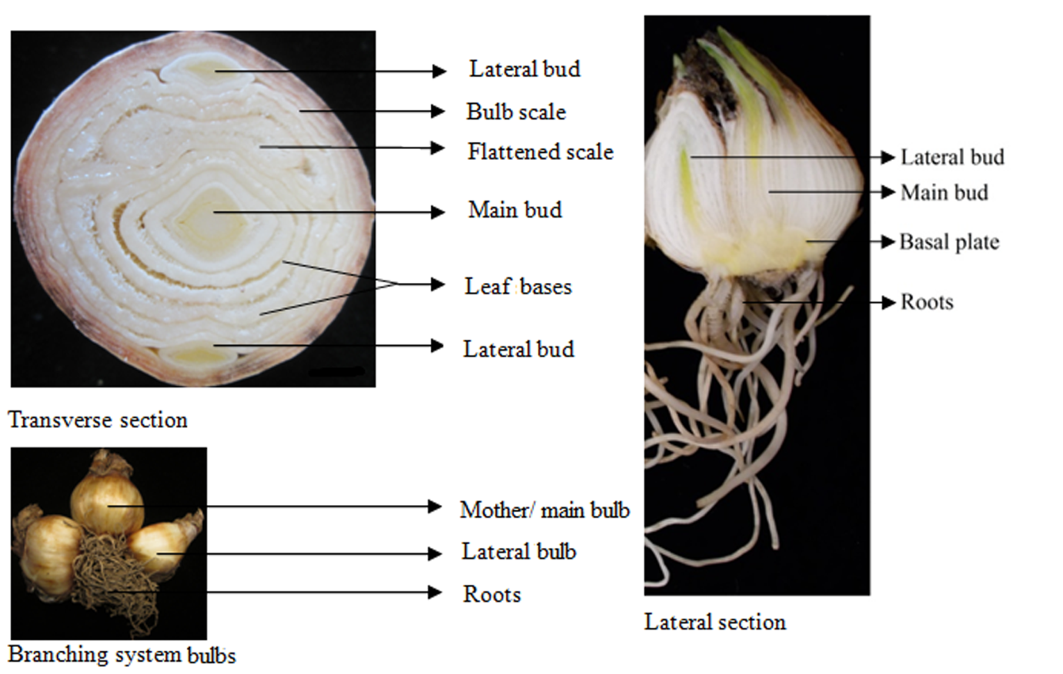

**Fig. 1.** Transverse and lateral sections of *Narcissus* bulb showing main and lateral buds and different bulb scales as well as branching systems bulbs with roots (field sample). Scale bars: 1.5 cm.

Bulb collection (eight to nine months old after flower senesced)

Breaking bulb dormancy (keeping at 4oC for 30 days)

Cleaning of old and dead scales

Hot water treatment at 52oC for 1 h

Drying overnight at room temperature

Bulbs cut into four halves and surface sterilization with Domestos bleach solution (20%) for 30 min

Twin-scale explant preparation and placing the explants in media treatments

After 8-12 weeks callus proliferation and direct bulblets

After 12-16 weeks bulblets with green and white shoots

After 12-14 weeks regenerated bulblets form callus

Incubation at 24±2oC for 12 h photoperiod

**Fig. 2.** Flowchart showing complete procedure and timing of *Narcissus* tissue culture from twin scale explant



**Fig. 3.** Effect of temperature pre-treatments (45oC for 2 h; 52oC for 1 h and 54oC for 1h) after 10 weeks of incubation on MS, MS with high NAA (20 mg/l) and low NAA (4 mg/l) media.

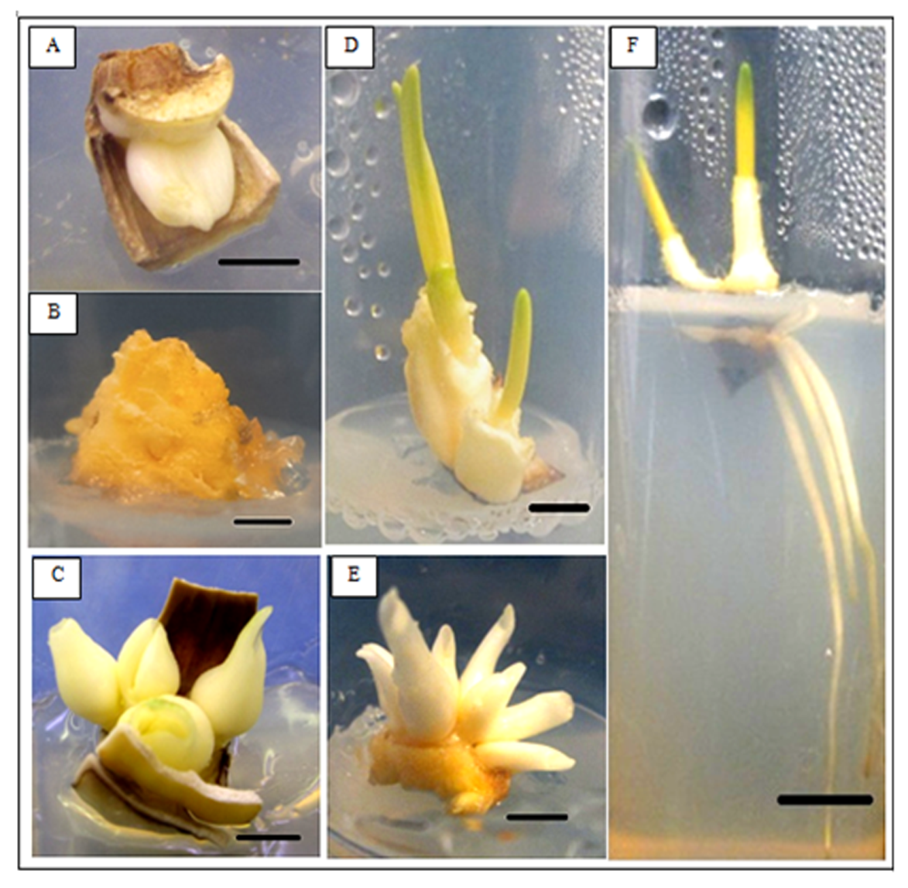

**Fig. 4.** Tissue culture derived samples from *N. pseudonarcissus* cv. Carlton: twin-scale explant with small bulblet (A) from MS basal medium after 4 weeks, callus (B) from high auxin medium after 8 weeks, white bulblets directly grown from the base of twin-scale (C) from low auxin medium after 8 weeks, small bulblets with green and white shoots (D) from MS basal medium after 12 weeks, bulblets regenerated from callus differentiation (E) on high auxin medium after 14 weeks and bulblets with roots (F) from MS basal medium after 16 weeks of incubation. Scale bars: 0.5 cm.



**Fig. 5.** Response of twin-scale explants to different media combinations and bulbs: (A) callus induction after 12 weeks; (B) callus differentiation to regenerated bulblets after sixteen weeks and (C) direct bulblets initiation from twin-scale base after twelve weeks of incubation. Multiple bars indicating the response of bulbs in multiple media with the absence of bars indicating no callus or bulblets were obtained, due to either contamination or senescence.

**Fig.6.** Representative Calibration curve of galanthamine standards for first batch of samples showing galanthamine molarities versus Gal peak area.

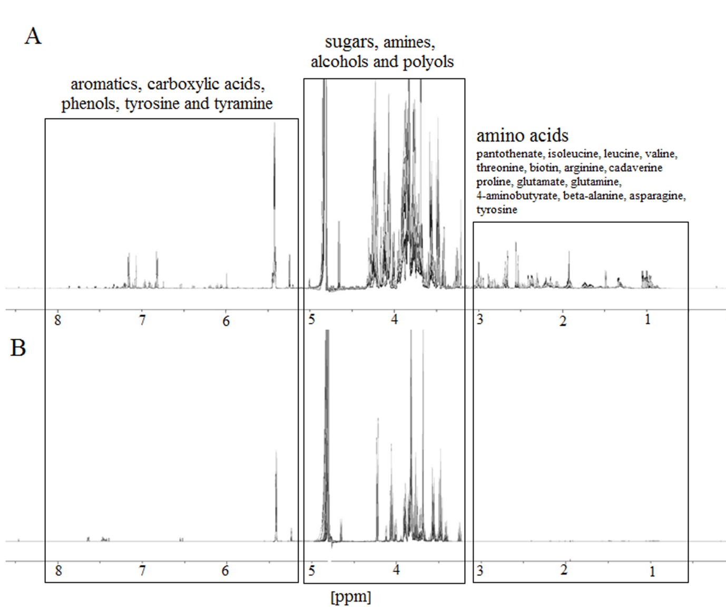

**Fig. 7.** Representative 1H NMR spectra from 0.7 ppm-8.0 ppm of *Narcissus pseudonarcissus* cv. Carlton field (A) and calli (B) samples representing the major groups of metabolites with their representative peaks.

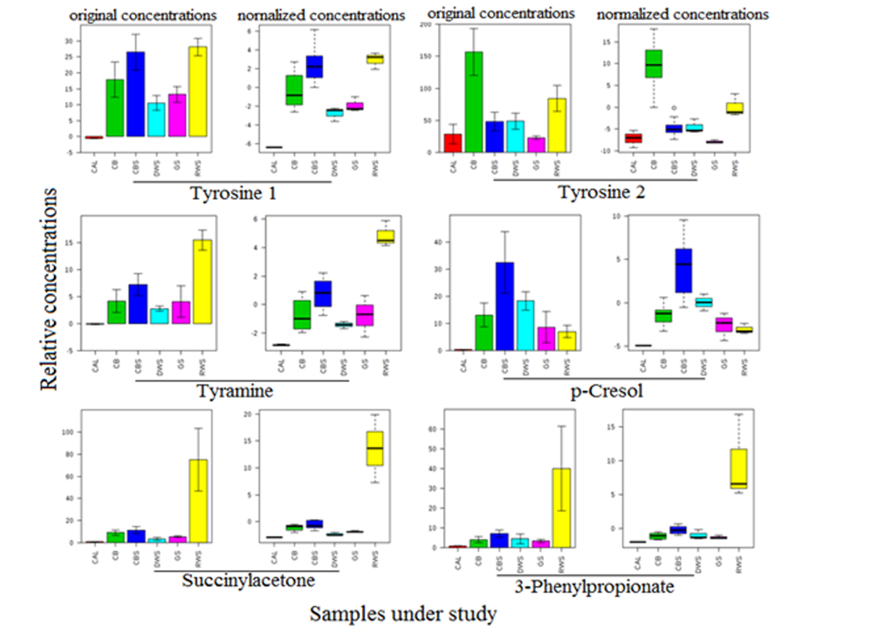

**Fig.8.** ANOVA boxplot representing the relative concentrations of significantly different metabolites (peaks or signals) involved in tyrosine and phenylalanine metabolism among all samples under study (field samples = CB and CBS; callus = CAL; regenerated white shoot = RWS; direct white shoot = DWS and green shoot = GS). Two sets of tyrosine (1 and 2) are due to the presence of two signals. Error bars = SE.

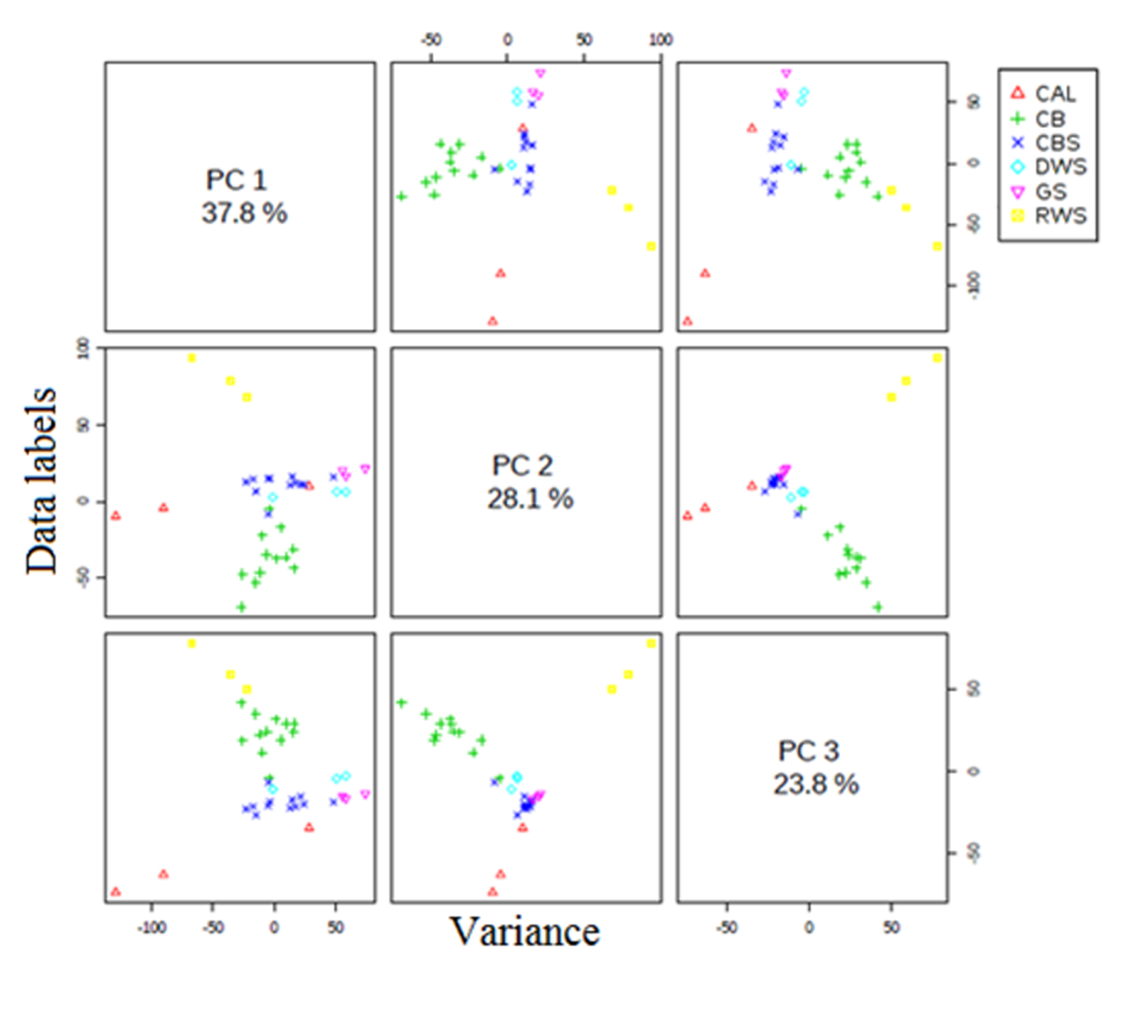

**Fig. 9.** A three-component pair wise score plot between the selected PCs for field and *in vitro* tissues, representing variance of each PC in the corresponding diagonal cell. CAL = callus; CB = Carlton bulb tissue; CBS = Carlton basal plate; DWS = direct white shoot; GS = green shoot and RWS = regenerated white shoot.

incubated in a culture room (24±2oC, 12 h photoperiod)

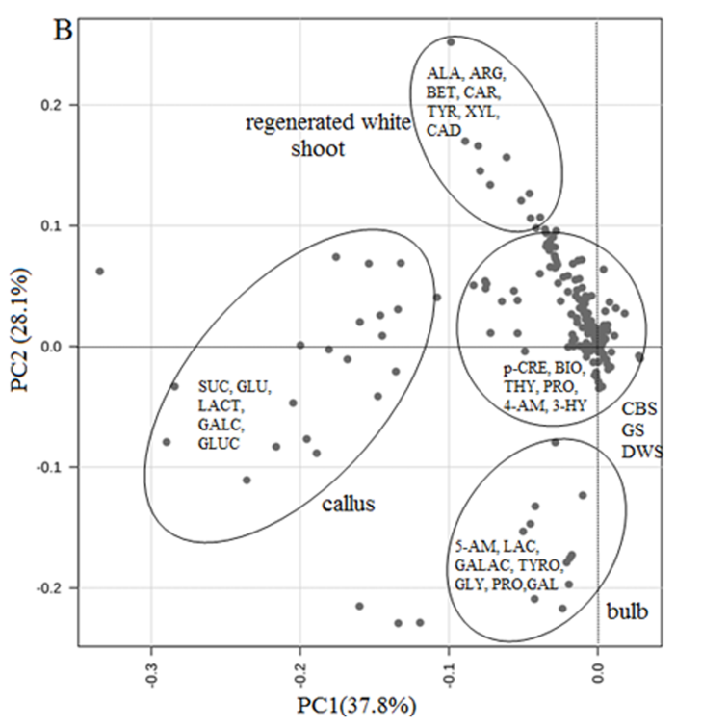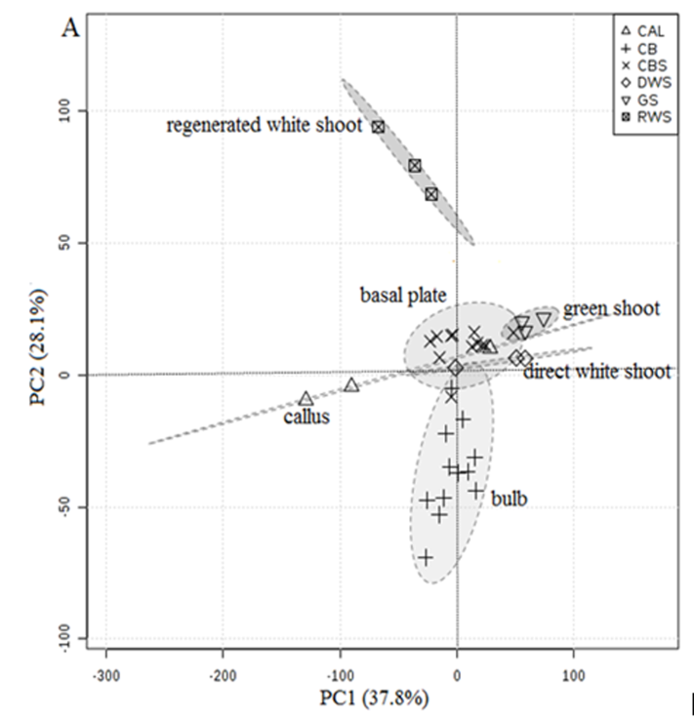

**Fig. 10.** Score scatter plot (A) for principal component analysis (PC1 versus PC2) obtained from 1H NMR spectra of *N. pseudonarcissus* cv. Carlton bulb (CB), basal plate (CBS), callus (CAL), direct white shoot (DWS), green shoot (GS) and regenerated white shoot (RWS); and corresponding loading plot (B). In the loading plot 'dots' represent 1H NMR signals (metabolites). Those important for discrimination of the assigned classes are labelled, ALA = alanine, ARG = arginine, BET = betaine, CAR = carnitine, TYR = tyramine, XYL = xylose, CAD = cadaverine, SUC = sucrose, GLU = glucose, LACT = lactose, GALC = galactitol, GLUC = glucitol, p-CRE= p-cresol, BIO = biotin, THY = thymol, PRO = proline, 4-AM = 4-aminobutyrate, 3-HY = 3-hydroxymandelate, 5-AM = 5-aminolevulinate, LAC = lactate, GALAC = galactarate, TYRO = tyrosine, GLY = glycolate, GAL = galactonate.