Typology of Grain Storage Structures
in Rural Communities in Kogi State – Nigeria:
Economic Implications on the Rural Farmers
Ahiaba U.V.¹, Parsa A.², Kempton J.²
¹Department of Agricultural & Environmental Engineering, University of Agriculture, P.M.B. 2373, Makurdi, Benue State, Nigeria
²School of Real Estate and Land Management, Royal Agricultural University, Stroud Road, Cirencester, GL7 6JS, United Kingdom
*Corresponding author: victorahiaba@gmail.com
Abstract This study examined the economic impact of grain storage structures and storage duration on the income of rural farmers in Kogi State, north-central, Nigeria. The study utilised the questionnaire method, supported by on-site observation and interactions with key players along the grain supply chain. Multistage sampling was used to select three hundred (300) rice and maize farmers spread across fifty (50) communities in the State that participated in the research. The results show that the storage systems and length of storage of the farm produce (maize and rice) has a significant impact on the annual income of the farmers, and only 1 per cent of the grain farmers’ population earned above the 2017 world’s poverty benchmark. We found out that access to technology for agricultural purposes was zero. The major challenges reported by the farmers are; poor processing/storage facilities (43.4 %), poor sales after harvest (30.3 %) and lack of agricultural credits (23.3 %). The existing storage structures encourages post-harvest waste and losses, affecting the quality of stored grains and invariably its market value and farmers’ income; the grain market is erratic with middlemen dictating the price of grains. None of the farmers surveyed had accessed agricultural credit at any time. The study recommends shared or communal storage centres for each of the communities, where farmers can either have their grains sold at Guaranteed Minimum Price or with an option to store the grains in anticipation of better prices in the future. Bank Accounts would be opened for the farmers, and a Grain Card would be issued to help keep and build the farmers’ “Activity Ratings” for economic purpose like credit assessment to determine eligibility for agricultural credit. Private firms should manage the shared or communal centre in each community in a public-private partnership with the government, but the farmers should be shareholders by default. The shared or communal centres should also be a reliable intermediary between the farmers and other key stakeholders, strengthening the rural economic institution, and serving as a training centre for the rural farmers. A theoretical shared or communal storage model was designed.
Keywords: community, economy, farmers, grains, poverty, rural, storage.
1. Introduction
In many locations where grain storage is through the traditional means, high volume of waste and losses are not uncommon. For example, traditional storage structures have been reported to cause grain waste and losses up to 59.48 and 54.05 per cent of farmers’ harvest in Uganda and Burkina Faso respectively [1]. In Nigeria, the situation is not different; poor storage systems cause a significant waste of farmers’ harvest each year [2,3]. For this reason, long term storage in anticipation of better price in the future is a problem for the rural farmers.
Pre-harvest and post-harvest waste and losses among rural farmers in Nigeria have been reported for various crops, ranging between 25 to 80 percent [4,5,6]. In general, the government of Nigeria placed the average post-harvest waste situation among farmers at 60 percent [7]. Poor storage can reduce the quality of the stored grains and could also deprive the farmers access to competitive markets, resulting in low income.
Leathers and Foster [8] posited that low income is the root cause of poverty, hunger/under nutrition, food shortage, uneven wealth distribution and quality of life of the people in developing countries. People must earn to be able to purchase many other things that they are unable to own themselves, to improve the quality of their lives. Even though agriculture remains the mainstay of Nigeria’s economy, employing between 30 to 70 percent of the population at different times [9], many of the farmers are economically weak, living in poverty. This is notwithstanding the large amount of money that has been spent on rural projects targeted at poverty reduction and eradication [10].
Efforts by the Nigerian government and donor agencies from across the world to tackle rural poverty and improve the economic condition of the rural farmers in Nigeria have not yielded the expected results [10]. At one time, Nigeria harboured the second largest impoverished population in the world after India [11,12]. Though annual economic growth averaged over seven per cent in the 2000s [13], the paradox was that the proportion of Nigerians living in poverty kept increasing every year despite the growth. In 2004 the relative poverty was 54.4 per cent which represents 68.7 million Nigerians; whereas in 2010, poverty incidence rose to 69.00% representing 112.47 million Nigerians [13]. It has been reported that 73.2% of the rural population and 61.8% of the non-rural populace in Nigeria earned lower than the world’s poverty line [14].
Access to competitive market by the farmers is also a problem. With about eighty per cent of the population of Kogi State, Nigeria, involved in agriculture, an established system for farmers’ produce would have been the ideal situation. Many government schemes aim to increase agricultural production but not to improve the marketing and sales of the outputs in a way that would benefit the farmers economically.
Besides the Agricultural Development Project (ADP) of the World Bank in the 70’s, one of the government projects in recent times, assumed to be the most impactful in helping the poor rural economic situation of the farmers, is the Growth Enhancement Support Scheme (GEES). It aimed at increasing farm inputs such as fertilisers and improved seeds for the farmers, and for creating an enabling atmosphere for private sector investment to modernise and industrialise agriculture in Nigeria. For the programme’s aims to be achieved, it was envisaged that agriculture must be treated as a business venture, with government facilitating rather than being directly involved. Also, the establishment of a risk-sharing facility by
the Central Bank of Nigeria, through the Nigeria Incentive-Based Risk Sharing System for Agricultural Lending (NIRSAL) in 2011, was to “de-risk” bank lending to farmers. It was aimed at making agricultural credit available to the farmers, but access to genuine farmers has been a problem as people who are not farmers took advantage of several structural loopholes [15].
Like the World Bank’s ADP, once the foreign support ended, or once the government of Nigeria changes hands, the projects becomes epileptic or abandoned. More so, rural farmers may have no information about NIRSAL, and if they do, meeting the requirements to access the credit could be a major problem because of lack of infrastructure required to assess the farmers. The means to assess the credit worthiness of the farmers is not there, making some people to access government agricultural credits and run away [16] without repaying the credit. In some cases, those who are not farmers would even obtain the agricultural credits and divert the credits into non-agricultural ventures or something else.
There is also the problem of adulteration of agricultural inputs like fertilizers [17] so bad that fertiliser merchants were reported to have mix sands with fertilisers and sold to the farmers as genuine fertilisers. Seeds that are not high yielding are also being sold to the farmers as high yielding, disease resistant varieties. Considering these challenges, it was not a surprise that agriculture contribution to the Gross Domestic Product (GDP) of Nigeria has been on the decline since the year of independence in 1960 [18,19] as shown in Figure 1, below.
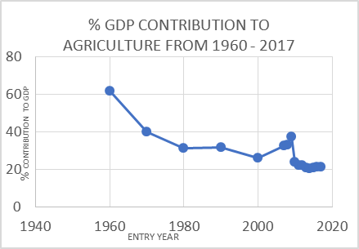
Figure 1. Contribution of agriculture to Nigeria’s GDP from independence in 1960 to 2017. Credit: Generated from the report by [18,19]
In this study therefore, we looked at the impact of storage systems, the duration of storage among the rural rice and maize farmers, on the farmers’ income, which invariably affects their economic condition, to recommending and designing an improved model that creates opportunities for the farmers to overcome the challenges within
their communities. Rice and maize were chosen because they are the main cultivated cereal crops in all the communities – both as food and cash crops.
2. Materials and Methods
Kogi State is one of the thirty-six States in Nigeria, with over 80% of its population living in rural areas [20,21], over 95 per cent of those in rural areas, are farmers with poor economic condition [22].
The State has some vegetation privileges compared to some other States in Nigeria. It lies at the transition between the tropical vegetation of the southern and the Sudan/Sahel savannah of the northern parts of Nigeria, making cultivation of various crops possible [23]. The State is also a confluence, with the merging of two major rivers in Nigeria – River Niger and River Benue, in the State’s capital, Lokoja. Kogi State was therefore selected as the case study for the Nigeria States.
A multistage sampling procedure was used to select the respondents, using the stratified sampling method. At the first stage, the State was divided into 50 strata called communities (the entire communities identified were 52. However, four were small and had no Community Heads at the time; these were merged in twos, bringing the total to 50). These communities comprise of several villages and towns. However, only the rural villages were considered to conform with the focus of the study. At the second stage, random sampling was used to select two villages from each community. At the third stage, participants were randomly chosen to conform to the type of participants required for the study. Where a randomly selected participant does not meet the necessary criteria or where other participants have completed a test, the data generated were discarded as saturated or invalid. In all, a total of 300 participants were selected for the study. Data collected were analysed using statistical techniques like frequency counts, percentages, means and standard deviation while inferences were drawn from analysis of variance on the following hypothesis:
Null Hypothesis: Storage systems and duration of storage has no impact on the farmers’ annual income in rural communities of Kogi State - Nigeria;
Alternate Hypothesis: Storage systems and duration of storage has an impact on the farmers’ annual income in rural communities of Kogi State – Nigeria.
2.1. Representative Sample Size Determination
The population of Kogi State (2017 projection) was 3,478,029 based on the projection from the previous census and annual growth rate. With 80 % of the population being farmers in rural areas [20], the population frame was 2,782,423. At 95% confidence level, 300 farmers were considered as the representative sample size, at the margin of error of 6, calculated at a normal distribution of fifty per cent, using the equation 1, below, provided for large population, as cited by [24].
(1)
Where,
SS = sample Size
P = Population proportion
M.E. = Margin of error or confidence level
Z² is the abscissa of the normal curve that cuts off an area α at the tails, obtained from Z value; M.E = the desired level of precision;
P = the estimated amount of a characteristic that is existing among the people;
Z can be found in statistical tables which contain the area under the normal curve.
Since this study involved a large population, it is assumed that the margin of error of 6 is good enough to draw a valid conclusion from the results of the field work. Statistically, as the margin of error increases, the sample size decreases and become less representative. At the margin of error of 6, the sample size was 267 (calculated), however, to improve the representativeness of the sample and result validity, this was round up to 300. The rounding up was done to also ease data analysis. With 50 communities in the State, six participants were required from each community (that is, 300 divided by 50 communities, equals 6). A report by [25] recommended that a comfortable margin of error should be chosen with a degree of precision based on variability, confidence level and margin of error. The most cost-effective (comfortable) sample was selected at the margin of error of six (6).
The sampling stages followed the pattern of Figure 2, below. Since the numbers of villages in each community were uneven, a random sampling was carried out on the villages to determine where the participants should emerge, giving every village an equal chance of being selected. Another random sampling was done on the sampled villages for the emergence of the participants. However, the attributes of the participating farmers were pre-determined to ensure balance in gender and age of the farmers. A minimum farmer age of 18 years was chosen to correspond with the beginning of adult age in Nigeria, while the 45 years was chosen to correspond to the mean age of the farmers obtained from the survey, and it closely relate to the mean age obtained by other researchers such as [2,20,22].
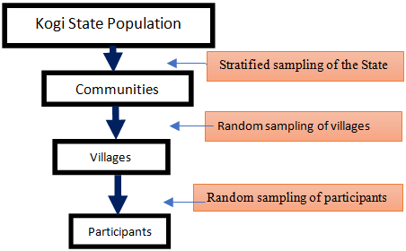
Figure 2. Sampling stages to decide the participants
2.2. Data Gathering Tools
The questionnaire was used for data gathering, supported by on-site observation and interactions with key players along the grain supply chain. For the survey, the farmers were asked how long they store grains (rice and maize) before selling them off; the annual earnings from the sales were estimated. The yearly income of the participating farmers, which represents the probable yearly income of the farmer population in the State, was then compared with the poverty benchmark of 2017 (based on purchasing power parity).
The different storage systems found in Kogi State were grouped into “six” according to the walling and roofing materials. Note however, that farmers that do not store their grains at all after harvesting but sell them off immediately were considered as a “storage type”, code-named as “No-Storage” farmers. This was done to allow a fair comparison of income among the farmers. Similarly, farmers who “live-in” with their stored grains were also grouped such that they were distinct from farmers that store their grains separately from their dwelling place (non-live-in), even though the storage materials or medium may be the same.
To support the questionnaire, an on-site observation was used to physically assess the existing storage systems, which were then grouped according to the materials used for the walls and roofs, for analysis. There was also an interaction with key players along the grain supply chain. The reason for the interaction was to look at the impact of the middlemen on the income of the rural farmers. For this, the minor (rural level) and major grain merchants, the grain transporters, and manufacturing firms that uses agricultural produce as raw materials were involved in the interaction. The players were asked questions on the farmers they patronize and who patronizes them.
3. Results and Discussion
3.1. Farmers’ Income and Poverty Benchmark
The responses of the farmers on their income were summarized as shown in Table 1, harmonised with their respective storage types. Using a line chart, the comparison between farmers’ annual income and poverty benchmark could be visualised easily, as shown in
Figure 3 (Note: 1 USD = 350 Naira was the exchange rate used). Similarly, Figure 4 is the line chart showing the yearly income of the farmers as compared to the length of storage. The typology of grain storage structures found in the communities is as shown in Figure 5.
Table 1. Average storage duration for the storage types identified
Storage type identified | Storage Groups Codes | Mean length of storage (weeks) | Mean annual income (USD) | Number of farmers | Poverty  benchmark (USD)
Thatch wall with thatch roofs | 1 | 18.0 | 476.2 | 6 | 693.5
Thatch walls with zinc roofs | 2 | 5.0 | 191.8 | 14 | 693.5
Mud walls with thatch roofs | 3 | 12.0 | 321.1 | 97 | 693.5
Plastered mud/concrete walls with zinc roofs (non-Live-in) | 4 | 7.0 | 162.8 | 80 | 693.5
“No-Storage” farmers | 5 | 0.0 | 88.9 | 48 | 693.5
Plastered mud/concrete walls with zinc roofs (Live-in with grains) | 6 | 8.0 | 163.6 | 55 | 693.5
Total |  |  |  | 300

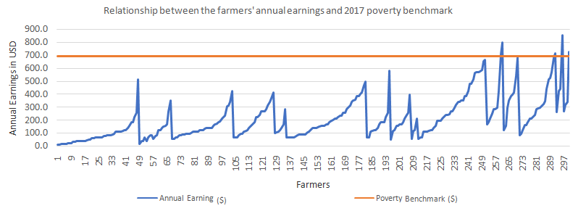
Figure 3. Comparing the 2017 poverty benchmark and farmers’ annual income

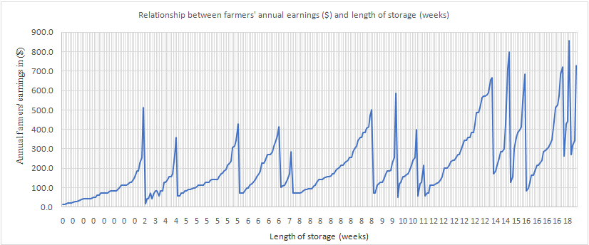
Figure 4. Line chart showing the yearly income of the farmers and the length of storage

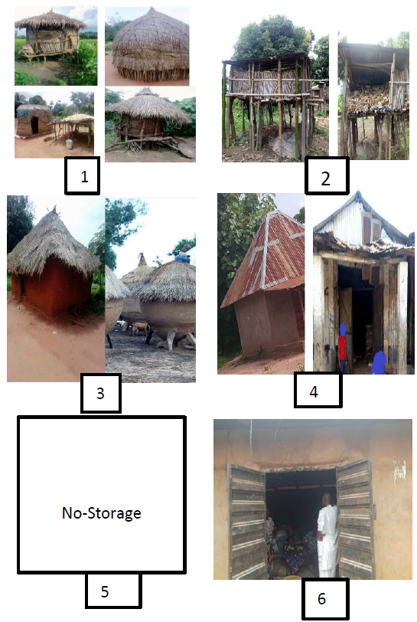
Keys: 1 = Thatch wall with thatch roofs; 2 = Thatch walls with zinc roofs; 3 = Mud walls with thatch roofs; 4 = Plastered mud/concrete walls with zinc roofs (Non-live-in); 5 = No-Storage structures; 6 = Plastered mud/concrete walls with zinc roofs (Live-in with grains)
Figure 5. Typology of grain storage structures identified
3.2. The Challenges Identified in the Communities from the Survey
The problem with the storage structures in Figure 5 above is that they are neither air-tight, fire-proofed nor rodent-proofed. However, best practices require that grains are stored in rodent-proof containers [26]. Some storage materials may prevent insect attack, like the hermetic bags, but they do not avert rodent attack [1]. For rice grain [27] opined that extended safe storage
of rice is possible if grain moisture content is less than 14%, and stored away from insects, rodents and birds. For the various storage systems, Table 2 shows the major challenges identified by the farmers while the grains are in store. From the table, farmers in Kogi State
are having a difficult time with storage, such that could potentially compromise the quality of the stored grains, their incomes and health, like the case of Lassa
fever outbreak in the State [28]. The carrier of Lassa fever is wild rat, and it is transmitted through the urine of the rats, having contacts with food materials like grains in store.
Table 2. Challenges of storage identified by the farmers
Storage type | Problems in storage | Number of farmers
Thatch wall with thatch roofs | Insects, mice/rats, fungi, fire outbreak; | 55
Thatch walls with zinc roofs | Insects, mice/rats, fungi, fire outbreak; | 159
Mud walls with thatch roofs | Insects, mice/rats, fungi, fire outbreak; | 80
Plastered mud/concrete walls with zinc roofs (live-in and non-live-in) | Insects, mice/rats, fungi; | 6
No-Storage farmers | NA | NA

Access to dangerous pesticides, especially a brand called “Sniper” which has DDVP (Dichlorvos or 2,2-dichlorovinyl dimethyl phosphate) as its active agent, is not just common among the farmers, its usage is in excess, and represents food risks to the public. Its excessive usage is because, DDVP is commonly effective against household and agricultural pests [29]; and these are the pests that farmers reported as their storage pests. More so, DDVP was reported to have been declared as a nerve gas (agent) or chemical warfare agents (CWA) or both [30]. The effect of DDVP on pests go beyond the pests, and as far back as 1998, the EU had banned it from use [31] – the ban that applies to all the EU countries, including the UK.
From Figure 3, the survey revealed that only three farmers, representing just a per cent of the farmers that participated earned above the 2017 world poverty benchmark, based on purchasing power parity. It confirmed the report by [14] that most of the poverty situations are in the rural areas compared to those in urban areas. From figure 4, most of the farmers are huddled around yearly income between $100 to $400 and the length of storage for these farmers ranges from 0 to a little above two months (8-10 weeks) before the grains are sold. The grain market in the rural areas appears extremely erratic and non-competitive. We found out that some of the farmers who stored for about ten weeks were seen earning the same amount per kilogram compared to those that stored up to 18 weeks because the middlemen dictate the price always. Access to the right market at the right time may also have played a role in deciding what each farmer earned. However, long-storage-farmers appears to do better economically.
When the farmers were asked to identify the key challenges confronting rural farming, Table 3, below show their responses. The trio problems of storage, poor sales and lack of access to agricultural credits were indicated, with nearly half of them pointing to the direction of the challenges resulting from poor processing and storage facilities.
The result agreed with [32] for Osun State, Nigeria. Post-harvest waste and losses as reported by the farmers are as shown in Table 4, and about 93.6 percent of the population losses between 21 to 60 percent of their grain harvests each year. On access to credit, out of the 300 farmers, none had accessed agricultural credit facility at any time in their lives.
From Table 4 below, up to sixty per cent losses were recorded by some farmers, a situation that is considered alarming. The best practice is for the farmers to have zero per cent wastes and losses. However, loss between 2 to 5 percent may happen but beyond 5 per cent is technically and economically unacceptable in this modern era of technological advancement in the management of stored products.
3.3. Testing the Hypothesis: One-Way Analysis of Variance (ANOVA)
The ANOVA was used to estimate the significant difference between the mean of three or more unrelated groups of the storage system. It primarily tests the null hypothesis that;
(2)
Where µ means group mean and x means some
groups — one Way ANOVA gives a significant result. However, the ANOVA does not tell where each specific group were different from one another; the f-value does. Table 5 shows the ANOVA table between the annual income of the farmers and the duration of storage.
An f-value in a One-Way ANOVA test helps find out if the means between two populations are significantly different. It tells if a group of variables are jointly significant. Expectedly, the f-value must be used in combination with the p-value when deciding if overall results are substantial. The f-value in the ANOVA test also determines the p-value; the p-value is the probability of receiving an outcome at least as extreme as the one that was observed, should the null hypothesis be correct.
Since the f-value, f-critical value and the p-values between groups fulfil the condition required to reject the null hypothesis, the null hypothesis was at this point rejected with 95 percent confidence.
In other words, farmers’ income in Kogi State, Nigeria, is greatly influenced by the length of storage, which is invariably determined by the type of storage systems the farmers adopted. The alternate hypothesis (H1) is therefore correct.

Table 3. Challenges reported by the farmers
Challenges | Agricultural Credits | Poor market (Sales after harvest) | Processing and Storage Facility | Total
No. of Farmers | 79 | 91 | 130 | 300
Percentage (%) | 26.3 | 30.3 | 43.4 | 100

Table 4. Percentage of post-harvest waste reported by the farmers
Waste recorded based on grain quantity before and after storage (in 100 kg bags) | Number of responses | Percentage (%)
Zero waste | 0 | 0.0
5 – 20 % | 19 | 6.4
21 – 40 % | 193 | 64.3
41 – 60 % | 88 | 29.3
61 - 100 | 0 | 0.0
Total | 300 | 100.0

Table 5. Analysis of variance (ANOVA) showing the difference between the annual income of the farmers and the duration of storage for each set of farmers
ANOVA: SINGLE FACTOR
SUMMARY
Groups | Count | Sum | Average | Variance
Annual income ($) | 6 | 1404.4 | 234.06 | 19821.53
Length of Storage (Weeks) | 6 | 50.6 | 8.43 | 37.36
ANOVA
Source of Variation | SS | df | MS | F | P-value | F crit
Between Groups | 152731.20 | 1 | 152731.20 | 15.38 | 0.0028 | 4.96
Within Groups | 99294.48 | 10 | 9929.44
Total | 252025.69 | 11
Keys: df = Degree of freedom; SS = Sum of squares; MS = Mean Square.
Farmers that stored up to 18 weeks before sales, made the most profit at the end of the year, though the market appears to be erratic. Storage up to 24 weeks could have yielded an even better income, but only very few farmers could wait for that long without the possibility of the grain deteriorating while in-store owning to the pests and other problems associated with the storage systems as identified. Storage between 24 and 40 weeks could be possible, and with a greater chance of higher earnings, as old stocks may have been used up, paving the way for the soon-to-come new harvest. So, the implication of storing between 24 and 40 weeks comes with both positive and negative possibilities, as the farmers may obtain the best price for their grains or otherwise. The farmers who do not store at all earn incomes equivalent to one-fifth of the earning of those who stored up to 18 weeks and above for the same grain quantity and quality.
3.4. Economic Implications
We also found out that the number of middlemen between the farmers and the main primary end users (like major food manufacturing firms) of the farm produce is substantial – even up to 5 intermediaries on average. This long exchange of hands could lead to waste and contaminations ranging from insect infestation to some large-scale chemical use, like pesticides to prevent the grains from deterioration.
It was not a surprise therefore that, between 2014 and 2016 alone, the European Commission rejected 109 processed and semi-processed food products originated from Nigeria to the European Union. Some of the food items were rejected because they contained foreign agents, such as glass fragments, rodents’ excrement, and dead insects. Elevated levels of chemical contaminants, used in fumigation, such as aluminium phosphide, dichlorvos, dimethoate, trichlorphon, cyhalothrin, were also discovered in the products. Microbes, such as salmonella, aflatoxins, and mould growth, were also found in some of the products [33]. A red alert is on food products from Nigeria till date.
It was clear that the farmers are earning a little from their farm work. Equation (3) below, estimates the amount the farmers are paid by the local grain merchant (the first middleman to patronize the rural farmers) and the amount the major food manufacturing firms pay the last middleman that delivers agricultural raw materials to them.
(3)
k = the amount paid to farmers for x kg of grains;
p = amount paid by the manufacturing firms to the last middleman that delivers the grains to the firms for the same x kg of grains;
ϵ = is a number between 6.28 and 21. This denotes how much times the farmers could have earned if the number of middlemen reduced accordingly. It means farmers would earn up to 21 times their current earning if they can access the market without the middlemen and with high quality grains.
Considering the challenges of storage systems as earlier reported above, the post-harvest waste and losses being encountered by the farmers and the poor sales that creates a deep dent in their earnings, plus the general absence of technology utilisation in agriculture, there was a need to propose an alternative model which will not only solve the storage problems, but would create a solid rural institution to solve the other identified challenges, including the grain marketing systems, access to credit and technology.

3.5. Shared or Communal Processing and Storage Model
The shared or communal processing and storage centres did not just appear out of the blues. Previous research had indicated a lack of “localised feel” among the agricultural schemes or programmes in Nigeria [34,35]. So, we asked the farmers how they would prefer any developmental projects in their communities. We found out that 76.3 per cent prefer that their community be inclusive in such projects, including having the projects named after their communities. Five (5) per cent were undecided on the matter while 4.3 per cent would prefer to associate with the local council/state/zone where their community is situated. Also, 14.4 per cent says they do not care about the project and its location, but the effectiveness of the project. It shows from the result, that many of the farmers would feel a sense of “belonging” dealing with one another as a “community” than as a council or zone. We saw reasons why [36] had suggested an all-inclusive model that create markets for the farmers, as an effective means to reduce poverty in developing countries.
It was important we consider the political situations that plays among the rural communities also, because they are great divisions among them, even though they are a strong force in deciding who wins an election or otherwise, owing to the population in the rural areas (80%). Political elections are conducted at the ward, council and zonal boundaries, thereby separating the farmers politically. We realized that many of the communities’ span across local councils or zones, which means, people from the same community, who normally would want to do things together, were found separated by the way the councils or zones are bounded. These issues led to the concept of shared or communal processing and storage centres within each community, aimed at training and building the needed bridge between the farmers and various stakeholders. This way, we separated the model from political structures that exist among the communities.
Before now, the government had established zones called the Staple Crops Processing Zones of the federal government of Nigeria to boost crop production, minimize postharvest waste and encourage agro-industrialization [7]. However, its impact has been grossly ineffective, in some zones failed, because of the political attachment to such projects; more so, it was far from the beneficiaries in a top-down solution of the government that does not consider the beneficiaries. This is unlike this study. In fact, one hundred percent of the said they have not even heard of the scheme, including the grain storage silos complex located at the State capital – Lokoja.
Shared or communal processing and storage centres would allow farmers to bring their harvests to a shared point within their community for processing and storage to be done with modern equipment and expertise. We found farmers drying farm produce using odd platforms like the hard shoulder of a road, car park and even on bare surfaces, as shown in Figure 6, below. These platforms create rooms for contamination, even before the produce gets to the storage.
3.6. How the Model Works
With this model, the harvested grains could be exchanged for cash immediately at a Guaranteed Minimum Price (GMP) right within their communities. The GMP is arrived at using equation 4 or 5 below.
(4)
Where A = Cost of input (fertilizer, pesticides, and improved seedlings) /ha; B = Cost of land lease/ha;
C = Cost of labour/ha; D = Cost of transportation;
E = Cost of other materials; F = Insurance premiums;
P = profit for the farmers, which should be at least between 5 – 25 percent per ton.
Or
(5)
where = $k= A+B+C+D+E+F$.
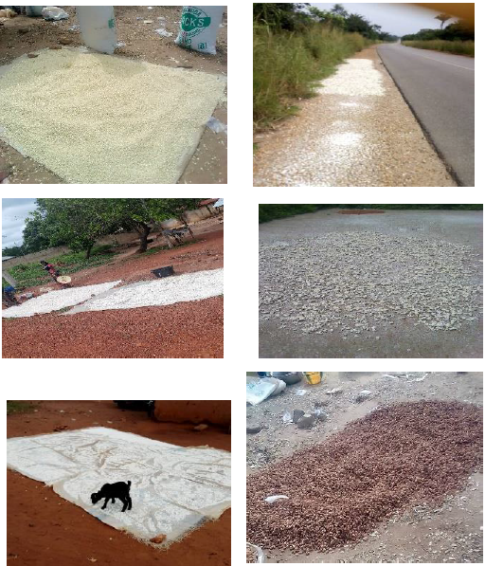
Figure 6. Agricultural product drying platforms
For farmers to break even, GMP > (k + P) always. This formula works for the States in north-central zone of Nigeria because of similarity in vegetation, mode of storage and general agricultural practice. For the southern part of Nigeria, the cost of labour per hectare (C), either with human labour or machines, could be up to six times that of the north-central zone (like Kogi State) for the initial land preparation, owing to the forested vegetation, coupled with swamps and mangroves. For the northern part of Nigeria, the labour cost could be 3/4C because its vegetation is less thick compared to that of the central and southern parts of Nigeria. These must be considered if the formula must be applied in the south and north of Nigeria.
Alternatively, the harvested grains could be stored for later sales following negotiations between the management of the shared or communal centres and the prospective buyers (in which case the farmers pay premiums, but not more than 10 percent of the produce stored per annum, to cater for storage cost and administrative charges involved in connecting with the buyers), hence allowing the sustainability of the communal centres. Reference [1] had suggested community level silos, as an economical alternative to having individual silos because the cost per unit grains decreases with an increase in the size of the silo.
In Indonesia, concepts like the contract farming [37] have been used to effectively pull many farmers out of poverty. The author had explained, that “through contractual arrangements, agro-industry [assisted] the smallholders to shift from subsistence or traditional agriculture to the production of export-orientated, high-value products”.
On rural agricultural financing, repayment with harvested crops has been reported to have effectively worked for farmers in some communities in Kogi State [23]. Therefore, similar and other flexible repayment platforms could be worked out for flexibility. The flexibility is important since this model is still at its emerging stage.
At the shared centres, the farmers would receive extensive training on good agricultural practices and technology adaptation on a continuous basis. Reference [1] posited that training of smallholder farmers is equally as necessary as the technology dissemination. Information and training about the use, maintenance of agricultural technologies by the local communities would determine how well the farmers would adapt to the techniques. Consequently, Harvest and Bank accounts would be opened for each farmer as the standard practice, and they would be issued a Grain Card, containing all the information about them such as their next of kin (in case a farmer passes on while having grains in store), the farm location, size, and the quantity of grains that they have sold or stored through the shared storage. Bank accounts are necessary because, of the 300 farmers surveyed, only two claimed to have bank accounts. In this electronic age, flexibility and local content must blend and still fit into the international standards, hence farmers would have to receive training, adopt the technology of today for speedy transactions.
The Grain Cards would help to keep the farmers’ Activity Ratings based on performance measured by how much grains they have processed, stored, or sold through their respective shared or communal centres. For a farmer to be able to access the services of the Centres, the farms must be known and assessed by the experts at the Centres, and unique identification numbers are issued. This is to prevent fraud and to correct the challenges identified with the previous schemes such as the GEES, where non-farmers had all access to inputs that were meant for real farmers. Also, grains can be sold or traded among farmers without physically moving the grains from the store. When there is a large demand from firms, the Centre would contact the member farmers of the offers – whereby the farmers are at liberty to accept the offered price or reject. For those that accept, the quantity sold would be deducted from their Harvest Accounts. If another farmer had purchased from another farmer, the quantity traded would debit on the seller and credit on the buyer, and the paid amount would be credited to the seller’s account less administrative charges. The framework of the Centre is as shown in Figure 7, below. The framework was based on the extensive mapping (Figure 8) of the communities, recognizing the several factors in deciding where the Shared or Communal Centre should be in each community.
A good Activity Ratings for a farmer means the farmer may be recommended for credits such as input credit, equipment or even personal items based on collaborations between the Centres and the stakeholders (Figure 9), driven by the internet. The villages around each community (indicated with small orange pentagon) would be managed by the shared/communal centres in that community (represented with medium green pentagon in the figure). The government may liaise with the communal centres to feed the Central Grain Reserve Silos (indicated with largest pentagon) in the State that has been under construction since 1994, even though it was scheduled for completion within two years (facts from empirical results involving an on-site assessment and an interview with a key government staff, at the silos complex, located in Zango – Lokoja). The central reserve can then feed Value Addition Centres (the blue shaded pentagon) for processing its old stocks into manufactured foods and compete with other food manufacturing firms. Such competition is necessary from the government to checkmate prices of manufactured foods also, and to tap into the opportunities in that sector. We therefore considered access to road network, electricity and production volume in mapping the Centres. We also considered access to telephone networks, centrality of the location and population density of the farmers (factors mentioned according to importance) in the mapping.
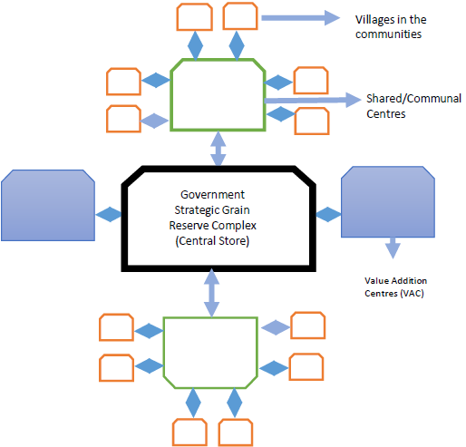
Figure 7. Framework of the Shared or Communal Processing and Storage Centres

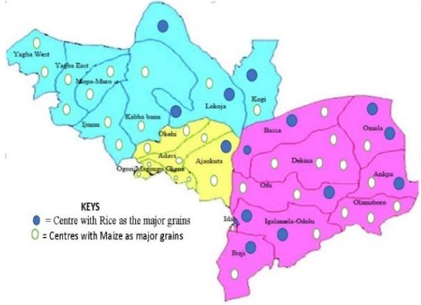
Figure 8. The mapping of the communities
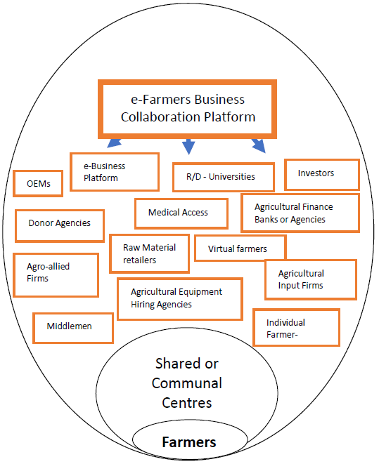
Figure 9. The stakeholders that can engage with the farmers for mutual benefits

For immediate storage for family use, the existing storage systems available for individual farmers could suffice. However, for “storage for better profit”, the quality of the stored produce is determined by the effectiveness of the storage systems. Therefore, a shared or communal storage system is recommended, to be managed by Good Agricultural Practices (GAP) professionals licensed by the government in a private-public partnership. However, the welfare of the farmers must be the focal theme of the shared or communal storage systems and centres. The government plays regulatory and support roles, and it can also be one of the clients of the farmers and the Centre if it wants to build up its grain reserve for emergencies. The farmers must be able to earn at least, between 5-25 per cent profit for any production cost incurred. If farmers cannot break-even, then the essence of the manual toiling is defeated. The model is applicable in other States and communities in Nigeria, with little or no modifications.
We also recommend the restructuring of the National Agency for Food & Drug Administration and Control (NAFDAC) into two: The National Agency for Food Safety (NAFS) and then The National Agency for Drug Administration and Control (NADAC). The food sector requires more scrutiny than the drugs in many cases, in that with adequate food safety and utilization, the need for drugs may drastically reduce.

Acknowledgements
We acknowledge the University of Agriculture, Makurdi – Nigeria, for part-funding this research geared towards a formidable rural economic institution in Nigeria.
References
[1] Kumar, D. and Kalita, P. “Reducing post-harvest lose during the storage of grain crops to strengthen food security in developing countries”, MDPI 6(1): 8. 2017.
[2] Alabadan, B.A., “Evaluation of Wooden Grain Bins during Storage of Maize (Zea mays) in Humid Tropical Climate”, Agricultural Engineering International: the CIGR e-journal. Manuscript BC 05 013. Vol. VIII, 2006.
[3] Okuneye P.A. “Rising Cost of Food Prices and Food Insecurity in Nigeria and its Implication for Poverty Reduction”, Central Bank of Nigeria Economic & Financial Review, Vol. 39 N0. 4. 2011.
[4] Adepoju, A.O. “Post-harvest losses and welfare of tomato farmers in Ogbomosho Osun state, Nigeria”, Journal of Stored Products and Postharvest Research. Vol. 5 (2), pp. 8-13), 2014.
[5] Adeoye, et al. “Agricultural Post-Harvest Waste Generation and Management for Selected Crops in Minna, Niger State, North Central Nigeria”, Journal of Applied Sciences in Environmental Sanitation, 6 (4):427-435, 2011.
[6] Olayemi et al. “Assessment of postharvest losses of some selected crops eight local government areas of Rivers State, Nigeria”, Asian Journal of Rural Development, Vol. 2 (1), 13-23, 2012.
[7] FMARD “The agriculture promotion policy (2016-2020): building on the successes of the agricultural transformation agenda (ATA), closing key gaps – policy and strategy document “Federal Ministry of Agriculture and Rural Development (FMARD), Nigeria, 2016.
[8] Leathers, H.D. and Foster, P. The world food problem: toward understanding and ending undernutrition in the developing world. 5th ed. Lynne Rienner Publishers Inc., 2017.
[9] NBS “Household and micro enterprise (informal sector): labour force statistics, national manpower stock and employment generation survey” National Bureau of Statistics (NBS), 2010.
[10] World Bank – IEG (2012) “Agricultural Development Projects in Nigeria”, World Bank Independent Evaluation Group, 2012.
[11] World Bank “FAQs Global Poverty Line Update”, World Bank, 2015.
[12] United Nations, “Millennium Development Goals Report 2015”, United Nations, 2015.
[13] World Bank (2013) Nigeria Economic Report. World Bank, Nigeria Economic Report No.1.
[14] Sunday, B.A.; Inimfon, V.P., and Amina A. “Level of income inequality and determinants of poverty incidence among youth farmers in Akwa Ibom State, Nigeria”, Journal of Sustainable Development; Vol. 9, No. 5, 2016.
[15] GrowAfrica “Fertilizer Subsidy Reform Revives Nigeria’s Agriculture: Targeting subsidies through farmer registration”. GrowAfrica, p. 1-16, 2015.
[16] BoA – Bank of Agriculture “Enhancing Wealth Creation Across the Agricultural Value Chains”, Bank of Agriculture Nigeria and Premium Times, 2018.
[17] FEPSAN Fake fertilizer now in circulation, producers raise the alarm, News Agency of Nigeria, 3 August 2018 (online). Available: https://punchng.com/fake-fertilizer-now-in-circulation-producers-alert-govt-farmers/.
[18] NBS “Nigerian gross domestic product report Q4 and full year 2017 National Bureau of Statistics, 2017.
[19] Ahungwa, G., Haruna, U., & Rakiya, Y. “Trend analysis of
the contribution of agriculture to the gross domestic product
of Nigeria (1960-2012)”, IOSR Journal of Agriculture and Veterinary Science, 7(1), 50-55, 2014.
[20] KSMRD - Kogi State Ministry of Rural Development Kogi: Building the rural economy, Kogi State Government Press, 2015.
[21] ADP - Agricultural Development Project “Village Listing Survey. An Occasional Report of Planning, Monitoring and Evaluation Unit, Lokoja”, Agricultural Development Project, Kogi State, 2003.
[22] Ibitoye, J.I. and Odiba, J. “Analysis of the Impact of Community Based Poverty Reduction Project on Farming Communities in Kogi State, Nigeria”, Journal of Economics and Sustainable Development, pp. 18-24, 2015.
[23] Ahiaba, V.U. “Agricultural Credit Repayment Preference among Rural Farmers in Some Rural Communities in Kogi State, North-Central Nigeria”, American Journal of Rural Development, Vol. 7, No. 1, 1-5, 2018.
[24] Glenn, D.I. Determining Sample Size. Available at: https://www.tarleton.edu/academicassessment/documents/Samplesize.pdf (Accessed: 24 October 2017), 2003.
[25] Capital Health, Guidelines for developing surveys/questionnaires. Performance Excellence Program - Capital Health. Available at http://docplayer.net/30687995-Guidelines-for-developing-surveys-questionnaires.html Accessed: 02 January 2017, 2009.
[26] FAO – “Post-Harvest Processing”, Food and Agriculture Organization, The Chromium Authors, 2015.
[27] RKB, “Moisture Content for Safe Storage”, Rice Knowledge Bank, 2017.
[28] WHO – World Health Organization Lassa Fever – Nigeria. WHO. http://www.who.int/csr/don/01-march-2018-lassa-fever-nigeria/en/[Assessed: 9 October 2018].
[29] Das, S., A review of Dichlorvos toxicity in fish. Curr World Environ 8(1), 2018. Available: http://www.cwejournal.org/?p=3061 (Accessed: 26 November 2018).
[30] Musilek, K. and Kuca, K. Novel cholinesterase reactors: handbook of toxicology of chemical warfare agents. 2015, 2nd edn. Elsevier.
[31] Food and Fairness Briefing No. 1 (2008) Which insecticides are banned in Europe. Available athttps://www.pan-europe.info/old/Resources/Links/Banned_in_the_EU.pdf (Accessed: 26 November 2018).
[32] Alabi, D.L., Akintola, O.M., and Famakinwa, M. (2018) “Perception of maize processors towards utilisation of maize value addition techniques: implications for rural entrepreneurship development – a study in Nigeria”,The Journal of Agricultural Sciences, Vol. 13, No. 2, pp 141-152,May 2018.
[33] RASFF - Rapid Alert System for Food and Feed of the European Commission 2016 Annual Report – Health & Safety. European Commission, 2016.
[34] Essiet, D. Can food processing zones do the trick? The Nation, July 24, 2014.
[35] Daneji, M. I., Agricultural Development Intervention Programmes in Nigeria (1960 To Date): A Review. Savannah Journal of Agriculture, Volume 6(1), 2011.
[36] FAO, IFAD and WFP, “The State of Food Insecurity in the
World 2015. Meeting the 2015 international hunger targets: taking stock of uneven progress”, Food and Agriculture Organization, 2015.
[37] Patrick, I. “Contract farming in Indonesia: Smallholders and agribusiness working together”, ACIAR Technical Reports No. 54, 88 pp, 2003.

