Running title: Edge effects on ancient woodland plants

Double-edged effect? Impact of dual edge proximity on the distribution of ancient woodland indicator plant species in a fragmented habitat.

Swallow, K. A.^{1,3} and Goodenough, A. E.²
^{1.} Centre of Environment, Royal Agricultural University, Cirencester, UK
^{2.} Department of Natural and Social Sciences, University of Gloucestershire, Cheltenham, UK
^{3.} Corresponding author. Email kelly.swallow@rau.ac.uk

Key words: Edge effect, Fragmentation, Ancient Forest Species, Plants, Herb layer, Conservation

Abstract:
The influence of edge proximity on woodland plants is a well-established research area, yet the influence of dual edge exposure has rarely been investigated. This novel research aims to establish whether proximity to two edges has any additive influence on Ancient Woodland Indicator (AWI) species presence relative to proximity to a single edge. Several AWI species are threatened and thus specific conservation priorities, while Ancient Semi-Natural Woodland (ASNW) itself is often highly fragmented: almost half of remnant patches are less than 5ha, which increases the potential for dual edge effects. Here, systematic mapping of herbaceous AWI species was conducted in 310 vegetation plots in two formerly-connected ASNW fragments in South-West England. Linear regression modelling revealed that distance to nearest edge and distance to second nearest edge were both univariately positively correlated with AWI species richness. After distance from nearest edge was entered into a multivariate model first, distance from second edge was entered in a second optional step after meeting stepwise criteria. The resultant multivariate model was more significant, and explained more variance, than either variable in isolation, indicating an additive effect of dual edge exposure. Likewise, binary logistic regression modelling showed presence of individual AWI species (Anemone nemorosa, Hyacinthoides non-scripta, Lamiastrum galaeobdolon and Paris quadrifolia) was significantly related not only to distance from the nearest and second nearest edges in isolation, but significantly more strongly by the additive effect of distance from both edges in a single model. We discuss the implications of these findings from community ecology and conservation perspectives.
Abbreviations: AWI – Ancient Woodland Indicator, ASNW – Ancient Semi-Natural Woodland
Nomenclature: IPNI (2015) The International Plant Names Index http://www.ipni.org/

Introduction
The presence of scarce and range-restricted flora in Ancient Semi-Natural Woodland (ASNW) (Peterken 1974, Wulf, 1997, Honnay et al. 1999, Palo et al. 2013) contributes to its status as an ecosystem of high conservation value (Peterken, 1983, Rackham, 2003, Goldberg et al. 2007). The ancient woodland concept is well-integrated into forest research and conservation practice, although definitions and date thresholds vary amongst countries (Hermy et al. 1999; Wirth et al., 2009). In England, ASNW is defined as predominantly a native broadleaf canopy established through natural regeneration (Rackham, 2008) on land that has remained continuously woodland since at least the year 1600 (Goldberg et al. 2007).
Ancient woodland indicator (AWI) species are vascular plants that are particularly, but not exclusively, associated with ASNW (Rose, 1999, Glaves et al. 2009). Regional AWI lists were developed to assist in determining ancient woodland status and are additionally used to assess habitat quality (Glaves et al. 2009). AWI species are considered to have low colonisation potential due to poor seed production, low dispersal capability and short-term persistence in the seed bank (Honnay et al. 1998). As such, AWI species may not be able to colonise alternative woodland habitats if ASNWs are lost or conditions become sub-optimal (Hermy et al. 1999). The limited distribution of AWI species and their specific ecology has promoted extensive use in woodland research (Peterken, 1974, Spencer, 1990, Wulf, 1997, Honnay et al. 1998, Hermy et al. 1999, Rose, 1999, Kirby and Goldberg, 2002, Rackham, 2003, Kirby and Morecroft, 2010, Kimberley et al. 2014, Stefańska-Krzaczek et al. 2016).
Landscape fragmentation is a significant threat to ASNW plant communities (Rackham, 2008, Corney et al. 2008), not only due to reduction in dispersal potential of AWI species, but also due to increased edge effects. Edge width is defined as the outer part of a woodland compartment where environmental conditions differ significantly from the interior (Honnay et al. 2002). Corney et al. (2008) report that 48% of ancient woodlands are under 5 ha, which means they have a high edge: interior ratio and a large edge width, especially if they deviate from an optimum circular shape (Laurance, 2008). Edge environmental conditions are generally considered to be less favourable for persistence of specialist flora, including many AWI species, due to altered abiotic and biotic variables (Matlack, 1993; Murcia, 1995; Honnay et al., 2002; Willi et al., 2005; Hofmeister et al., 2013; Tinya and Odor, 2016), as well as anthropogenic influences (Corney et al., 2008).
Abiotic and biotic variables commonly exhibit an edge width of between 10-60m in temperate forests (Palik and Murphy, 1990; Matlack, 1993; Matlack, 1994; Gehlhausen et al., 2000; Honnay et al., 2002). Additionally, studies seeking to avoid edge influence, have situated sample plots at >20m from the edge (Bossuyt and Hermy, 2000), >30m (Brunet et al. 2012), and >50m (Gelhausen, 2000, Coote et al., 2012). Exceptionally, edge effects have been evidenced over 100m from the edge (Hofmeister et al. 2013; Pellissier et al. 2013) but such findings are not comparable to small ancient woodland fragments in the UK. Land use in the matrix (Gove et al. 2007), prevailing wind direction (Smithers, 2000) and aspect (Murcia, 1995; Honnay et al., 2002) influence the extent to which edge effects permeate woodland.
This is the first study to investigate multiple edge effects in relation to AWI species and ancient woodland. The impact of multiple edges is an important but overlooked factor (Ries and Sisk, 2004). Few studies have explicitly gathered primary data to analyse this in relation to any species or ecosystem (Fletcher et al., 2005), instead measuring linear distance to the closest edge only. A small number of studies have been completed with explicit focus on AWI response to nearest edge proximity (Willi et al., 2005; Hofmeister et al, 2013; Pellissier et al., 2013; Kimberley et al., 2014). Despite the potential importance of edge effects on AWI species, both in their own right as specialist species, and in terms of their efficacy of indicators, a search of the literature revealed no studies relating to multiple edge effects on these species. This is surprising given that the highly-fragmented nature of ANSW means that the potential for exposure to multiple edge effects is considerable.
We test for relationship with the nearest edge, as well as any additional contribution of the second edge to take account of double exposure within fragment corners. We hypothesised that (1) AWI richness will increase with distance from any edge; (2) the second nearest edge would also correlate with AWI richness so that a multivariate model with both distances would be superior to a univariate model using either in isolation; (3) the patterns for AWI species richness would also hold true for specific AWI species analysed on a presence/ absence basis.

Methods
The study site was a fragmented species-rich ASNW in the South-West UK. The two discrete fragments comprising the site were situated near Cheltenham on the Cotswold Hills escarpment of Jurassic oolitic limestone, at 265m above sea level and centred on 51°53’35.5’’N, 2°00’34.60’’W (Fig. 1). The mean diurnal temperature was 8.6-14.7°C and annual precipitation was 843mm (MET office, 1981-2010). The fragments have comparable geology, edaphic variables and topography. The coppice-with-standards woodland classifies as National Vegetation Classification W8b (Rodwell, 1991), with a canopy dominated by Fraxinus excelsior and Quercus robur.
Both fragments, henceforth referred to as Fragment 1a and 1b were located within an agricultural (arable and equine) matrix. Fragment 1a was 4.8ha and of approximately rectangular dimension (190x255m). Fragment 1b was a remnant of 0.6ha located 25m from the eastern edge of Fragment 1a. Historic map evidence showed that both fragments formed a single woodland until c1965. Both fragments are classified by DEFRA (2016) as ASNW.
In order to assess any influence of dual-edge effect in Fragment 1a, presence of AWI species was mapped and recorded via a total of 256 2x2m plots. Plots were located in the corners of Fragment 1a within 60m of both the nearest edge (Edge 1) and second nearest edge (Edge 2). The distance of 60m was deemed a conservative upper limit for detection of edge effects based on previous studies (Murcia, 1995; Gelhausen et al., 2000; Honnay et al., 2002; Vallet et al., 2010). Plots were located at 0, 5, 10, 20, 30, 40, 50 and 60m on transects perpendicular to the Western and Eastern edges, with 0m defined as the commencement of woody species’ stems (Murcia, 1995). Changing the sampling distance from 10m to 5m at the edges of the fragment allowed small-scale change to be better detected (Honnay et al., 2002). Recorded species were restricted to herbaceous and semi-woody plants (Brunet et al., 2011) identified as Ancient Woodland Indicators in the South-West UK (Rose, 1999). To complement analysis of the larger fragment and demonstrate any difference in species richness and presence between the two fragments, Fragment 1b was surveyed on the same system with plots at 0, 5, 10 and 20m from the Eastern and Western edges (n=54). All statistical analyses apply to Fragment 1a.
To predict the influence of Edge 1 and Edge 2 on AWI richness, separate univariate linear regression analyses were performed (n=256). To test any additive influence of both edges, a hierarchical multivariate model was created where Edge 1 was entered via forced entry and Edge 2 was available as a candidate variable in a second step using a stepwise approach (entry criterion α = 0.05, except L. galaeobdolon α = 0.1) (De Keersmaeker et al., 2004). Normality assumptions were met, and collinearity was within accepted limits: VIF < 10 (Myers, 1990) and tolerance >0.2 (Menard, 1995). The same principles were followed using binary logistic regression to test the influence of Edge 1 and Edge 2, separately and additively, on the presence AWI species (those found in >10% of plots) (n=256). The R² (linear regression) and Nagelkerke pseudo R² (logistic regression) statistics were calculated to measure the relative influence of single and additive edges on, respectively, AWI richness and species presence.

Results and analysis
Mapping of Fragment 1a, showed clear spatial patterns in AWI richness in relation to edge proximity (Fig. 2). AWI richness was very low at the edge, and increased gradually up to 60m; this effect was most pronounced at the corners where a distinct edge effect was apparent up to 20-30m, rather than 5-10m on transects located mid-edge. Within the very small Fragment 1b, AWI richness is lower throughout than in Fragment 1a, with no clear edge or corner pattern (Fig. 2).
Regression analysis showed significant positive directional relationships between AWI richness and distance from the edge in Fragment 1a (Table 1). When tested independently, Edge 1 and Edge 2 were both shown to be significantly positively related to AWI richness, but Edge 1 was related more strongly than Edge 2. Used in a hierarchical framework, Edge 2 met the stepwise criteria for entry as a second variable into a multivariate model after Edge 1 had already been entered. This, together with the resultant multivariate model being more significant and explaining more variance than either Edge 1 or Edge 2 in isolation, strongly suggests dual-edge exposure is important for AWI richness.
Repeating the above analytical framework using hierarchical multiple logistic regression for the seven most prevalent species (those present in >10% of plots) showed that the presence of four species increased significantly with increasing distance from edge (Table 1). For each of these species (A. nemorosa, H. non-scripta, L. galaeobdolon and P. quadrifolia) Edge 1 and Edge 2 were both significant when analysed separately and again the R² statistic for Edge 2 was slightly lower than Edge 1. In all four cases, running a stepwise model with Edge 2 available as a candidate variable resulted in a multivariate model being created that had a substantially lower P value and substantially higher R² value than either edge tested alone. For where species Edge 2 was not entered using standard stepwise criteria (α = 0.05 or 0.10), forcing this variable into the model did not improve it relative to using Edge 1 alone and all models were non-significant.
Thirteen AWI species were recorded within Fragment 1a sample plots and eight within Fragment 1b (Appendix 1). The four species significantly associated with distance showed clear reductions in prevalence in Fragment 1b, in comparison to 1a (Appendix 1). Presence of A. nemorosa and H. non-scripta in Fragment 1b was half of that in 1a, while L. galaeobdolon and P. quadrifolia were absent from Fragment 1b. Of prevalent species not significantly associated with distance, only A. ursinum occurred considerably more frequently in Fragment 1b than in Fragment 1a.

Discussion
The above results show that not only are edge conditions less suitable for the majority of AWI species present, but the AWI community is vulnerable to a dual-edge effect whereby the combined influence of two edges is amplified and permeates further into a woodland near corners. The distance to the nearest two edges combined explained 11% of the variation in AWI richness and up to 17% of the variation in the presence/ absence of specific AWI species (Table 1). Dual-edge exposure explained a significant, and consistent, additional 1-3% of the variation in AWI richness and presence of some species than the single nearest edge alone (Table 1). The findings reinforce the need to protect ancient woodlands from fragmentation. Two species with conservation designations, H. non-scripta and L. galaeobdolon, were especially adversely affected by edge proximity (Table 1). At 4.8ha, Fragment 1a is among the larger of the 48% of ancient woodlands that are smaller than 5ha (Corney et al. 2008), with a considerable area exposed to single and dual-edge effects. Fragment 1b is smaller still, and mapping suggests is influenced in its entirety by edge conditions.
Both woodlands reinforce the edge: interior ratio theory proposed by Laurance (2008). For this reason, some AWI species might not be appropriate indicators in small fragments where there is a high proportion of edge habitat, as they may be absent even from small ancient woodlands. Our findings show a lower richness count and predominantly lower prevalence of AWI species in Fragment 1b despite its adjacent position and history of connectivity with 1a. However, both fragments have what is considered to be an acceptable AWI score (Fragment 1a = 13; Fragment 1b = 8). Thresholds of 10-12 AWI species (including woody species, forbs and ferns) are used by organisations for allocating conservation priority, while ASNWs under 2ha with >5 AWI species were recommended for inclusion in a county ancient woodland inventory (Glaves et al. 2009). If AWI species counts are used in small fragments, consideration should be given to only using the subset of species that are not seemingly affected by edge effects.
AWI species have been considered as a guild (Hermy et al. 1999), but in this study the response of the community and individual species in relation to edge proximity indicates variation in niche requirements. Of the species significantly influenced by edge proximity, all increased in prevalence with distance from the edge (Table 1). The preference of P. quadrifolia for woodland interior may be accounted for by its adaptation for vegetative growth during low light periods (Bjerketvedt et al. 2003). Similarly to this study, Honnay et al. (2002) found A. nemorosa to have a positive edge-distance distribution in ancient woodland study sites in Belgium. Of those not exhibiting significant relationships with edge, only V. reichenbachiana decreased in prevalence with distance from either and both edges, possibly accounted for by its greater light requirement for a summer second leafing period (Rackham, 2003).
This study has demonstrated dual-edge proximity has a substantial effect on AWI community composition, and has highlighted the species-specific nature of the response to different plants to the edge. It has also emphasised the effects of edge orientation and woodland size on floral response to edge conditions. Future research on the influence on multiple-edge biotic and abiotic variables in small ASNWs would be beneficial in further explaining spatial distribution of AWI species and for development of conservation management practices.

Acknowledgements: We would like to thank Gloucestershire Wildlife Trust and R. Robinson for site survey permission.

References
Bjerketvedt, D. L., A. Odland, J. Naujalis and J. Lazutka. 2003. The growth and phenology patterns of herb Paris (Paris quadrifolia L., Trilliaceae): relation to soil and air temperatures. Ekolgija 1: 75-80
Bossuyt, B. and Hermy, M., 2000. Restoration of the understorey layer of recent forest bordering ancient forest. Appl. Veg. Sci. 3: 43-50.
Brunet, J., K. Valtinat, M. L. Mayr, A. Felton, M. Lindbladh and H. H. Bruun. 2011. Understorey succession in post-agricultural oak forests: habitat fragmentation affects forest specialists and generalists differently. For. Ecol. Manage. 262: 1863-1871
Brunet, J., De Frenne, P., Holmström, E. and Mayr, M.L., 2012. Life-history traits explain rapid colonization of young post-agricultural forests by understory herbs. For. Ecol. and Manag. 278: 55-62.
Coote, L., French, L.J., Moore, K.M., Mitchell, F.J.G. and Kelly, D.L., 2012. Can plantation forests support plant species and communities of semi-natural woodland? For. Ecol. Manag. 283: 86-95.
Corney, P., R. Smithers, K. J. Kirby, G. Peterken, M. Le Duc and R. Marrs. 2008. Impacts of nearby development on the ecology of ancient woodland. Report to the Woodland Trust, Grantham
DEFRA (2016) MAGIC map application [online]. Available from: http://magic.defra.gov.uk/MagicMap.aspx. {Accessed 09/06/16}
De Keersmaeker, L., Martens, L., Verheyen, K., Hermy, M., De Schrijver, A. and Lust, N., 2004. Impact of soil fertility and insolation on diversity of herbaceous woodland species colonizing afforestations in Muizen forest (Belgium). For. Ecol. Manag. 188: 291-304.
Fletcher, R.J., 2005. Multiple edge effects and their implications in fragmented landscapes. J. Anim. Ecol. 74: 342-352.
Gehlhausen, S.M., Schwartz, M.W. and Augspurger, C.K., 2000. Vegetation and microclimatic edge effects in two mixed-mesophytic forest fragments. Plant Ecol. 147: 21-35.
Glaves, P. M., C. Handley, J. Birkbeck, I.D. Rotherham and B. Wright. 2009. A survey of the coverage, use and application of ancient woodland indicator lists in the UK. Report to the Woodland Trust, Grantham.
Goldberg, E., K. J. Kirby, J. Hall and J. Latham. 2007. The ancient woodland concept as a practical conservation tool in Great Britain. J. Nat. Conserv. 15: 109-119
Gove, B., S. Power, G. Buckley and J. Ghazoul. 2007. Effects of herbicide spray drift and fertilizer overspread on selected species of woodland ground flora: comparison between short-term and long-term impact assessments and field surveys. J. Appl. Ecol. 44: 374-384
Hermy, M. J., O. Honnay, L. Firbank, C. Grashof-Bokdam and J. E. Lawesson. 1999. An ecological comparison between ancient and other plant species of Europe, and the implications for forest conservation. Biol. Conserv. 87: 73-84
Hofmeister, J., J. Hošek, M. Brabec, R. Hédl and M. Modrý. 2013. Strong influence of long-distance edge effect on herb-layer vegetation in forest fragments in an agricultural landscape. Perspect. Plant Ecol. Evol. Syst. 15: 293-303
Honnay, O., B. Degroote and M. Hermy. 1998. Ancient-forest plant species in western Belgium: a species list and possible ecological mechanisms. Belg. J. Bot. 130: 139-154
Honnay, O., M. Hermy and P. Coppin. 1999. Effects of area, age and diversity of forest patches in Belgium on plant species richness, and implications for conservation and reforestation. Biol. Conserv. 87: 73-84
Honnay, O., K. Verheyen, J. Butaye, H. Jacquemen, B. Bossuyt and M. Hermy. 2002. Possible effects of habitat fragmentation and climate change on the range of forest plant species. Ecol. Lett. 5: 525-530
Kimberley, A., Alan Blackburn, G., Duncan Whyatt, J. and Smart, S.M., 2014. Traits of plant communities in fragmented forests: the relative influence of habitat spatial configuration and local abiotic conditions. J. Ecol. 102: 632-640.
Kirby, K. J. and E. Goldberg. 2002. Ancient woodland: guidance material for local authorities. Peterborough: English Nature
Kirby, K. and Morecroft, M. (2011). Flowers of the forest. In Savill, P., Perrins, C., Fisher, N. and Kirby, K. (eds) Wytham Woods: Oxford's ecological laboratory. Oxford University Press: Oxford
Laurance, W. F. 2008. Theory meets reality: how habitat fragmentation research has transcended island biogeographic theory. Biol. Conserv. 141: 1731-1744
Matlack, G.R., 1993. Microenvironment variation within and among forest edge sites in the eastern United States. Biol. Conserve. 66: 185-194.
Matlack, G.R., 1994. Vegetation dynamics of the forest edge--trends in space and successional time. J. Ecol. 82: 113-123.
MET Office. 1981-2010. Climate data for Cheltenham 1981-2010 [online]. Available http://www.metoffice.gov.uk/public/weather/climate/gcnx0z9e5. [Accessed 08/06/16]
Menard, S. 1995. Applied logistic regression analysis. Sage; Thousand Oaks
Murcia, C. 1995. Edge effects in fragmented forest: implications for conservation. Trends Ecol. Evol. 10: 58-62
Myers, R. 1990. Classical and modern regression with applications. PWS and Kent Publishing: Boston
Palik, B.J. and Murphy, P.G., 1990. Disturbance versus edge effects in sugar-maple/beech forest fragments. For. Ecol. Manag. 32: 187-202.
Palo, A., M. Ivask and J. Liira. 2013. Biodiversity composition reflects the history of ancient semi-natural woodland and forest habitats – complication of an indicator complex for restoration practice. Ecol. Indic. 34: 336-344
Pellissier, V., Bergès, L., Nedeltcheva, T., Schmitt, M.C., Avon, C., Cluzeau, C. and Dupouey, J.L., 2013. Understorey plant species show long‐range spatial patterns in forest patches according to distance‐to‐edge. J. Veg.Sci. 24: 9-24.
Peterken, G. 1974. A method for assessing woodland flora for conservation using indicator species. Biol. Conserv. 6: 239-245
Peterken, G. 1983. Woodland conservation in Britain. In: A. Warren and F. B. E. Goldsmith (eds) Conservation in Perspective. Wiley. pp83-100
Rackham, O. 2003. Ancient Woodland: its history, vegetation and uses in England. Castlepoint Press, Colvend
Rackham, O. 2008. Ancient woodlands: modern threats. New Phytol. 180: 571-586
Ries, L. and Sisk, T.D., 2004. A predictive model of edge effects. Ecol. 85: 2917-2926.
Rodwell, J.S. (ed.) 1991. British Plant Communities. Volume 1. Woodlands and scrub. Cambridge University Press. Cambridge

Rose, F. 1999. Indicators of ancient woodland. British Wildlife. 10: 241-251
Savill, P. S., C. Perrins and K. Kirby. 2010. Wytham Woods: Oxford’s ecological laboratory. Oxford Univ. Press, Oxford.
Smithers, R. 2000. Woodland biodiversity: expanding our horizons. Landsc. Res. 25: 386-391
Spencer, J. W. 1990. Indications of antiquity: some observations on the nature of plants associated with ancient woodland. British Wildlife. 2: 90-102
Stefańska-Krzaczek, E., Z. Kacki and B. Szypula. 2016. Coexistence of ancient forest species as indicators of high species richness. Forest Ecol. Manag. 365: 12-21
Tinya, F. and Ódor, P., 2016. Congruence of the spatial pattern of light and understory vegetation in an old-growth, temperate mixed forest. For. Ecol. Manag. 381: 84-92.
Vallet, J., Beaujouan, V., Pithon, J., Rozé, F. and Daniel, H., 2010. The effects of urban or rural landscape context and distance from the edge on native woodland plant communities. Biodivers. Conserv. 19: 3375-3392.
Willi, J.C., Mountford, J.O. and Sparks, T.H., 2005. The modification of ancient woodland ground flora at arable edges. Biodivers. Conserv. 14: 3215-3233.

Wirth, C., Messier, C, Bergeron, Y., Frank, D. and Fankhanel, A. 2009. Old growth forest definitions: a pragmatic view. In Wirth, C., Heimann, M. and Gleixner, G. eds., 2009. Old Growth Forests. Springer. 11-33
Wulf, M. 1997. Plant species as indicators of ancient woodland in northwestern Germany. J. Veg. Sci. 8: 635-642

Figure 1. Study site location of the Cotswold Hills, UK.

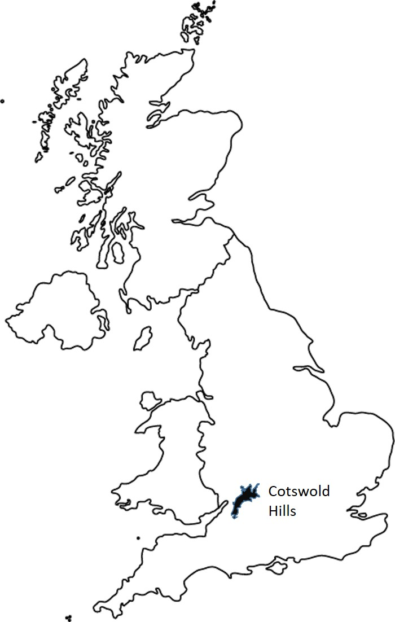

Figure 2. Richness of Ancient Woodland Indicator species in a total of 310 2x2m plots within two fragments of ancient semi-natural woodland.
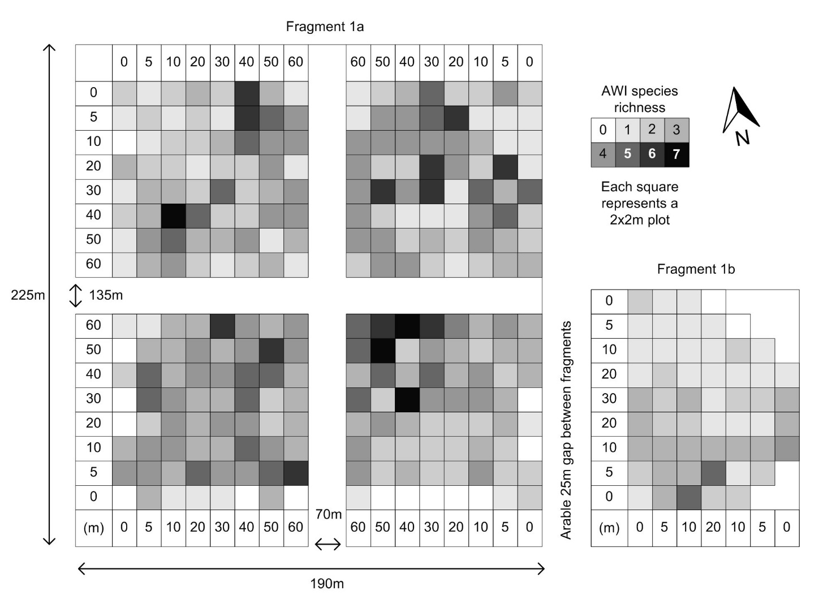

Table 1. AWI richness (all species) and species presence (most frequently occurring species in >10% of plots) relationship with distance from Edge 1, Edge 2, and both edges together. In all cases, the additive model was a hierarchical one whereby Edge 1 was entered first and then Edge 2 was available as a candidate variable for inclusion following a stepwise approach; the model was not calculated if the addition of Edge 2 into the model did not significantly improve it.
 |  | p R² Dir.
AWI richness | Edge 1  Edge 2  Additive | <0.001 0.099 +  <0.001 0.069 +  <0.001 0.115 +
Species |  | Chi (df) p R² Dir.
A. ursinum  A. nemorosa  G. odoratum  H. non-scripta  L. galaeobdolon  P. quadrifolia  V. reichenbachiana | Edge 1  Edge 2  Additive  Edge 1  Edge 2  Additive  Edge 1  Edge 2  Additive  Edge 1  Edge 2  Additive  Edge 1  Edge 2  Additive  Edge 1  Edge 2  Additive  Edge 1  Edge 2  Both | 0.357 (1) 0.425 0.030  0.187 (1) 0.666 0.080  Model not calculated  23.117 (1) <0.001 0.126 +  19.572 (1) <0.001 0.107 +  29.292 (2) <0.001 0.158 +  0.077 (1) 0.781 0.000  0.002 (1) 0.968 0.000  Model not calculated  27.550 (1) <0.001 0.141 +  20.323 (1) <0.001 0.105 +  33.100 (2) <0.001 0.168 +  11.866 (1) 0.001 0.064 +  9.321 (1) 0.002 0.036 +  14.417 (2) 0.001 0.077 +  16.698 (1) <0.001 0.095 +  16.117 (1) <0.001 0.092 +  22.287 (2) <0.001 0.126 +  0.699 (1) 0.403 0.005  2.044 (1) 0.153 0.014  Model not calculated
Dir. - direction of relationship for significant models. R² - Nagelkerke
Species present with conservation designations: Hyacinthoides non-scripta - Wildlife and Countryside Act, schedule 8; Lamiastrum galaebdolon - Vascular Plant Red List for Great Britain nationally scarce, vulnerable. Vascular Plant Red List for England, vulnerable; Viola reichenbachiana - Scottish Biodiversity List. Primula vulgaris (Wildlife Order Northern Ireland schedule 8); Sanicula europaea (Vascular Plant Red List for Great Britain, near threatened)

Appendix 1. Comparative frequency occurrence of AWI species in Fragments 1a and 1b. Total herbaceous AWI count of both fragments.
 | Fragment 1a | Fragment 1b
Frequency occurrence  Anemone nemorosa  Hyacinthoides non-scripta  Allium ursinum  Lamiastrum galaeobdolon  Galium odoratum  Paris quadrifolia  Viola reichenbachiana  Conopodium majus  Primula vulgaris  Euphorbia amygdaloides  Orchis mascula  Veronica montana  Sanicula europaea | 73%  66%  51%  31%  25%  22%  15%  4%  2%  1%  1%  1%  <1% | 35%  33%  96%  Absent  Absent  Absent  2%  2%  7%  Absent  2%  2%  Absent
Total AWI count | 13 | 8

